Inversion of control concept

the BeanFactory provides the configuration framework and basic functionality, and the
ApplicationContext adds more enterprise-specific functionality. The ApplicationContext is
a complete superset of the BeanFactory, and is used exclusively in this chapter in descriptions
of Spring's IoC container.

The interface org.springframework.context.ApplicationContext represents the Spring IoC
container and is responsible for instantiating, configuring, and assembling the aforementioned beans.
The container gets its instructions on what objects to instantiate, configure, and assemble by reading
configuration metadata. The configuration metadata is represented in XML, Java annotations, or Java
code.

Several implementations of the ApplicationContext interface are supplied out-of-thebox
with Spring. In standalone applications it is common to create an instance of
ClassPathXmlApplicationContext or FileSystemXmlApplicationContext

XML-based metadata
Annotation based metadata
Java based metadata (Javaconfig)
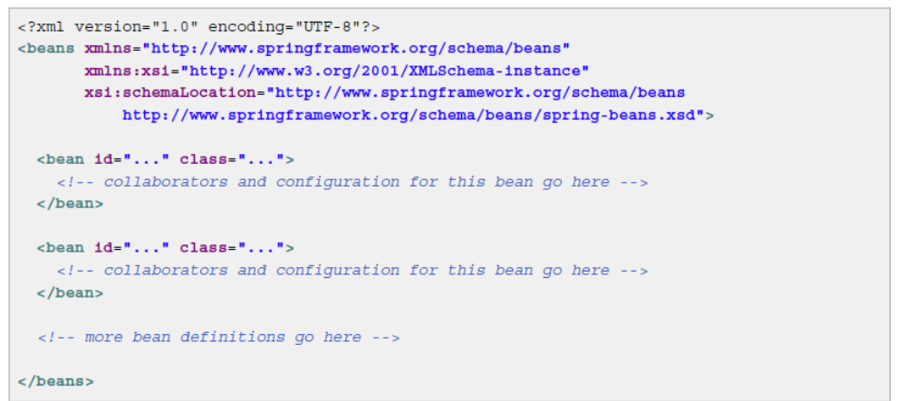

Instantiating a container

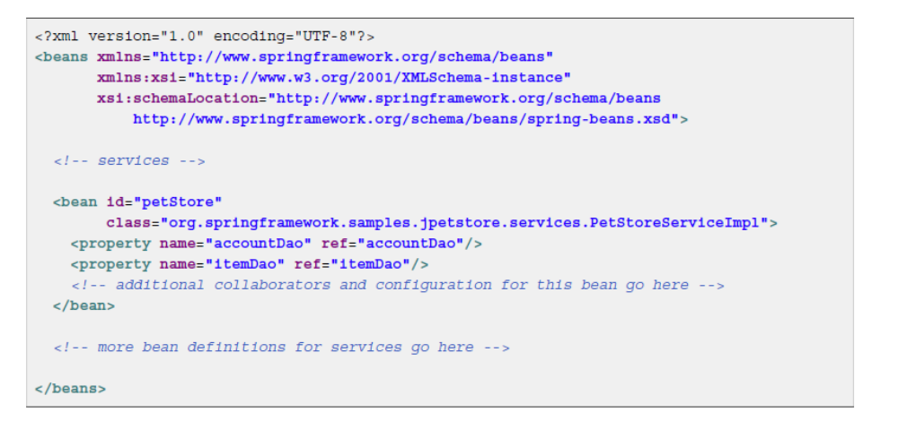
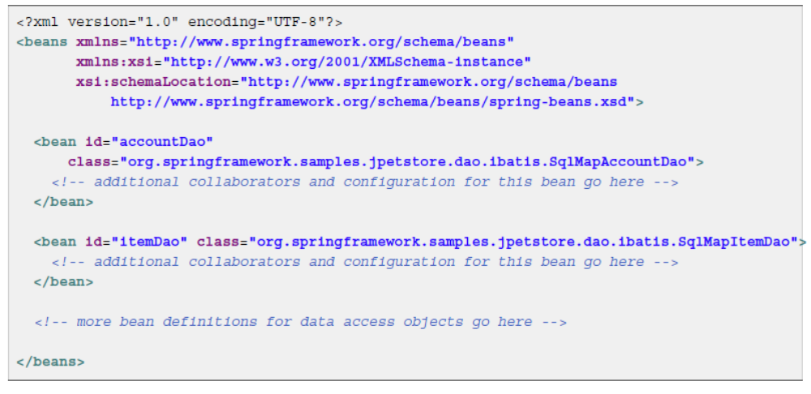
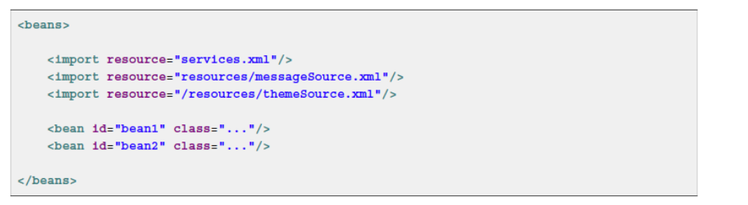

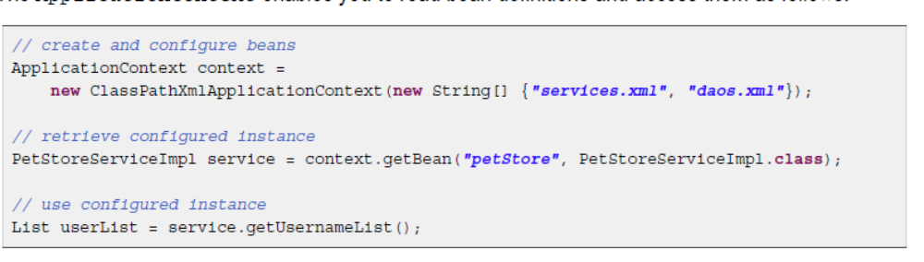
Within the container itself, these bean definitions are represented as BeanDefinition objects, which
contain (among other information) the following metadata:
package-qualified class name, scope, lifecycle callbacks, and so forth

Naming the beans

Every bean has one or more identifiers. These identifiers must be unique within the container that hosts
the bean. A bean usually has only one identifier, but if it requires more than one, the extra ones can
be considered aliases.
If you want to introduce other aliases to the bean, you can also specify them in the name attribute, separated by a comma (,),
semicolon (;), or white space.
Specifying all aliases where the bean is actually defined is not always adequate, however. It is
sometimes desirable to introduce an alias for a bean that is defined elsewhere. This is commonly the
case in large systems where configuration is split amongst each subsystem, each subsystem having its
own set of object definitions. In XML-based configuration metadata, you can use the <alias/> element
to accomplish this.
In this case, a bean in the same container which is named fromName, may also after the use of this
alias definition, be referred to as toName.
For example, the configuration metadata for subsystem A may refer to a DataSource via the name
'subsystemA-dataSource. The configuration metadata for subsystem B may refer to a DataSource
via the name 'subsystemB-dataSource'.

Instantiating beans
If you want to configure a bean definition for a static nested class, you have to use the binary
name of the inner class.
For example, if you have a class called Foo in the com.example package, and this Foo class
has a static inner class called Bar, the value of the 'class' attribute on a bean definition
would be...
com.example.Foo$Bar
Notice the use of the $ character in the name to separate the inner class name from the outer
class name.
Instantiation with a constructor
Instantiation with a static factory method
When defining a bean that you create with a static factory method, you use the class attribute to specify
the class containing the static factory method and an attribute named factory-method to specify
the name of the factory method itself.
instantiation with an instance factory method invokes a non-static method of an existing bean from the container to create a new bean. To use this
mechanism, leave the class attribute empty, and in the factory-bean attribute, specify the name of a
bean in the current (or parent/ancestor) container that contains the instance method that is to be invoked
to create the object. Set the name of the factory method itself with the factory-method attribute
Dependency injection
Dependency injection (DI) is a process whereby objects define their dependencies, that is, the other
objects they work with, only through constructor arguments, arguments to a factory method, or properties
that are set on the object instance after it is constructed or returned from a factory method. The container
then injects those dependencies when it creates the bean. This process is fundamentally the inverse,
hence the name Inversion of Control (IoC), of the bean itself controlling the instantiation or location of
its dependencies on its own by using direct construction of classes, or the Service Locator pattern

Constructor-based dependency injection
Setter-based dependency injection
Since you can mix both, Constructor- and Setter-based DI, it is a good rule of thumb to use
constructor arguments for mandatory dependencies and setters for optional dependencies
The Spring team generally advocates setter injection, because large numbers of constructor
arguments can get unwieldy, especially when properties are optional. Setter methods also make
objects of that class amenable to reconfiguration or re-injection later
Some purists favor constructor-based injection. Supplying all object dependencies means that the
object is always returned to client (calling) code in a totally initialized state.

Dependency resolution process
1. The ApplicationContext is created and initialized with configuration metadata that describes all
the beans. Configuration metadata can be specified via XML, Java code or annotations
2. For each bean, its dependencies are expressed in the form of properties, constructor arguments, or
arguments to the static-factory method if you are using that instead of a normal constructor. These
dependencies are provided to the bean, when the bean is actually created.
3 Each property or constructor argument is an actual definition of the value to set, or a reference to
another bean in the container.
4. Each property or constructor argument which is a value is converted from its specified format to the
actual type of that property or constructor argument. By default Spring can convert a value supplied
in string format to all built-in types, such as int, long, String, boolean, etc.
Circular reference

If you use predominantly constructor injection, it is possible to create an unresolvable circular
dependency scenario.
For example: Class A requires an instance of class B through constructor injection, and class B
requires an instance of class A through constructor injection. If you configure beans for classes
A and B to be injected into each other, the Spring IoC container detects this circular reference at
runtime, and throws a BeanCurrentlyInCreationException

Straight values (primitives, Strings, and so on)
The value attribute of the <property/> element specifies a property or constructor argument as a
human-readable string representation.
JavaBeans PropertyEditors are
used to convert these string values from a String to the actual type of the property or argument
The Spring container converts the text inside the <value/> element into a java.util.Properties
instance by using the JavaBeans PropertyEditor mechanism.

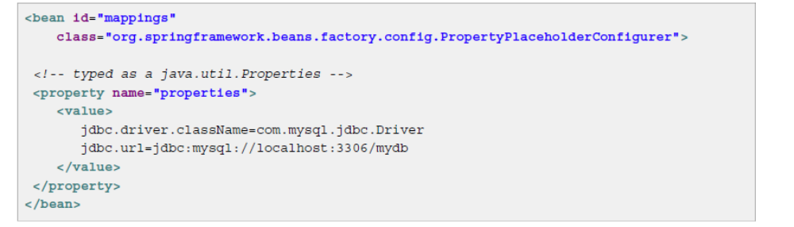
The idref element
The idref element is simply an error-proof way to pass the id (string value - not a reference) of another
bean in the container to a <constructor-arg/> or <property/> element.

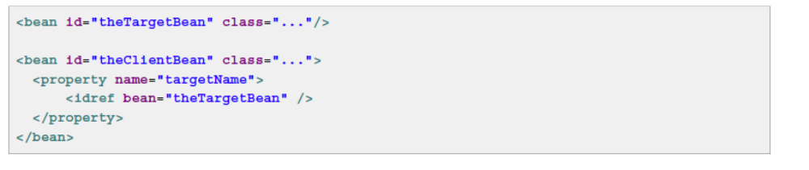
You can also use local

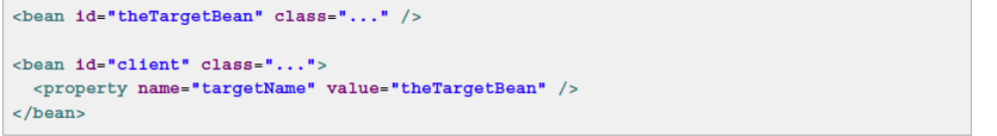

The first form is preferable to the second, because using the idref tag allows the container to validate at
deployment time that the referenced, named bean actually exists. In the second variation, no validation
is performed on the value that is passed to the targetName property of the client bean. Typos are
only discovered (with most likely fatal results) when the client bean is actually instantiated.
A common place (at least in versions earlier than Spring 2.0) where the <idref/> element brings value
is in the configuration of AOP interceptors in a ProxyFactoryBean bean definition. Using <idref/>
elements when you specify the interceptor names prevents you from misspelling an interceptor id.

First of all, as @AndrewFinnell and @KenLiu point out, in SVN the directory names themselves mean nothing -- "trunk, branches and tags" are simply a common convention that is used by most repositories. Not all projects use all of the directories (it's reasonably common not to use "tags" at all), and in fact, nothing is stopping you from calling them anything you'd like, though breaking convention is often confusing.
I'll describe probably the most common usage scenario of branches and tags, and give an example scenario of how they are used.
- Trunk: The main development area. This is where your next major release of the code lives, and generally has all the newest features.
- Branches: Every time you release a major version, it gets a branch created. This allows you to do bug fixes and make a new release without having to release the newest - possibly unfinished or untested - features.
- Tags: Every time you release a version (final release, release candidates (RC), and betas) you make a tag for it. This gives you a point-in-time copy of the code as it was at that state, allowing you to go back and reproduce any bugs if necessary in a past version, or re-release a past version exactly as it was. Branches and tags in SVN are lightweight - on the server, it does not make a full copy of the files, just a marker saying "these files were copied at this revision" that only takes up a few bytes. With this in mind, you should never be concerned about creating a tag for any released code. As I said earlier, tags are often omitted and instead, a changelog or other document clarifies the revision number when a release is made.

For example, let's say you start a new project. You start working in "trunk", on what will eventually be released as version 1.0.
- trunk/ - development version, soon to be 1.0
- branches/ - empty
Once 1.0.0 is finished, you branch trunk into a new "1.0" branch, and create a "1.0.0" tag. Now work on what will eventually be 1.1 continues in trunk.
- trunk/ - development version, soon to be 1.1
- branches/1.0 - 1.0.0 release version
- tags/1.0.0 - 1.0.0 release version
You come across some bugs in the code, and fix them in trunk, and then merge the fixes over to the 1.0 branch. You can also do the opposite, and fix the bugs in the 1.0 branch and then merge them back to trunk, but commonly projects stick with merging one-way only to lessen the chance of missing something. Sometimes a bug can only be fixed in 1.0 because it is obsolete in 1.1. It doesn't really matter: you only want to make sure that you don't release 1.1 with the same bugs that have been fixed in 1.0.
- trunk/ - development version, soon to be 1.1
- branches/1.0 - upcoming 1.0.1 release
- tags/1.0.0 - 1.0.0 release version
Once you find enough bugs (or maybe one critical bug), you decide to do a 1.0.1 release. So you make a tag "1.0.1" from the 1.0 branch, and release the code. At this point, trunk will contain what will be 1.1, and the "1.0" branch contains 1.0.1 code. The next time you release an update to 1.0, it would be 1.0.2.
- trunk/ - development version, soon to be 1.1
- branches/1.0 - upcoming 1.0.2 release
- tags/1.0.0 - 1.0.0 release version
- tags/1.0.1 - 1.0.1 release version
Eventually you are almost ready to release 1.1, but you want to do a beta first. In this case, you likely do a "1.1" branch, and a "1.1beta1" tag. Now, work on what will be 1.2 (or 2.0 maybe) continues in trunk, but work on 1.1 continues in the "1.1" branch.
- trunk/ - development version, soon to be 1.2
- branches/1.0 - upcoming 1.0.2 release
- branches/1.1 - upcoming 1.1.0 release
- tags/1.0.0 - 1.0.0 release version
- tags/1.0.1 - 1.0.1 release version
- tags/1.1beta1 - 1.1 beta 1 release version
Once you release 1.1 final, you do a "1.1" tag from the "1.1" branch.
You can also continue to maintain 1.0 if you'd like, porting bug fixes between all three branches (1.0, 1.1, and trunk). The important takeaway is that for every main version of the software you are maintaining, you have a branch that contains the latest version of code for that version.

Another use of branches is for features. This is where you branch trunk (or one of your release branches) and work on a new feature in isolation. Once the feature is completed, you merge it back in and remove the branch.
- trunk/ - development version, soon to be 1.2
- branches/1.1 - upcoming 1.1.0 release
- branches/ui-rewrite - experimental feature branch
The idea of this is when you're working on something disruptive (that would hold up or interfere with other people from doing their work), something experimental (that may not even make it in), or possibly just something that takes a long time (and you're afraid if it holding up a 1.2 release when you're ready to branch 1.2 from trunk), you can do it in isolation in branch. Generally you keep it up to date with trunk by merging changes into it all the time, which makes it easier to re-integrate (merge back to trunk) when you're finished.

