Repository Contents
The purpose of Git is to manage a project, or a set of files, as they change over time. Git stores this information in a data structure called a repository.
A git repository contains, among other things, the following:
A set of commit objects.
A set of references to commit objects, called heads.
The Git repository is stored in the same directory as the project itself, in a subdirectory called .git. Note differences from central-repository systems like CVS or Subversion:
There is only one .git directory, in the root directory of the project.
The repository is stored in files alongside the project. There is no central server repository

Commit Objects
A commit object contains three things:
- A set of files, reflecting the state of a project at a given point in time.
- References to parent commit objects.
- An SHA1 name, a 40-character string that uniquely identifies the commit object. The name is composed of a hash of relevant aspects of the commit, so identical commits will always have the same name.
The parent commit objects are those commits that were edited to produce the subsequent state of the project. Generally a commit object will have one parent commit, because one generally takes a project in a given state, makes a few changes, and saves the new state of the project. The section below on merges explains how a commit object could have two or more parents.
A project always has one commit object with no parents. This is the first commit made to the project repository.
Based on the above, you can visualize a repository as a directed acyclic graph of commit objects, with pointers to parent commits always pointing backwards in time, ultimately to the first commit. Starting from any commit, you can walk along the tree by parent commits to see the history of changes that led to that commit.
The idea behind Git is that version control is all about manipulating this graph of commits. Whenever you want to perform some operation to query or manipulate the repository, you should be thinking, “how do I want to query or manipulate the graph of commits?”

Heads
A head is simply a reference to a commit object. Each head has a name. By default, there is a head in every repository called master. A repository can contain any number of heads. At any given time, one head is selected as the “current head.” This head is aliased to HEAD, always in capitals.
Note this difference: a “head” (lowercase) refers to any one of the named heads in the repository; “HEAD” (uppercase) refers exclusively to the currently active head.

Referring to a Commit
Now that you’ve created commits, how do you refer to a specific commit? Git provides many ways to do so. Here are a few:
- By its SHA1 name, which you can get from git log.
- By the first few characters of its SHA1 name.
- By a head. For example, HEAD refers to the commit object referenced by HEAD. You can also use the name, such as master.
- Relative to a commit. Putting a caret (^) after a commit name retrieves the parent of that commit. For example, HEAD^ is the parent of the current head commit.
TALE OF THREE TREES (Tree – files and sub directories)
Tree command
FIRST TREE HEAD
Head point to
Cat .git/HEAD
Each time you commit you record a snapshot. HEAD is last commit and next parent for future commit

2nd TREE INDEX
STAGING AREA IS INDEX ( new proposed commit while after add command)
Ls files
Git add git add git add then delete file in working directory and commit. Your all modified file got commited. Because commit command only look at index not working directory
3rd TREE WORKING DIRECTORY (sandbox)
Working directory actual project files
Checkout -> from HEAD TO WORKING DIRECTORY
Add -> from WORKING DIRECTORY TO STAGING AREA

Commit-> from STAGING AREA(INDEX) TO HEAD
GIT STATUS command tell differences between these 3 trees.
Green part difference between last commit and index
If not green index and head are same.
Red is difference between working directory and index
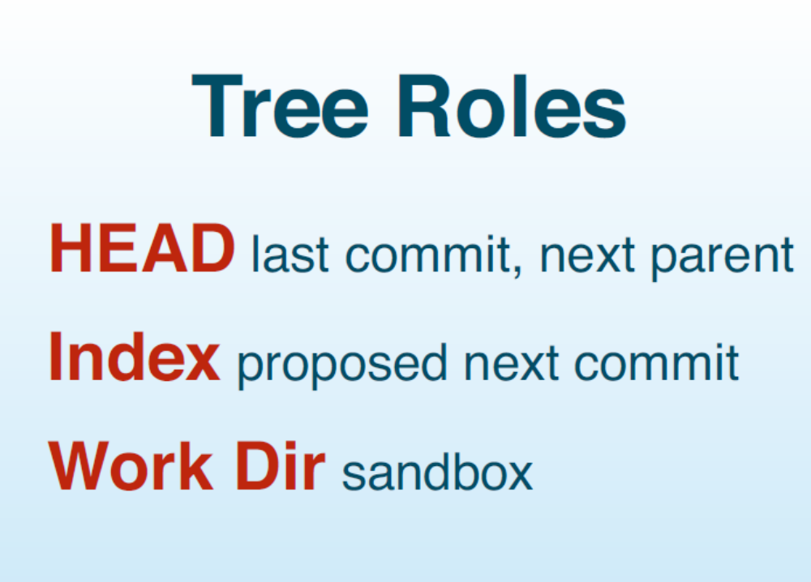

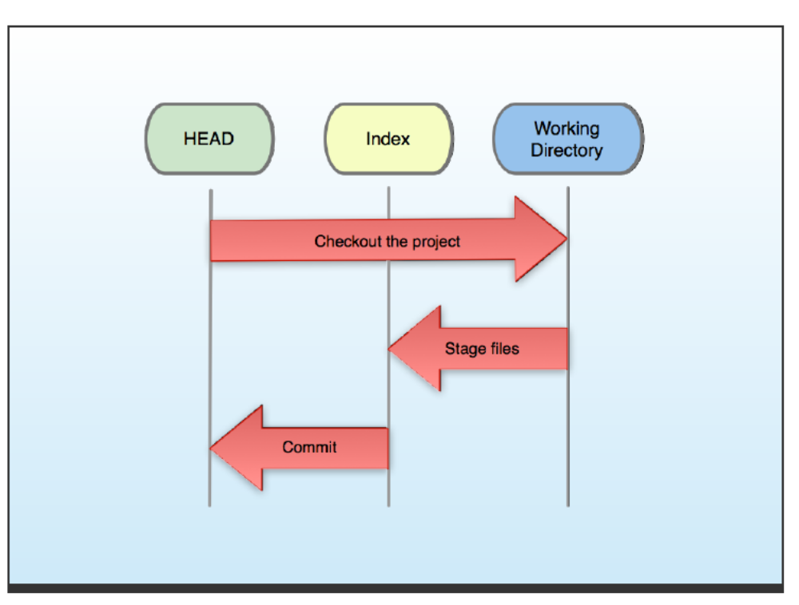

When u say git init there is no index 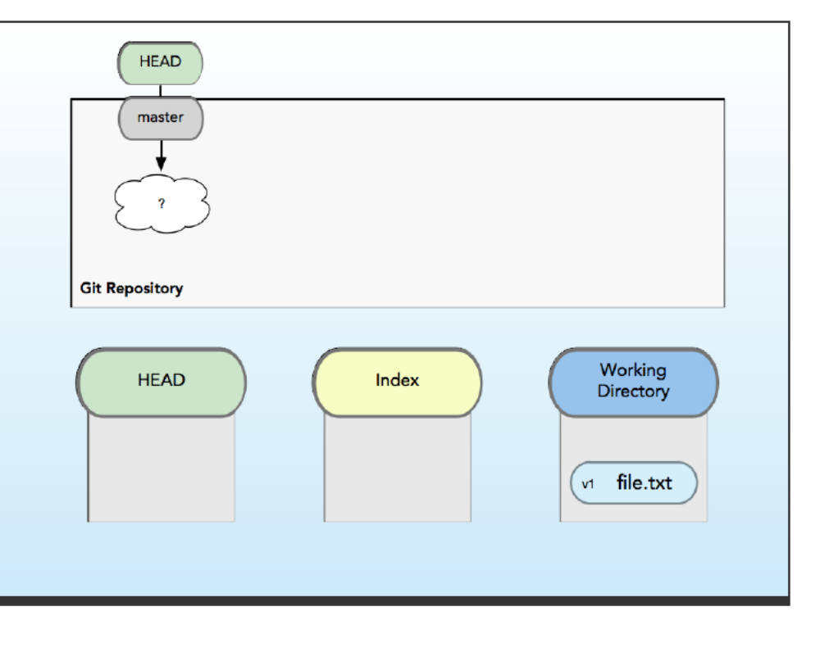
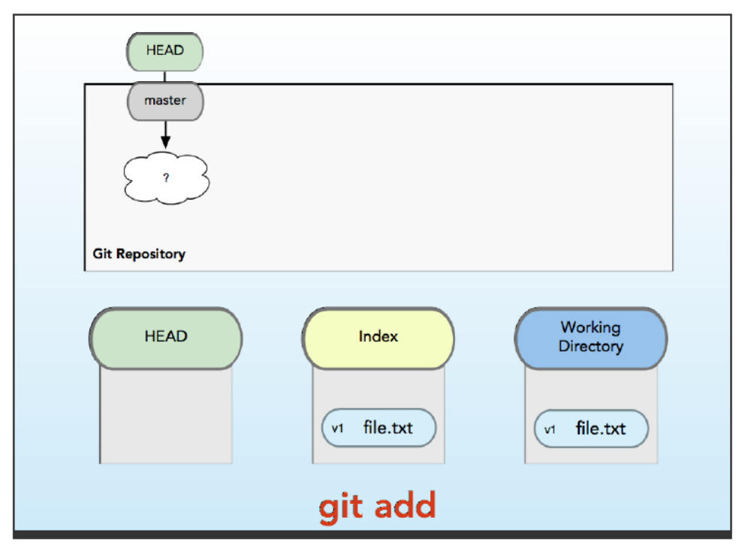
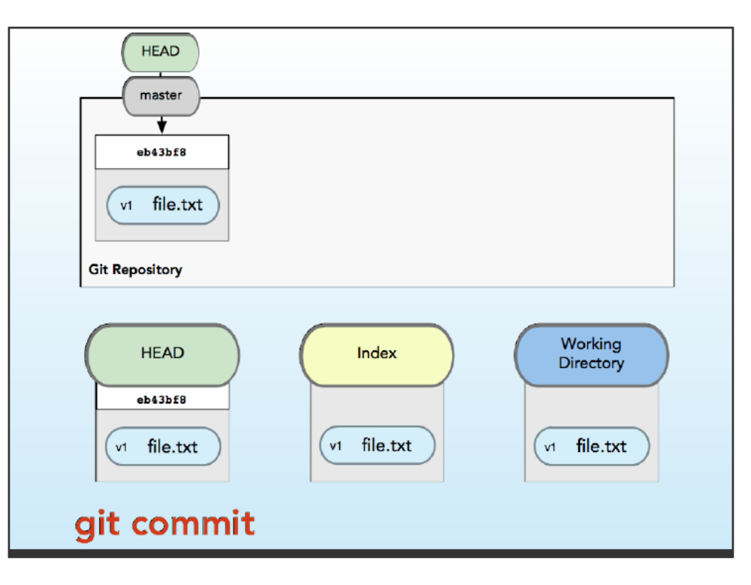
GIT STATUS NOTHING SHOWN UP
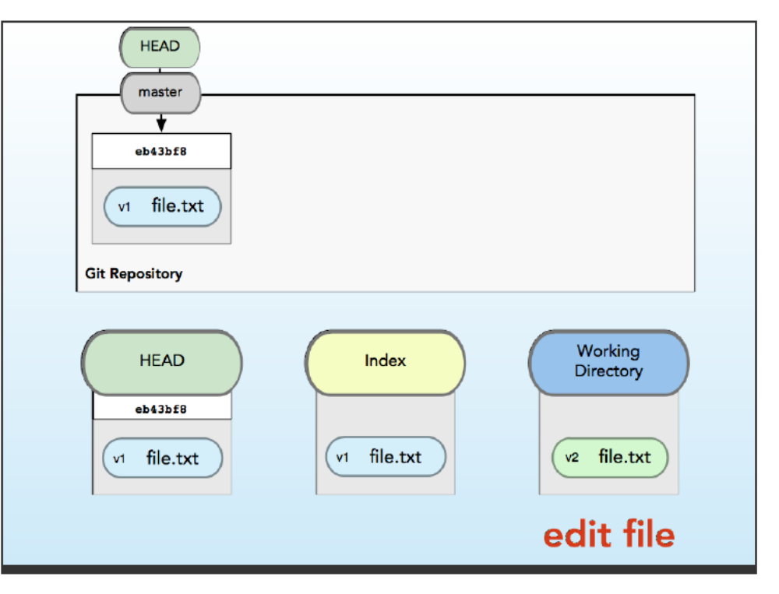
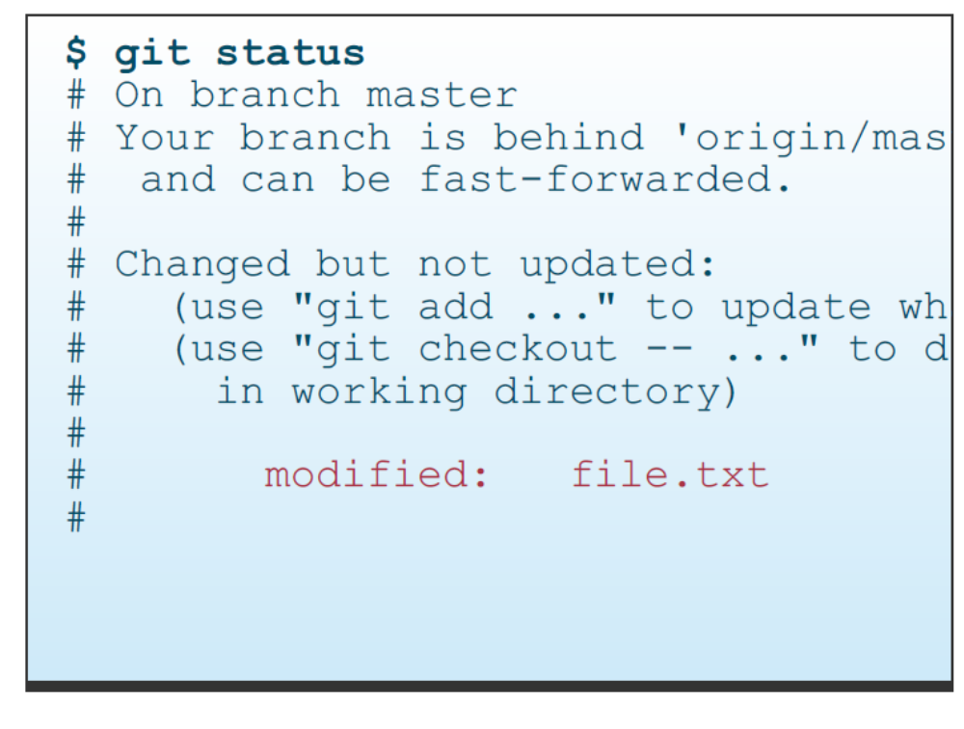
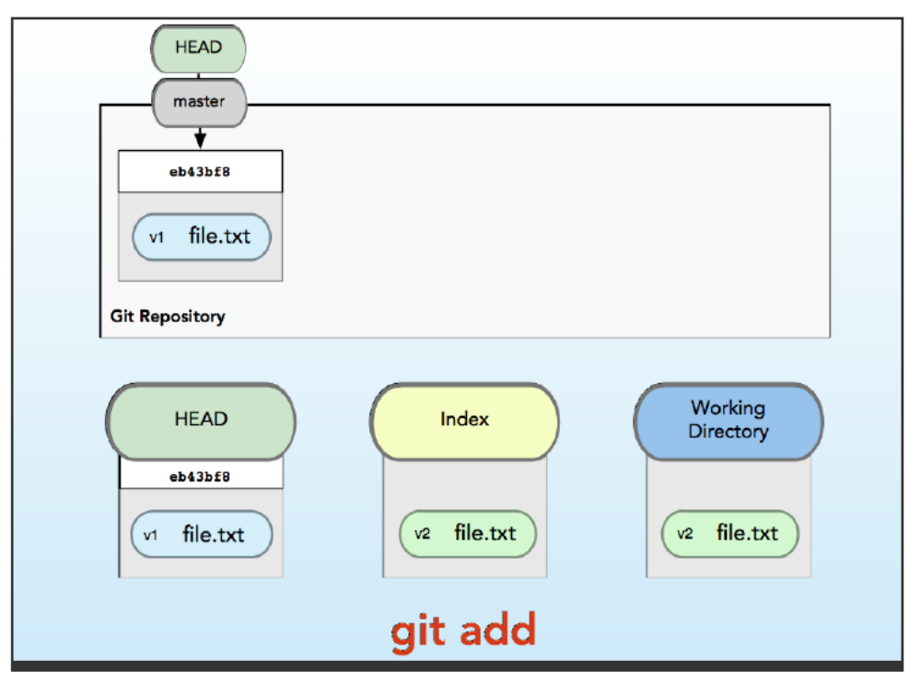
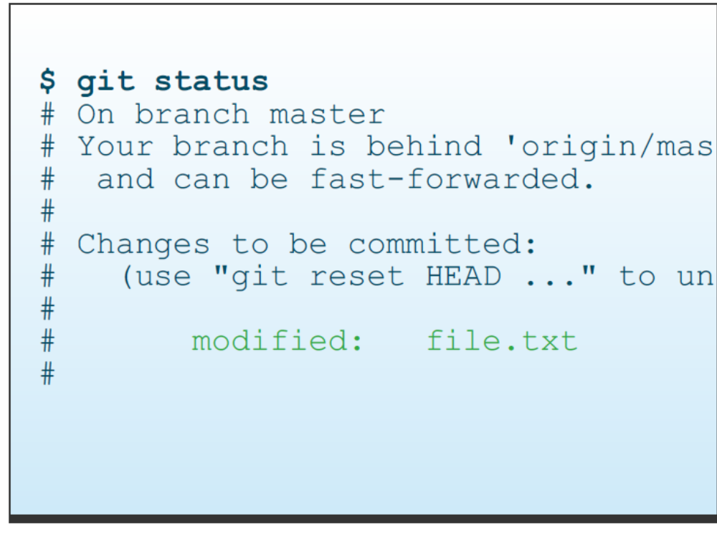
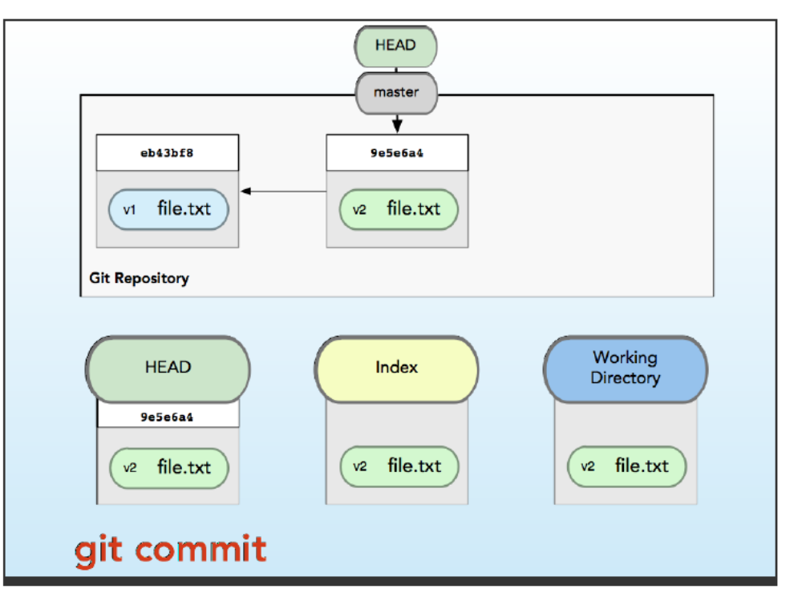
Git add command take files from working directory and make index looks like working directory

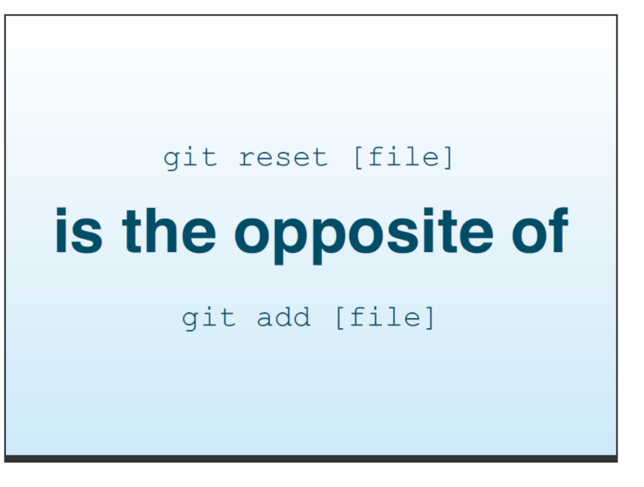
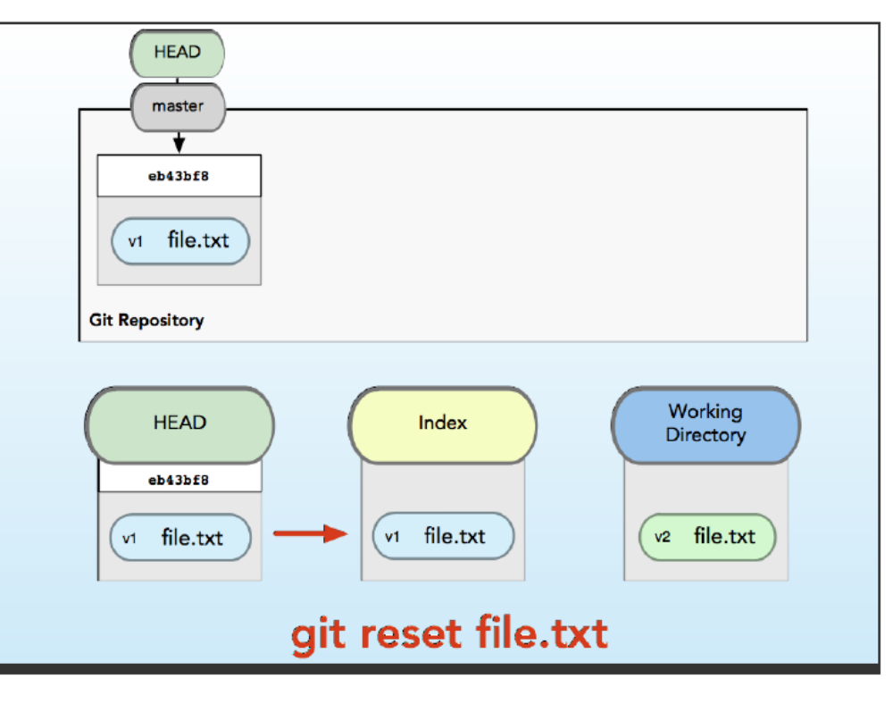
Git reset take data from HEAD and put it back to index
GIT RESET MANIPULATE INDEX IT ALSO BRING OLD COMMIT INTO YOUR INDEX WITHOUT MODIFIYING YOUR COMMIT
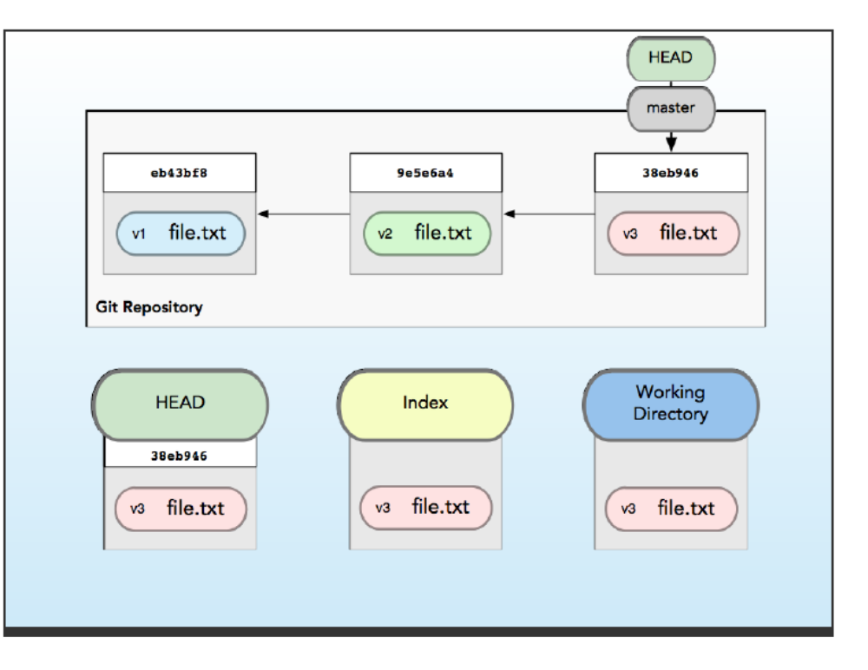
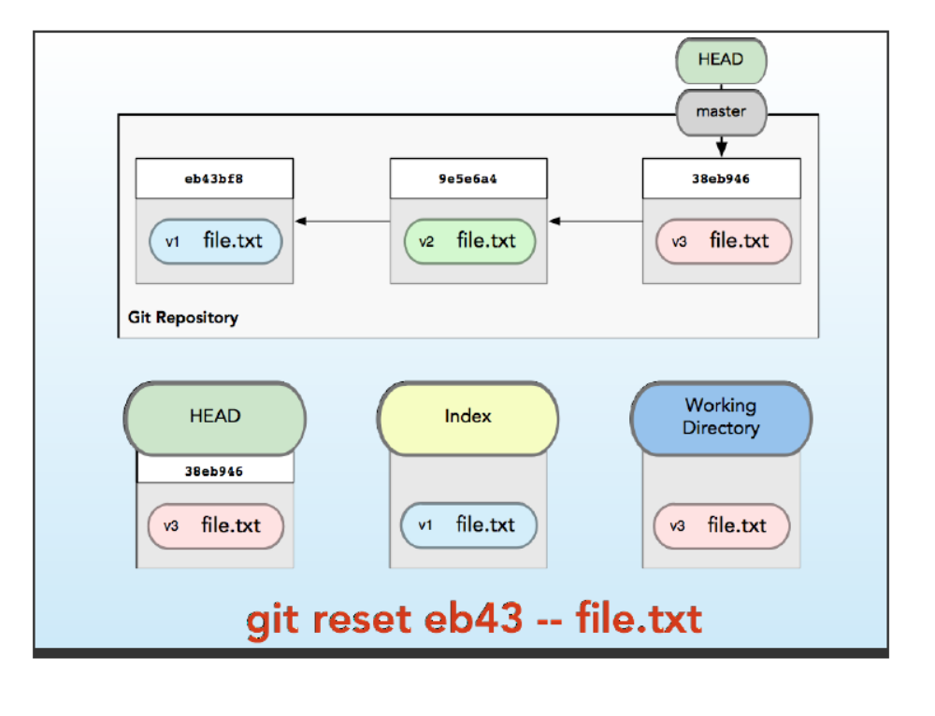
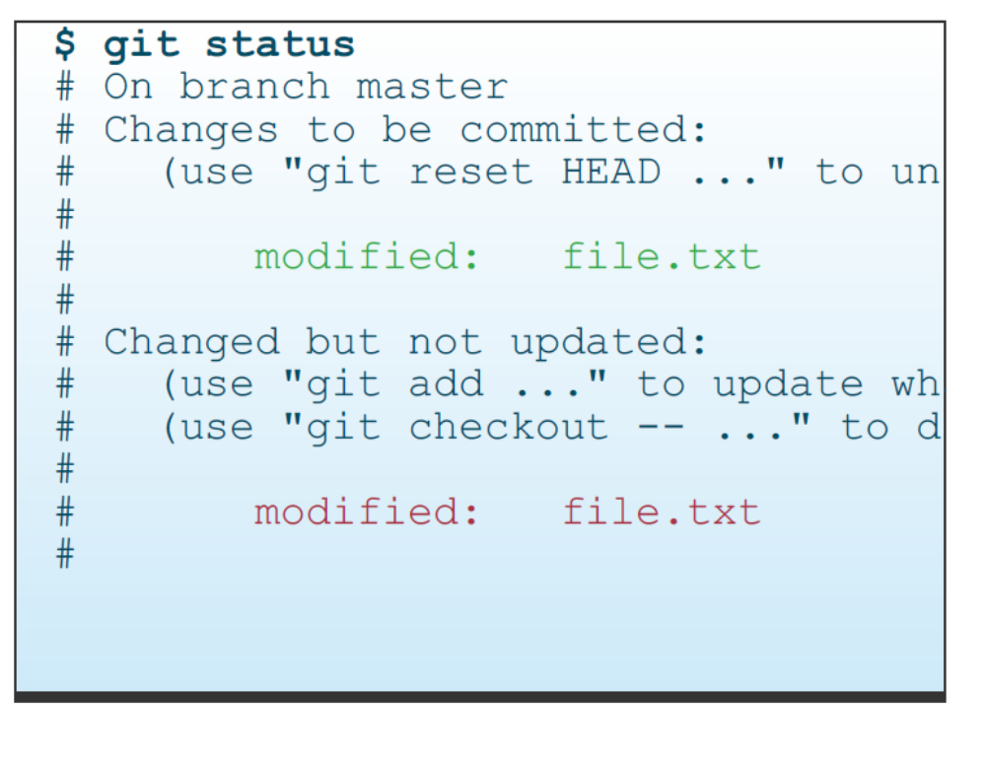
GIT RESET –SOFT IS OPPOSITE OF GIT COMMIT . soft move HEAD TO ANOTHER COMMIT
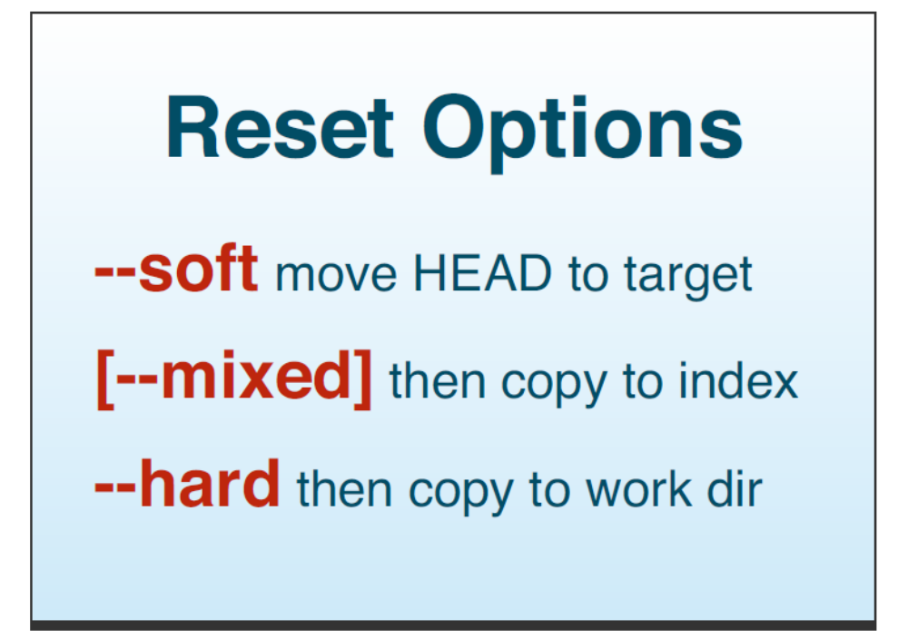

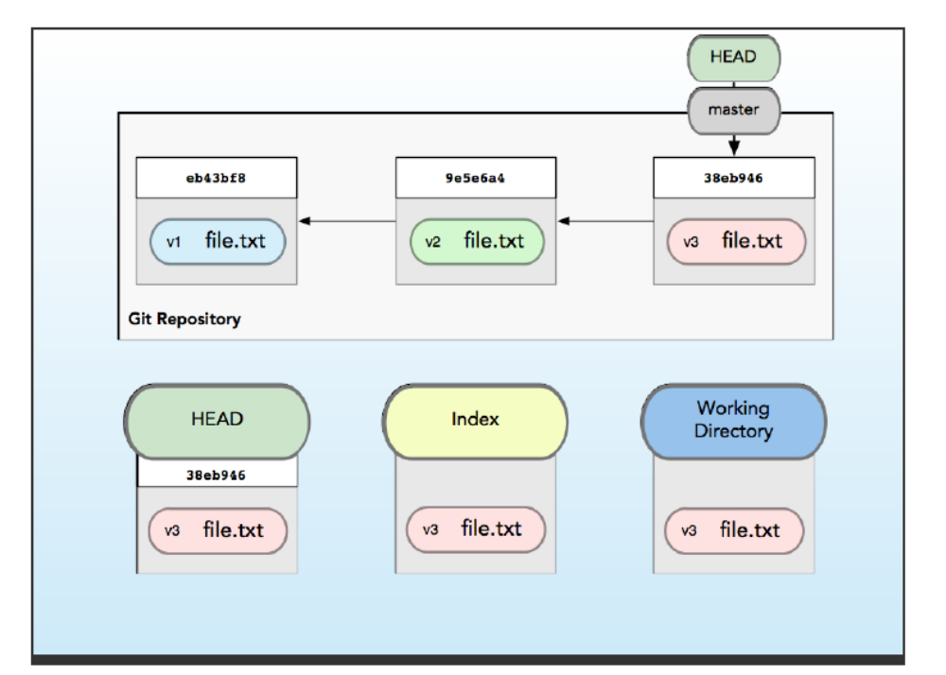

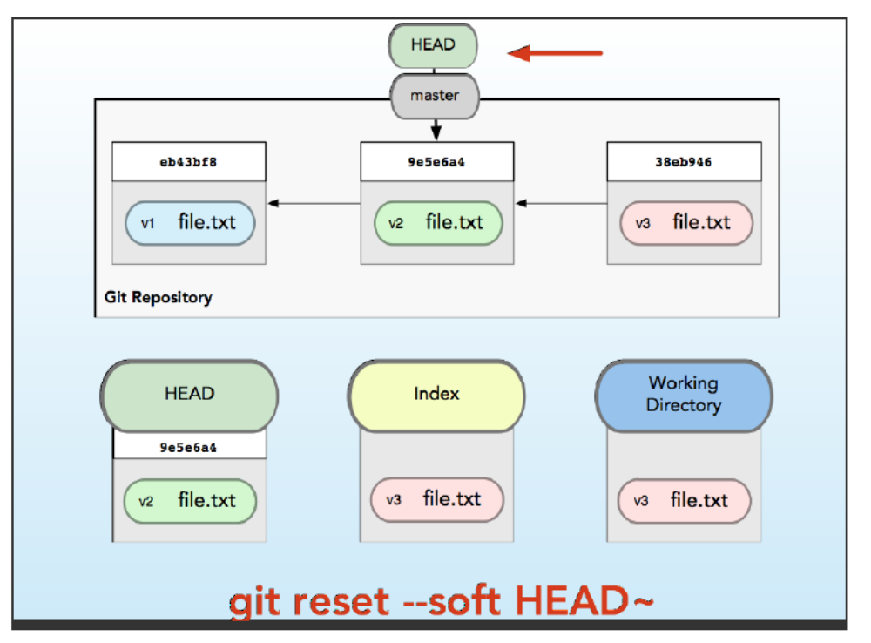

--mixed move head to another commit and then copy to index
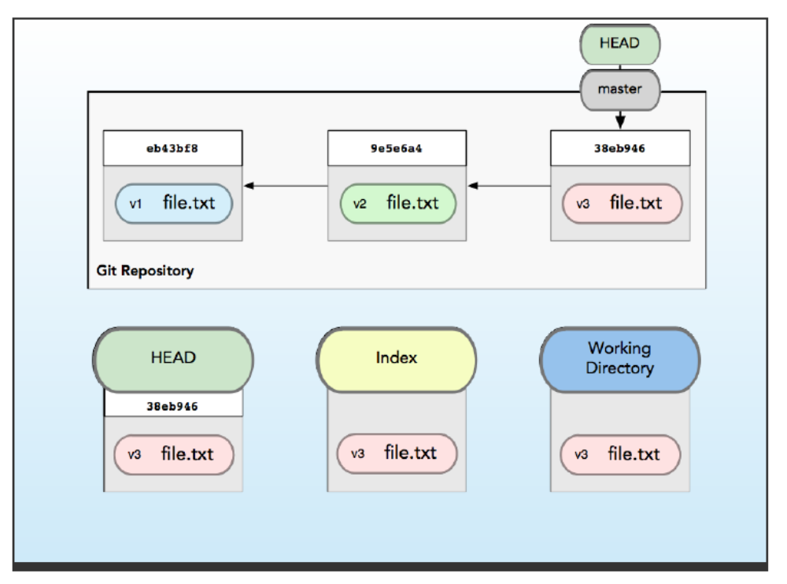

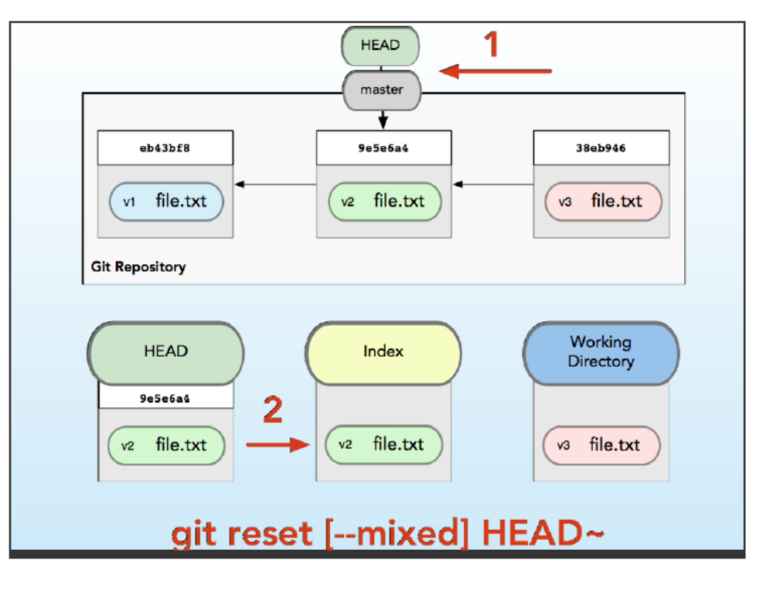
--HEAD MOVE HEAD COPY TO INDEX COPY TO WORKING DIRECTORY

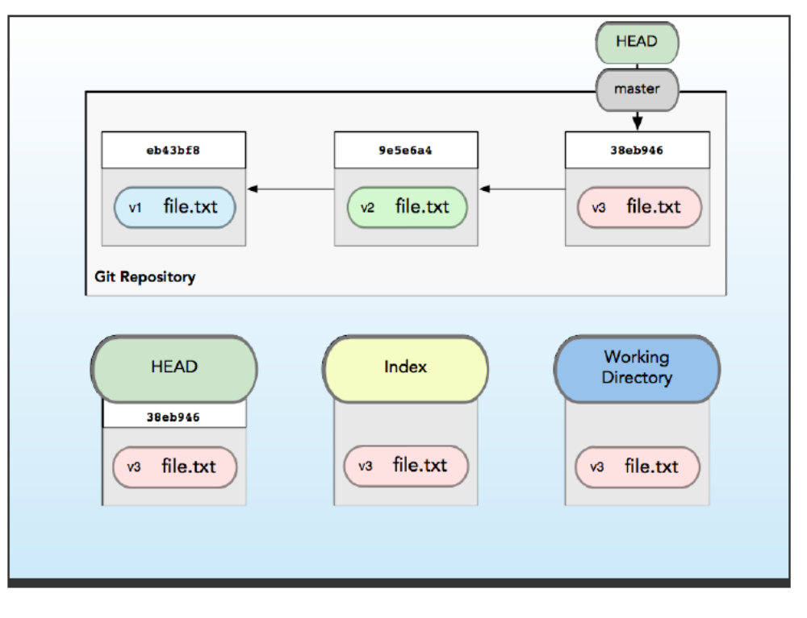
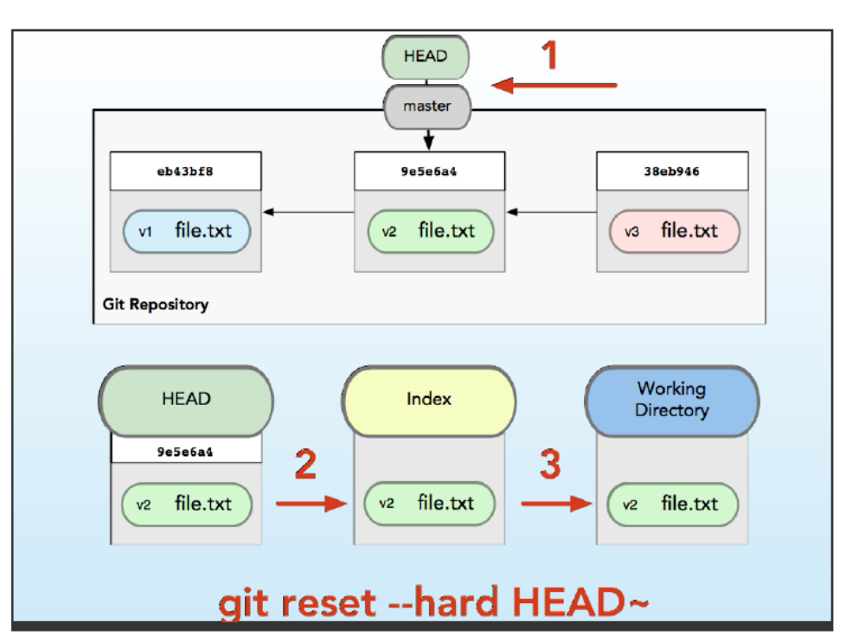
Move head back and move index back
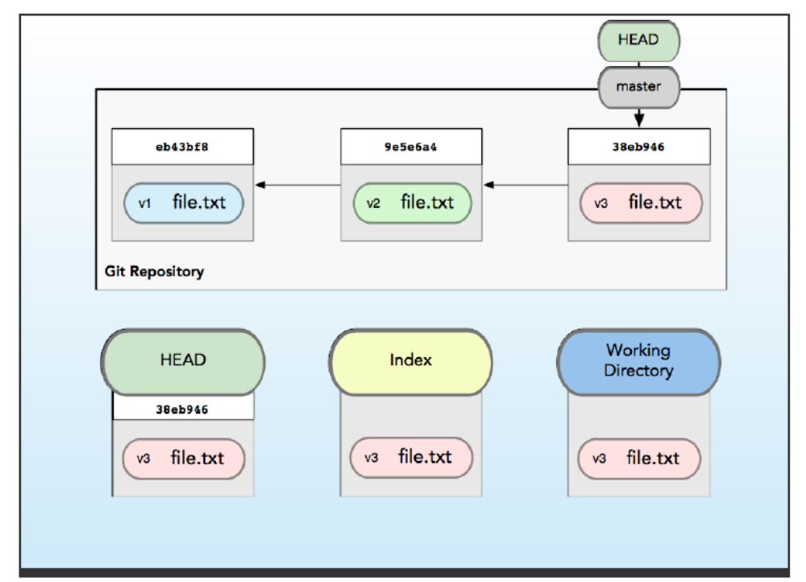

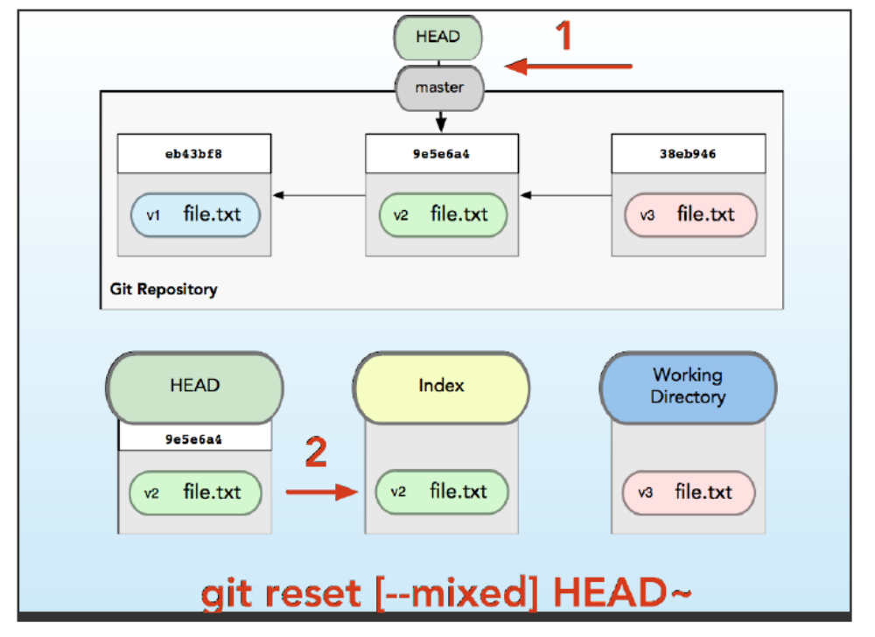

Move head back and but keep index
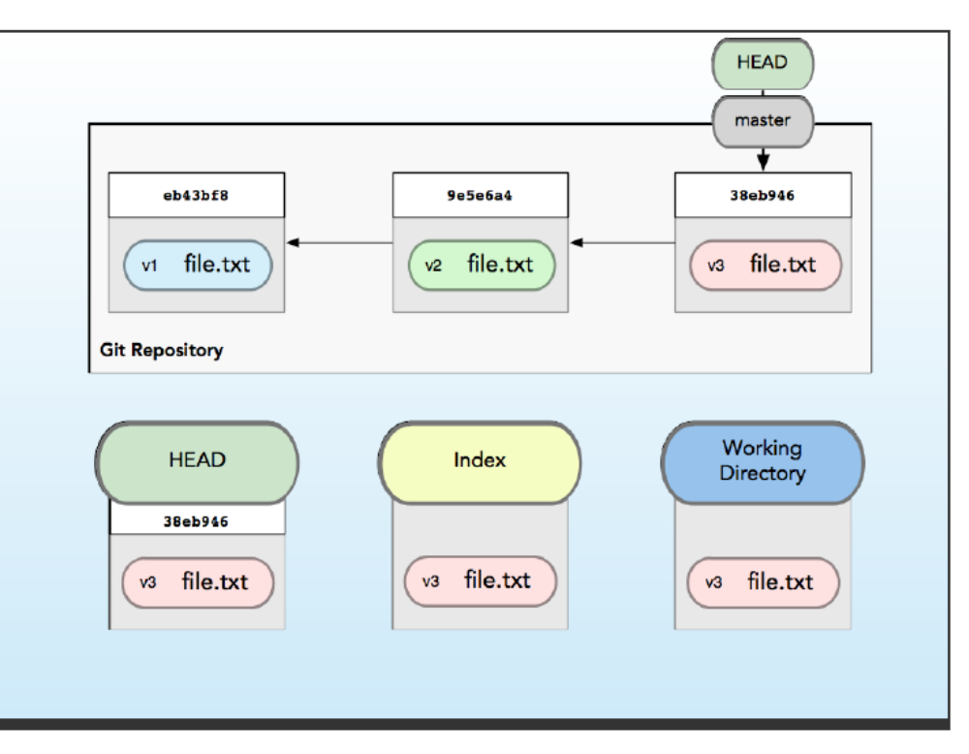
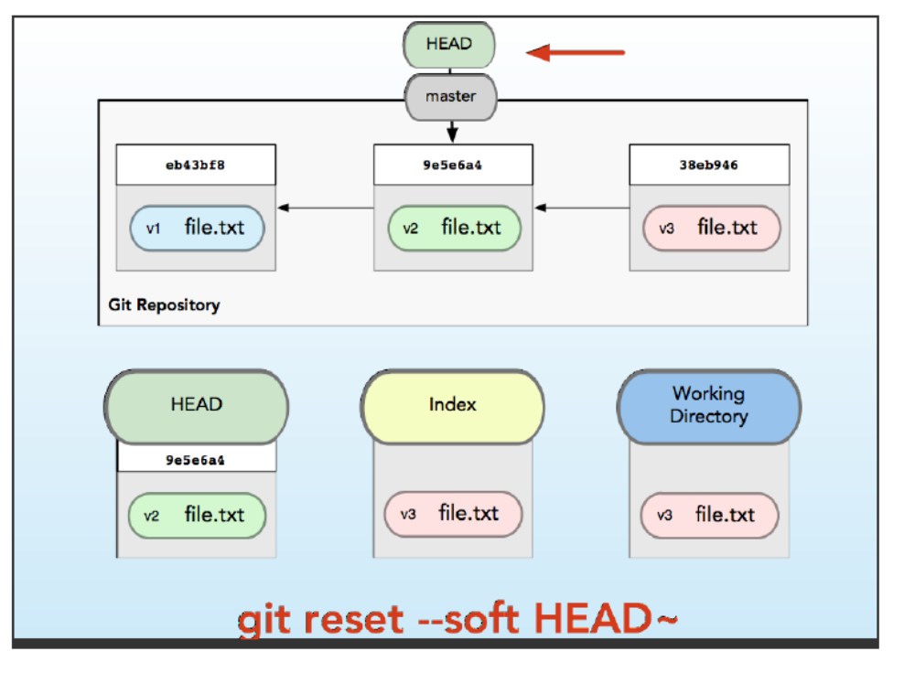
MOVE HEAD BACK AND KEEP THE INDEX
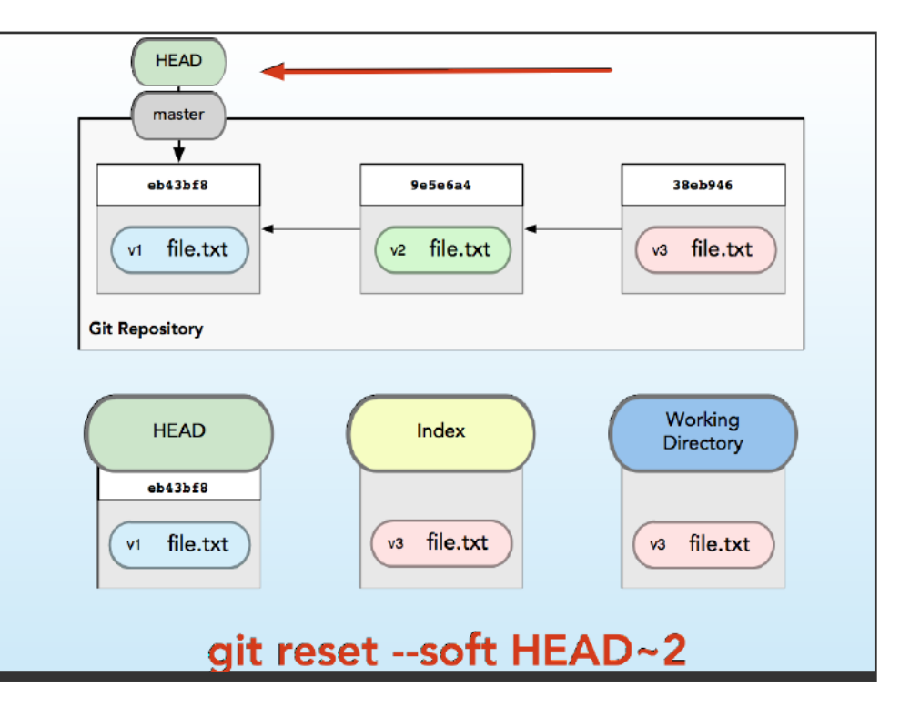
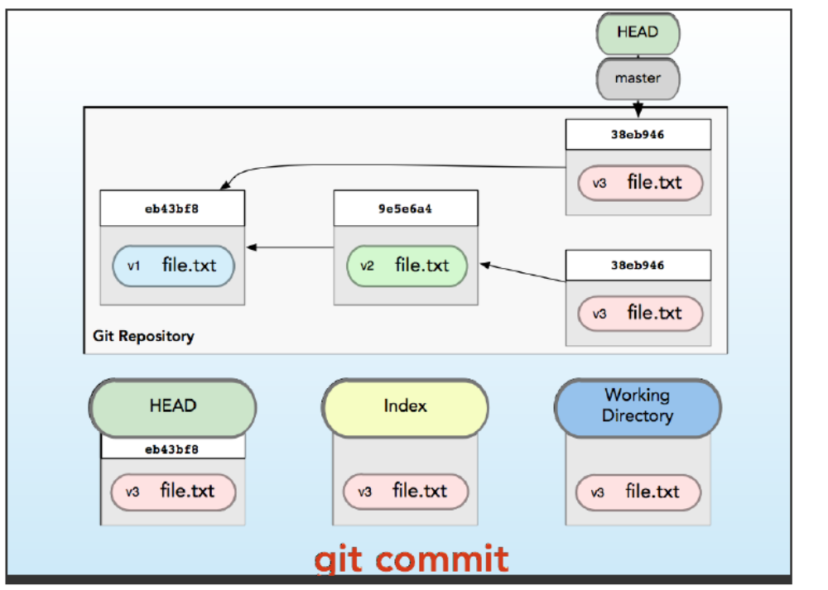

DOES NOT MOVE BRANCH MOVE HEAD .
GIT REST MASTER IT MOVES DEVELOP BRANCH BACK WHERE IT STARTED
GIT CHECKOUT MASTER MOVE HEAD ITSELF TO MASTER
GIT CHECKOUT = RESET –HARD MOVE THE BRANCH ITSELF .
