1. Run url <http://127.0.0.1:5000/> on browser (local machine)

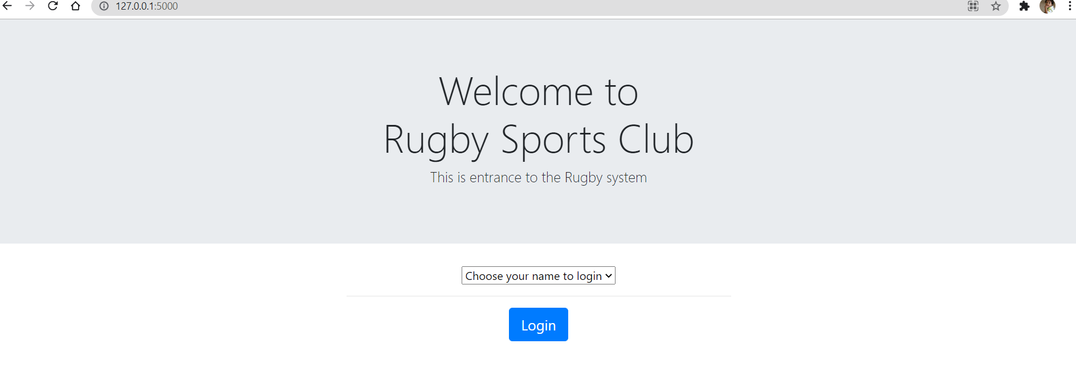

1. Select the Member to login. Selecting standard user.

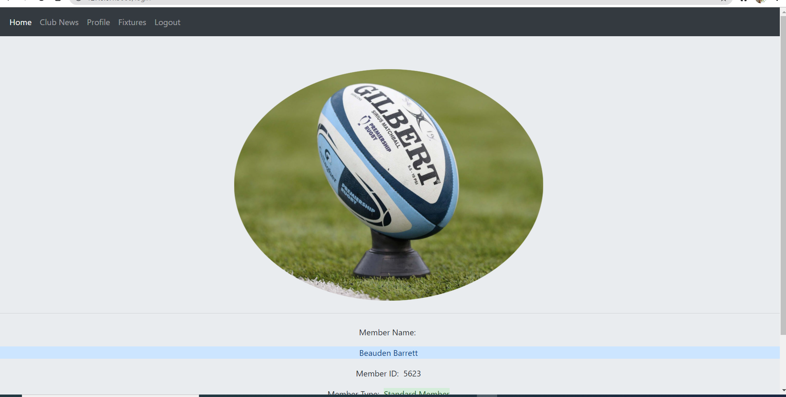

1. From Menu, goto Club News: This will show all the club news where the member belongs to

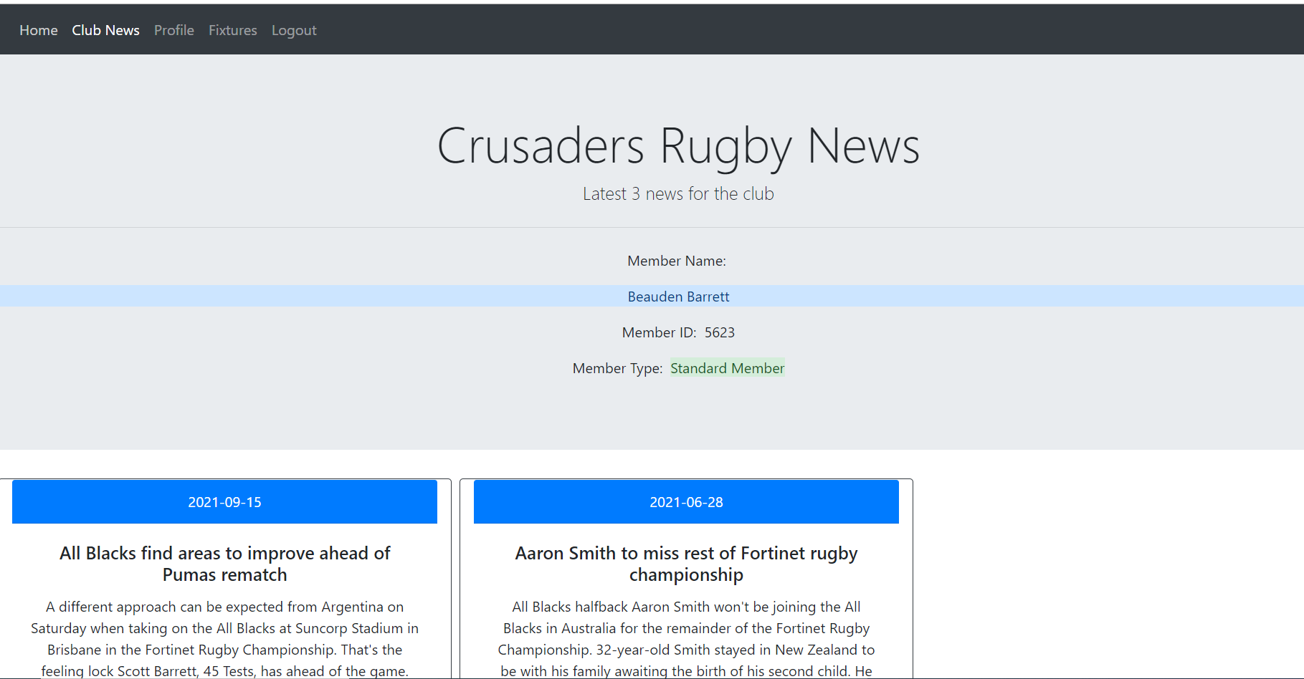

1. Select Profile: Member can view contact details and edit to update it.  
   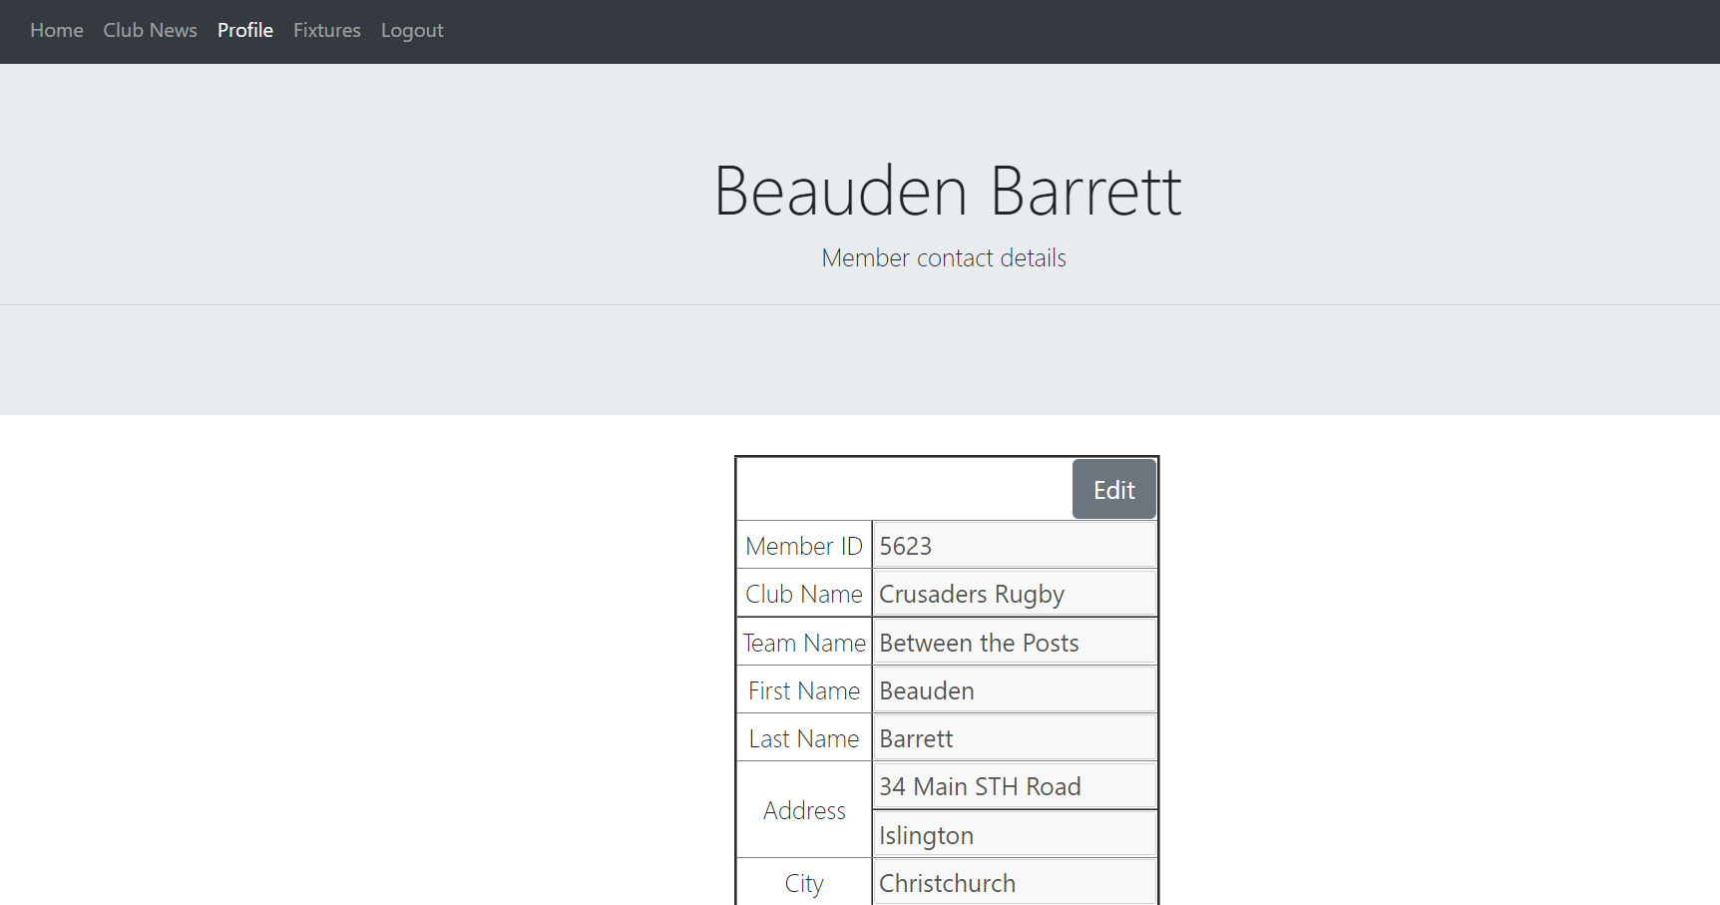
2. Click on Fixtures: Will show all the fixtures and scores of the team the member belongs to

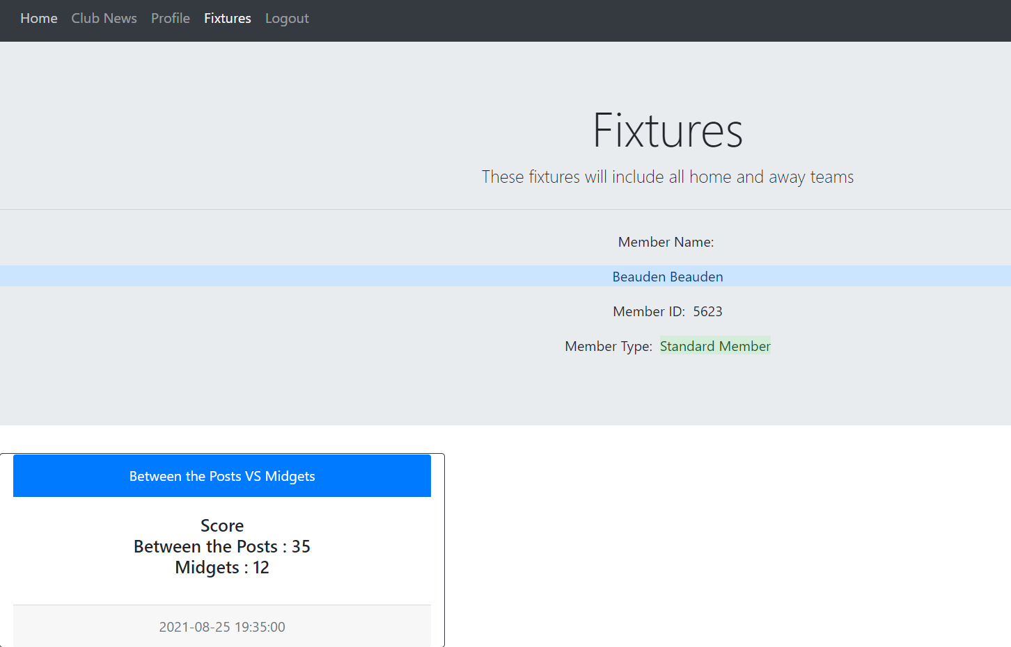

1. Click on logout, and then select an admin member to login

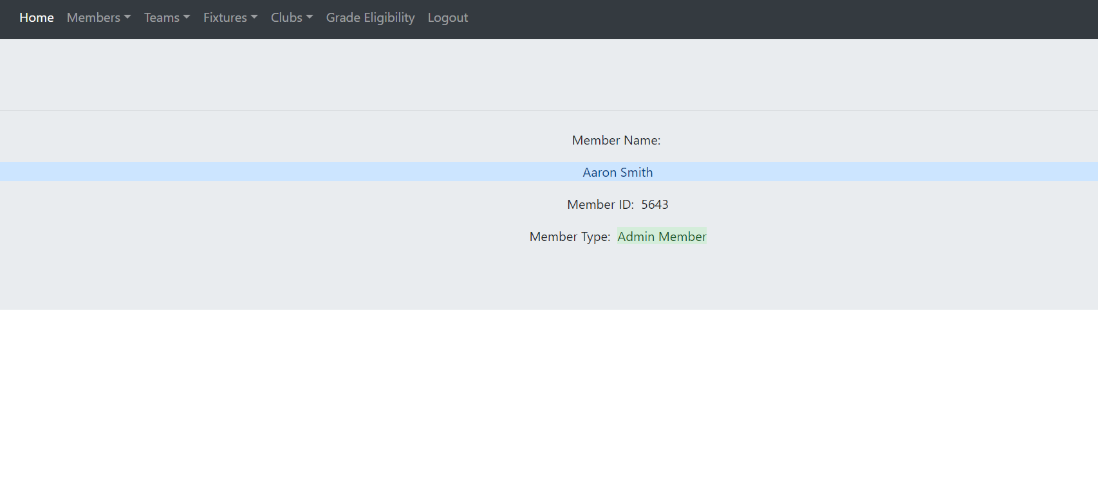

1. From Menu, click on Members – Update Member

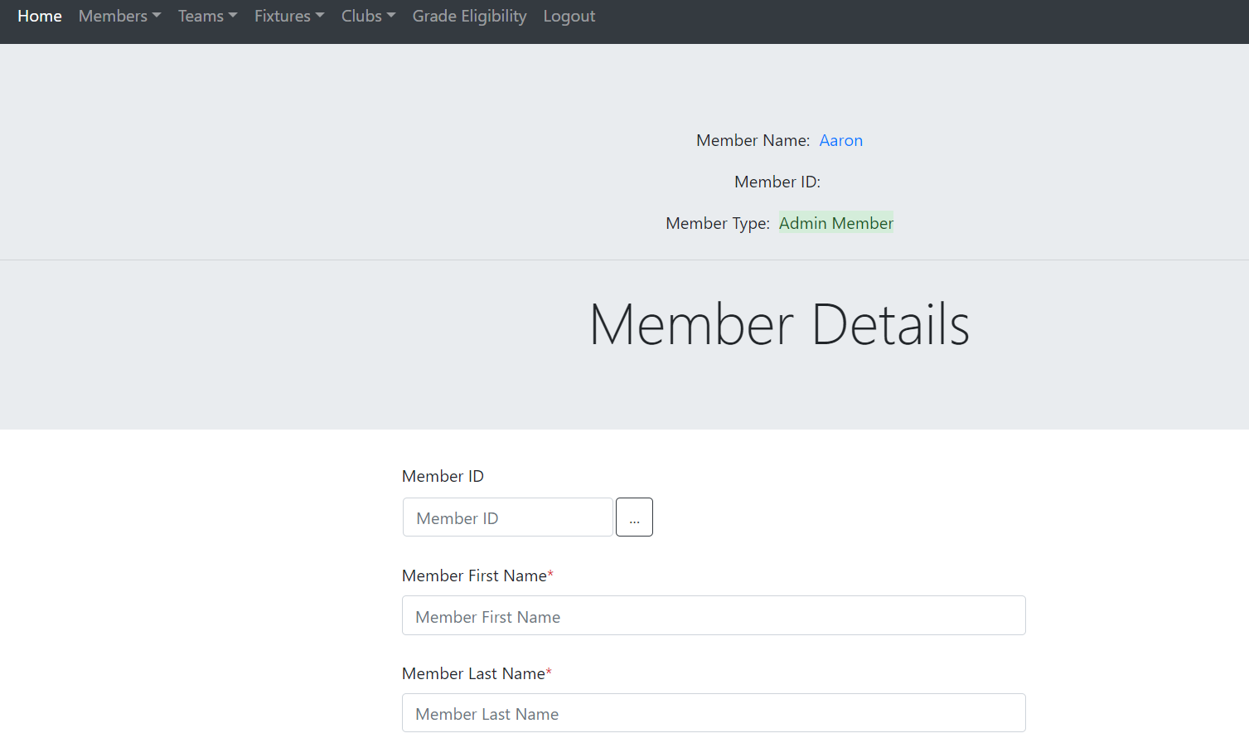

1. Enter Member Id to fetch details and then update if any field required to be updated. Click save

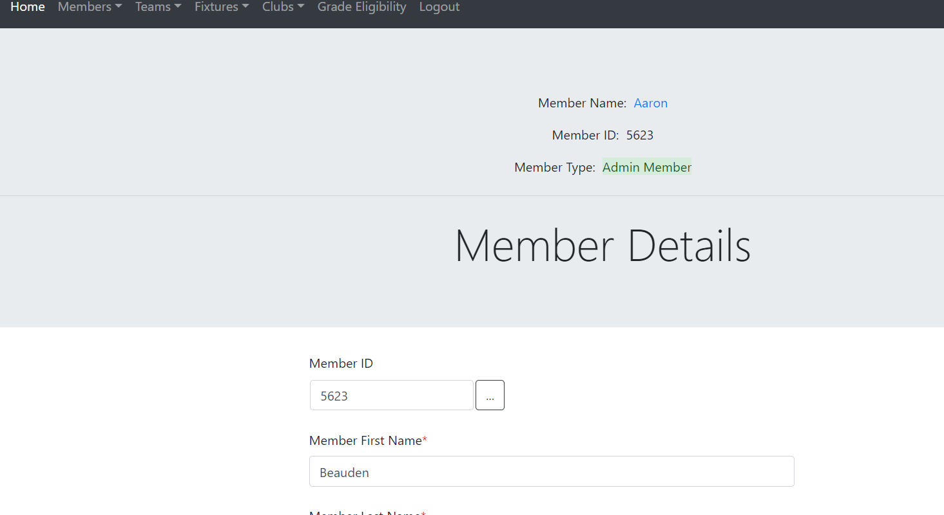

1. Click on Menu, Members – Add a new Member:

This will prompt a form with autogenerated Member Id which can not be updated. Enter all the required and click on save.

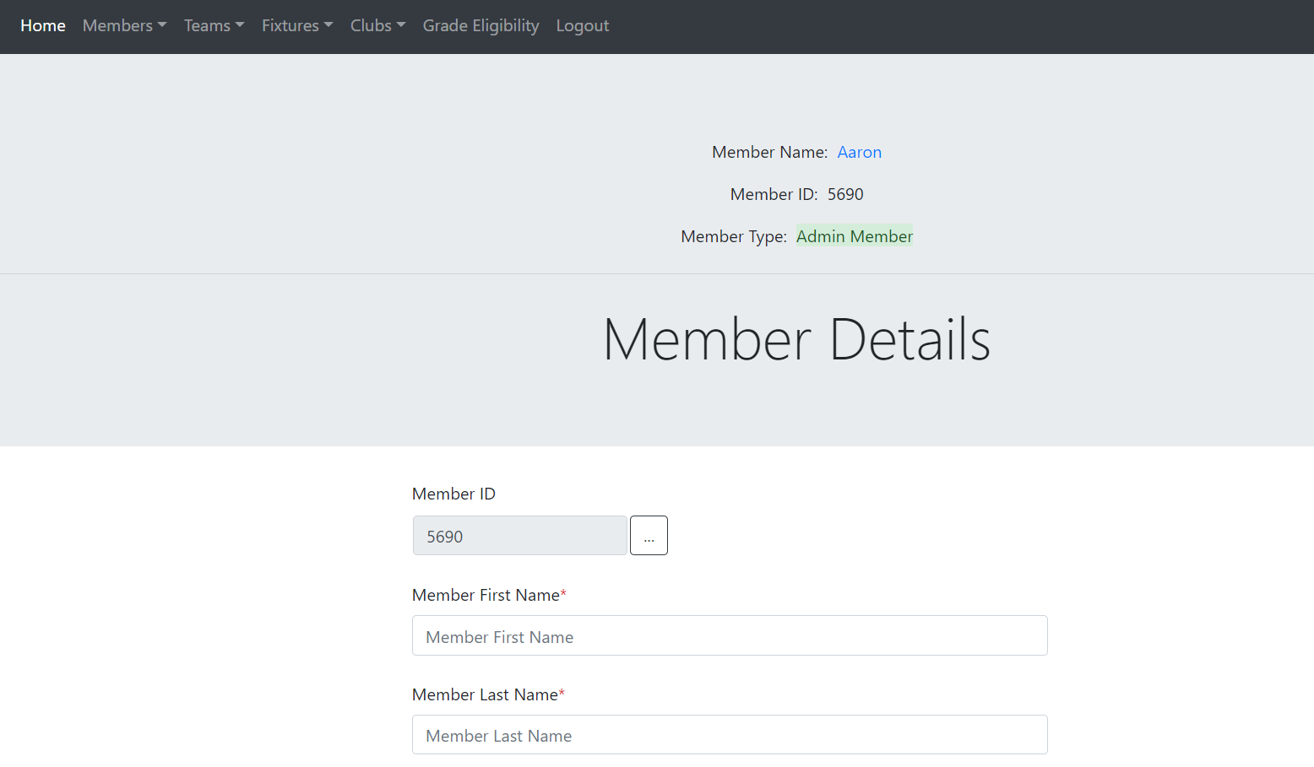

1. Click on Menu -> Teams -> Create new team

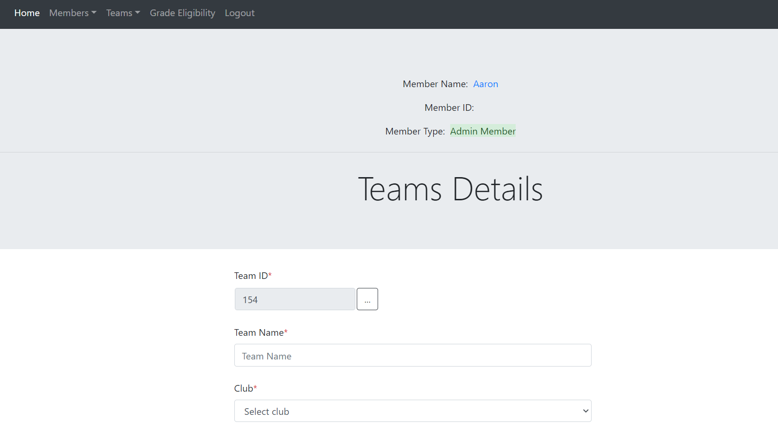

1. Click on save, after filling all the required fields.
2. Click on menu -> Teams -> Update team

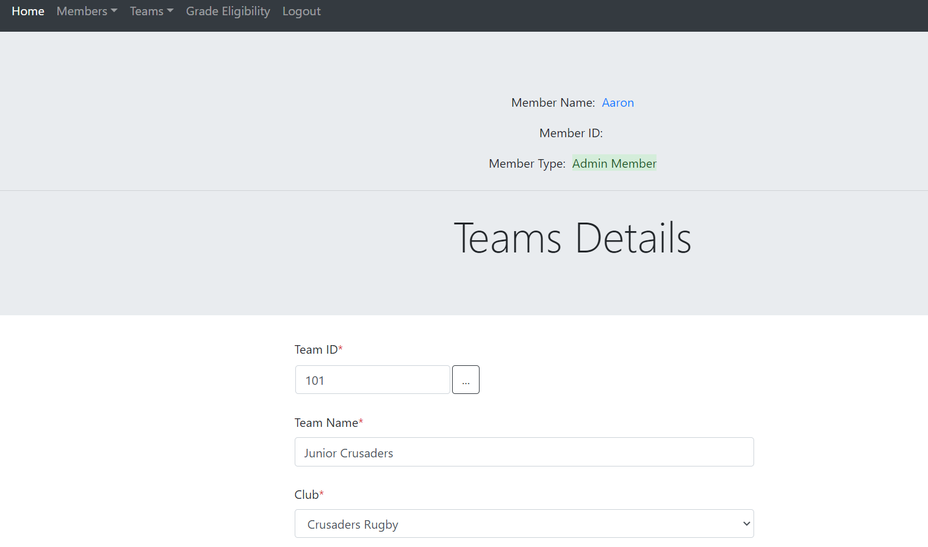

1. Click save to save the changes on the database.
2. Click on Menu -> Teams -> View Items: this will show all the teams

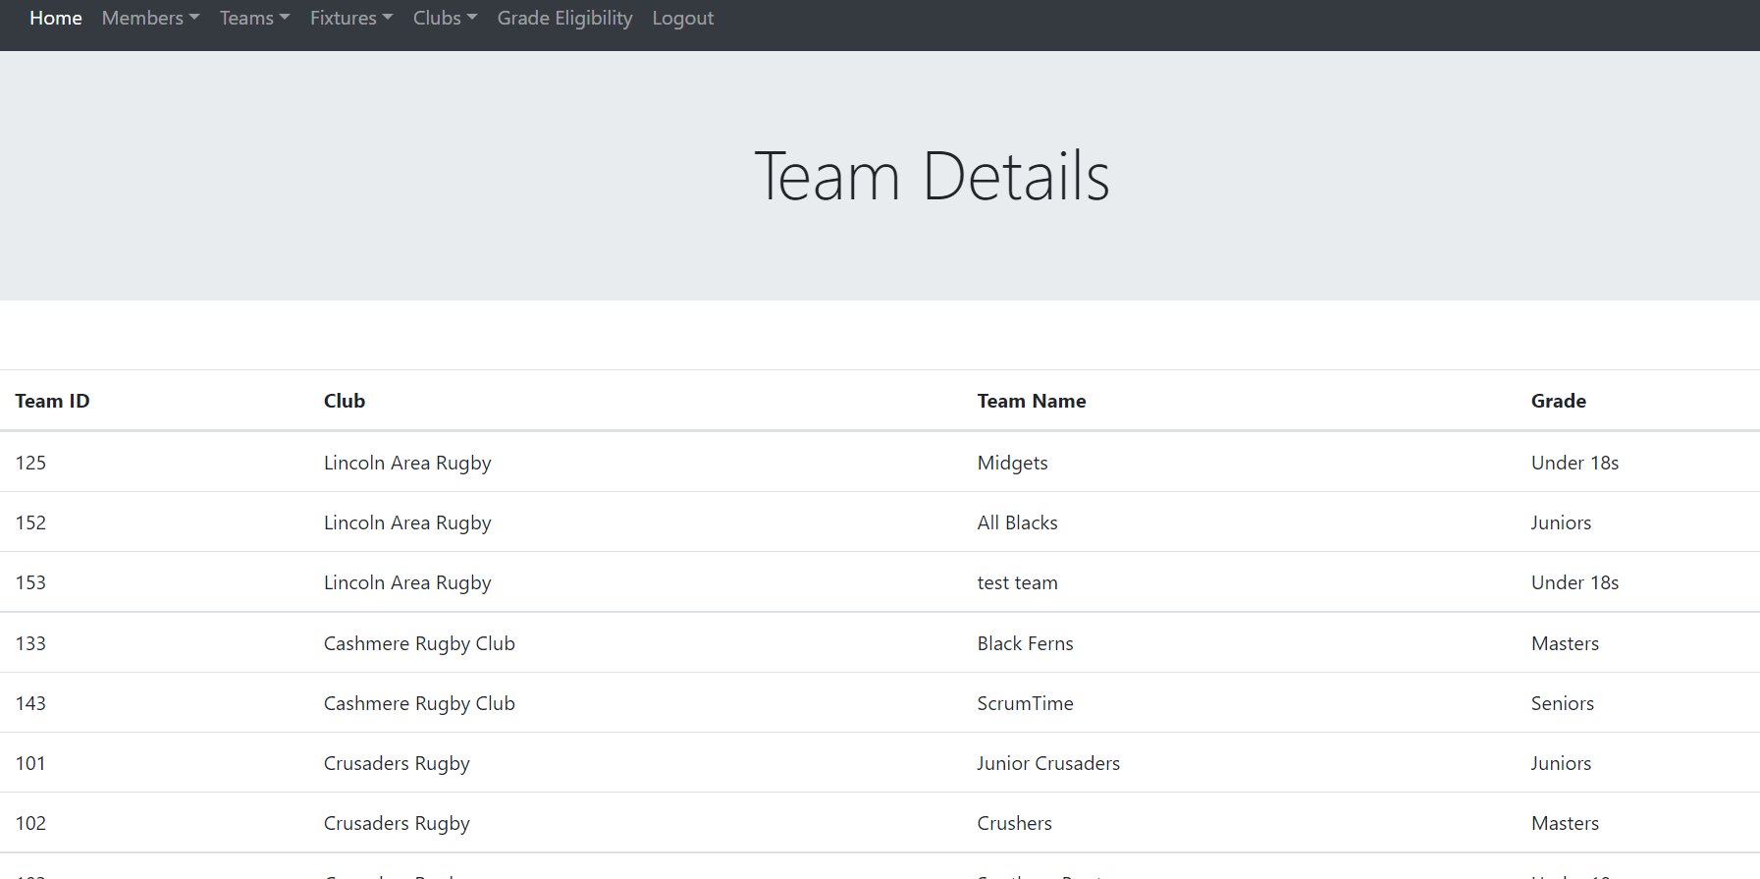

1. Click on Menu -> Eligibility Criteria: this will give report of all the eligible members under selected age group and eligibility date

