GROUP REPORT

Which Card Transactions
Should We Review?
A Cost-Based Policy Evaluation Using Synthetic 2026 Credit Card Data

Team Lions
Naga Nitesh Sanka | Lindi Wang | Md. Hossain | Rajesh Rayidi
University of the Cumberlands
MSDS 530: Fundamentals of Data Science
Dr. McGee
October 25, 2026
Study design: time-based holdout • Cost-sensitive review threshold • 1,000 bootstrap samples

Abstract
Fraud review uses limited staff time. A bank must decide which card transactions to check and which ones to let pass. We studied this decision with 100,000 simulated transactions from the Credit Card Fraud Detection Dataset 2026. We trained models on January–August data, selected the model and review cutoff on September, and evaluated the fixed policy on October–December. Logistic regression was selected over gradient boosting by validation average precision. In the test period, its PR-AUC was 0.136, compared with a fraud rate of 0.022. A score cutoff of 0.78 flagged 1,573 transactions, including 215 fraud cases. Under assumed costs of $5 per review and an 80% fraud-loss prevention rate, the policy produced $25,174 in estimated net savings, compared with $11,056 for a simple high-risk-country rule. The estimated advantage was $14,118 (95% bootstrap interval $6,082–$24,519). The model was poorly calibrated, and detection was lower for customers aged 60 and older. Because the data are synthetic, our results demonstrate a decision method rather than justify direct use by a bank.
Keywords: credit card fraud, logistic regression, precision-recall, cost-sensitive learning, bootstrap, fairness

Executive Summary
This project starts with one business question: which incoming card transactions should a fraud operations manager hold for manual review? We do not try to label each transaction as definitely fraudulent. Instead, a statistical model ranks transactions so reviewers can focus on cases that may prevent the greatest loss. The project compares that score-based policy with a clear rule that reviews transactions when the merchant is located in one of four dataset-defined high-risk countries.
Result. The selected logistic regression model reaches a test PR-AUC of 0.136, about 6.3 times the no-skill rate of 0.0217. On 25,337 held-out test transactions, the chosen threshold of 0.78 flags 6.2% of transactions and catches 39.1% of fraudulent transactions and 51.4% of fraud dollars.
Business impact. With the explicit assumptions of $5 per review and 80% loss prevention on flagged frauds, estimated net savings are $25,174, compared with $11,056 for the country-risk rule. The difference is positive in both transaction-level and customer-level bootstrap checks.
Important trade-off. The model sends more transactions to review than the rule: 1,573 versus 1,256. It also creates more false alerts in absolute terms. The reason to prefer it is better fraud capture and higher estimated net savings, not a smaller total review queue.
Decision boundary. All transactions and dates are simulated. We recommend a shadow evaluation on real issuer data, measurement of real costs and customer friction, and a controlled pilot only after the policy is validated again. The synthetic cutoff of 0.78 should not be used as a real bank rule without new evidence.
Table 1
Executive scorecard: October–December 2026 synthetic test
Measure | Score-based policy | Country-risk rule
Transactions reviewed | 1,573 (6.2%) | 1,256 (5.0%)
Fraud flagged | 215 of 550 | 144 of 550
Recall | 39.1% | 26.2%
Precision | 13.7% | 11.5%
Fraud dollars flagged | $41,299 (51.4%) | $21,669 (27.0%)
Estimated net savings | $25,174 | $11,056

Note. The financial values are counterfactual estimates under a $5 review cost and 80% effective loss prevention; they are not realized bank savings.

1. Business Problem, Decision, and Hypotheses
Card issuers face two costs at the same time. A fraudulent transaction that is not stopped can create a financial loss. A legitimate transaction sent for review uses analyst time and may delay a customer. Fraud is rare, so a model that predicts every transaction as legitimate can appear highly accurate while providing no fraud protection. Research on statistical fraud detection recommends ranking transactions for investigation and measuring the operational costs of errors (Bolton & Hand, 2002; Dal Pozzolo et al., 2018).
The decision owner is the fraud operations manager. The manager must choose a score threshold that converts the model ranking into a review queue. Higher thresholds reduce the number of reviews, but they may leave more fraud unattended. Lower thresholds find more fraud but use more staff time. Our project therefore measures both technical ranking quality and estimated financial value.
Primary research question. Can transaction-time information support a manual-review policy that produces higher estimated net savings than a simple, fixed country-risk rule?
H1 — ranking. On the held-out later months, the selected model will rank fraud better than a no-skill baseline. We set a descriptive target of PR-AUC at least three times the test fraud rate.
H2 — business value. The cost-selected model threshold will produce more estimated net savings than the country-risk rule. We evaluate the difference with a paired 95% bootstrap confidence interval.
The three-times value is a project evaluation target, not a universal statistical standard. If a model had failed either test, the project would still report the result and its decision implications. Our goal is a reliable comparison, not a guaranteed win for machine learning.

2. Dataset, Provenance, and Data Quality
We used the Credit Card Fraud Detection Dataset 2026 published by Thalla (2026) on Kaggle. The provided CSV contains 100,000 transactions and 43 original columns dated January 1 to December 31, 2026. One row represents one card transaction, and each has a unique transaction ID. The file includes 8,000 customers, 8,000 cards, and 3,000 merchants. The outcome field is is_fraud (1 for fraud; 0 for legitimate). The dataset contains 2,055 fraud transactions, or 2.055%, and $279,842.20 in labeled fraud losses.
The author’s GitHub README identifies dataset version 1.0 (updated October 2026) and declares a CC0 public-domain license (Thalla, 2026). The README also says there are no missing values, but our audit found 41,709 blanks in the browser field; this difference is important even though the blanks are structural. The source describes the data as research-calibrated. In addition, 18,601 records are dated after October 24, 2026, the charter date. The future dates and some internal inconsistencies indicate that the dataset is synthetic rather than historical bank data. We use the calendar only to simulate a time-based development and evaluation process. No real issuer or real customer is represented by the financial claims in this report.
Table 2
Data profile and analytical roles
Field group | Examples | Use
Identifiers | transaction_id, customer_id, card_id, merchant_id | Not model inputs; customer_id used for grouped bootstrap
Transaction | amount, hour, channel, category, merchant_country | Candidate model inputs
Behavior | transactions_last_1h, amounts_last_24h, chip and PIN | Candidate model inputs
Account | account age, credit limit, prior chargebacks | Candidate model inputs if known at authorization
Protected attributes | customer_age, customer_gender | Audit only; excluded from predictors
Outcomes | is_fraud, fraud_type, fraud_amount_lost | Label; descriptive losses; cost evaluation on known historical outcomes

Note. The model uses 32 input fields after exclusions and creation of the training-based night flag.

2.1 Data Quality Decisions
The data audit found no duplicate transaction IDs and no impossible values under the tested range checks. The browser column had 41,709 missing entries (41.7%), all in in-store or ATM transactions. We coded these as "None" because a browser is not used in those channels. We did not impute a fictional browser value or remove those transactions.
The supplied day-of-week labels disagreed with the date on all 100,000 rows, and the weekend indicator disagreed with the timestamp on 57,158 rows. Because these fields were unreliable, we excluded both from modeling. We also found 5,932 ATM records with card-not-present status despite PIN use, 4,593 records where spending during the last hour exceeded spending over 24 hours, and 139 fraud records with a fraud type that conflicted with the card-presence flag. These errors are additional evidence of imperfect synthetic generation.
We retained the remaining records in the main analysis because deleting every inconsistent record would remove all ATM activity and 324 fraud cases. In a separate robustness check, fixing selected fields or removing inconsistent rows changed test PR-AUC by no more than 0.003 and did not reverse the model’s estimated advantage over the country-risk rule. This does not repair the data, but it helps us understand how much the main conclusion depends on these choices.

3. Related Literature and Statistical Approach
Statistical fraud detection is unusual because positive cases are rare and patterns can change as fraudulent behavior changes. Bolton and Hand (2002) describe both concerns, and Dal Pozzolo et al. (2018) argue for evaluation on later data and attention to investigator capacity. These ideas support our time-based split and review-queue design.
When positive cases are rare, accuracy alone does not show how useful the alerts will be. Precision is the percentage of flagged transactions that are truly fraudulent. Recall is the percentage of all fraud cases the model finds. Average precision (AP), reported as PR-AUC in this project, summarizes the precision-recall trade-off across score thresholds. The no-skill reference is approximately the positive-class prevalence (Davis & Goadrich, 2006; Saito & Rehmsmeier, 2015).
A second group of studies connects classification to economic decisions. Elkan (2001) explains that error costs affect optimal decisions, while Provost and Fawcett (2013) show how predicted outcomes can be translated into expected value. We follow that approach by choosing the review threshold from estimated prevented fraud losses minus review cost, rather than using the default 0.5 cutoff.
Model validation must also prevent information leakage. Kaufman et al. (2012) describe how labels or features that would not be known at prediction time can inflate measured performance. We therefore exclude outcome-derived fields and design the night feature from training data only. We compare regularized logistic regression, which is explainable, with gradient boosting, which can capture more complex interactions (Hosmer et al., 2013; Friedman, 2001).
Finally, a model can rank cases well while producing unreliable probability values (Niculescu-Mizil & Caruana, 2005). Resampling can show uncertainty in performance and savings (Efron & Tibshirani, 1993), while resampling whole customers accounts for repeated transactions (Field & Welsh, 2007). Removing age and gender from predictors does not eliminate all fairness concerns because other features can act as proxies; error rates still need to be audited (Barocas et al., 2023).

4. Reproducible Analysis Design

4.1 Fixed Time Split
The project uses a fixed calendar split: January–August for training (66,388 transactions, 1,341 frauds); September for model and threshold selection (8,275 transactions, 164 frauds); and October–December for final testing (25,337 transactions, 550 frauds). This simulates the use of older information to review later transactions. It is not a real prospective validation because the dataset is synthetic.
Table 3
Time split and decision rights
Period | Transactions | Fraud | Allowed actions
Jan–Aug — Train | 66,388 | 1,341 | Explore training patterns; design features; fit model
September — Validate | 8,275 | 164 | Choose model by PR-AUC; choose cost-based threshold
Oct–Dec — Final test | 25,337 | 550 | Evaluate fixed policy and report uncertainty

4.2 Features and Model Selection
We excluded transaction, customer, card, and merchant identifiers from the prediction model. We also excluded date and month, the incorrect weekday and weekend indicators, fraud_type, fraud_amount_lost, customer_gender, and customer_age. The two outcome-derived fields would be unavailable when a transaction arrives; age and gender were reserved for fairness checks. Other account and behavior variables were treated as transaction-time inputs as labeled in the dataset, although a real issuer would need to verify their timing.
The one engineered feature is night_0_4: whether the transaction took place from midnight through 4:59 a.m. We selected that window using only January–August, where fraud rate was 6.11% in the window versus 1.92% at other hours. We then applied the same rule without modification to September and the test period.
Logistic regression uses standardized numeric inputs, one-hot encoded categorical inputs, L2 regularization (C = 0.5), and balanced class weights. Gradient boosting uses a histogram-based classifier with fixed settings, including up to 300 iterations and early stopping. We did not run a large hyperparameter search. Logistic regression was selected because its validation PR-AUC was higher than the challenger’s. The final threshold was chosen afterward using validation-month economic outcomes only. The notebook fixes the random seed to 42 and reproduces figures and tables (Pedregosa et al., 2011).

4.3 Cost-Based Review Policy
For any review policy, estimated net savings are calculated as:
Estimated net savings = s × sum(fraud_amount_lost for flagged true frauds) − c × number of flagged transactions.
Here, s is the assumed percentage of fraud loss prevented by review, and c is the assumed analyst cost per review. The base case uses s = 0.80 and c = $5. The sum of fraud loss comes from known labeled outcomes in the validation and test data, not from information the model uses when scoring an incoming transaction. We evaluated thresholds from 0.02 to 0.95 in 0.01 steps on September and selected the threshold with the highest estimated net savings.
The country-risk baseline flags high_risk_country = 1. In the synthetic dataset, this means merchants in China, Nigeria, Romania, or Russia. The country flag is a pre-defined indicator, not a list chosen by inspecting test outcomes. We apply the same loss-prevention assumption and cost-per-review value to the model and rule. We compare a cost-sensitive model policy against a static country rule, which is straightforward but does not use transaction behavior.
The analysis measures estimated savings relative to no manual review. It assumes a uniform effective prevention rate for all flagged fraud losses. It does not measure false customer interruptions, merchant losses, long-term customer churn, latency, or fixed system costs. These assumptions limit the use of estimated savings outside this exercise.

5. Exploratory Analysis and Key Patterns
The simulated fraud rate differs strongly by transaction context. The high-risk-country group has an 11.05% fraud rate. Other international transactions have a 2.68% rate, and domestic transactions have a 0.35% rate. Online transactions have a 3.18% rate versus 0.80% for in-store. These associations explain why a country rule may catch some fraud, but they are not proof that merchant location causes fraud.
Figure 1
Fraud rate by synthetic country-risk group
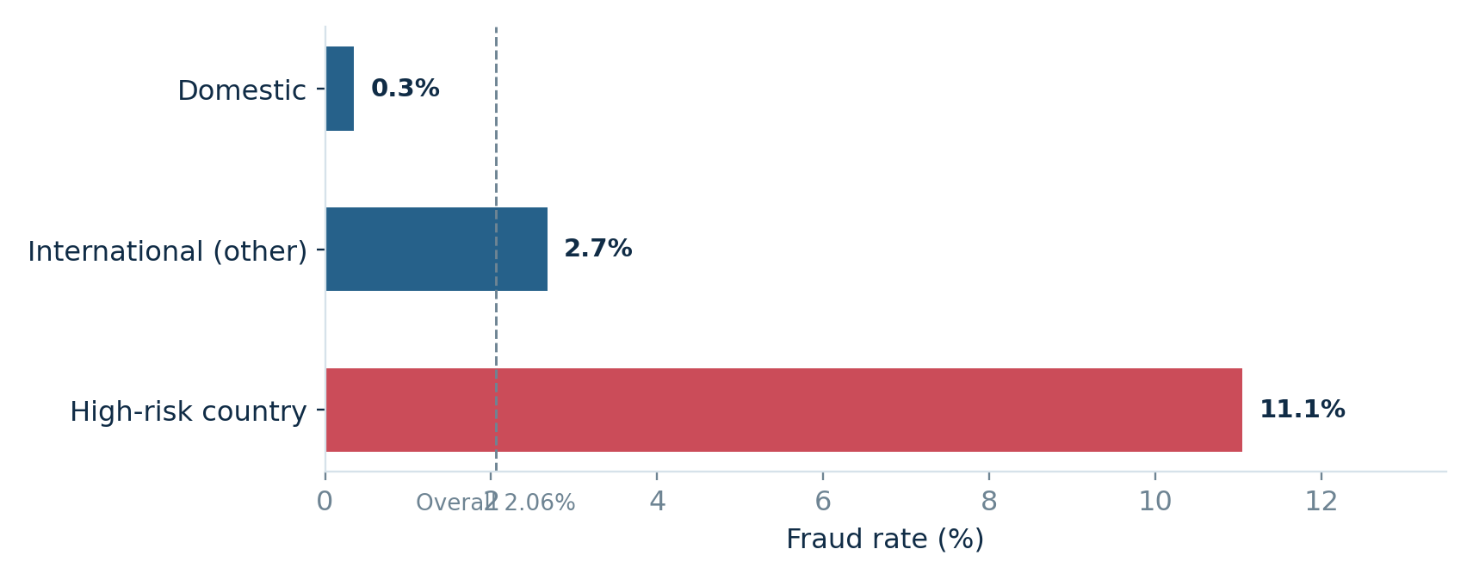
Note. Dashed vertical reference is the overall 2.055% fraud rate. The group categories come from the dataset indicators.
Time of day also matters. Fraud rate reached 11.3% at 3 a.m. in the full dataset, compared with around 2% during many daytime hours. The training period shows the same general overnight risk pattern and supports the engineered night feature. Median fraudulent transaction amount was $64.80, compared with $52.06 for legitimate transactions. The amount distributions overlap, so amount alone is not a strong screening rule.
Figure 2
Fraud rate by transaction hour
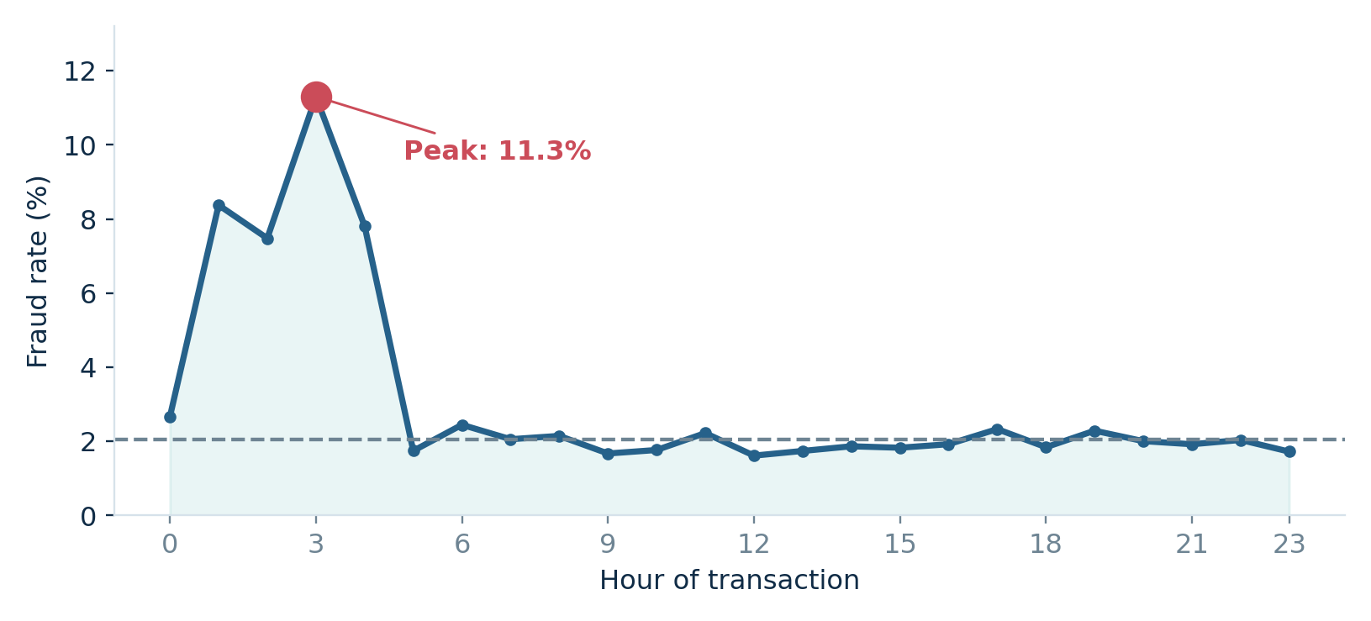
Note. The full-year figure is descriptive. The night feature used in modeling was selected using training-period data only.
The mix of fraud losses also matters. Card-not-present fraud accounted for about $150,504 of the $279,842 total, more than all other fraud types combined. This suggests a review queue should be evaluated on dollar coverage as well as the number of fraud cases captured. Fraud type is used only after outcomes are known; it is never a prediction input.
Figure 3
Labeled fraud loss by fraud type
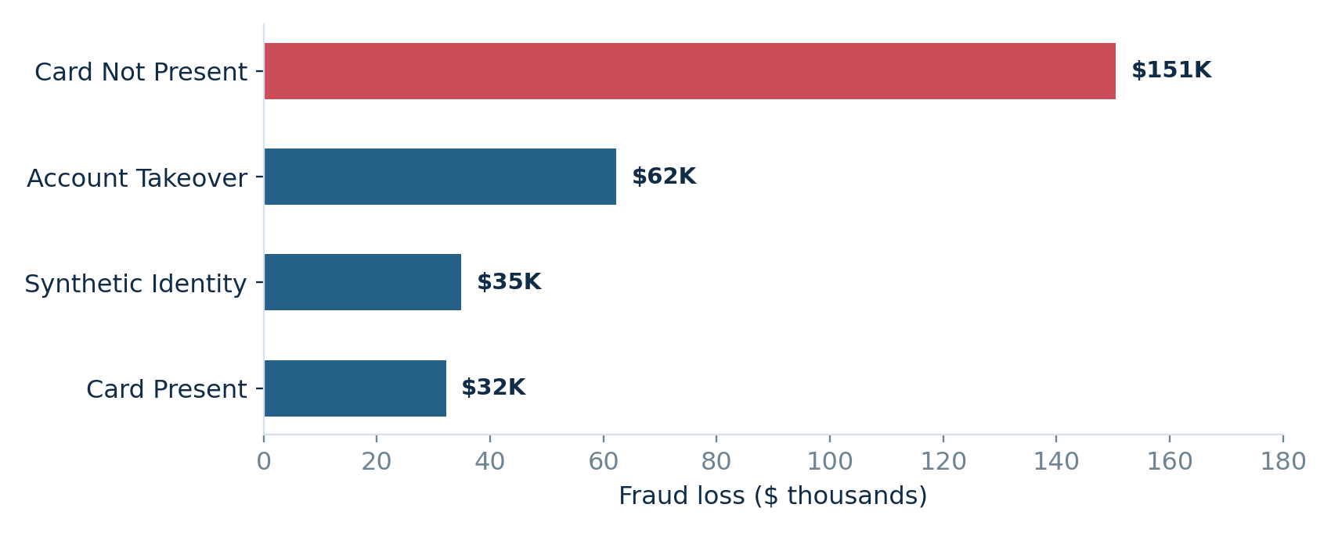
Note. Descriptive analysis only. These categories are outcome labels and were excluded from all prediction features.

6. Results: Model Quality and Policy Selection

6.1 Technical Performance and H1
We selected regularized logistic regression because September PR-AUC was 0.180, compared with 0.137 for gradient boosting. The advantage remained on the held-out test period: logistic regression scored 0.136 and gradient boosting scored 0.131. The test no-skill level was the fraud prevalence of about 0.0217. Logistic regression therefore scored approximately 6.3 times the no-skill level, above the three-times evaluation target. H1 was supported on this synthetic test.
Table 4
Candidate model performance
Candidate | Validation PR-AUC | Validation ROC-AUC | Test PR-AUC | Test ROC-AUC
Logistic regression (selected) | 0.180 | 0.826 | 0.136 | 0.836
Gradient boosting | 0.137 | 0.839 | 0.131 | 0.836
No-skill reference | 0.020 | 0.500 | 0.022 | 0.500

Note. PR-AUC is measured here with average_precision_score (average precision). It is not the accuracy classification rate. Bootstrap 95% CI for selected model test PR-AUC: [0.114, 0.166].
Figure 4
Average precision of candidate models across validation and test periods
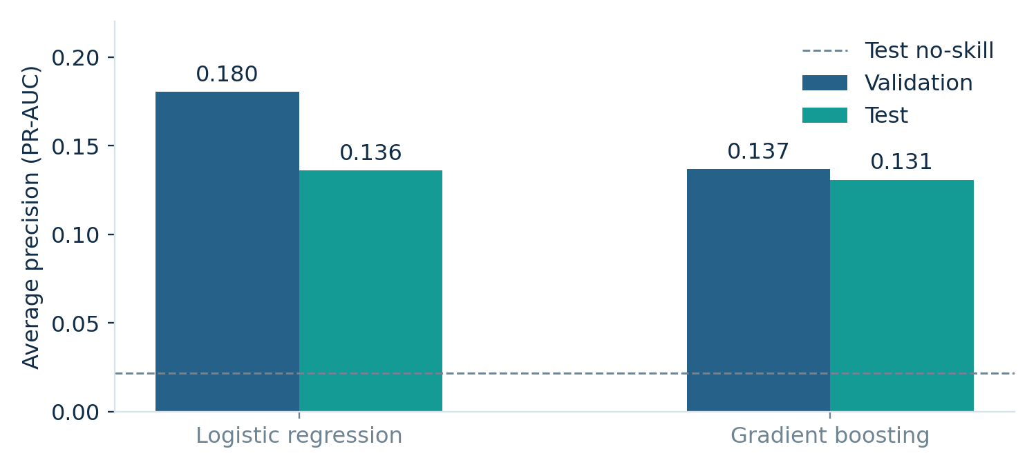

6.2 Why Threshold 0.78 Was Selected
After model selection, we evaluated review costs and covered losses at multiple score thresholds in September. Very low thresholds reviewed too many legitimate transactions, so analyst cost was large. Very high thresholds missed more fraud losses. Under the base assumptions, estimated September net savings peaked at score 0.78. We applied that score threshold unchanged to October–December.
Figure 5
Estimated net savings across model-score cutoffs on September validation data
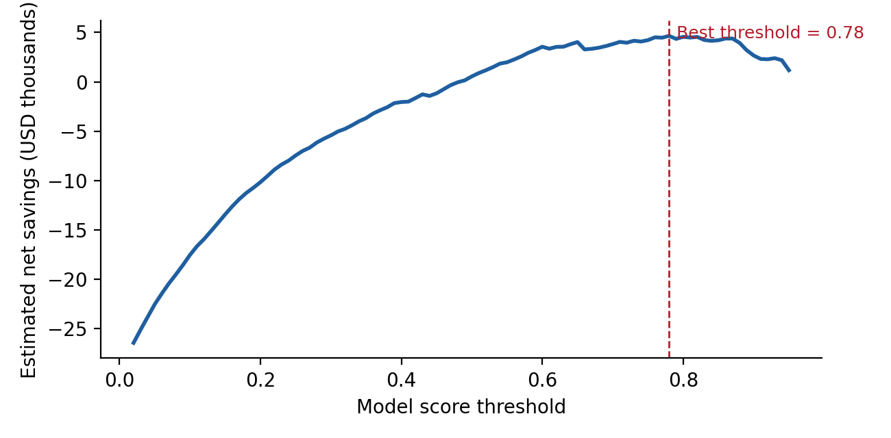
Note. This is an estimated profit curve under s = 80% and c = $5. The score 0.78 is not a calibrated 78% chance of fraud.

6.3 Test Policy and H2
On October–December, the model flagged 1,573 of 25,337 transactions, a 6.2% review rate, or about 17 reviews per day over the 92-day period. It found 215 of the 550 fraud cases (39.1% recall), and 13.7% of its flags were fraud (precision). It captured cases with $41,298.71 in labeled fraud losses, 51.4% of the total loss amount in the test set. At 80% effective prevention, expected losses prevented are $33,039. Subtracting $7,865 in review costs gives $25,174 net savings.
The country rule flagged 1,256 transactions, including 144 frauds. It captured $21,669 in fraud loss, giving $17,336 expected prevention, minus $6,280 in review costs, or $11,056 net savings. The estimated difference was $14,118 in favor of the model. The model requires 317 more reviews and produces 246 more false positives than the simple rule, so the trade-off is better fraud capture at a higher review count. We should not claim it reduces the total number of manual reviews.
Table 5
Test-period fraud-review economics
Measure | Model policy ≥ 0.78 | Country-risk rule
Transactions flagged | 1,573 (6.2%) | 1,256 (5.0%)
Fraud cases identified | 215 / 550 (39.1%) | 144 / 550 (26.2%)
Precision | 13.7% | 11.5%
Fraud dollars on flagged cases | $41,299 / $80,328 | $21,669 / $80,328
Expected losses prevented | $33,039 | $17,336
Review expense | $7,865 | $6,280
Estimated net savings | $25,174 | $11,056
Paired model advantage | $14,118 | —

Note. Numbers rounded to nearest dollar. Results come from the synthetic final test only; $5 and 80% are assumptions.
Figure 6
Estimated net savings under the two held-out review policies
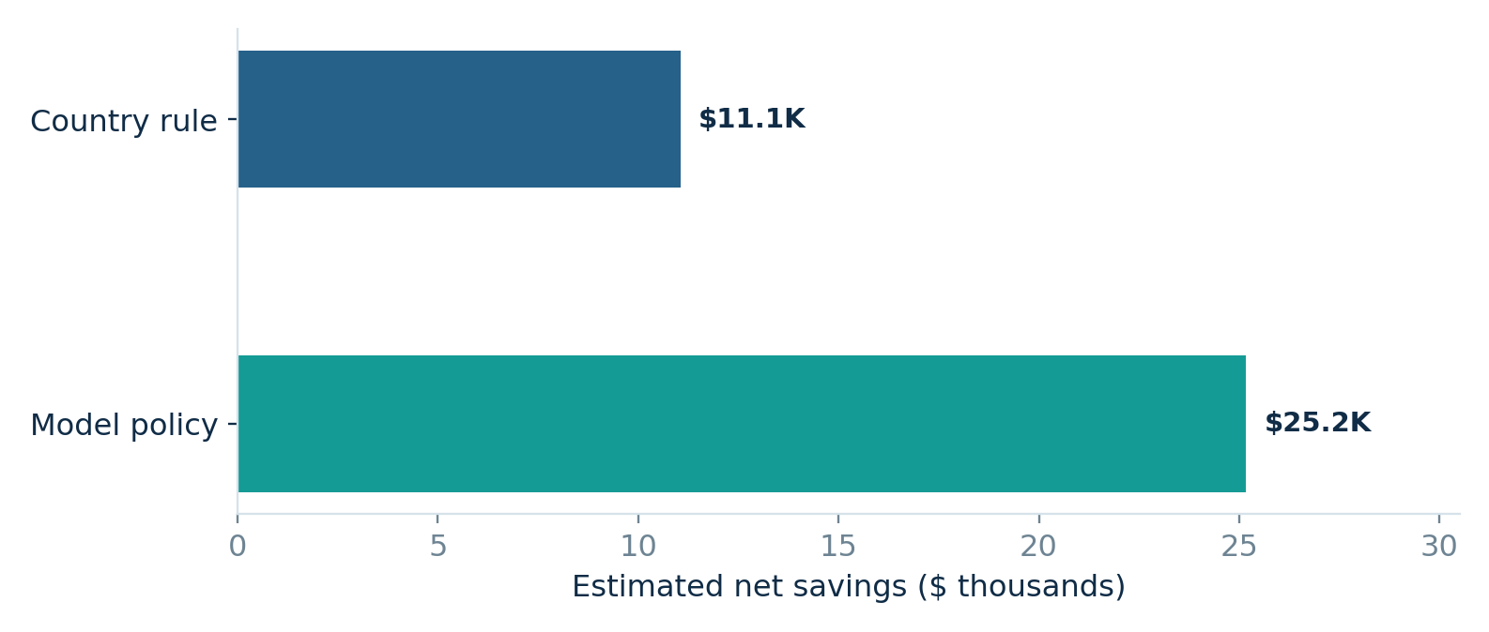
The model’s confusion matrix has 23,429 true negatives, 1,358 false positives, 335 false negatives, and 215 true positives. These counts remind us that the policy is a triage system. It cannot stop all fraud, and every false positive consumes staff time and may inconvenience a real customer.
Figure 7
Confusion matrix for the model review policy
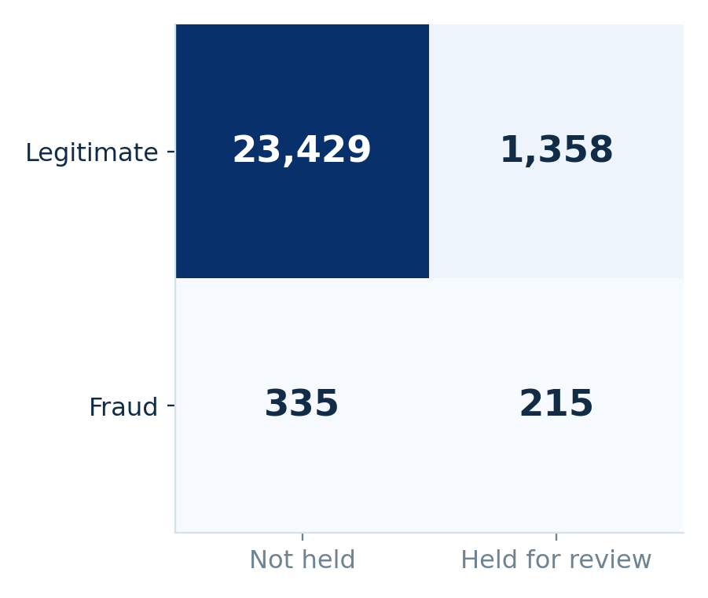

7. Confidence Intervals, Cost Sensitivity, and Robustness
We estimated 95% confidence intervals with 1,000 paired bootstrap samples of the test transactions. In each sample, the same sampled transactions were used to evaluate both policies, so the difference retains their shared variation. Estimated model net savings had a 95% interval of $14,520 to $37,632. The estimated model-minus-rule advantage was $14,118 with a 95% interval of $6,082 to $24,519. This interval excludes zero, so H2 was supported under the report’s test rule.
Transactions from the same customer may be correlated. We therefore repeated the comparison using a customer-level bootstrap. It gave a model advantage interval of $6,462 to $23,916, also fully above zero. The two bootstrap methods agree on the direction of the synthetic estimate, but neither makes the assumptions about review success or synthetic-data generalization disappear.
Figure 8
Estimated policy net savings with 95% transaction-bootstrap intervals
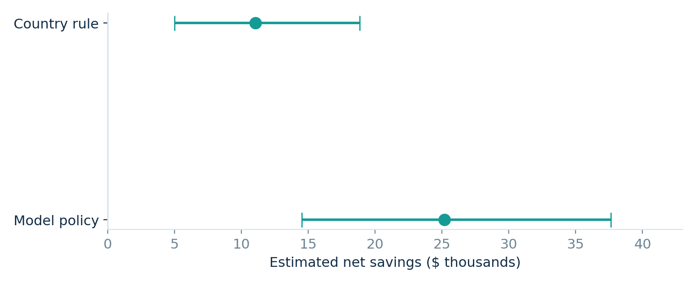
Note. The model-policy interval and country-rule interval are marginal intervals; H2 uses the separate paired difference interval.
Review cost and assumed prevention success strongly affect the best threshold. We tested all 12 combinations of review cost ($2, $5, $10, $20) and effective prevention (60%, 80%, 100%). We re-selected each threshold using September, not the test set. At 80% prevention, the preferred threshold increased from 0.60 when a review cost $2 to 0.94 when it cost $20. The model stayed ahead of the country-risk rule in all 12 scenarios, but review volume changed considerably. Appendix A provides the full sensitivity table.
Figure 9
Estimated net savings by cost per review under 80% effective prevention
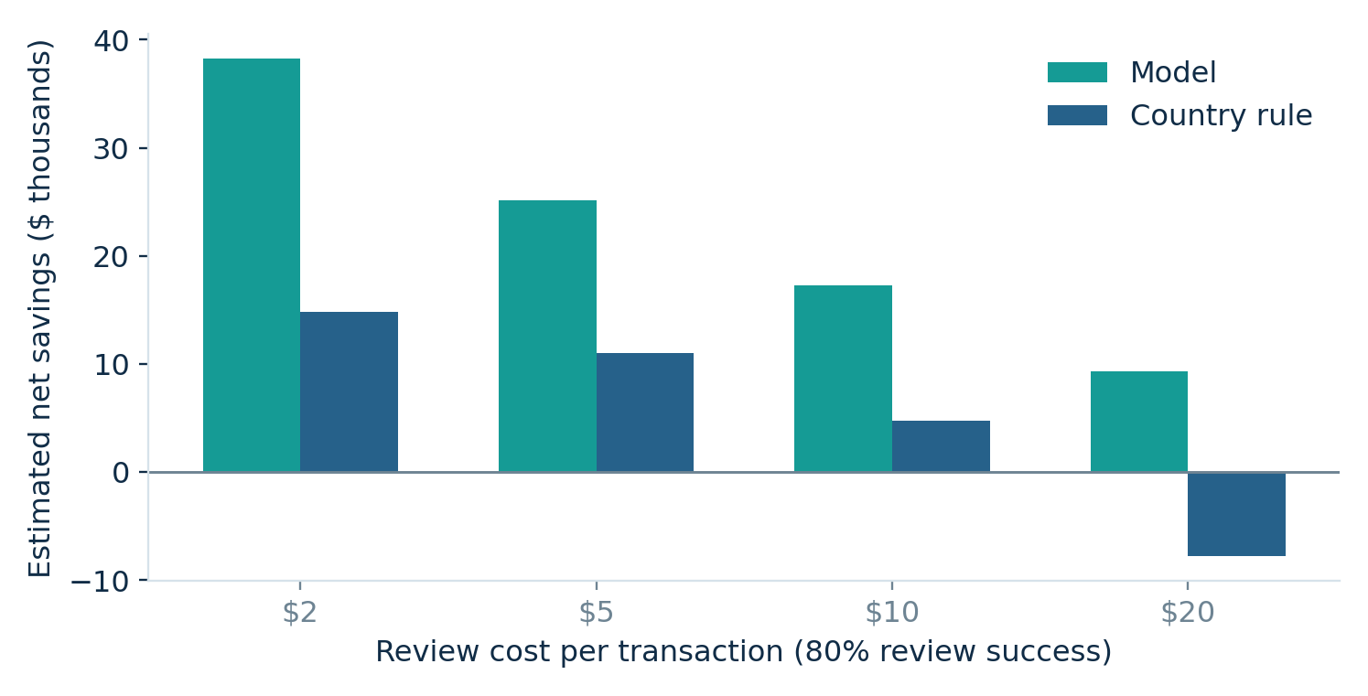
Note. Thresholds are selected separately from September for each cost scenario; results are evaluated on the fixed later test months.
The data-quality robustness comparison also supported the direction of the finding. The main analysis produced test PR-AUC 0.136 and $25,174 model savings. Recoding selected inconsistent fields produced PR-AUC 0.136 and $25,182. Dropping inconsistent records produced PR-AUC 0.133 and $21,822, compared with $9,200 for the rule on that smaller subset. These variations still favored the model in the synthetic sample.

8. Diagnostics: Calibration, Drift, and Feature Contributions

8.1 Scores Are Not Calibrated Probabilities
A useful ranking does not guarantee reliable predicted probabilities. The selected logistic regression uses balanced class weights to pay more attention to the rare fraud label. Its score calibration is poor: in the test set, transactions with scores around 0.8 were fraudulent only about 10% of the time. A score of 0.78 is a cut point in the model ranking, not a statement that a transaction has a 78% probability of fraud. If scores are shown to human reviewers or used in risk communication, the bank must calibrate them on new validation data (Niculescu-Mizil & Caruana, 2005).
Figure 10
Observed fraud rate compared with the selected model’s score
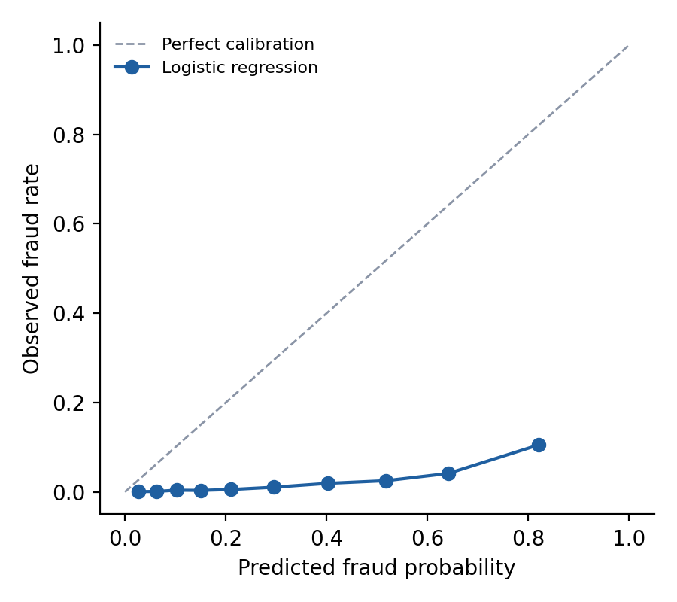

8.2 Important Signals and Monthly Stability
Permutation importance on held-out records suggests that the strongest predictors include high_risk_country, the number of transactions in the last hour, international status, and the night flag. Account age and chip/PIN signals also matter. These patterns are intuitively understandable, but because the source data are synthetic, they may reflect how labels were generated. This analysis does not prove the same ordering of predictors would exist in real issuer data.
Figure 11
Permutation importance, measured as drop in average precision
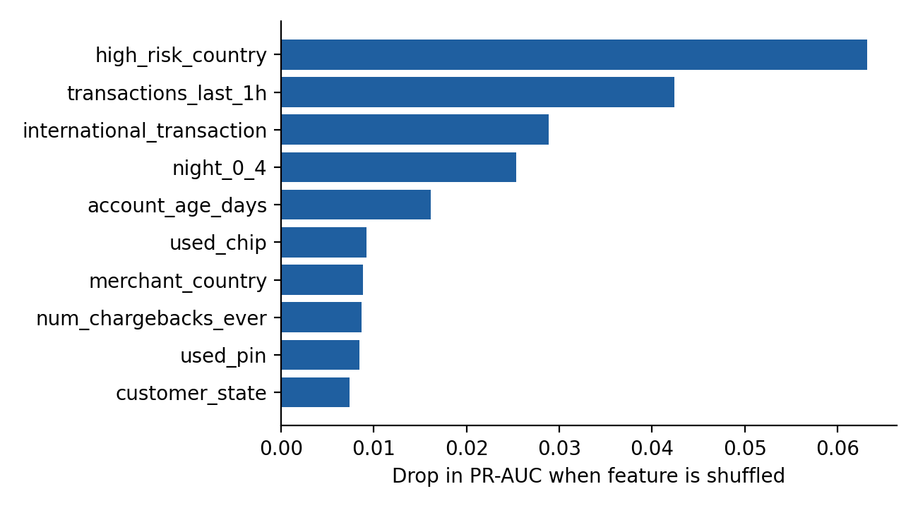
Month-by-month test recall was 37.4% in October, 44.6% in November, and 35.6% in December. This is not a monotonic decline, but the variation matters because operating thresholds and risk patterns can drift. A real bank should check monthly performance with new labeled outcomes and refresh the model when performance or calibration changes materially.

9. Fairness and Human Oversight
Customer age and gender were excluded from model inputs. However, removing them alone cannot guarantee equal treatment, because other inputs, such as geography, can correlate with protected characteristics (Barocas et al., 2023). We therefore audited the final review rule across age and gender groups using test outcomes. A "false-flag rate" is the share of legitimate transactions held for review; "fraud recall" is the share of actual fraud transactions correctly flagged.
Table 6
Review policy outcomes by age group
Age | Transactions | Fraud cases | False-flag rate | Fraud recall
18–29 | 5,086 | 92 | 4.9% | 40.2%
30–44 | 9,285 | 201 | 5.9% | 44.8%
45–59 | 7,928 | 191 | 5.4% | 36.6%
60+ | 3,038 | 66 | 5.5% | 27.3%

Note. Age was not used to predict fraud. Recall for age 60+ is based on 66 fraud cases, so it is uncertain.
Figure 12
Fraud recall by customer age group on the final synthetic test
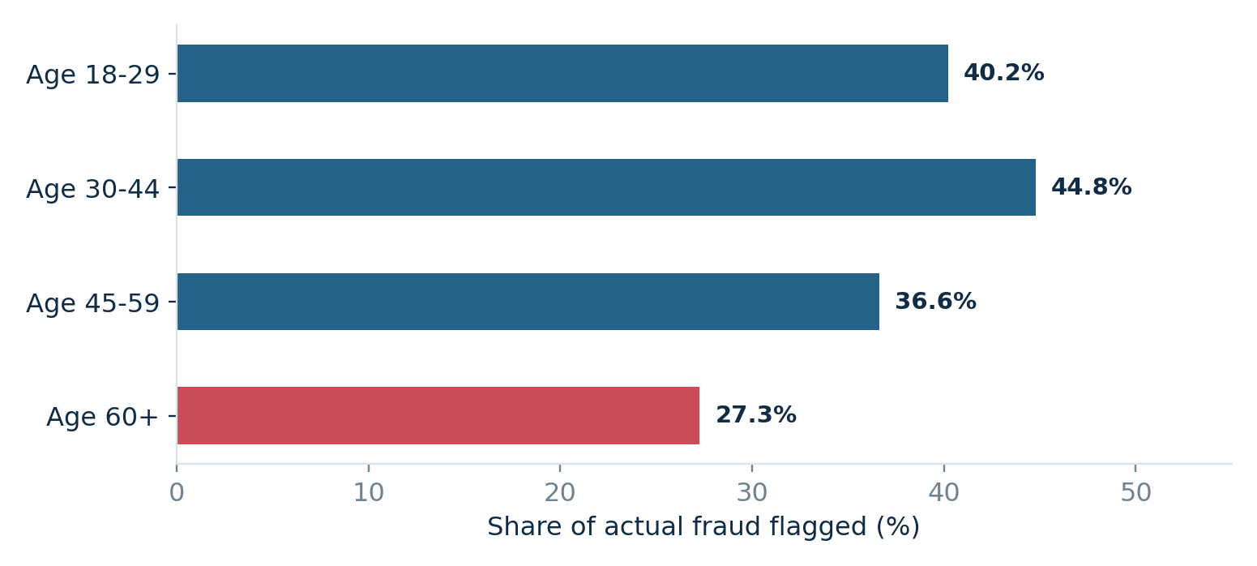
False-flag rates were relatively similar across age groups (4.9%–5.9%). Fraud recall varied more, and detection for customers aged 60 and older was 27.3%, below the 36.6%–44.8% range for the other groups. The group has only 66 fraud cases, so this difference should not be overinterpreted. Gender-group recall also differed in the test: 41.7% for female, 36.3% for male, and 41.7% for the small "Other" group. Those differences also need careful uncertainty checks in a real application.
Our proposed system uses a human reviewer, not automatic declines. A real pilot would record false alerts, appeal outcomes, review waiting times, and complaints, then monitor whether the same types of customer repeatedly face holds. Rules based on merchant countries require explicit policy and fairness review. The synthetic country labeling must not be treated as a finding about actual countries or nationalities.

10. Practical Decision Plan and Guardrails
The current model’s synthetic evidence can guide the design of a pilot but cannot justify immediate real-world use. The recommendation is to validate the approach on real issuer transaction histories, compare it with an actual existing policy, and choose a new threshold using measured costs. The following steps connect the analysis with a bounded operational decision.
Table 7
Phased review-policy evaluation
Stage | What the team should do | Evidence needed to advance
0. Reality check | Confirm data rights, source variables, timestamps, and fraud-label availability. | Verified real transaction-time features and data access approval.
1. Shadow scoring | Score real authorization requests without holding them; compare with existing rules. | Stable PR-AUC, capture at fixed capacity, calibration, segment audit.
2. Cost measurement | Measure analyst time, review effectiveness, delayed purchases and complaints. | Real cost per review and effective prevented-loss estimates.
3. Controlled pilot | Choose threshold on real validation data and test a limited review queue. | Net value and service impact better than status quo with uncertainty.
4. Governance | Monitor drift, calibration, fairness, appeals, and review capacity. | Documented escalation and rollback rules.

A manager should not take the value 0.78 directly from this report into a production rule. That cutoff is specific to the synthetic validation month, model version, and assumed costs. In real operations, the model would need new training and calibration, a threshold that respects the team’s daily capacity, ongoing outcome monitoring, and a way to reverse the policy if legitimate customers are harmed.

11. Limitations and Interpretation
- Synthetic data: the records and dates were constructed for research. The study does not estimate real-world financial savings, international fraud rates, or causal effects of merchant location.
- Incomplete economics: $5 per review and 80% effective prevention are assumptions. The formula excludes interruptions, customer churn, investigation escalation, and infrastructure cost.
- Score calibration: balanced logistic regression ranks cases but produces raw scores that do not equal fraud probabilities. The threshold is specific to its current scoring scale.
- Single validation month: September includes only 164 frauds. A different month might select a different threshold, especially because the profit curve is relatively flat near the top.
- Observational dependencies: customers can appear in multiple transactions; customer-level bootstrap is useful but does not reproduce all real operational dependencies.
- Potential label-generation artifacts: geographic risk and behavior features may be simulated with strong patterns, making the model easier to evaluate than it would be on noisy issuer data.
- Feature availability: historical chargebacks and rolling transaction windows must be checked against real-time feature systems before deployment. The public dataset does not prove they were all created without future information.
The confidence intervals quantify resampling variability under the observed synthetic test and fixed cost assumptions. They do not account for all uncertainty about whether the synthetic patterns, real fraud losses, investigator effectiveness, or customer behavior would transfer to a bank. This is why our final recommendation is a measured shadow evaluation rather than immediate production use.

12. Team Reflection, Contribution, and Conclusion
Our team learned that the business decision should guide the model. At the start, it was tempting to compare algorithms by accuracy. The rare fraud base rate showed that accuracy would be misleading. We changed our focus to ranking quality, threshold choice, and net value. Logistic regression beat the more complex gradient-boosting model on validation average precision, so added complexity was not justified in our sample.
A second lesson was that data quality requires choices rather than automatic deletion. We audited every feature and found that the weekday labels were wrong in every record and that some transaction fields contradicted each other. We excluded the unreliable date labels, checked alternative cleaning rules, and designed the night feature from training data only. These checks increased the credibility of our result.
A third lesson was that statistical performance and responsible use are different. The model ranked fraud well, but the scores were poorly calibrated, and fraud capture was lower for customers aged 60 and older. A model can be useful without being safe to deploy. Our group agreed that a defensible report should state both its benefits and its weaknesses.
Table 8
Team contribution statement
Member | Role | Work
Naga Nitesh Sanka | Project lead | Charter, decision framing, literature review, and final integration.
Rajesh Rayidi | Data engineer | Data-quality checks, feature preparation, leakage review, and code.
Md. Hossain | Modeling lead | Model comparison, threshold optimization, bootstrap, and sensitivity.
Lindi Wang | Insights and ethics | Charts, fairness audit, slides, peer review, and report editing.

In conclusion, the selected logistic regression policy had higher estimated value than the fixed country-risk rule on the held-out synthetic data. The test showed a $14,118 estimated advantage, and the paired confidence interval was positive. This is evidence that a cost-aware, transparent review policy can be a useful analytical approach. It is not evidence that a bank should deploy this exact model or threshold. The next step is to repeat the work with real, approved issuer data and measured operating costs.

References
Barocas, S., Hardt, M., & Narayanan, A. (2023). Fairness and machine learning: Limitations and opportunities. MIT Press.
Bolton, R. J., & Hand, D. J. (2002). Statistical fraud detection: A review. Statistical Science, 17(3), 235–255. https://doi.org/10.1214/ss/1042727940
Chawla, N. V., Bowyer, K. W., Hall, L. O., & Kegelmeyer, W. P. (2002). SMOTE: Synthetic minority over-sampling technique. Journal of Artificial Intelligence Research, 16, 321–357. https://doi.org/10.1613/jair.953
Dal Pozzolo, A., Boracchi, G., Caelen, O., Alippi, C., & Bontempi, G. (2018). Credit card fraud detection: A realistic modeling and a novel learning strategy. IEEE Transactions on Neural Networks and Learning Systems, 29(8), 3784–3797. https://doi.org/10.1109/TNNLS.2017.2736643
Davis, J., & Goadrich, M. (2006). The relationship between precision-recall and ROC curves. Proceedings of the 23rd International Conference on Machine Learning (pp. 233–240). https://doi.org/10.1145/1143844.1143874
Efron, B., & Tibshirani, R. J. (1993). An introduction to the bootstrap. Chapman & Hall.
Elkan, C. (2001). The foundations of cost-sensitive learning. Proceedings of the Seventeenth International Joint Conference on Artificial Intelligence (pp. 973–978). Morgan Kaufmann.
Fawcett, T. (2006). An introduction to ROC analysis. Pattern Recognition Letters, 27(8), 861–874. https://doi.org/10.1016/j.patrec.2005.10.010
Field, C. A., & Welsh, A. H. (2007). Bootstrapping clustered data. Journal of the Royal Statistical Society: Series B, 69(3), 369–390. https://doi.org/10.1111/j.1467-9868.2007.00593.x
Friedman, J. H. (2001). Greedy function approximation: A gradient boosting machine. Annals of Statistics, 29(5), 1189–1232. https://doi.org/10.1214/aos/1013203451
Hosmer, D. W., Jr., Lemeshow, S., & Sturdivant, R. X. (2013). Applied logistic regression (3rd ed.). Wiley.
Kaufman, S., Rosset, S., Perlich, C., & Stitelman, O. (2012). Leakage in data mining: Formulation, detection, and avoidance. ACM Transactions on Knowledge Discovery from Data, 6(4), Article 15. https://doi.org/10.1145/2382577.2382579
Niculescu-Mizil, A., & Caruana, R. (2005). Predicting good probabilities with supervised learning. Proceedings of the 22nd International Conference on Machine Learning (pp. 625–632). https://doi.org/10.1145/1102351.1102430
Pedregosa, F., Varoquaux, G., Gramfort, A., Michel, V., Thirion, B., Grisel, O., Blondel, M., Prettenhofer, P., Weiss, R., Dubourg, V., Vanderplas, J., Passos, A., Cournapeau, D., Brucher, M., Perrot, M., & Duchesnay, É. (2011). Scikit-learn: Machine learning in Python. Journal of Machine Learning Research, 12, 2825–2830.
Provost, F., & Fawcett, T. (2013). Data science for business: What you need to know about data mining and data-analytic thinking. O’Reilly Media.
Saito, T., & Rehmsmeier, M. (2015). The precision-recall plot is more informative than the ROC plot when evaluating binary classifiers on imbalanced datasets. PLOS ONE, 10(3), Article e0118432. https://doi.org/10.1371/journal.pone.0118432
Thalla, M. K. (2026). Credit card fraud detection dataset 2026 (Version 1.0) [Data set and README]. Kaggle; GitHub. https://github.com/mohan13krishna/Credit-Card-Fraud-Detection-Dataset-2026

Appendix A. Full Cost and Review-Success Sensitivity Analysis
Table 9
Twelve decision scenarios; score cutoff selected on validation data
Success | Review cost | Threshold | Flagged | Model net | Rule net
60% | $2 | 0.60 | 18.2% | $26,368 | $10,490
60% | $5 | 0.87 | 2.9% | $14,840 | $6,722
60% | $10 | 0.87 | 2.9% | $11,120 | $442
60% | $20 | 0.94 | 0.7% | $6,028 | $-12,118
80% | $2 | 0.60 | 18.2% | $38,231 | $14,824
80% | $5 | 0.78 | 6.2% | $25,174 | $11,056
80% | $10 | 0.87 | 2.9% | $17,307 | $4,776
80% | $20 | 0.94 | 0.7% | $9,297 | $-7,784
100% | $2 | 0.60 | 18.2% | $50,093 | $19,157
100% | $5 | 0.65 | 14.3% | $34,885 | $15,389
100% | $10 | 0.87 | 2.9% | $23,494 | $9,109
100% | $20 | 0.87 | 2.9% | $16,054 | $-3,451

Note. All estimated model-minus-rule 95% intervals were positive. The result depends on the labeled synthetic outcomes and scenario assumptions.

Appendix B. Additional Data Dictionary and Integrity Checks
Table 10
Selected original variables and their analysis roles
Variable | Meaning | Use / caution
transaction_datetime | Date and time of the transaction | Split by month; not model input
transaction_amount | Amount paid in the transaction | Model feature; right-skewed
transaction_channel | Online, mobile app, store, ATM | Model feature; some card-presence conflicts
merchant_country | Merchant location | Model feature; potential geographic proxy
high_risk_country | Fixed binary merchant-country rule | Model feature and simple policy benchmark
transactions_last_1h | Number of recent transactions | Model feature; timing must be checked in real systems
night_0_4 | Derived indicator for hours 0–4 | Engineered from training-data pattern only
customer_age, customer_gender | Demographic attributes | Held out of model; used for fairness
is_fraud | Fraud ground-truth label | Target; not input feature
fraud_amount_lost | Loss when fraud occurs | Used for validation economic scoring; not prediction

The dataset’s high_risk_country indicator is fixed by merchant location for the four countries defined in the source. This should not be read as a real-world ranking of national fraud risk. The status and fairness impact of geographic features should be evaluated separately in real issuer data.

Appendix C. Reproducibility and Audit Trail
The accompanying fraud_review_full_analysis.ipynb contains the full Python implementation. It uses pandas, NumPy, matplotlib and scikit-learn, fixes the random seed to 42, and outputs the charts and a results.json file. The analysis was rerun against the supplied 100,000-row CSV before this report and presentation were prepared. The final evaluation uses the same model, threshold and dataset split as the source notebook.
Input file. credit_card_fraud_detection_2026.csv. The file has 100,000 rows and 43 columns.
Notebook. fraud_review_full_analysis.ipynb. Run top-to-bottom in Google Colab after uploading the CSV, or run the verified Python script with the CSV path in a local Python environment.
Model selection. Choose between regularized logistic regression and gradient boosting by September average precision; use September to select the cost-based cutoff.
Evaluation. Apply the fixed cutoff to October–December, compare with the binary country-risk rule, estimate 1,000 paired bootstrap samples, repeat a customer-level bootstrap, and audit fairness.
Primary outputs. figures/, results.json, and the tables and figures reproduced in this report. Derived data are not real customer records.

Appendix D. Key Modeling Decisions
Table 11
Analytical choices and reasons
Decision | Chosen approach | Reason
Fraud metric | Average precision (PR-AUC) | Useful with rare fraud labels; no-skill equals base rate
Split | Train/validation/test by time | Mimics later-month deployment in the simulated calendar
Bad weekday fields | Exclude weekday and weekend | Disagree with timestamp on most/all records
Night feature | Derived using training months | Avoids selecting based on test outcomes
Model | Logistic regression | Higher September PR-AUC than gradient boosting
Threshold | 0.78 on September | Maximizes estimated net savings under base assumptions
Benchmark | high_risk_country = 1 | Transparent, fixed rule with no tuned cutoff
Uncertainty | Paired and customer bootstrap | Preserves policy comparison; checks repeated customer risk
Human oversight | Hold for manual review | Avoids automatic high-impact declines
Deployment claim | Method demonstration only | The dataset is simulated and cost assumptions are unverified

