**Lesson 3 Demo 1**

**Create an AMI image**

**Objective:** To create an AMI image

**Tools required:** AWS workspace

**Prerequisites:** None

**Steps to be followed:**

1. Create an AMI image

**Step 1: Create an AMI image**

* + 1. Open the Console Home dashboard, click the search option, and type EC2.

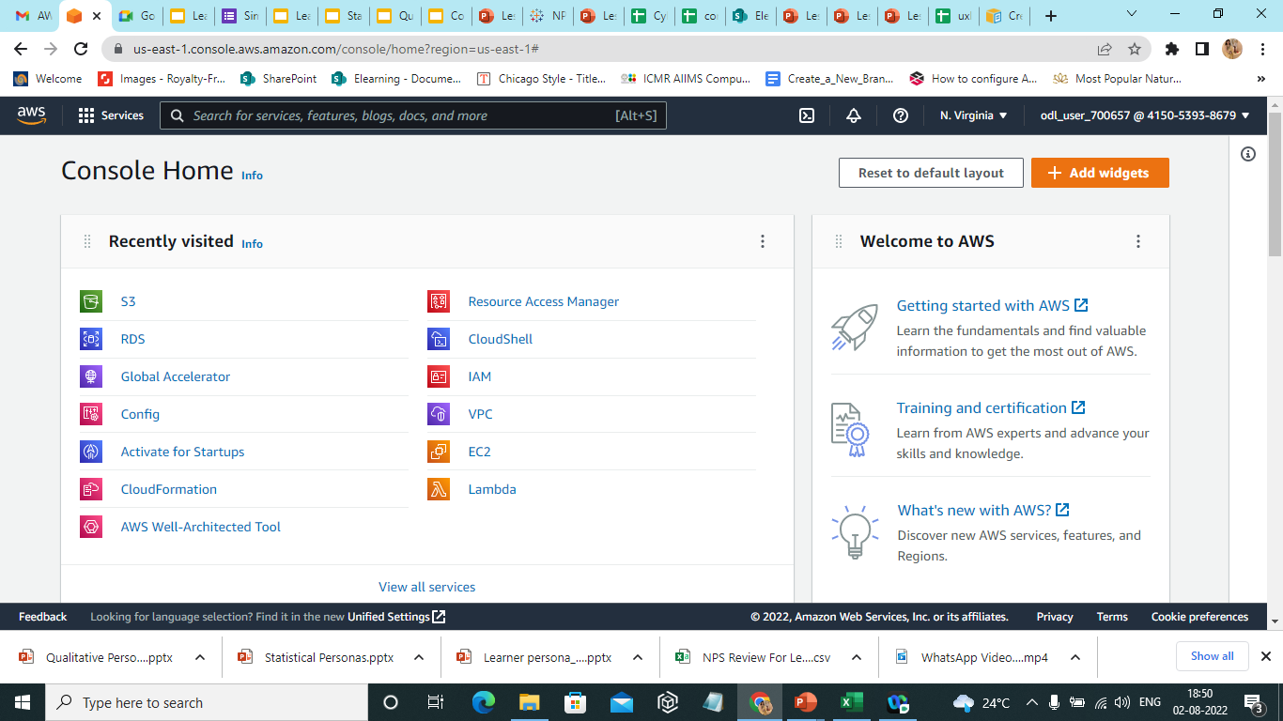

* 1. Select **EC2** and click on it. Users are redirected to the **New EC2 Experience** dashboard.

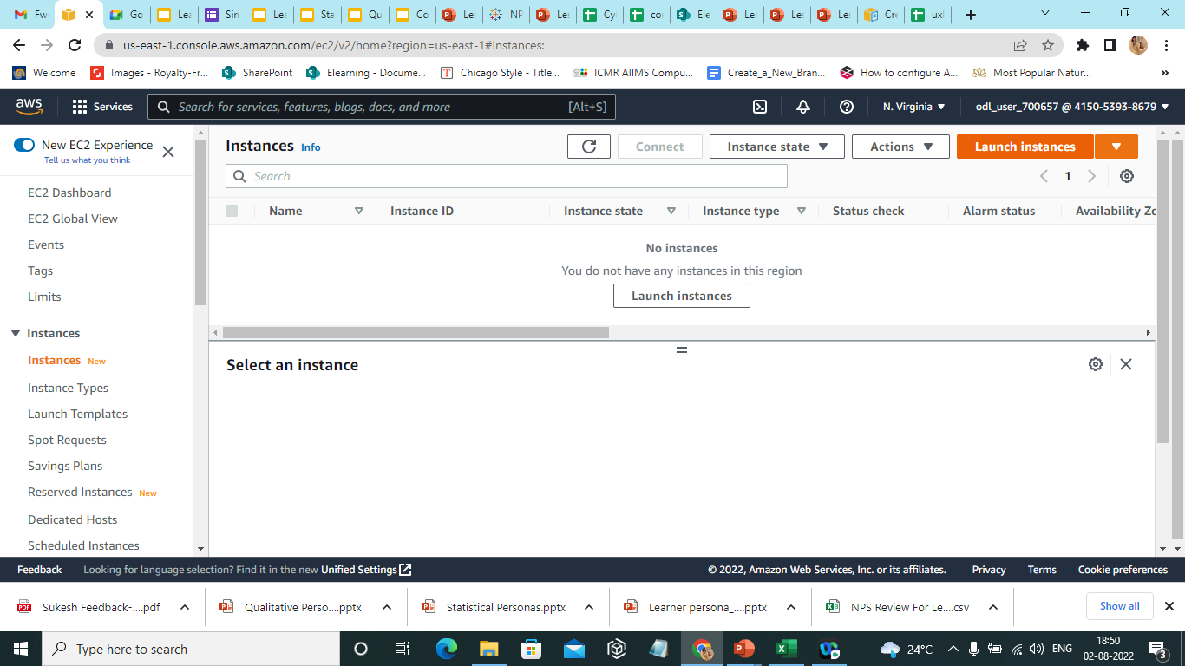

* 1. Select **Launch instances** to create an instance. On clicking **Launch an instance,** this page appears.

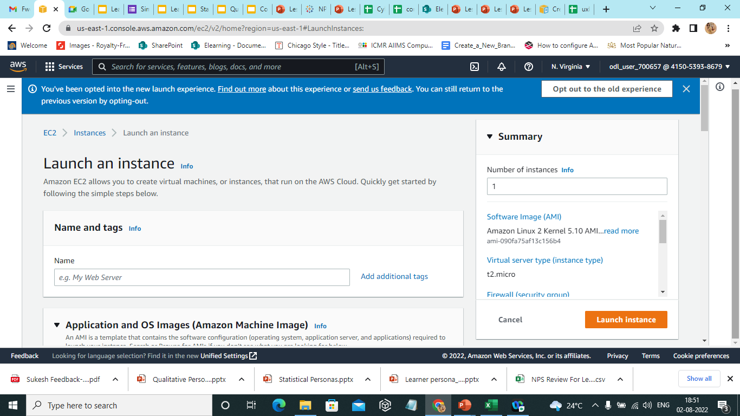

* 1. Once the details are filled, select **Launch instance.**

* 1. The success message appears on the screen.

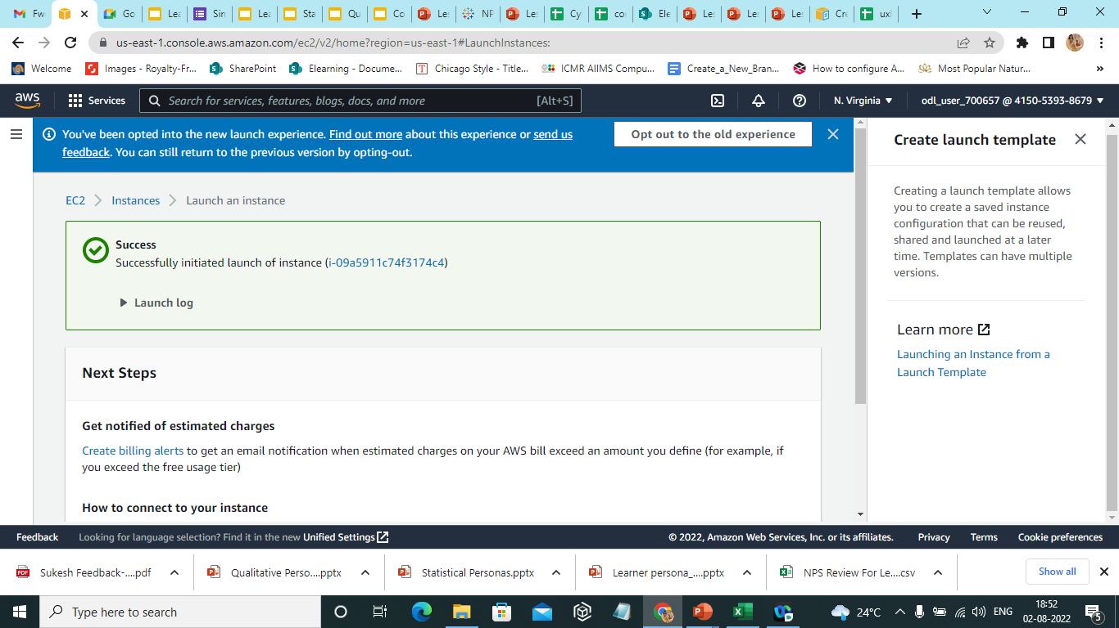

* + 1. Select the instance, and then select **Image and templates** from **Actions.**

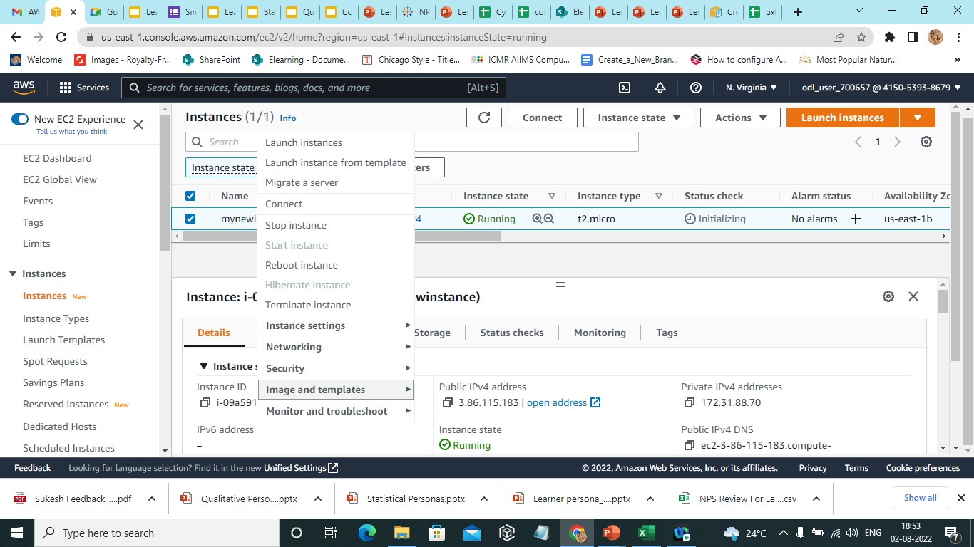

* + 1. Select **Create Image** from **Image and templates.**

* 1. On the **Create Image** page, fill in the following details.

* 1. Click on the **Create Image** option.

1.10The AMI image is created successfully.