**Lesson 3 Demo 6**

**Classic Load Balancer**

**Objective:** To create and deploy a Classic Load Balancer

**Prerequisites:** AWS free tier Account

**Steps to be followed:**

1. Creating a Security Group
2. Launching two instances with different Availability Zones
3. Creating a Classic Load Balancer
4. Deploying the Classic Load Balancer to an EC2 instance

**Step 1: Creating a Security Group**

* 1. Go to the AWS Management Console home page and search for Security Groups.

* 1. Create a **Security Group** by filling in the basic details as shown in the below screenshots:

* 1. Set the **Inbound rules** **Type** as SSH and HTTP with source **Anywhere IPv4** as shown in the below screenshot:

* 1. Click on **Create security group**.

The Security group has been successfully created.

**Step 2: Launching two instances with different Availability Zones**

* 1. Launch the first instance with a name, and under the Network settings, provide the subnet information with an Availability Zone as shown in the below screenshots:

* 1. Select the **existing security group**, which has been already created.

* 1. Provide the below **user data** code under the **Advanced details**:

**#!/bin/bash**

**# Use this for your user data (script from top to bottom)**

**# install httpd (Linux 2 version)**

**yum update -y**

**yum install -y httpd**

**systemctl start httpd**

**systemctl enable httpd**

**echo "<h1>Welcome to AWSNetworks web-server $(hostname -f)</h1>" > /var/www/html/index.html**

2.4 Click on **Launch instance**.

* 1. Repeat the steps from 2.1 to 2.4 to launch the second instance.

**Note:** Provide different availability zones for both the instances.

The instances with different Availability Zones have been launched successfully.

**Step 3: Creating and deploying the Classic Load Balancer**

* 1. Go to the EC2 console and click on the **Load Balancers** tab under **Load Balancing**.

* 1. Click on **Create Load Balancer** tab.

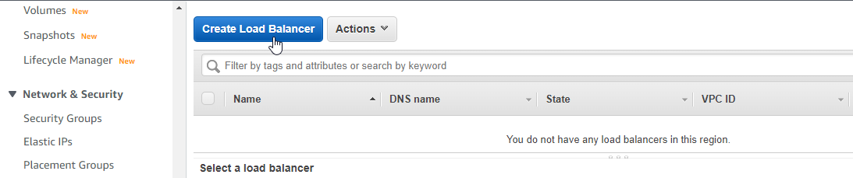

* 1. Go to the **Classic Load Balancer** and click on **Create**.

* 1. Provide a **Load Balancer name** and click on **Next: Assign Security Groups**.

* 1. Select an existing security group **MyHttpServer** and click on **Next: Configure Security Settings**.

* 1. Click on **Next: Configure Health Check**.

* 1. Configure Health Check with the default details as shown in the below screenshot and click on **Next: Add EC2 Instances**.

EC2 Instances with different availability zones should be added.

* 1. Select both the instances and click on **Next: Add Tags**.

* 1. Provide a **Key** and **Value** name as per your choice and click on **Review and Create**.

3.10 Under **Review**, verify the details and click on **Create**.

The Classic Load Balancer has been successfully created.

**Step 4: Deploying the Classic Load Balancer to an EC2 instance**

* 1. Go to the Load Balancer **CLB-Demo** which is created and check for the details under the **Description** tab.

* 1. Go to the **Instances** tab and check the **status** for both the instances.

**Note:** The status needs to be **InService** which means both the instances are running successfully.

* 1. Go to the **Description** tab, copy the DNS name **CLB-Demo-1514223846 us-east-1.elb.amazonaws.com** and paste it into a new web browser to see the deployment.

The deployment of Classic Load Balancer to an EC2 instance has been completed while the user data script is running successfully.