**Lesson 3 Demo 7**

**Application Load Balancer**

**Objectives:** To create a load balancer using the AWS Management Console

**Tools required:** AWS Lab

**Prerequisites:** AWS Lab access with an AWS account created

**Steps to be followed:**

1. [Configure a target group](https://docs.aws.amazon.com/elasticloadbalancing/latest/application/create-application-load-balancer.html#configure-target-group)
2. [Register targets](https://docs.aws.amazon.com/elasticloadbalancing/latest/application/create-application-load-balancer.html#select-targets)
3. [Configure a load balancer and a listener](https://docs.aws.amazon.com/elasticloadbalancing/latest/application/create-application-load-balancer.html#configure-load-balancer)
4. [Test the load balancer](https://docs.aws.amazon.com/elasticloadbalancing/latest/application/create-application-load-balancer.html#test-load-balancer)

**Step 1: Configure a target group**

* 1. Login to your AWS lab

1.2 Open the Amazon EC2 console

1.3 In the left navigation pane, under **Load Balancing**, choose **Target Groups**

1.4 Choose **Create target group**

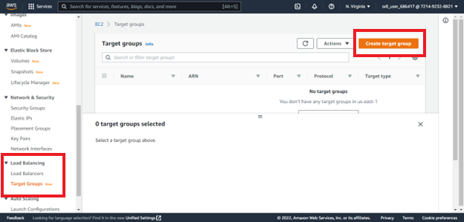

1.5 In the **Basic configuration** section, set the following parameters:

* + For **Choose a target type**, select **Instance** to specify targets by instance ID

* + For **Target group name**, enter a name for the target group

1.6 In the **Health checks** section, default settings are already present

For **Advanced health check settings**, choose the health check port, count, timeout, interval, and specify success codes

* If health checks consecutively exceed the **Unhealthy threshold** count, the load balancer takes the target out of service
* If health checks consecutively exceed the **Healthy threshold** count, the load balancer puts the target back in service

1.7 (Optional) Add one or more tags as follows:

* + Expand the **Tags** section
  + Choose **Add tag**
  + Enter the tag **Key** and tag **Value**. Allowed characters are letters, spaces, numbers (in UTF-8), and the following special characters: + - = . _ : / @. Do not use leading or trailing spaces. Tag values are case-sensitive

1.8 Click **Next**

1.9 Choose **Create target group**

1.9 Now go back to EC2 dashboard and launch two EC2 instances in two different regions (follow the steps from previous demos)

Note: As you can see different regions in the Subnet for both the instances have been selected

Note: The two instances launched have been named as Webserver1 and Webserver2 as shown in the image above

**Step 2:** [**Register targets**](https://docs.aws.amazon.com/elasticloadbalancing/latest/application/create-application-load-balancer.html#select-targets)

2.1 Now On the left pane of the **EC2 dashboard** click on **Target Group**

2.2 Select the target group created previously then click on **Register targets** from **Actions**

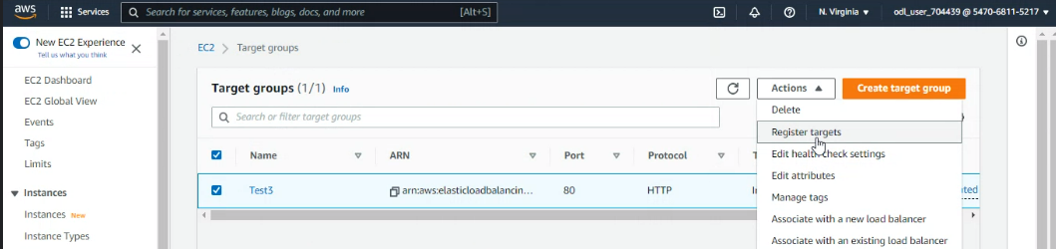

2.3 Now select **the instances** launched previously then click **Include as pending below**

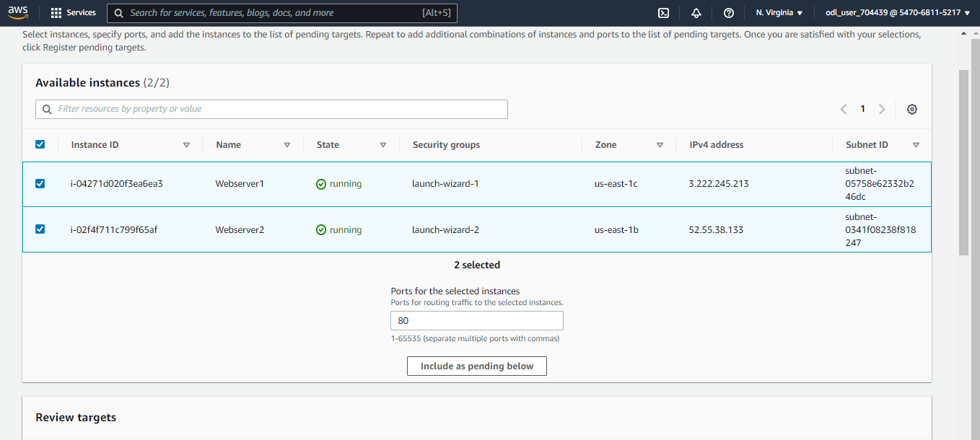

2.4 Now click on **Register pending targets**. Targets are registered now

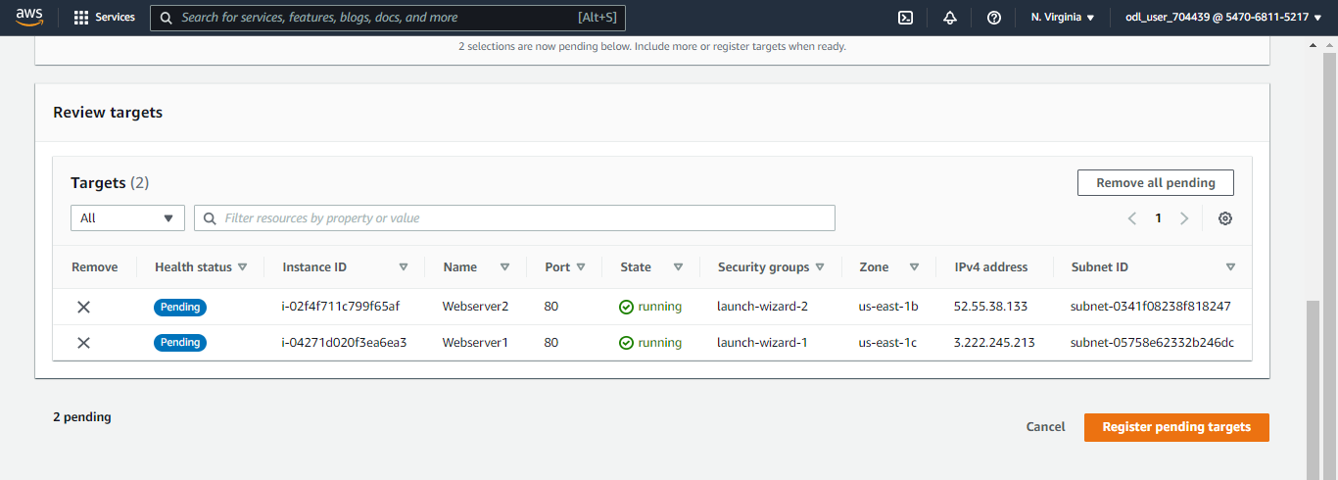

**Step 3:** [**Configure a load balancer and a listener**](https://docs.aws.amazon.com/elasticloadbalancing/latest/application/create-application-load-balancer.html#configure-load-balancer)

3.1 Open the Amazon EC2 console

3.2 In the navigation pane, under **Load Balancing**, choose **Load Balancers**

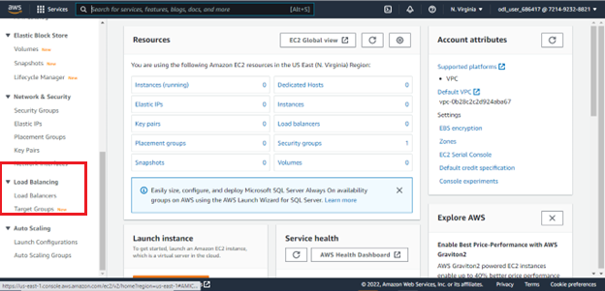

3.3 Choose **Create Load Balancer**

3.4 Under **Application Load Balancer**, choose **Create**

3.5 Basic configuration

* For the **Load balancer name** enter a name for your load balancer. For example, **my-alb**. Names can have a maximum of 32 characters and can contain only alphanumeric characters and hyphens. They cannot begin or end with a hyphen.
* For **Scheme**, choose **Internet-facing** or **Internal**.
* An Internet-facing load balancer routes request from clients to targets over the Internet.
* An internal load balancer routes request to targets using private IP addresses.
* For **IP address type**, choose **IPv4**

3.6 Network mapping

* For **VPC**, select the VPC that you used for your EC2 instances. If you selected **Internet-facing** for **Scheme**, only VPCs with an Internet gateway are available for selection.
* For **Mappings**, select two or more Availability Zones and corresponding subnets. Enabling multiple Availability Zones increases the fault tolerance of your applications.

3.7 For **Security groups**, select an existing security group, or create a new one

3.8 For **Listeners and routing**, the default listener accepts HTTP traffic on port 80. You can keep the default protocol and port

3.9 Review your configuration and choose **Create load balancer**

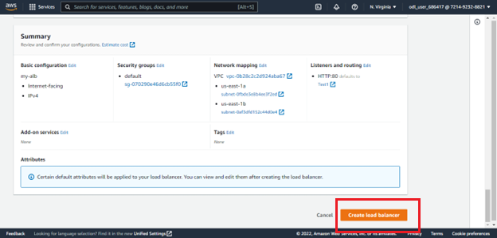

3.10 After clicking on Create Load Balancer, the below page appears

**Step 4: Test the Load Balancer**

4.1 In the navigation pane under **Load Balancing,** choose **Target Group**

4.2 Select the newly created target group

4.3 Choose **Targets** and verify that your instances are ready

4.4 In the navigation pane, under **Load Balancing**, choose **Load Balancers**

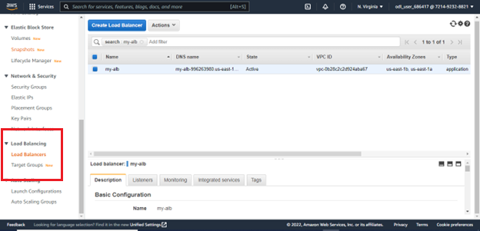

4.5 Select the newly created **load balancer.** Here choose the description and copy the DNS name of the **Load Balancer.**  Paste the DNS name into the address field of an Internet-connected web browser. Testing the DNS in browser tab will show the webservers which are the registered targets of the target group

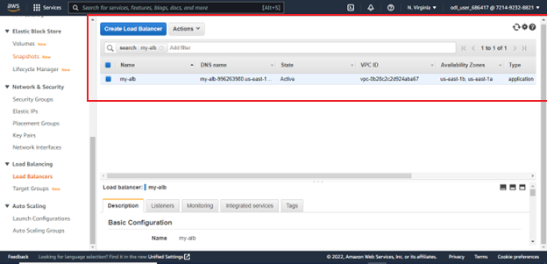

Thus, the above process will help a user to successfully create a load balancer using AWS Management Console.