**Lesson 3 Demo 11**

**Auto Scaling with Launch Templates**

**Objective:** To create an Auto Scaling group using a launch template

**Tools required:** AWS workspace

**Prerequisites:** Create a launch template and have IAM permissions to create an

Auto Scaling group using a launch template

Steps to be followed:

1. Create a launch template
2. Create a launch configuration
3. Create an Auto Scaling group

**Step 1: Create a launch template**

* 1. Open the **AWS** console and search for **Amazon EC2** in the search fieldGraphical user interface, application

     Description automatically generated

* 1. On the left navigation pane, choose **Launch Templates**. Click on the **Create launch template** button

* 1. Enter a **Name** and provide a **description** for the initial version of the launch template

* 1. For **Amazon machine image (AMI),** enter the **ID** of the AMI for the instance. Choose the **t2.micro** instance type

* 1. Choose **Create launch template**

* + 1. Users will get a message as shown in the following screenshot

**Step 2: Create a launch configuration**

* 1. Go to the Amazon console and search for **Amazon EC2** in the search field

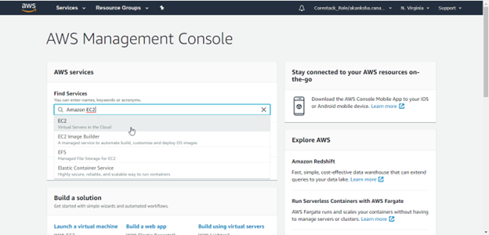

* 1. On the left navigation pane, choose **Launch Configurations**

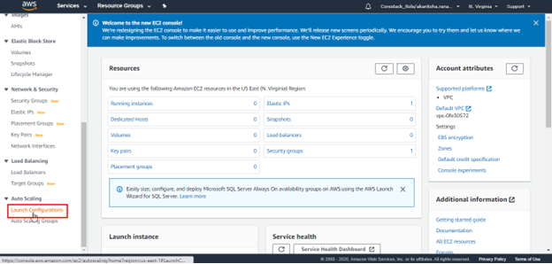

* 1. Click on the **Create launch configuration** button

* 1. Enter a **Name** for the launch configuration

* 1. Select an AMI for the instances. On the **Choose Instance Type** page, select the **t2.micro** instance type, and then choose **Next: Configure details**

2.6 Choose **Skip to review**. On the **Review** page, choose **Edit security groups**. Users can select an existing security group or create a new one

2.7 Choose **Download key pair**

2.8 Choose **Create launch configuration**

**Step 3: Create an Auto Scaling Group**

* 1. Go to the **Amazon console.** Search for **Amazon EC2** in the search field

* 1. On the left navigation pane, choose **Auto Scaling Groups**

* 1. Choose **Create an Auto Scaling group**

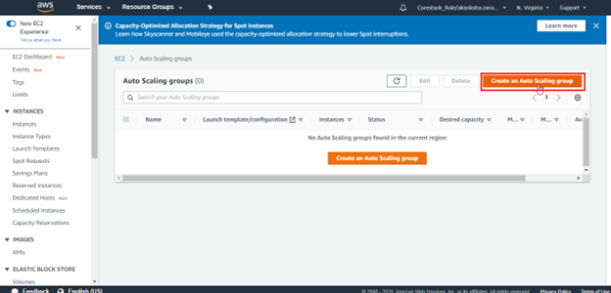

* 1. On the **Choose launch template or configuration** page, enter a name for the Auto Scaling group
  2. Choose the **launch template** that is created, and then click on the **Next** button

* 1. On the **Configure advanced options** page, choose **Enable load balancing.** Choose **Application Load Balancer** or **Network Load Balancer**, and then select the **load**  **balancer**

* 1. Choose **Skip to review**
  2. Click on the **Create Auto Scaling group** button

* 1. User will get a message as shown in the following screenshot.

