**Lesson 03 Lesson-end Project**

**Vertical Scaling of EBS Volume for a Linux VM**

**Project agenda:** To do vertical scaling of EBS volume for a Linux VM

**Description:** Your company is experiencing business growth where solution deployment is happening with limited resources. In this case, the vertical scalability feature of AWS can be used to create a cost-optimised architecture.

**Tools required:** AWS account

**Prerequisites:** A running EC2 Instance

**Expected deliverables:** EBS volume storage using EC2 Instance

**Steps to be followed:**

1. Creating an EC2 Instance
2. Identifying the EBS volume that is created
3. Creating a snapshot
4. Creating a new volume
5. Detaching the existing volume from the EC2 Instance
6. Attaching a new volume to the EC2 Instance

**Step 1:** **Creating an EC2 Instance**

* 1. Navigate to the AWS Management Console, search for EC2, and click on **Launch Instances** as shown in the below screenshots:

1.2 Enter a name for the **Instance**.

* 1. Select an **Amazon Linux** VM.

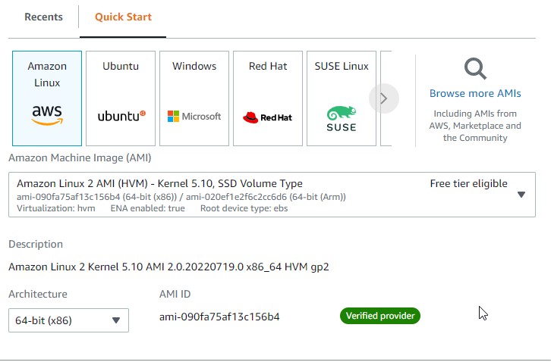

* 1. Create a **key pair** if one has not been created already.

The EC2 Instance has been successfully launched.

**Step 2:** **Identifying the EBS volume that is created**

* 1. Navigate to the **Elastic Block Store** and click on **Volumes**.

* 1. Identify the **Volume** and edit the **Volume** name as shown in the below screenshot:

**Step 3:** **Creating a snapshot**

3.1 **Create a** **snapshot** by clicking on the **Actions tab** of **Old volume**.

3.2 Enter a description and click on **Create snapshot**.

The snapshot has been successfully created.

**Step 4:** **Creating a new volume**

* 1. Create a new volume by clicking on **Create volume**.

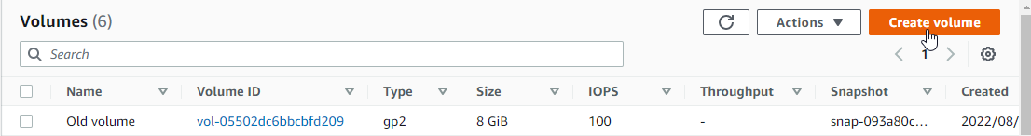

* 1. Enter the details as shown in the below screenshot:

**Note**: The Availability Zone should be provided as the same as the EC2 instance created.

* 1. Click on **Create volume**.

* 1. Edit the name as **New Volume** as the volume has been successfully created.

* 1. Connect to the **AWS Linux** VM by selecting the **Instance** and clicking on the **Connect** button.

* 1. Click on **Connect**.

Successfully connected to the Amazon Linux VM.

* 1. Enter the below command to view the EBS volumes created:

**lsblk**

**Step 5:** **Detaching the existing volume from the EC2 Instance**

5.1 Navigate to the instance **my-ebs-volume** and select **Stop instance** from the **Instance state** tab.

5.2 Click on **Stop**.

5.3 Select the **Old volume**, and under the **Actions** tab, click on **Detach volume**.

5.4 Click on **Detach**.

The Old volume has been successfully detached.

5.5 Now, try to connect to the Instance by clicking on the **Instance state** tab and starting the Instance.

**Note**: It shows as failed to start instance as there is no volume attached.

**Step 6:** **Attaching the new volume to the EC2 Instance**

* 1. Now select the **New Volume** and click on **Attach volume** under the **Actions** tab.

* 1. Select the **instance my-ebs-volume** and click on **Attach volume**.

The New Volume with 13 GiB has been successfully attached.

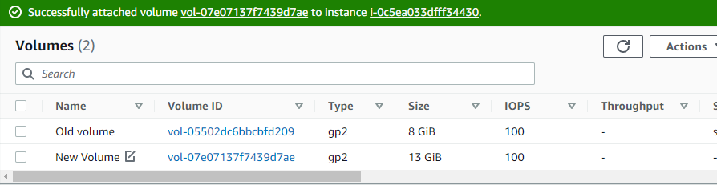

6.3 Now, navigate to the Instance and click on **Start Instance**.

The EC2 Instance has been successfully started after attaching the volume to it. This attachment and detachment of volumes shows the vertical scalability of the Amazon Linux VM.