**Lesson 4 Demo 5**

**Replication of Objects from Source to Destination Bucket**

**Objectives:** To replicate an object from a source to destination bucket using replication rules

**Prerequisites:** None

**Steps to be followed:**

1. Creating two new buckets for source and destination
2. Adding a file to the source bucket
3. Creating a replication rule from the source bucket
4. Replicating the object file from the source to the destination bucket
5. Deleting and verifying the replicated object file

**Step** **1:** **Creating two new buckets for source and destination**

1. Create two new buckets with different AWS Region as shown in the screenshot below:

Note: Please make sure the versioning is enabled while creating the buckets and select different AWS regions

**Step** **2:** **Adding a file to the source bucket**

2.1 Add a file to the source bucket **demo-easyaws-origin-2022**

2.2 Go to the **demo-easyaws-origin-2022** bucket and click on **Objects** to view the file that is added

**Step** **3:** **Creating a Replication rule from the source bucket**

3.1 Go to the Management tab of the source bucket **demo-easyaws-origin-2022** and under the Replication rules, click on **Create replication rule**

3.2 Enter the replication rule name and make sure the status is enabled:

3.3 Choose the rule scope as **Apply to all the objects in the bucket** and choose the destination bucket as **demo-easyaws-replica-2022**

3.4 In IAM role section, select **create a new IAM role**

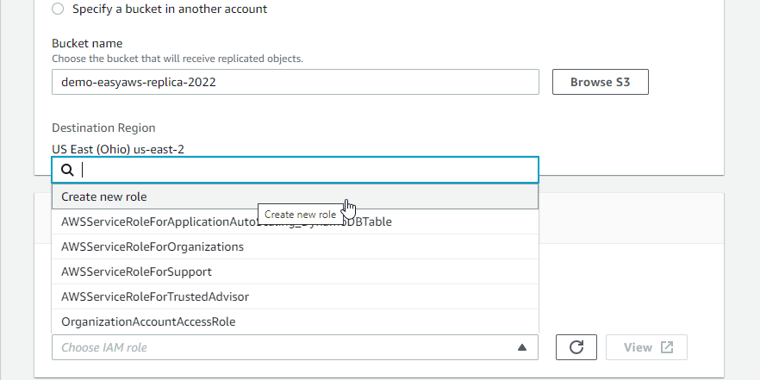

3.5 Please make sure you select the **Delete marker replication** before saving the replication rule

3.6 Click on Save and **Submit** by not making any changes

3.7 **Replication rule** is successfully created.

**Step** **4:** **Replicating the object file from the source to the destination bucket**

4.1 Go to the destination bucket **demo-easyaws-replica-2022** to verify if the object file is already reflecting or is empty

**Note:** The destination bucket will be empty as we have enabled the property to not replicate the existing objects.

4.2 Go to the source bucket **demo-easyaws-origin-2022** to reupload the object file and click on the **show versions** tab to view both the uploaded files:

4.3 Once the object file is reuploaded, go to the destination bucket **demo-easyaws-replica-2022** and click on the refresh button to view the replicated object file

**Step** **5:** **Deleting and verifying the replicated object file**

5.1 Go to the source bucket **demo-easyaws-origin-2022** and delete the uploaded object file

5.2 Go to the destination bucket **demo-easyaws-replica-2022** and verify if the replicated object file is still available and not deleted:

**Note:** The object file is available in the **destination bucket** because the **Delete marker replication rule** has been enabled.

Hence, it is proved that the **replication** of an **object file** from one **source bucket** to a different **destination bucket** can be possible.