**Lesson 4 Demo 7**

**Create and Mount EFS on Linux Server**

**Objectives:** To create an EFS with two AWS instances and mount it on Linux Server

**Prerequisites:** AWS account with an S3 bucket created

**Steps to be followed:**

1. Creating and customizing an EFS
2. Creating a Security Group to configure network access
3. Creating two AWS instances to access the EFS
4. Installing EFS on the created instances

**Step** **1:** **Creating and customizing an EFS**

1. Go to the AWS management console home page and search for EFS service:

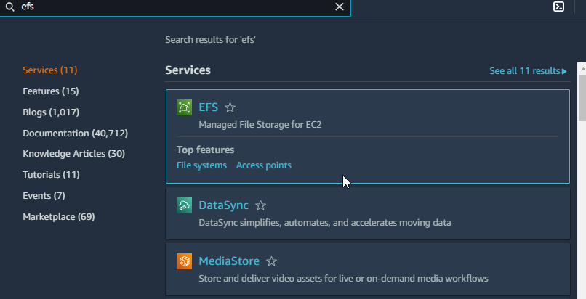

1. Click on **Create file system**:

* 1. Click on **Customize** and check the default settings as mentioned in the screenshots below and click on **Next**:

**Step** **2:** **Creating a Security Group to configure network access**

* 1. Go to the EC2 Management Console and navigate to **Security Groups** under **Network & Security**:

* 1. Click on **Create security group** to create one security group for configuring network access in EFS:

* 1. Fill in the **Security group name** and **Description** fields and click on **Create security group**:

The **Security group** has been successfully created, which needs to be added to the EFS

* 1. Go to the network settings in the EFS console and remove all the default security groups present

* 1. Add the security group that is created and click on **Next** as shown in the screenshots below:

* 1. Under the network access, click on **Next** as shown in the screenshots below:

* 1. Click on **Create** and the EFS will be successfully created

**Step** **3:** **Creating two AWS instances to access the EFS**

* 1. Create two instances to access the files system that is already created. Go to the **Instances** tab on the EC2 management console and click on **Launch Instance**:

* 1. Select the **Amazon Linux 2 AMI**:

* 1. Select **t2.micro** and click on **Next: Configure Instance Details**

* 1. Under the **Configure Instance Details,** follow the steps mentioned in the below screenshots:

* 1. Select an availability zone for **subnet** and click on **Next: Add Storage**

* 1. Click on **Add Tags** and then click on **Next: Configure Security Group**:

* 1. Create a new security group and name it. Then, click on **Review and Launch**

* 1. Click on the **Launch** tab and launch the instance

* 1. Select an existing key pair or create a new key pair and click on **Launch Instances**:

3.10 **Launch** another instance with a different availability zone by following the steps from 3.1 to 3.9:

Both the instances have been successfully launched.

3.11 SSH to both the instances as shown in the below screenshots:

**Step** **4:** **Installing EFS on the created Instances**

* 1. Go to the EFS that is created and click on the **Attach** button:

* 1. Select **Mount via DNS**:

* 1. To proceed further with the installation, install the **amazon-efs-utils** package in both the instances. To do so, go to [https://docs.aws.amazon.com/efs/latest/ug/mounting-fs.html#mounting-fs-mount-cmd](https://docs.aws.amazon.com/efs/latest/ug/mounting-fs.html%23mounting-fs-mount-cmd), and click on **Installing the amazon-efs-utils Package on Amazon Linux**
  2. Execute the below-mentioned commandin each instances:

**sudo yum install -y amazon-efs-utils**

* 1. Create an EFS directory for both the instances using **mkdir efs**

4.6 Before mounting the EFS, go to the security group **my-efs-demonstration** and add inbound rules for NFS

4.7 Once the rule is added, go to the instance, and mount an EFS in the instance using the **EFS mount helper** present in the EFS





4.8 Log into one of the instances and create a file that says **hello.txt**

4.9 Log in to the other instance and you will be able to see the same file **hello.txt** in that instance as well

This shows that you have successfully mounted the **EFS** and have customized the file system by using a specific **EC2 Instance**.