**Lesson 4 Lesson-end Project**

**Implementation of S3 Buckets for Web Content Hosting**

**Project agenda:** To host content on the static website using an S3 bucket

**Description:** The admin of an organization wanted to deliver HTML content on a static website. An S3 bucket has been used to perform this activity.

**Tools required:** AWS

**Prerequisites:** AWS free-tier account

**Expected deliverables:** The website content needs to be hosted using an S3 bucket.

**Steps to be followed:**

1. Creating an S3 bucket
2. Generating Bucket Policy
3. Enabling static website hosting by uploading index.html content
4. Testing and verifying the hosted content

**Step 1:** **Creating an S3 bucket**

* 1. Navigate to the AWS Management Console, search for S3, and click on **Create bucket**.

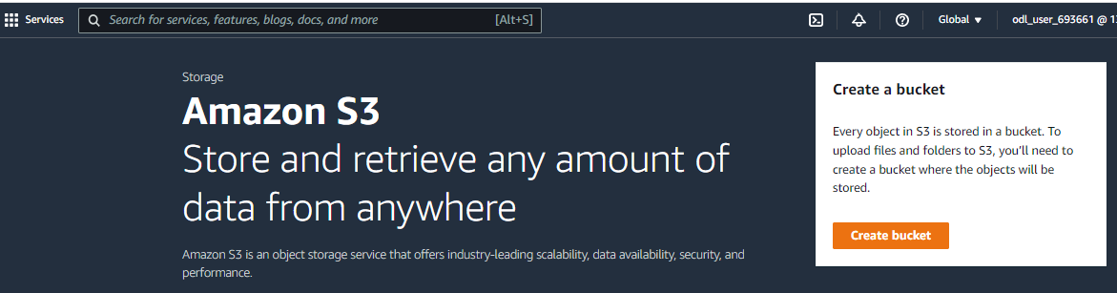

* 1. Provide a name for the bucket and make sure **ACLs** are enabled under the **Object Ownership** as shown in the below screenshots:

* 1. Click on **Create bucket**.

S3 bucket **my-webcontent-demo** has been successfully created and launched.

**Step 2:** **Generating Bucket Policy**

* 1. Go to the **Permissions** tab and click on **Policy generator**.

* 1. Choose **Select Policy Type** as **S3 Bucket Policy** and fill in the **Add statements**.

**Note:** **Principal** value should be **\*** and **Actions** should be **GetObject**

* 1. Fetch the **ARN** from the **Properties** tab under the Bucket overview and click on **Add Statement** as shown in the below screenshots:

* 1. Click on the **Generate Policy** button.

The Bucket Policy has been successfully generated.

* 1. Add the generated **Bucket Policy** and click on **Save changes**.

**Note:** While pasting the Bucket policy in the policy page, check whether **Resource line** in the code mentioned in the following way: "Resource": "arn:aws:s3:::my-webcontent-demo**/*".**

If the /* symbols not found at the end of the line, then add it and click save changes.

Hence, bucket policy is successfully added.

**Step 3:** **Enabling static website hosting by uploading index.html content**

* 1. Upload an **index.html** file inside the S3 bucket **my-webcontent-demo** as shown in the below screenshot:

* 1. Go to **Permissions** of **my-webcontent-demo** and edit **Block public access** to make the bucket publicly accessible.

* 1. Go to **Properties** of **my-webcontent-demo** and click on edit **Static website hosting**.

* 1. Enable the **Static website hosting** and **specify the default page of the website** and click on **Save changes**.

The static website hosting has been successfully edited.

**Step 4:** **Testing and verifying the hosted website content**

4.1 Navigate to the **properties** tab, scroll down to **Static website hosting,** and click on the **Bucket website endpoint** link.

As the content is reflecting on the web browser, implementation of an **S3 bucket** using the **static website hosting** has been successful.