**Lesson 10 Demo 3**

**Create an EC2 Cluster and a Task Definition, and Then Run the Task**

**Objective:** To create an EC2 cluster and a task definition then run that task using Amazon ECS

**Tools required:** AWS account

**Prerequisites:** NA

Steps to be followed:

1. Create a cluster
2. Create a task definition
3. Run a task from that task definition on the cluster

**Step 1: Create a cluster**

* 1. 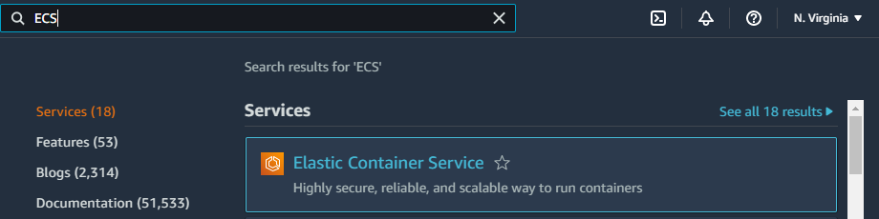In the AWS management console, search for **ECS** and then click on **Elastic Container Service.**
  2. In the ECS dashboard, click on **Clusters.**

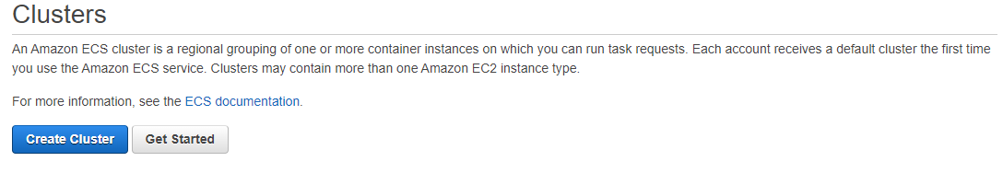 1.3 Click on **Create Cluster**

1.4 In the **Select cluster template** section, select **EC2 Linux + Networking.**

1.5 In the **Configure cluster** section:

* For **Cluster name,** enter any arbitrary name for the cluster
* Click on **Create**

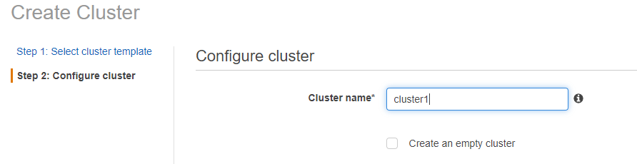

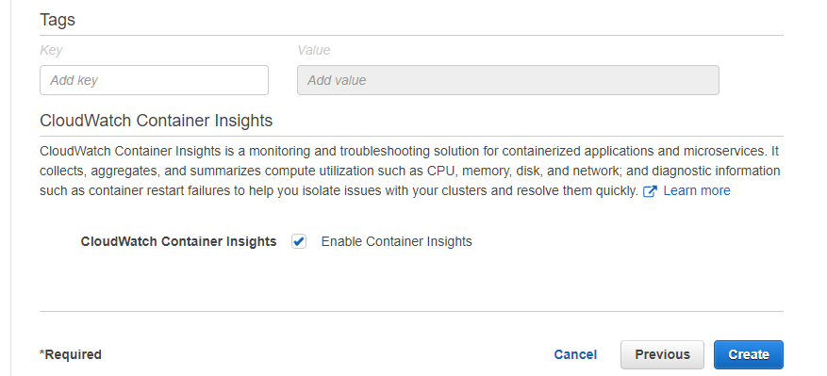

1.6 In the **Launch status,** click on **View Cluster.**

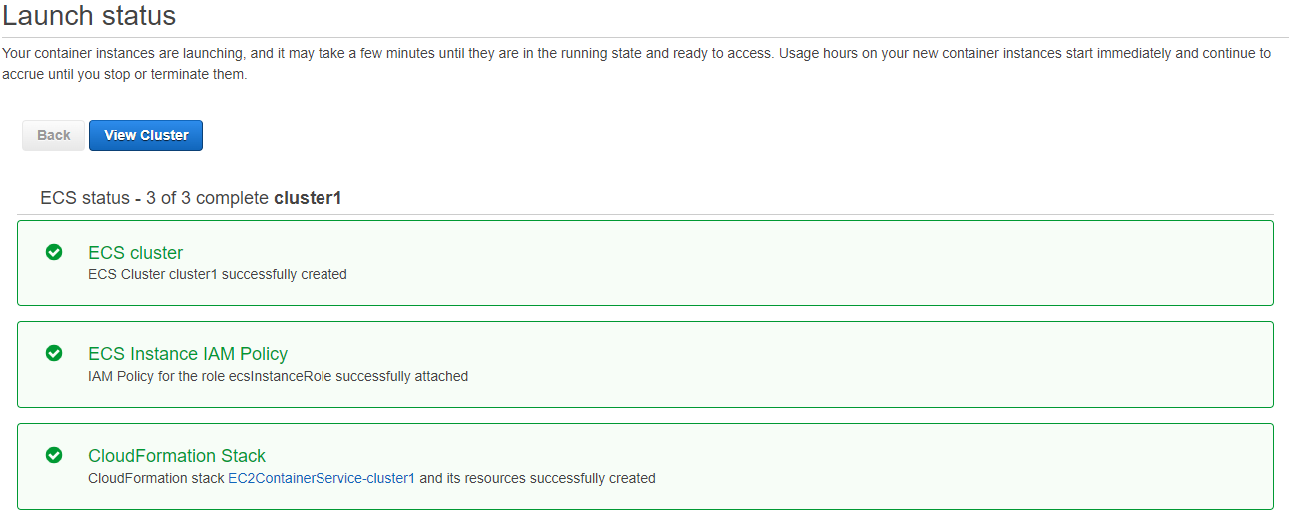

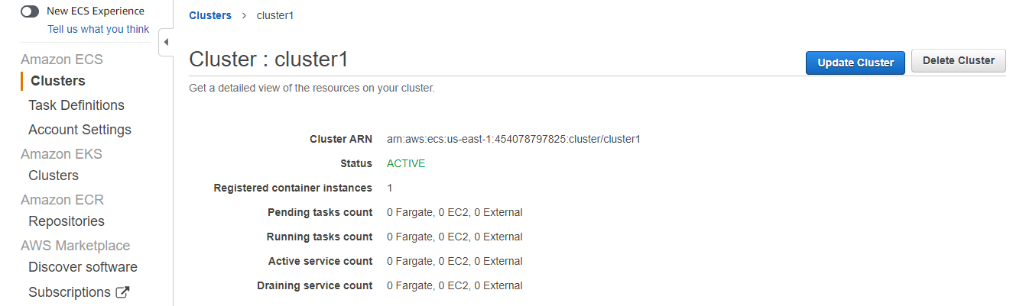

**Step 2: Create a task definition**

2.1 In the ECS dashboard, click on **Task Definitions.**

2.2 Click on **Create new Task Definition**

2.3 In **Select launch type compatibility,** select **EC2.**

2.4 In the **Configure task and container** **definitions,** do the following:

* Add an arbitrary name for the Task Definition in the **Task definition name**
* In **Task memory (MiB),** enter 512 and 1024 in **Task CPU (unit)**
* Click on **Add container**

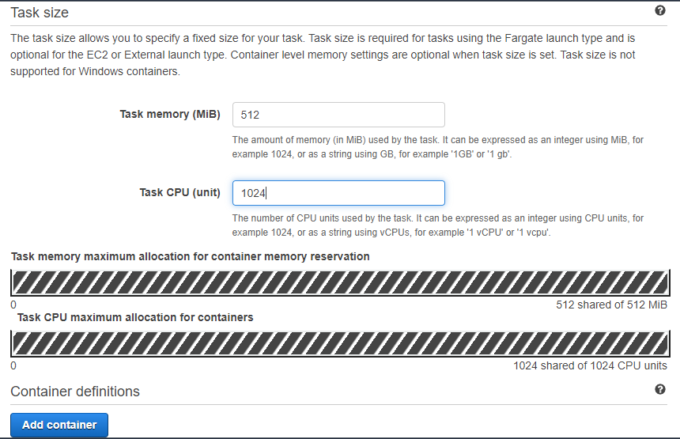

2.5 In the **Add container** console, do the following:

* Give an arbitrary name to the container for the **Container name**
* Graphical user interface, application

  Description automatically generatedEnter **nginx:latest** for **Image**

* 1. Graphical user interface, application

     Description automatically generatedEnable **Auto-configure CloudWatch Logs** in the Storage and Logging section and then click on **Add**

2.7 Click on **Create** in the **Configure task and container** **definition** console:

**Step 3: Run a task from that task definition on the cluster**

3.1 In the **Task Definition** dashboard, click on **Actions** and select **Run Task.**

3.2 In the **Run Task** console, do the following:

* Select **EC2** as **Launch type**
* 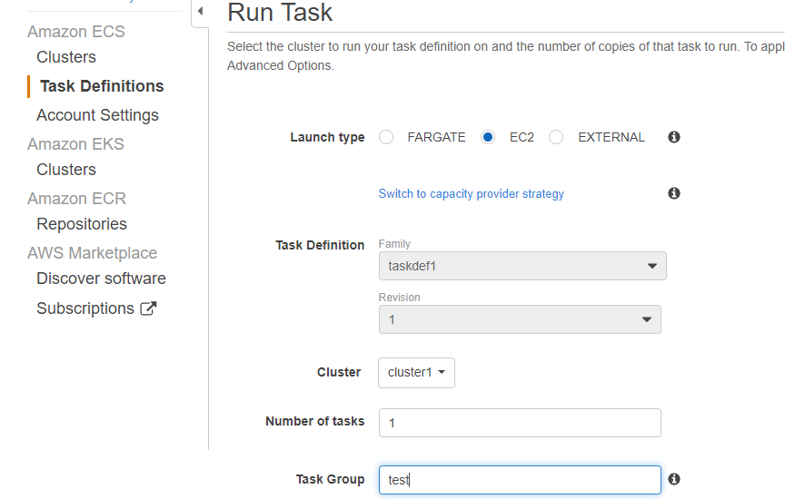Enter an arbitrary name for the **Task Group**

* 1. 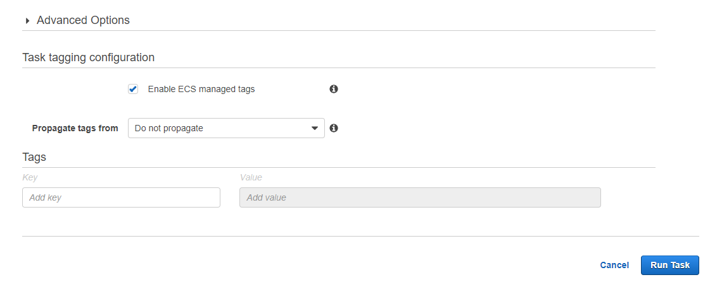Click on **Run Task**

3.4 From the **Clusters** dashboard, open the task definition created in step 2:

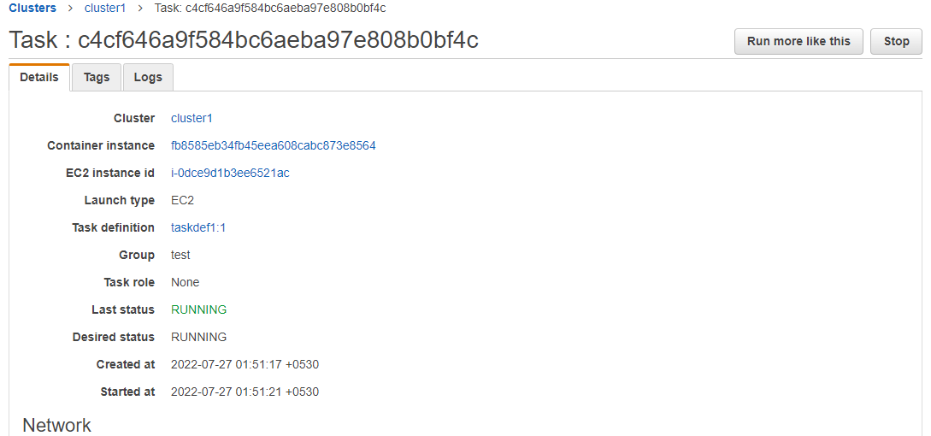

* 1. 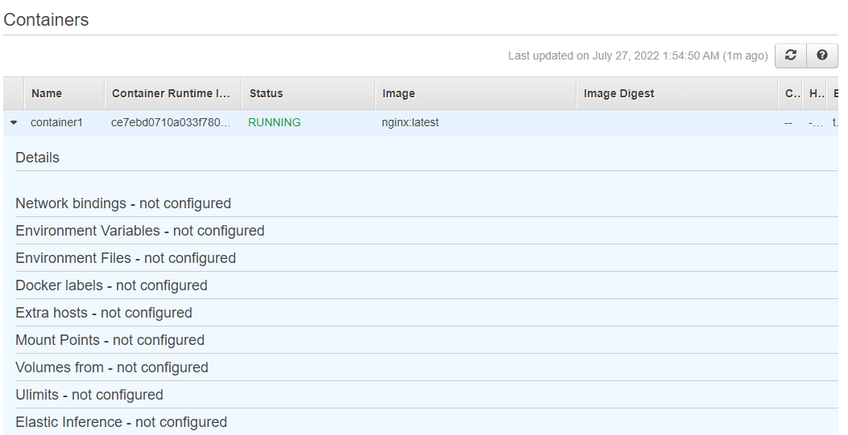Scroll down the task window and check the status of the task definition

Hence, your task definition is successfully running on your cluster.