**Lesson 10 Demo 5**

**Run Task on a Fargate Cluster**

**Objective:** To run a task on a Fargate Cluster

**Tools required:** An AWS account

**Prerequisites: N/A**

Steps to be followed:

1. Create a Fargate Cluster
2. Create Task Definition
3. Run its Service

**Step 1: Create a Fargate Cluster**

* 1. In the AWS Management Console, search for ECS and select Elastic Container Service

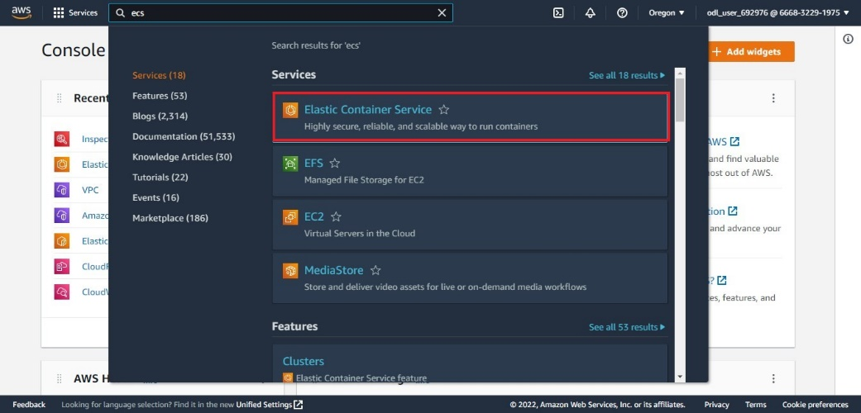

* 1. On the left panel of the ECS console click on **Clusters** then click on **Create Cluster**

* 1. Choose **Networking Only**

Click on Next Step

* 1. In the Cluster Configure window do the following:
* Enter an arbitrary name for Cluster under **Cluster Name**
* Check the box under **Create VPC**
* Let the other settings stay at default settings, then click on Create

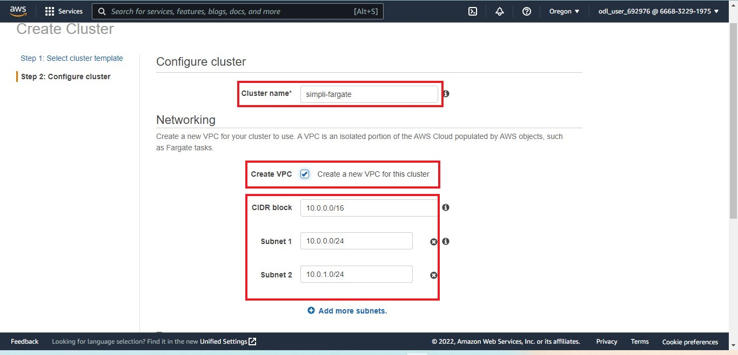

Do not close this tab. It will be necessary for reference. ECS Cluster will be created.

**Step 2: Create Task Definition**

1. In the AWS Management Console search for **ECS** and select **Elastic Container Service**

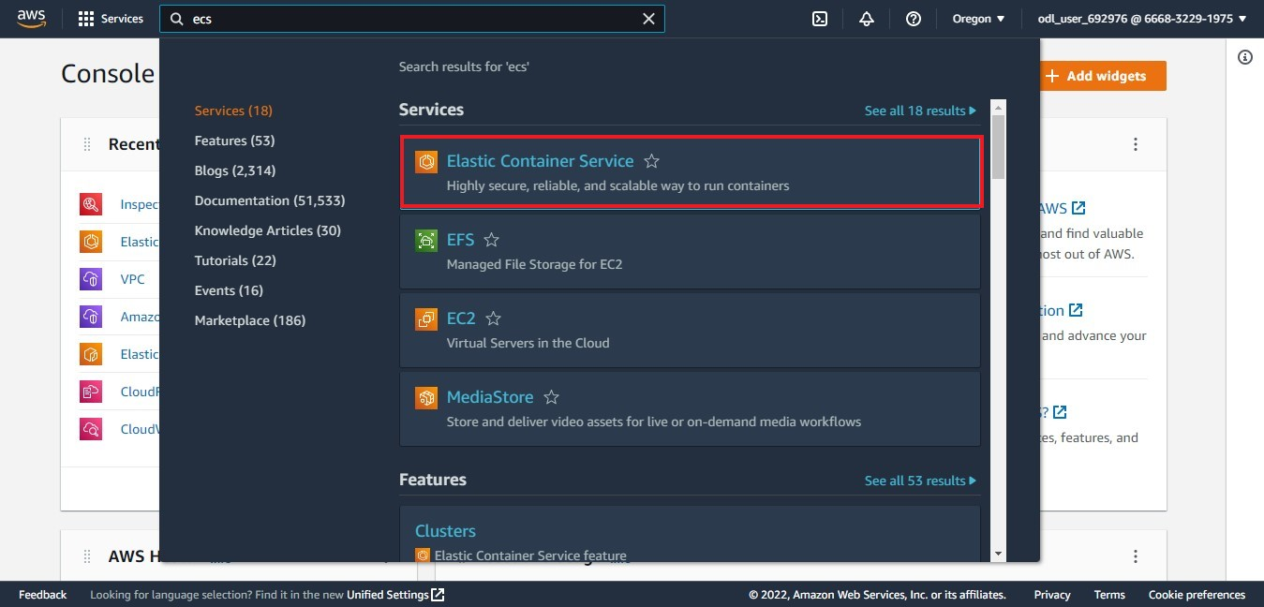

2.2 On the left panel of ECS console click on **Task Definitions** then click on **Create new Task**

**Definition**

* 1. Choose **FARGATE** and click on **Next Step**

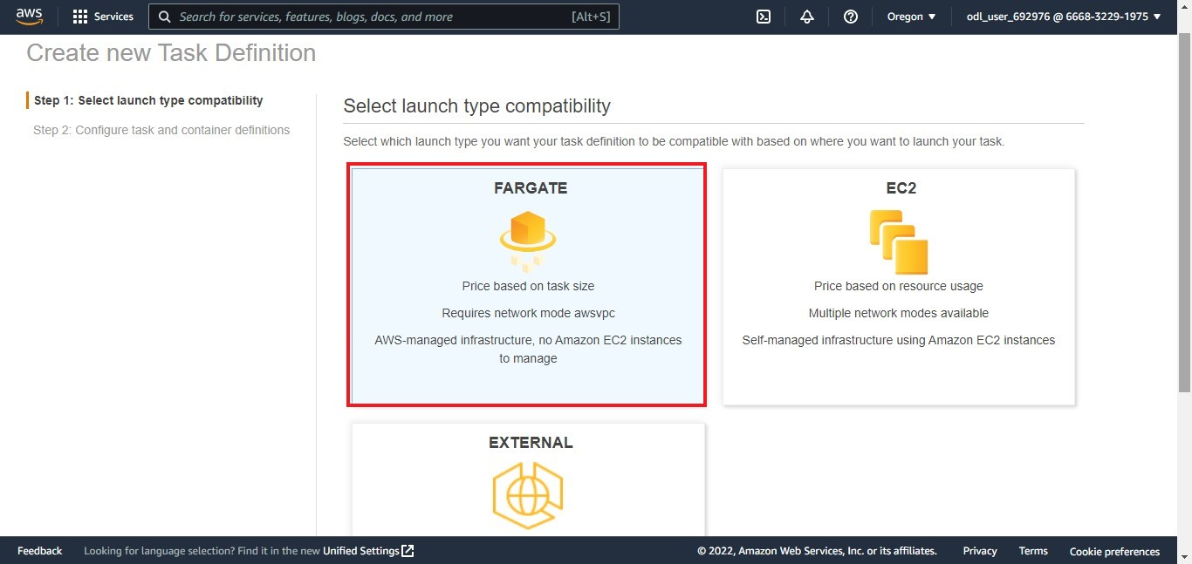

* 1. Enter a name for the **Task Definition NameGraphical user interface, text, application

     Description automatically generated**
  2. Scroll Down to **Task Size**. Under **Task memory** choose **0.5 GB** from the drop box and for

**Task CPU** choose **0.25 vCPU** thenclick on **Add Container**

* 1. In the **Add Container window** do the following:
* Enter a **Container name**, and **image**
* Enter **Port** number as **80** and let the other settings be at default.
* Click on **Add**

Click on **Create**

**Step 3: Run its Service**

1. Return to the **ECS** home page, and open the newly created cluster from **Clusters**

1. Click on **Create** under **Services**

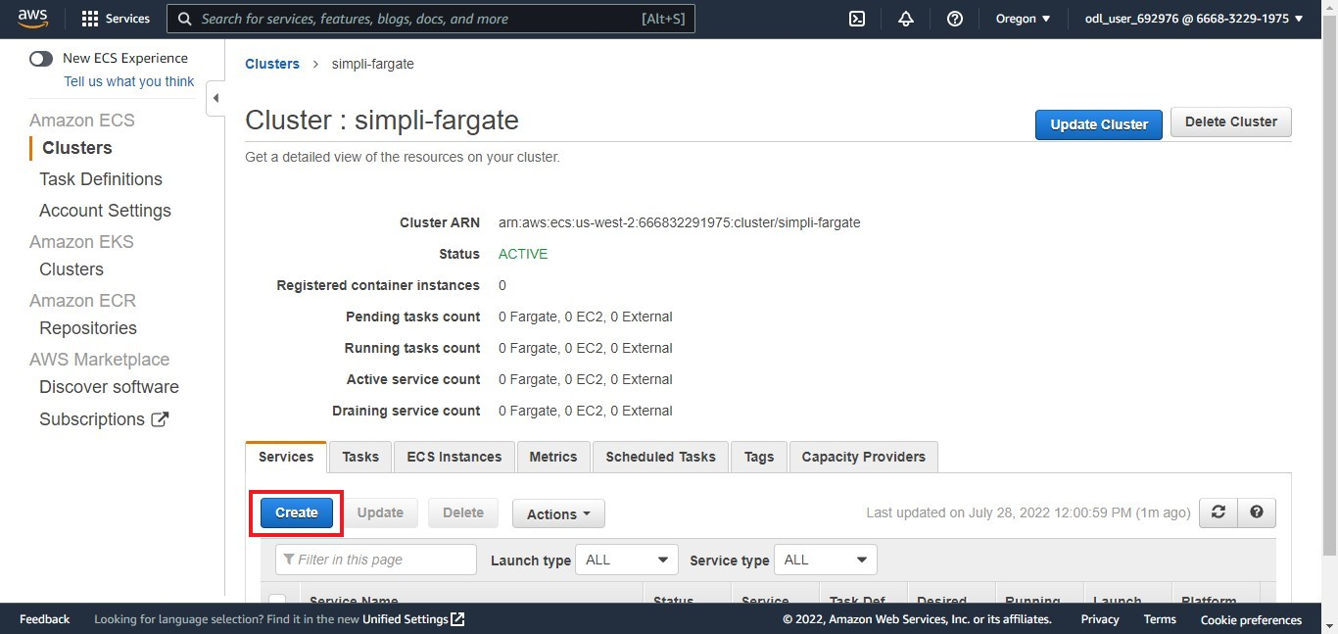

1. Choose **FARGATE** under Launch Type. Enter a service name and enter value **1** for the **Number of Services** Graphical user interface, application

   Description automatically generated

Keep other settings as default and click on Next Step

1. Select the **VPC** and **Subnets** from the drop-down list. Refer to the VPC from the cluster formation page (refer to step number 1.6)Graphical user interface, text, application

   Description automatically generated

Keep the rest of the settings as default then click on **Next Step**

1. Select **Configure Auto Scaling** and enter the following data:

* **Minimum Number of tasks** as **1**
* **Desired number of tasks** as 1
* **Maximum Number of tasks** as **5**

Enter a **Policy name** and set up the **Target value** as **60** then click on **Next Step**

1. Click on **Create Service**

1. Scroll down to the end of the page and click on **View Service**

1. Click on the created cluster name and scroll down to copy its Public IP

3.10 Paste the Public IP in another tab and press **Enter** on the keyboard. You can see the cluster is successfully made and the service is running properly.