**Lesson 10 Demo 6**

**Fargate with an Application Load Balancer**

**Objective:** To deploy tomcat by using Fargate cluster with an application load balancer

**Tools required:** AWS account

**Prerequisites:** NA

Steps to be followed:

1. Create a cluster
2. Create a task definition
3. Create an application load balancer
4. Create a cluster service

**Step 1: Create a cluster**

* 1. 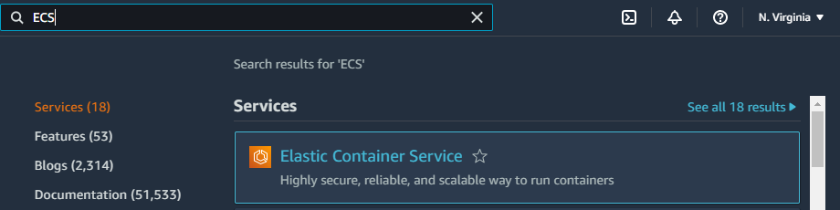In the AWS management console, search for **ECS** and then click on **Elastic Container Service**
  2. In the ECS dashboard, click on **Clusters**

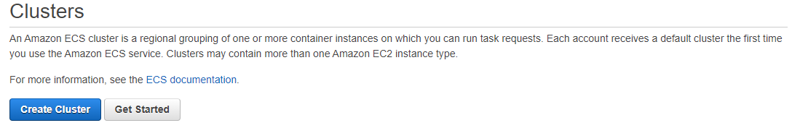 1.3 Click on **Create Cluster**

1.4 In the **Select cluster template** section, select **Networking only**

Then click on the **Next step**

1.5 In the **Configure cluster** section:

* In **Cluster name** enter any arbitrary name for the cluster
* Click on **Create**

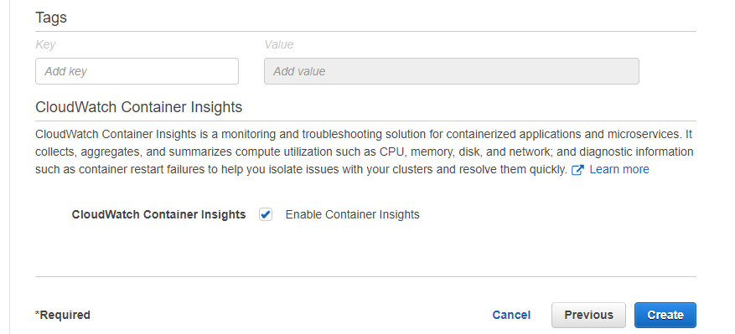

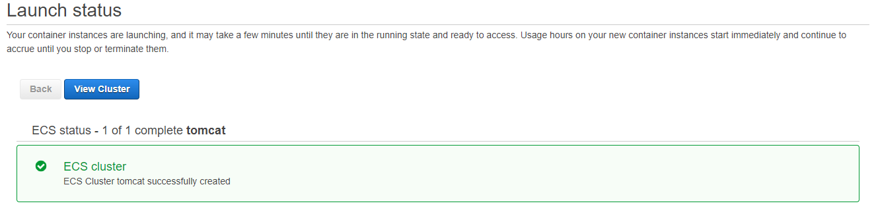 1.6 In the **Launch Status,** click on **View Cluster**

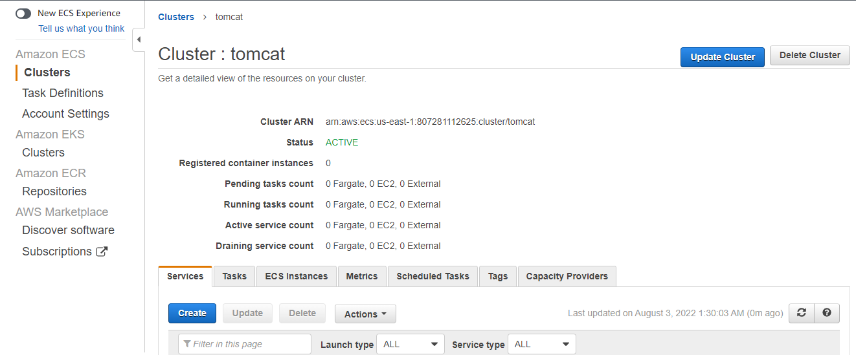

**Step 2: Create a task definition**

2.1 In the ECS dashboard, click on **Task Definitions**

2.2 Click on **Create new Task Definition**

2.3 In **Select launch type compatibility**, select **EC2**

Then click on the **Next step**

2.4 In the **Configure task and container** **definition**, do the following:

* Add an arbitrary name for the Task Definition in the **Task definition name**
* In **Task memory(GB)** select **0.5 GB** and **0.25 vCPU** in **Task CPU(vCPU)**
* Graphical user interface, text, application, email

  Description automatically generatedClick on **Add Container**

2.5 In the Add container console, do the following:

* Enter an arbitrary name for the container in the **Container name**
* Enter **tomcat:9.0** in **the image**
* Enter **8080** in **Port mappings**,then click on **Add**

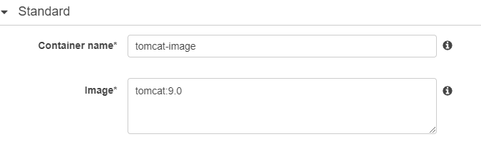

2.6 Click on **Create** in **Configure task and container** **definition** console

Then click on **View task definitions**

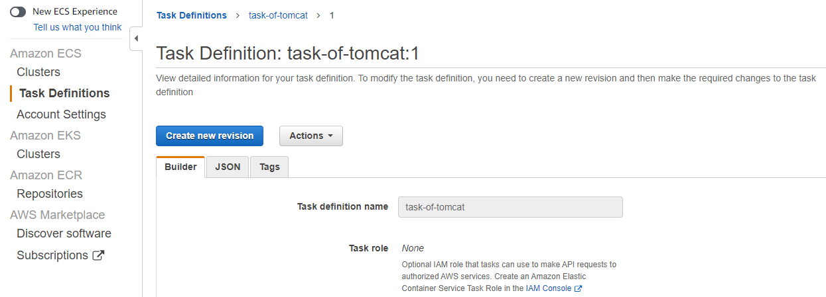

**Note**: Leave this tab as it is, and open a duplicate tab of this tab to perform further steps

**Step 3: Create an Application Load Balancer**

3.1 On the left pane of the **EC2 console**, click on **Load Balancer**

3.2 In the **Load Balancer Dashboard**, click on **Create Load Balancer**

3.3 In the **Load balancer types,** select **Application Load Balancer**,then click on **Create**

* 1. In the **Basic configuration** section, do the following:
* Enter an arbitrary name for the load balancer in the **Load balancer name**
* In **Network mappings**, keep **VPC** as default and select all the **Availability Zones**

* 1. In the **Security Group** section, do the following:
* Delete the **default security group**
* Graphical user interface, text, application, email

  Description automatically generatedClick on **Create new security group**

* Enter an arbitrary **Security group name** and **Security group description**

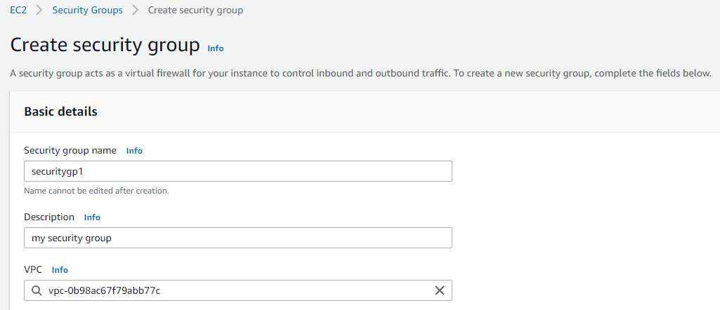

* Click on **Add rule** in Inbound rules

* 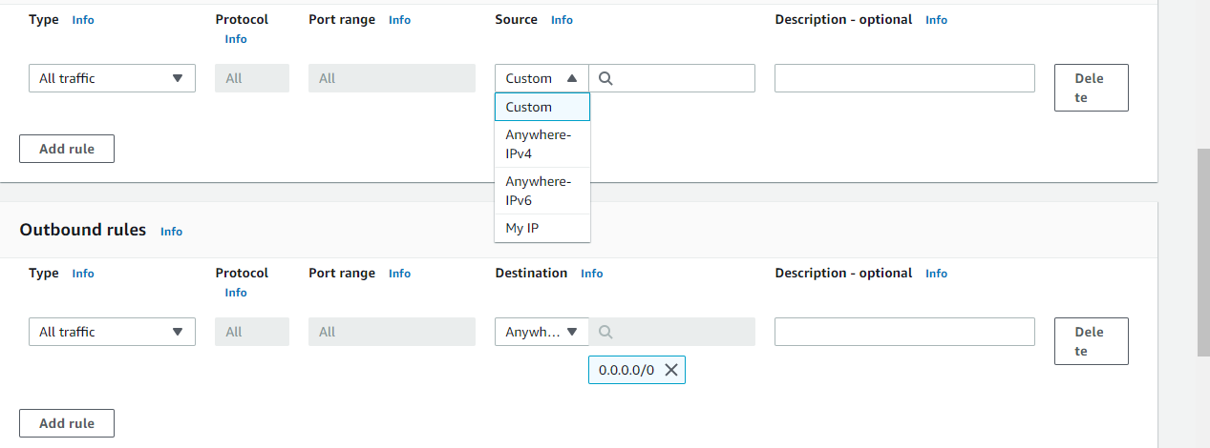Select All traffic in **Type** and **Anywhere** in Source

* Similarly, in **Outbound rules,** select **All traffic** in **Type** and **Anywhere** in **Destination** (if in case the outbound rule is empty like an inbound rule)

* Click on **Create security group**

* 1. Once the security group is created, add that group to the **Security groups** of the load balancer

* 1. In the **Listeners and routing** section, click on **Create target group**

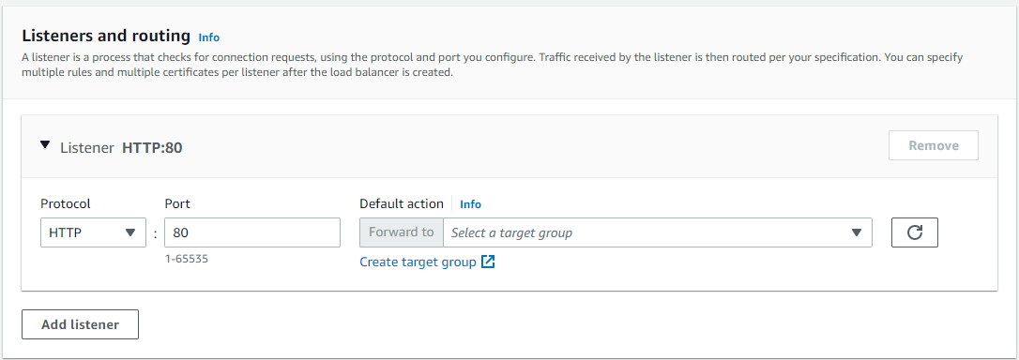

3.9 In the **Choose target type** section, select **Instances**

* In the **Target group name** section give an arbitrary **name** to the target group

* Graphical user interface, text, application, email

  Description automatically generatedNow click on **Next**

* Graphical user interface, text, application, email

  Description automatically generatedAfter clicking on **Next** the Target group will be successfully created:

Now close your target group tab and go back to the Load balancer console

3.10 Add this target group to your **Default action**

* Click on **Create load balancer**

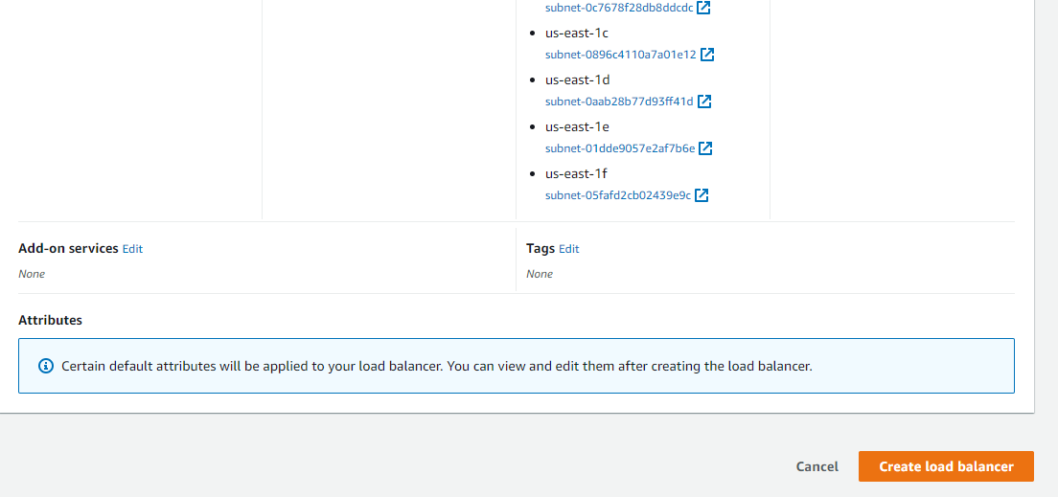

* Now, click on **View load balancer:**

Now click on **View load balancer**

3.11 In the **Load Balancer dashboard**, go to the **Listeners** tab and select the **HTTP:80**,thenclick on **delete**

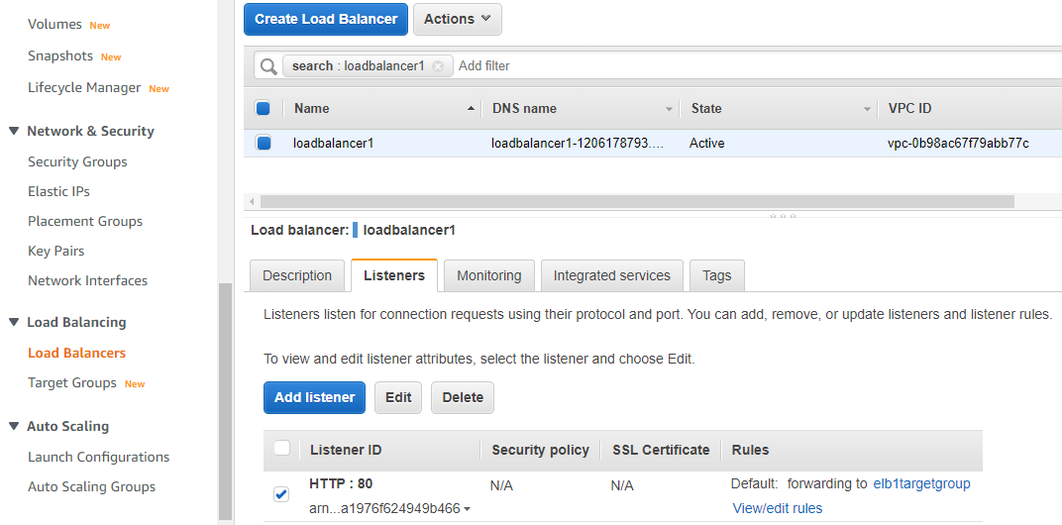

3.12 Similarly go to the **Target Groups** console and **Delete** the target group created in step

Now go back to your **Cluster dashboard**

**Step 4: Create a cluster service**

4.1 In the cluster dashboard, go to the **Services** tab, then click on **Create**

4.2 In the **Configure service** section, do the following:

* Select **FARGATE** as **Launch type**

* Enter an arbitrary name in the **Service name**
* Enterthe **Number of tasks** as **2**,and **the Minimum healthy percentage** as **2**

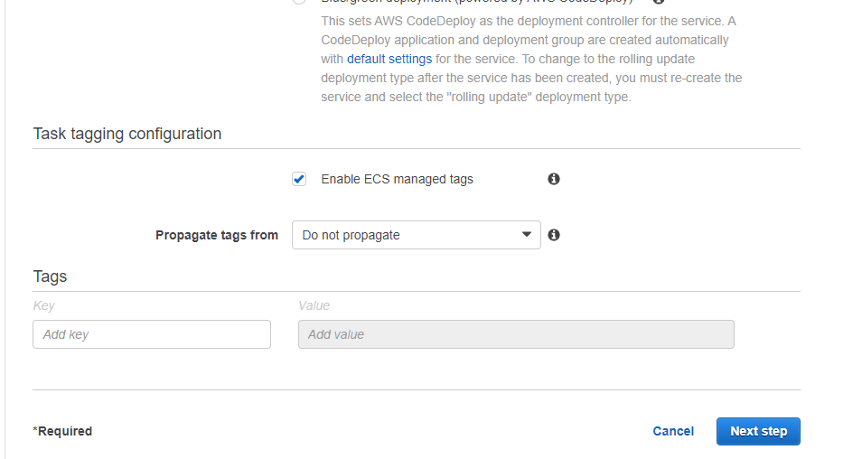 Click on the **Next step**

4.3 In the **Configure network** section, do the following:

* Add all the 6 subnets present in the **Subnets** dropdown list

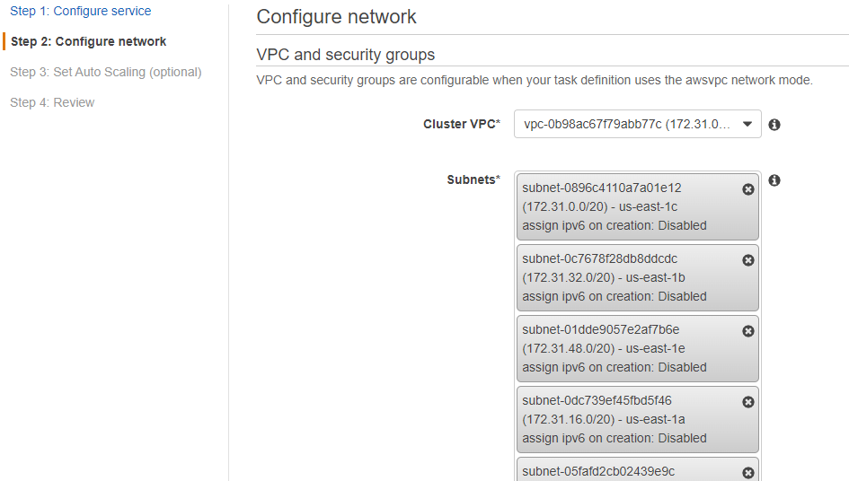

* Click on **Edit** in **Security groups**

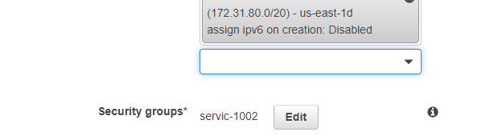

* Select **Create new security group** in **Assigned security groups** and then click on **Add Rule**

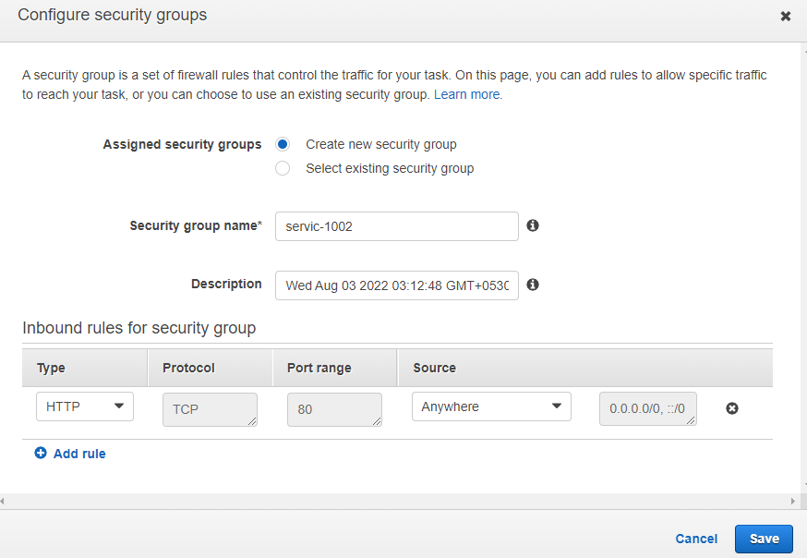

* Select **Custom TCP** in **Type**
* Enter **8080** in Port Range
* Select **Source group** in **Source** and then select the **Security group id** of the load Balancer

**Note**: Open a duplicate tab, go your load balancer dashboard, and from there check the **Security group** **Id** of the load balancer.

* Click on **Save**

* Select **Application Load Balancer** in **Load balancer type**

* Select the **Load balancer name** which you created in step 3
* Click on **Add to load balancer**

* Enter **8080** in **the Production listener port**
* Enter an arbitrary name in the **Target group name**

Then click onthe **Next step**

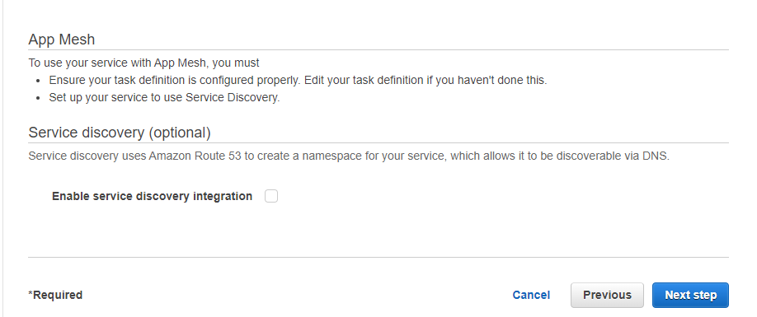

4.4 Select **Do not adjust the service’s desired count** in **Service Auto Scaling**,then click on

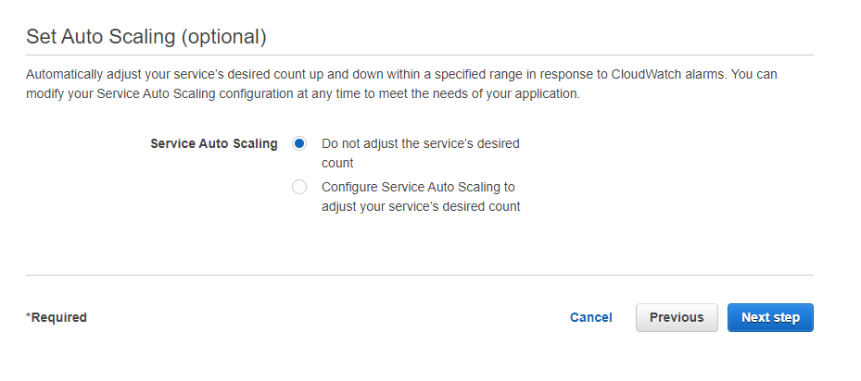the **Next step**

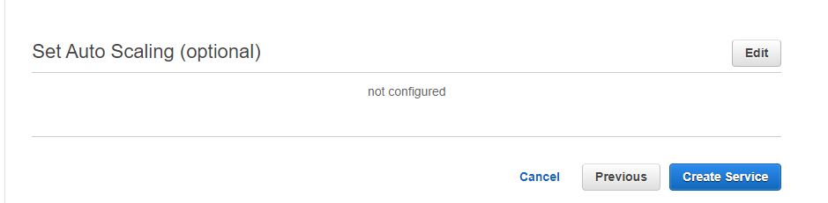4.5 Click on **Create Service**

* Click on **View Service**

* Now you can see that the tasks are running

Hence you have successfully deployed a tomcat app by using AWS Fargate with the

load Balancer.

**Note**: Users can also deploy any other application depending upon the use case.