**Lesson 5 Demo 1**

**How to Create Key Pair for EC2**

**Objectives:** To set up the prerequisites and create Keypair for EC2

**Tools require:** AWS workspace

**Prerequisites:** AWS account

**Steps to be followed:**

1. Creating a keypair for EC2

**Step** **1:** **Setting up the prerequisites for configuring a key pair**

1. Navigate to the AWS portal home screen and click on the Searchtab, click on **EC2**:

1. On the EC2 page, click on **key pairs** under the **Resources**:

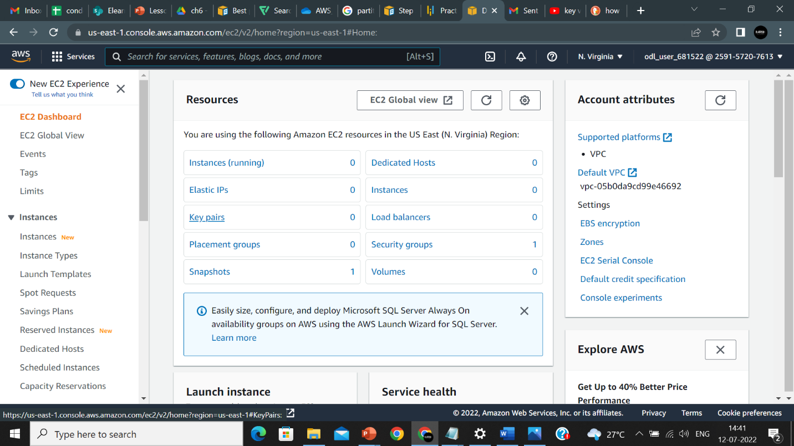

1. In the Key pairs tab, click on the **Create key pair:**

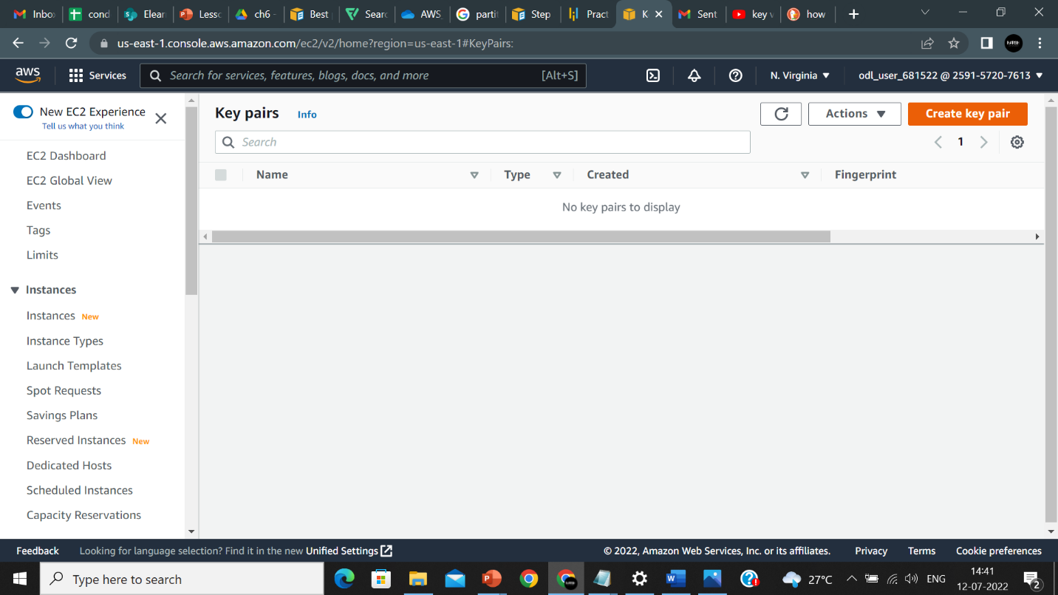

1. On the **create key pair** page, click on the **name,** and name it accordingly, then select the **key pair type** as **RSA** and select **Private key file format**, and select **.ppk** :

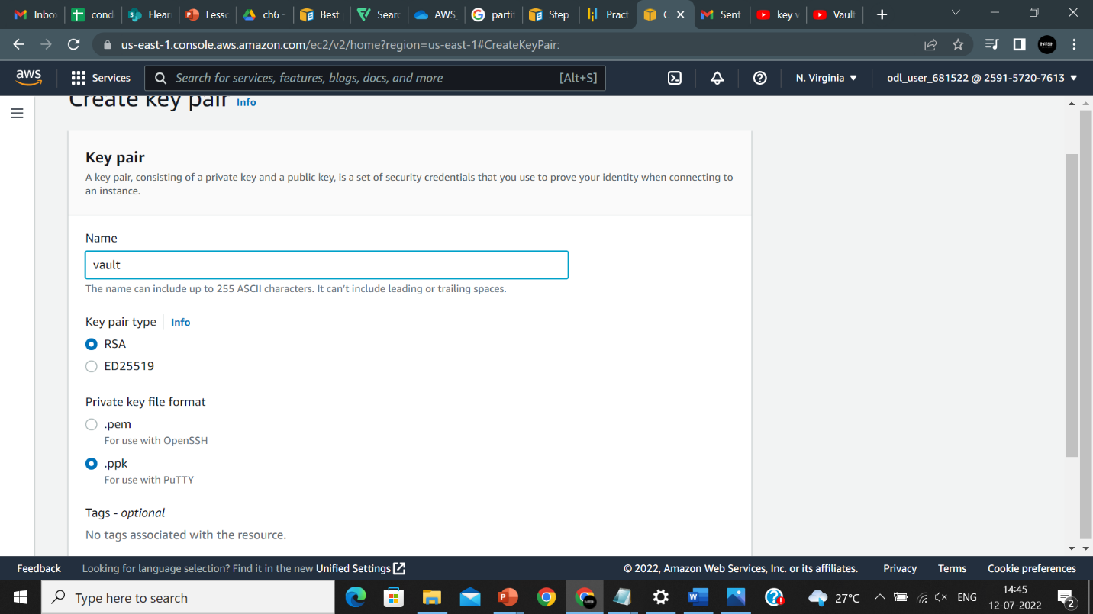

1. Click on **create key pair**:

1. Key pair is created:

