**Lesson 5 Demo 2**

**Create a default VPC**

**Objectives:** To set up the prerequisites and create a VPC

**Tools require:** AWS workspace

**Prerequisites:** AWS account

**Steps to be followed:**

1. Creating a default VPC

**Step** **1:** **Setting up the prerequisites for configuring a VPC.**

1. Navigate to the AWS portal home screen and click on the Searchtab, click on **VPC**:

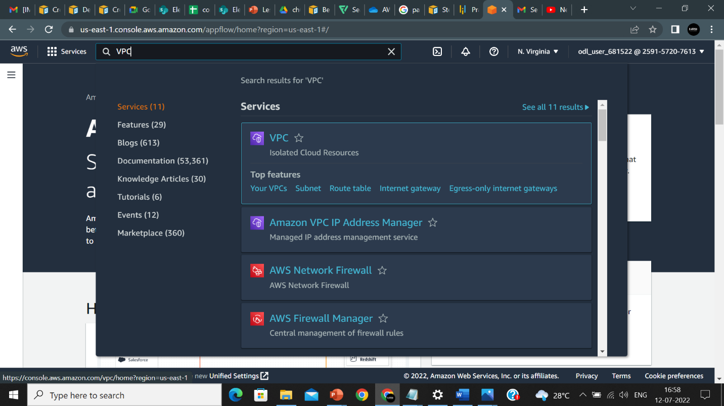

1. On the VPC page, click on **VPCs:**

1. In the **VPC settings** tab, click on the **Name tag** and name accordingly and then select **Ipv4 CIDR** and enter **10.0.0.0.24** in the field**:**

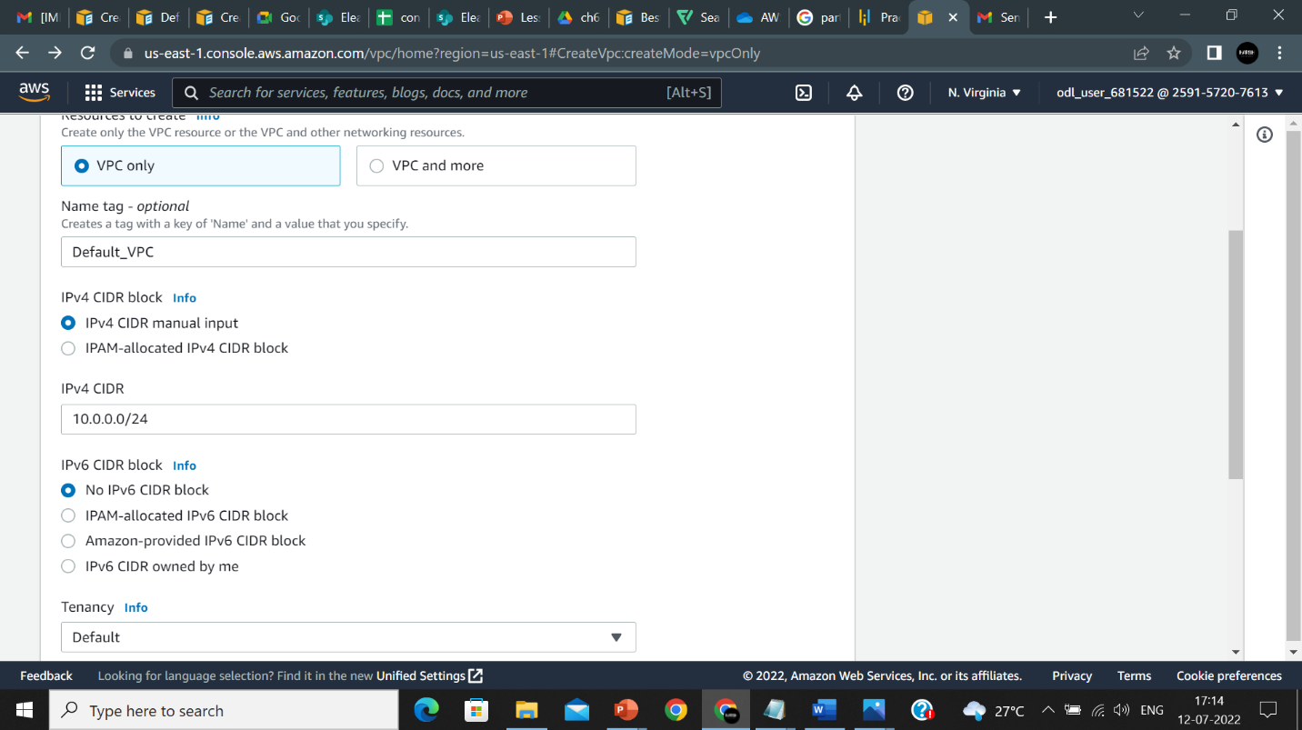

1. Click on **Create VPC:**

1. VPC is created:

