**Lesson 5 Demo 3**

**Explore Network ACL Firewall**

**Objectives:** To set up the prerequisites and explore Network ACL Firewall

**Tools require:** AWS workspace

**Prerequisites:** AWS account

**Steps to be followed:**

1. Creating an NACL.

**Step** **1:** **Setting up the prerequisites for configuring a Network ACL.**

1. Navigate to the AWS portal home screen and click on the Searchtab, click on **VPC**:

1. On the EC2 page, click on **Network ACLs** under the **Resources**:

1. In the **Network ALCs** tab, click on the **Create network ACL:**

1. On the **Create network ACL** page, click on the **name,** and give the name accordingly:

1. Click on **VPC** and select an option from the dropdown:

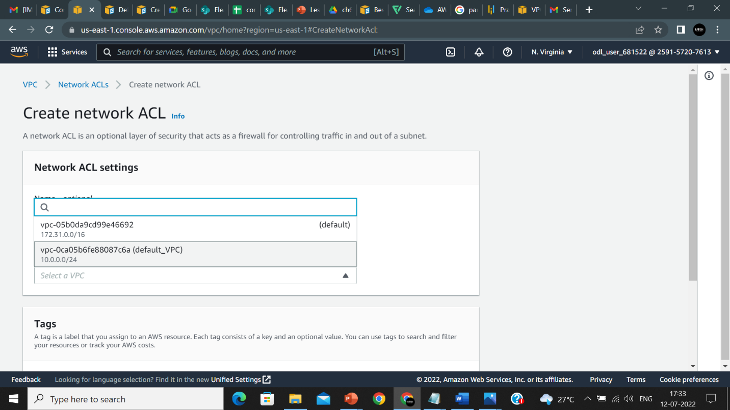

1. Click on **Create network ALC**:

1. The Network ACL is created:

