**Lesson 5 Demo 4**

**Create a VPC Flow Log**

**Objectives:** An S3 bucket is required to create a VPC flow log

**Tools required:** AWS workspace

**Prerequisites:** AWS account

**Steps to be followed:**

1. Create a VPC flow log

**Step** **1:** **Setting up the prerequisites for configuring a table**

1. In the console navigation pane, choose **VPC:**

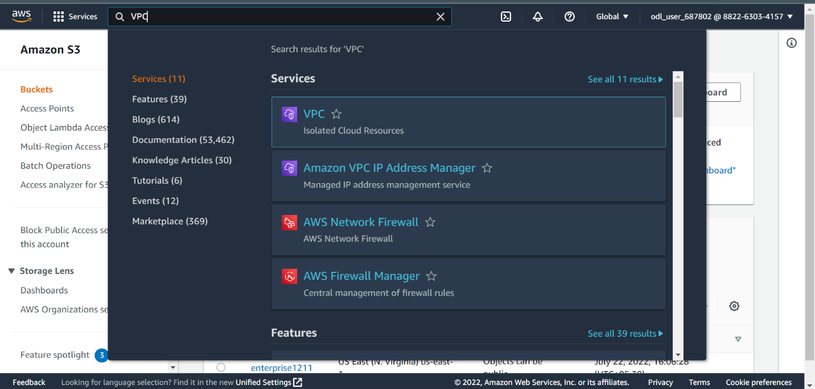

1. On the **VPC** page, click on **VPCs:**

1. Choose **default VPC**:

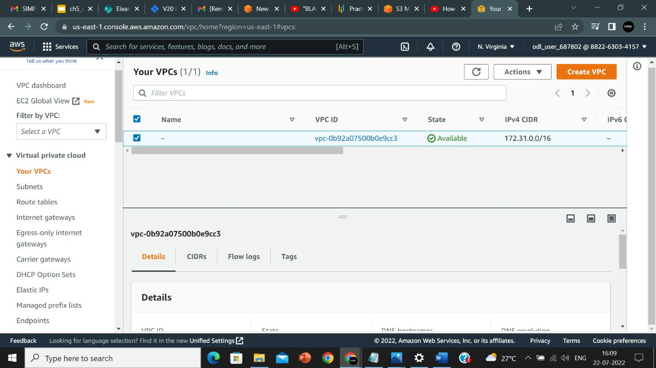

1. In the **Flow Logs** section, click on **Create flow log:**

1. In the **Create flow log** page, provide a **Name**:

1. Select default options:

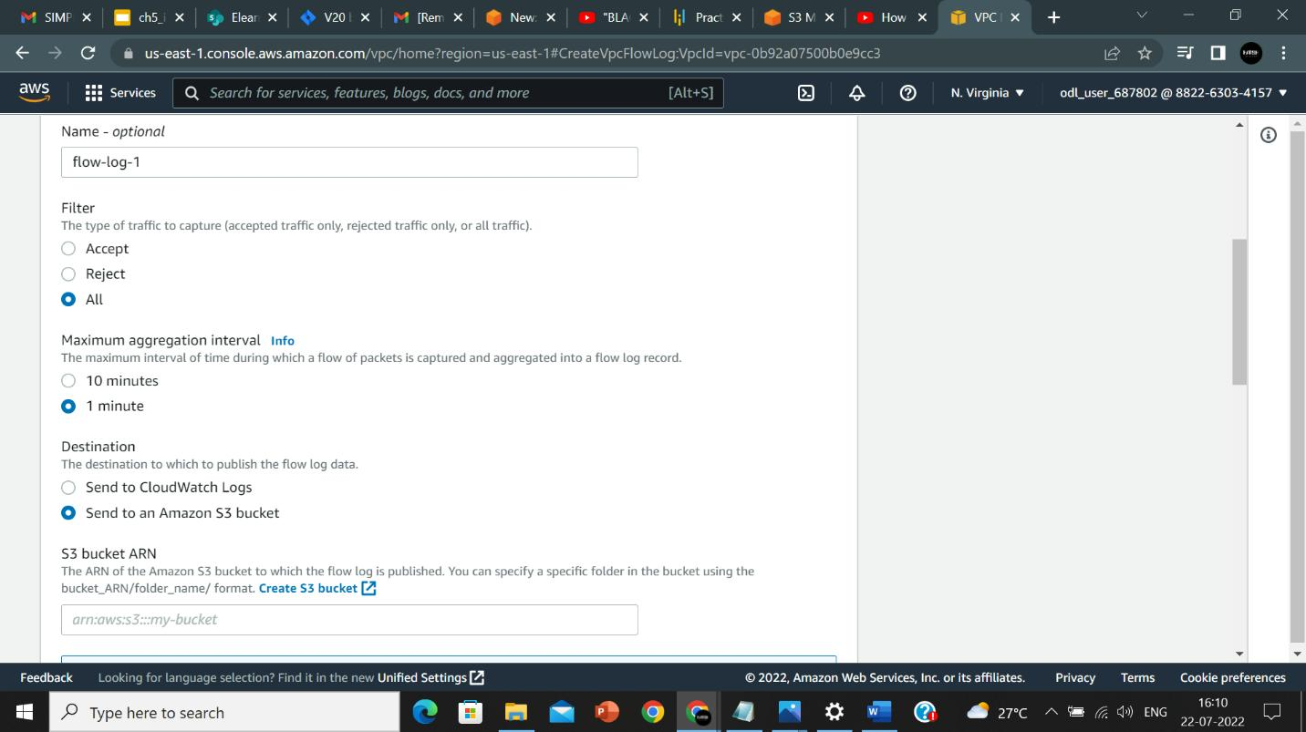

1. For the **S3 bucket ARN**, navigate to S3, select the bucket, and click on **Copy ARN**:

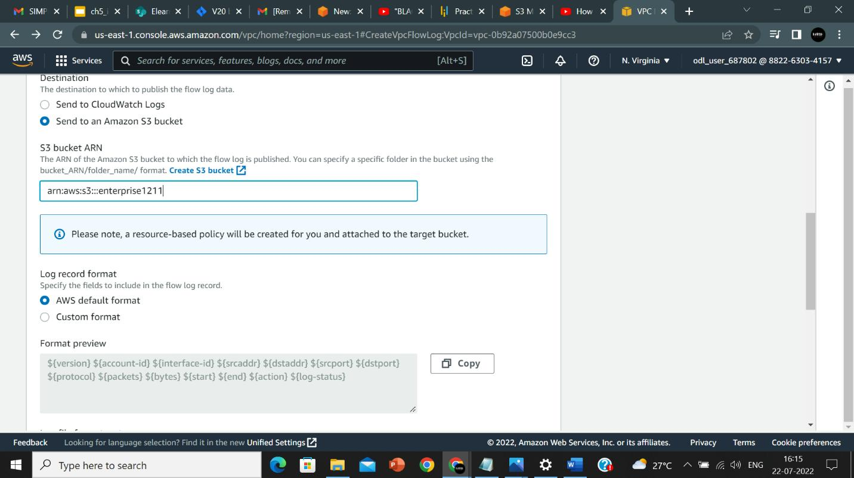

1. Click on **Create flow log:**

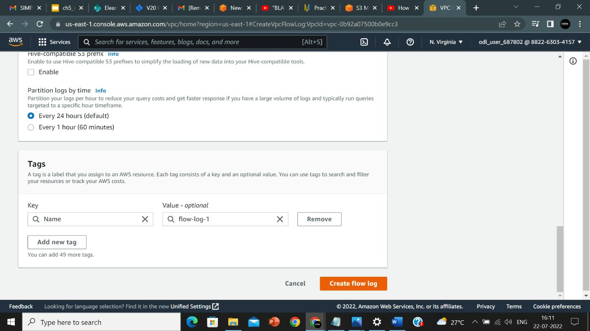

1. The flow log is created:

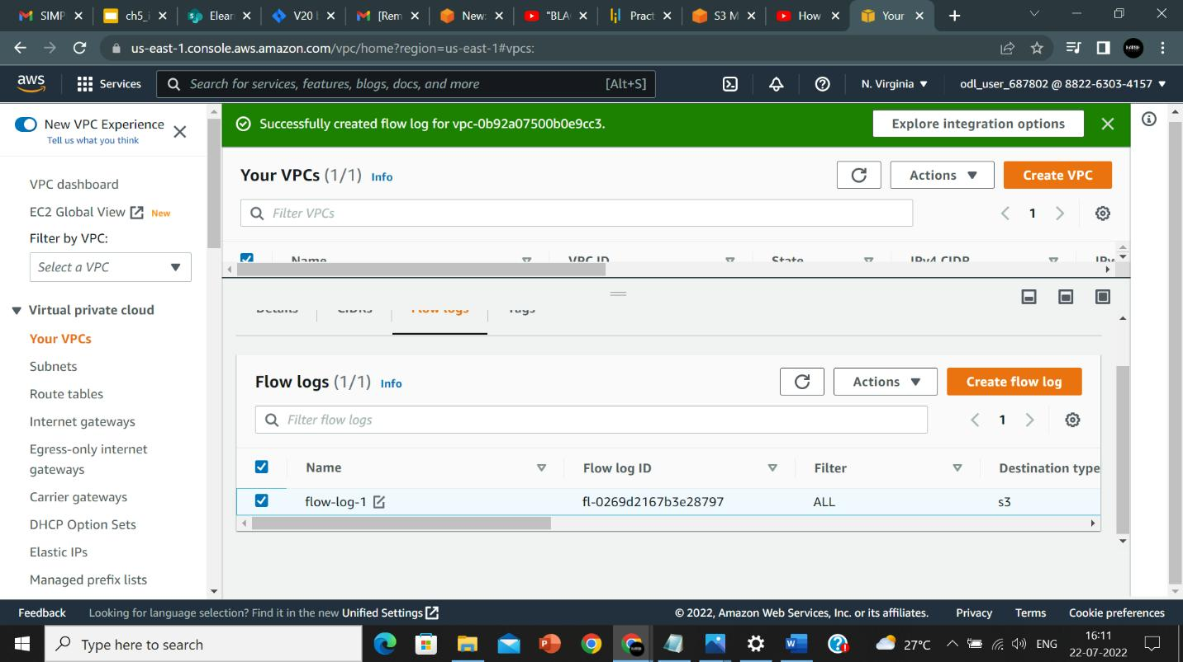

1. To view the flow log in S3, click on the **S3 bucket**, and you can see the flow log folder created in your bucket:

