**Lesson 5 Demo 6**

**Create a Default VPC Flow Logs, Resource Access Management, and NAT Source and Destination Check**

**Objectives:** To create Default VPC flow logs, Resource Access Manager, and NAT Source and Destination Check

**Tools required:** Amazon Workspace

**Prerequisites:** Amazon account

**Steps to be followed:**

1. Setting up the prerequisites for configuring default VPC Flow Logs
2. Creating a Resource Access Manager and NAT Source and Destination Check

**Step** **1:** **Setting up the prerequisites for configuring default VPC Flow Logs**

1. Navigate to the AWS portal home screen and click on the search button in the **CloudWatch** tab:

|  |
| --- |
| Note: The VPC Flow log is explained in the previous demo. Now, let us see how to create a Flow log. |

1. Click on **Log groups:**

1. Click on **Create log group**

1. Create **Log group name** and scroll down:

1. The **Log group** is created successfully**.**

1. Go back to **Your VPCs** and click on **Create flow log**

1. Enter the name and scroll down the page.   
      
     
   A screenshot of a computer

   Description automatically generated
2. Enter the **Destination log group** name and click on set up permission

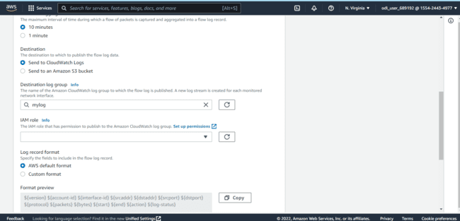

1. By selecting the **IAM role,** scroll down the page and click on create button

1.10 Once the create button is entered, the Flow Log is created successfully.

**Step 2: Creating a Resource Access Management and NAT source and destination check**

1. Enter **Resource Access Manager** on the search tab:

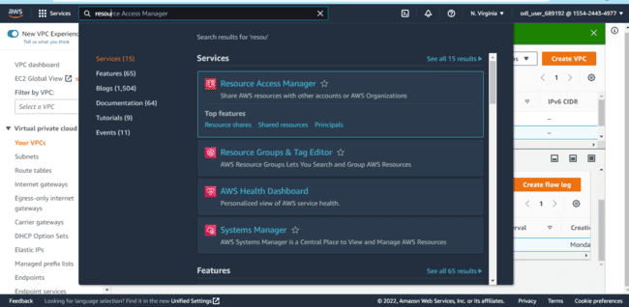

1. Now, click on **Create a** **resource share**

1. Enter the **Resource name** and select the subnets and the **Resource ID**. Scroll down and click on the **Nex**t button:  
     
   Graphical user interface, text, application, email

   Description automatically generated Graphical user interface, text, application, email

   Description automatically generated 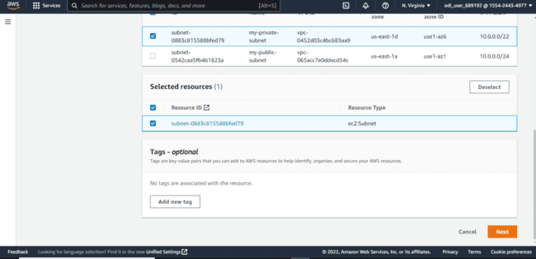
2. Now, on another page, enter the **Next** button again

1. Review and scroll down

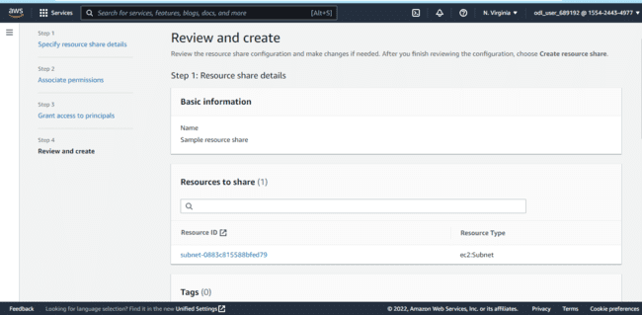

1. Enter the **Create resource Share** button

1. The **resource Share** has been created successfully

1. Enter **EC2** in thesearch tab and enter:

|  |
| --- |
| Note: The Launch Instance is already in the previous demos. Kindly check and see the further steps to NAT source and destination check. |

1. Select any **Launch Instance** in the list of launch instances

* 1. Go to tab **Actions** and select **Networking**

2.11 Next, select **Change** **source/destination check**

2.12 Tick the **Stop** button and click on **Save**

1. The source and destination check has been disabled for the selected instance:Graphical user interface, text, application

   Description automatically generated
2. Again unselect the Stop button and save the changes:A screenshot of a computer

   Description automatically generated
3. The source and destination check has been enabled successfully:Graphical user interface, text, application

   Description automatically generated