**Lesson 5 Demo 7**

**Create a VPC Endpoint**

**Objectives:** To set up the prerequisites and create a VPC endpoint

**Tools require:** AWS workspace

**Prerequisites:** AWS account

**Steps to be followed:**

1. Create a VPC Endpoint

**Step** **1:** **Create a VPC Endpoint**

1. Navigate to the AWS portal home screen and click on the searchtab, click on **VPC**:

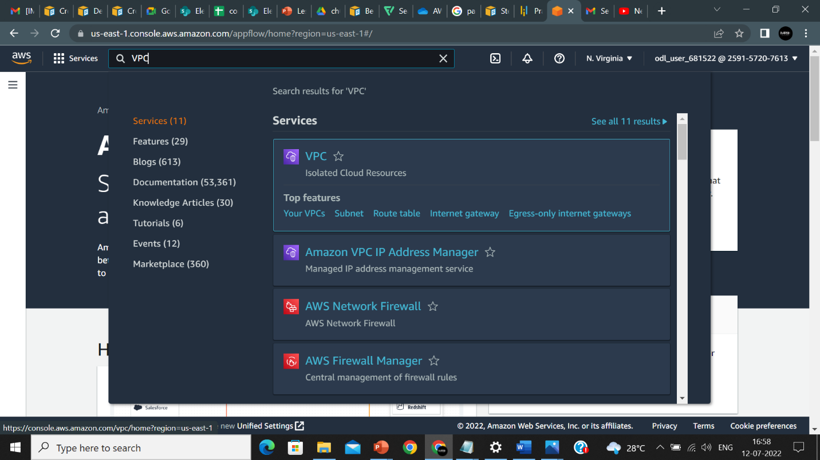

1. On the VPC page, click on **Endpoints:**

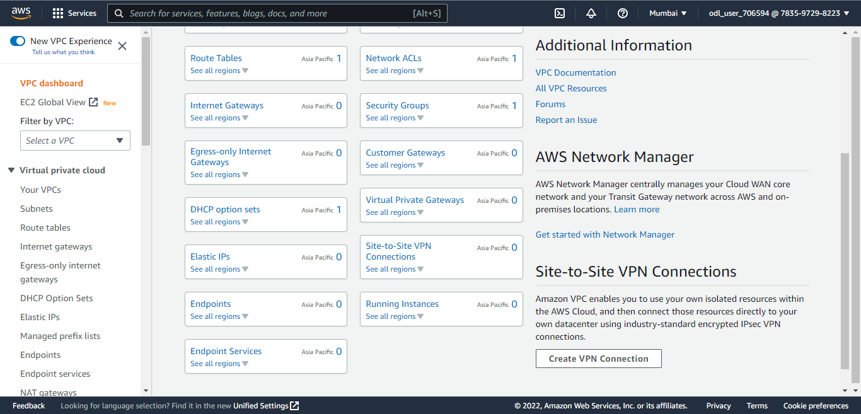

1. Click on **Create endpoint:**

1. Enter name under **Endpoint settings:**

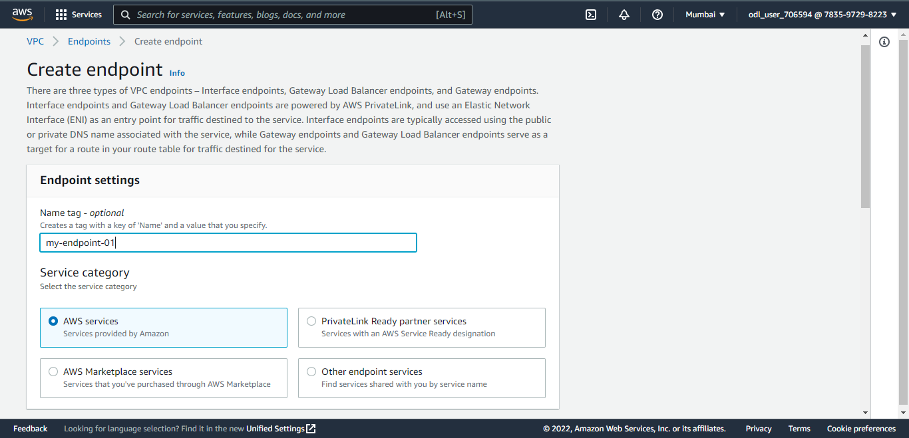

1. Under **Services** search for S3 and choose an S3 option:

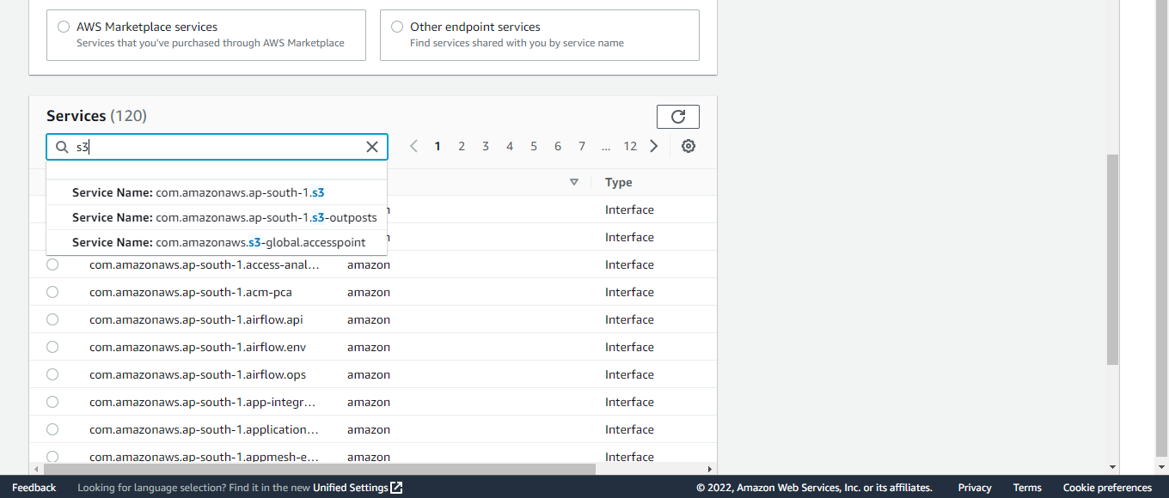

1. Select the VPC and click on **Create endpoint**:

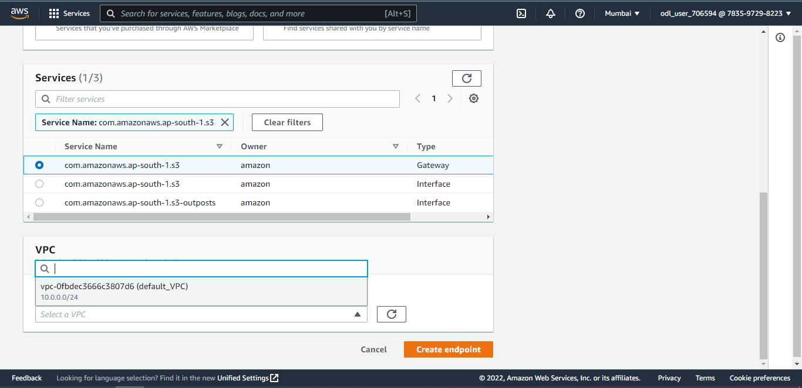

1. Endpoint is created successfully:

