**Lesson 5 Demo 8**

**Peering Connections**

**Objectives:** To connect two VPCs with different regions using Peering connection.

**Tools Required:** AWS account

**Prerequisites:** AWS account.

**Steps to be followed:**

1. Creating two VPCs with different regions
2. Peering connection

**Step** **1:** **Creating two VPCs with different regions**

1. Navigate to VPC in the AWS Management Console.

1. Click on **Create VPC,** enter the **name tag** and **IPV4 CIDR** as shown in the below screenshot:

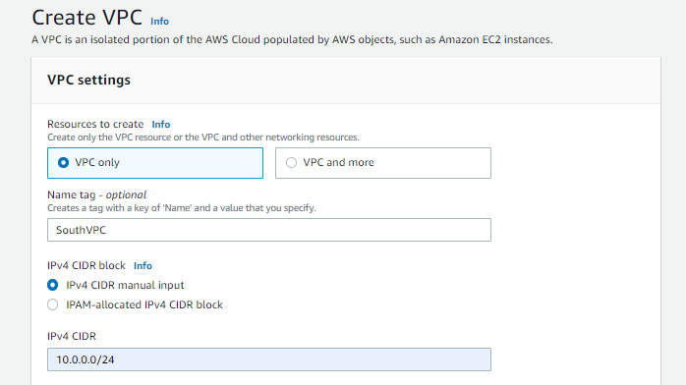

South VPC has been successfully created.

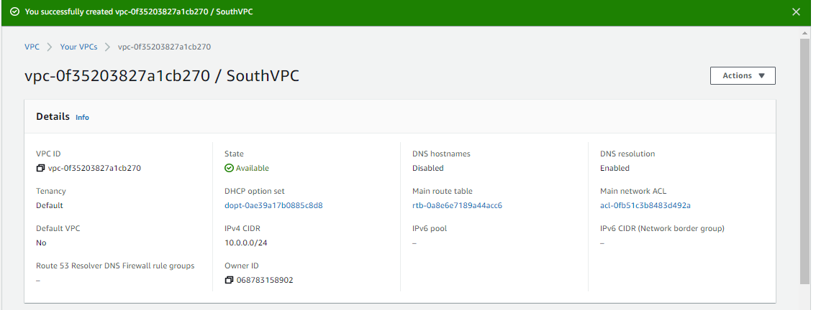

* 1. Repeat the steps from 1.1 – 1.2 by changing the region:



Note: Ipv4 CIDR block number should be different

North VPC has been created successfully.

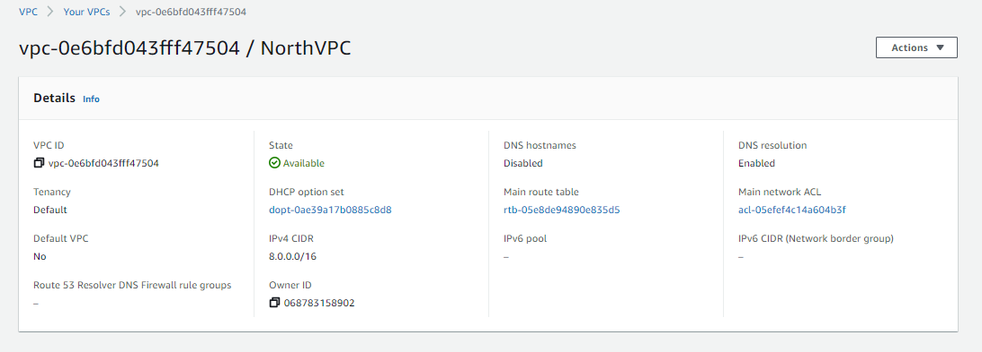

**Step** **2:** **Peering Connections**

1. Navigate to your first VPC, that is **SouthVPC** and select **Peering Connections**.

* 1. Click on **Create Peering connection** and enter the details as shown in the below screenshots:

* 1. VPC peering connection has been requested.

* 1. Navigate to the other VPC and **Accept request**.

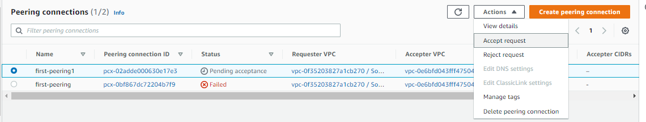

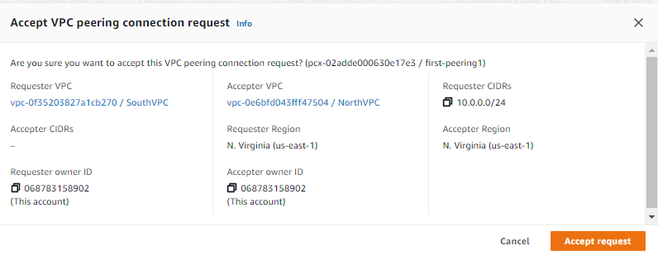

VPC Peering connection has been successfully established.

