**Lesson 5 Demo 9**

**CloudFront Distribution with S3 Origin**

**Objectives:** To host static web content in an Amazon S3 bucket, protected and accelerated by Amazon CloudFront

**Prerequisites:** AWS Lab access with an AWS account created

**Tools Required:** AWS account

**Steps to be followed:**

1. Create S3 bucket
2. Upload a file
3. Configure Amazon CloudFront

**Step 1: Create S3 bucket**

1. Login into the AWS console.

* 1. Search **S3** in the search bar

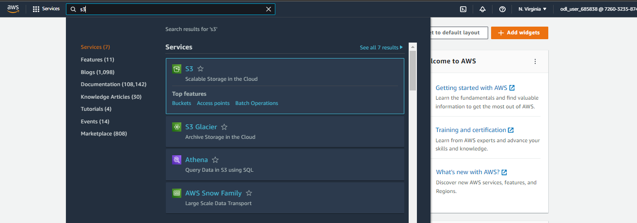

* 1. Click **Create bucket.**

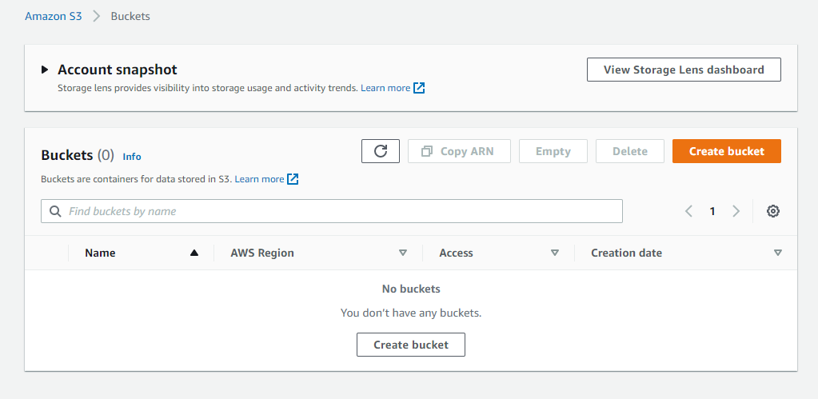

* 1. Add a name for the bucket and **Enable** Bucket Versioning.

* 1. Click **Create bucket.**

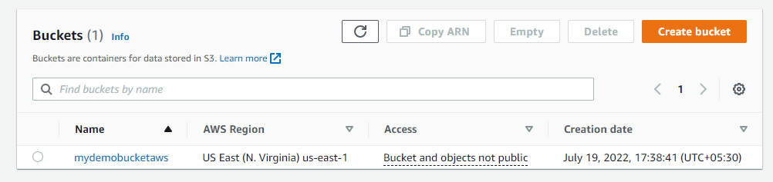

**Step 2: Upload a file**

* 1. Select the bucket created and click the **Upload** option.

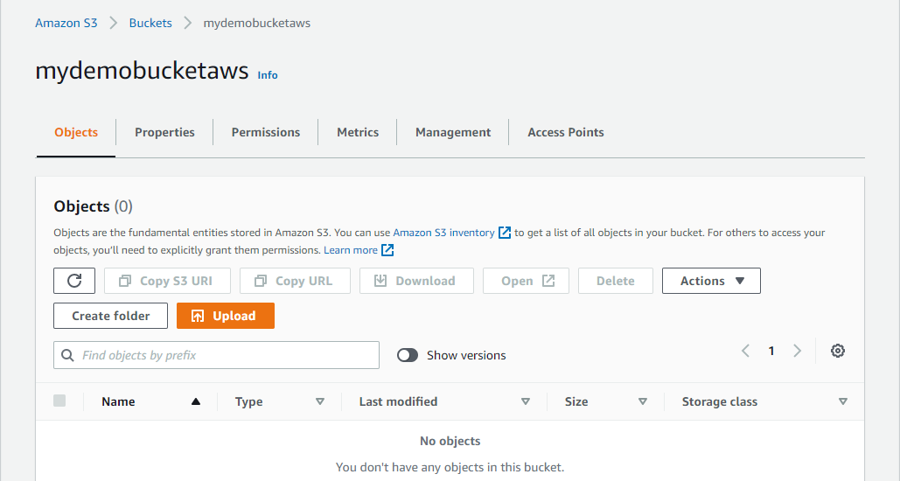

* 1. Click **Add files,** select the html file to upload and click **upload** button.

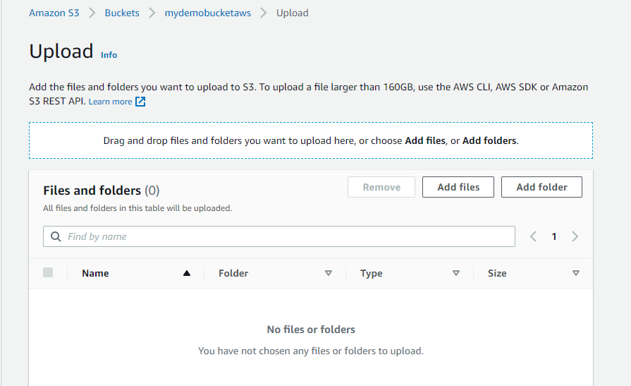

* 1. The uploaded file will appear in the list.

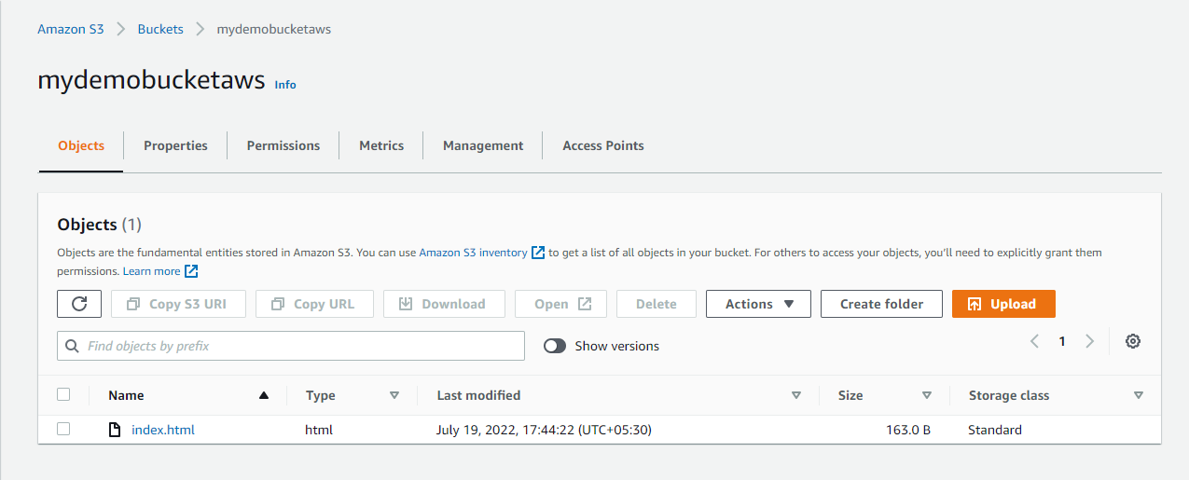

**Step 3: Configure Amazon ClouddoneFront**

* 1. Search Amazon CloudFront in the search bar.

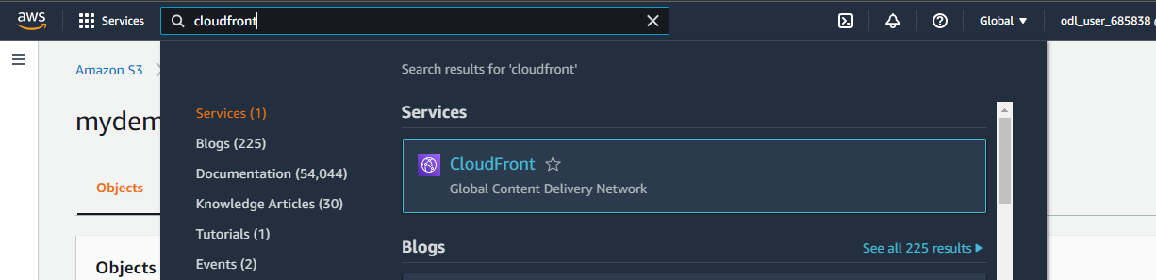

* 1. Select CloudFront and click **Create a CloudFront distribution.**

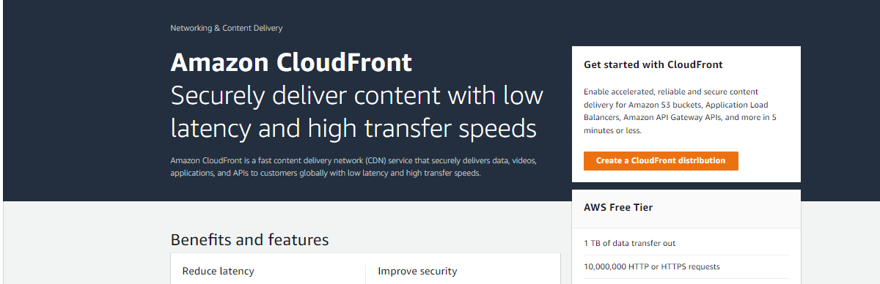

* 1. Select the bucket created in the **Origin Domain Name** field.
  2. Click **yes** button to restrict bucket access and click **Create new OAI.**

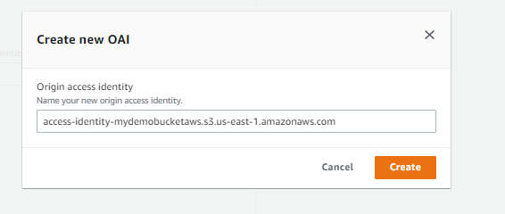

* 1. Click **yes** and **update the bucket policy.**

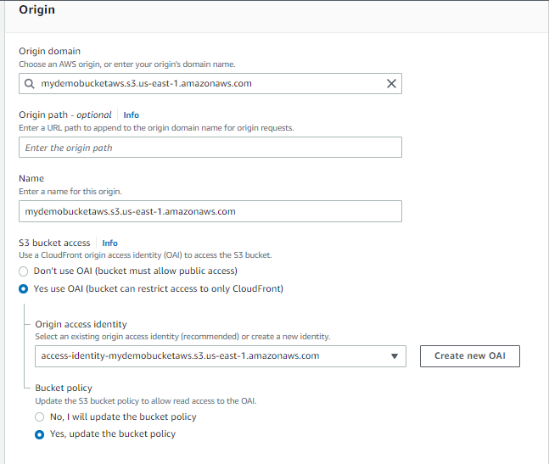

* 1. In Distribution settings, enter **index.html** in the **Default Root Object field.**

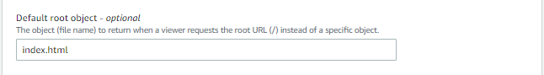

* 1. Click **Create distribution.**

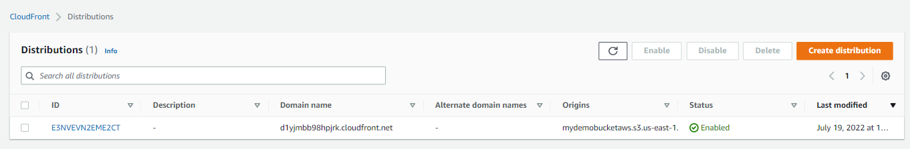

NOTE:Copy the domain name to the web browser to test.