**Lesson 5 Demo 10**

**Cache Configuration and Invalidation**

**Objectives:** To create an S3 bucket, perform distribution and invalidation

**Tools require:** AWS workspace

**Prerequisites:** Create an S3 bucket and have a text file uploaded.

**Steps to be followed:**

1. Create Distributions
2. Create Invalidation

**Step** **1:** **Create Distributions**

* 1. In the navigation console, choose **CloudFront**:

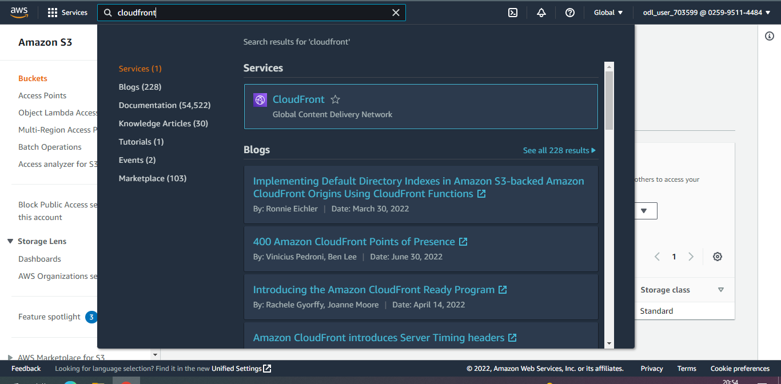

* 1. In **Create distribution,** select your S3 bucket in the **Origin domain:**

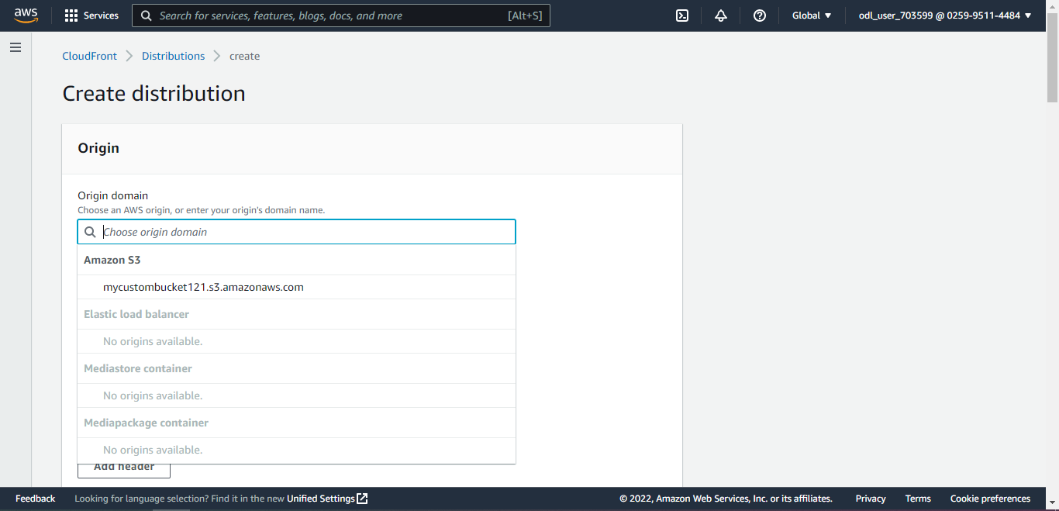

* 1. Choose the default settings and click on **Create distribution**:

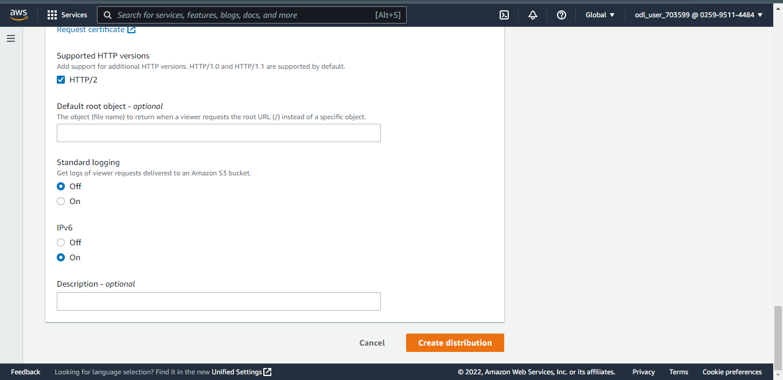

**Step 2: Create Invalidation**

* 1. Select the created distribution and click on **Create invalidation**.

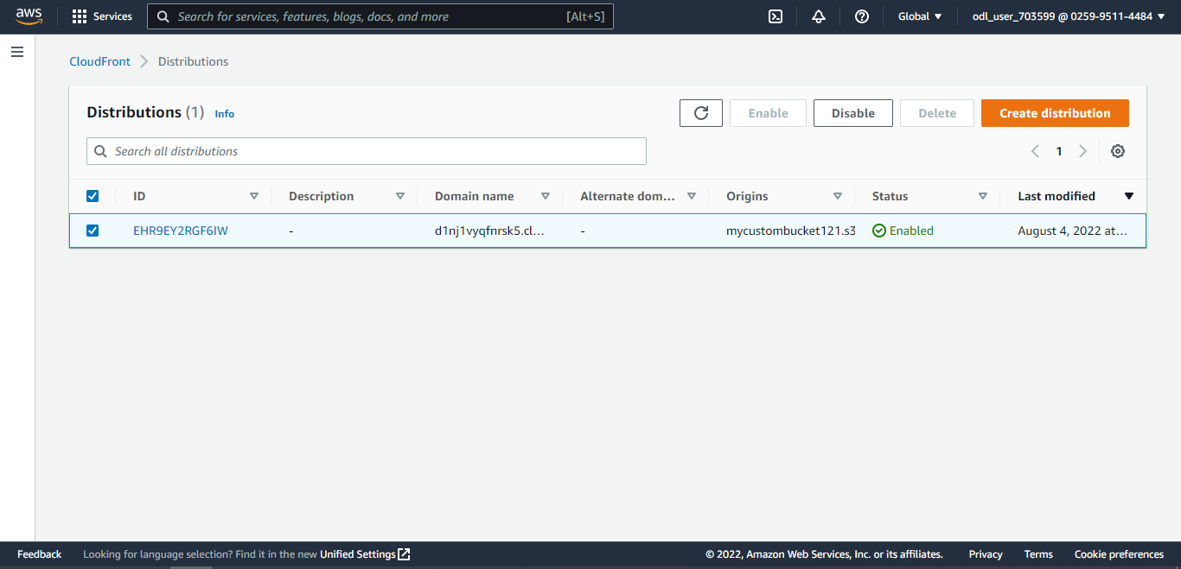

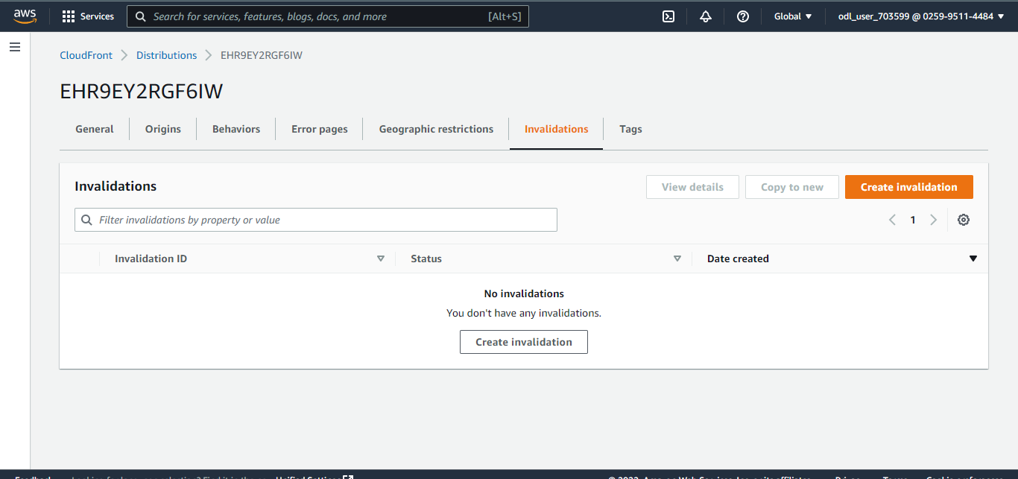

* 1. Enter **/.txt** under **Object paths,** and click on **Create invalidation:**

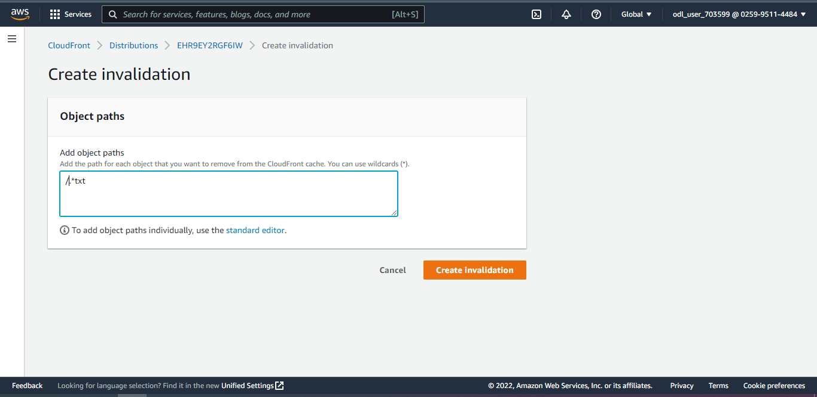

* 1. Navigate to the S3 bucket, select the text file and go to **properties**:

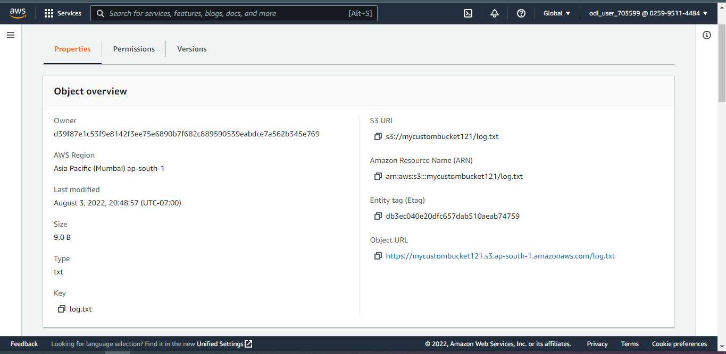

* 1. Under the **properties**, select **Edit metadata:**

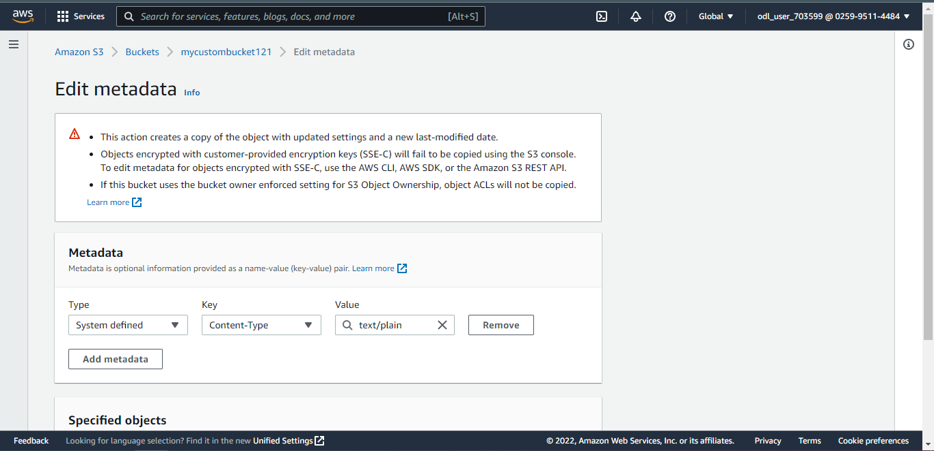

* 1. Click on **Add metadata** and under **Key** choose **Cache-Control**:

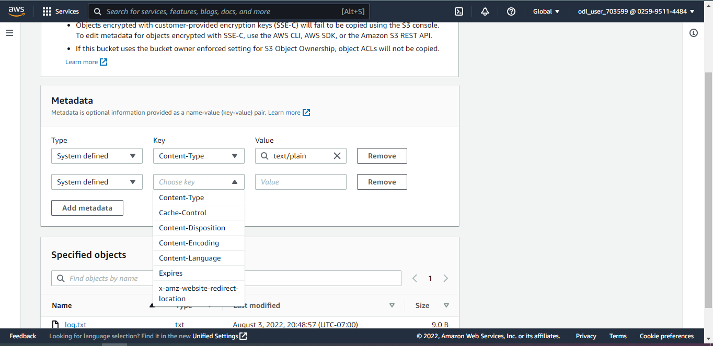

* 1. Enter max-age=300 under **Value** and click on **Save changes:**

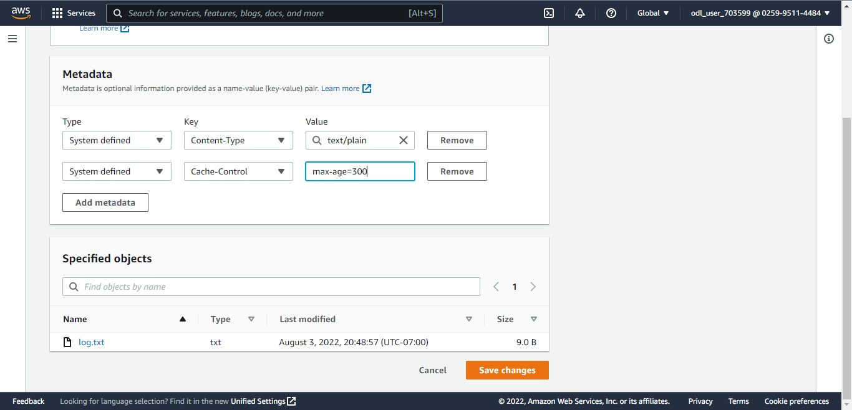

* 1. Navigate back to distribution and copy the **Distribution domain name**:

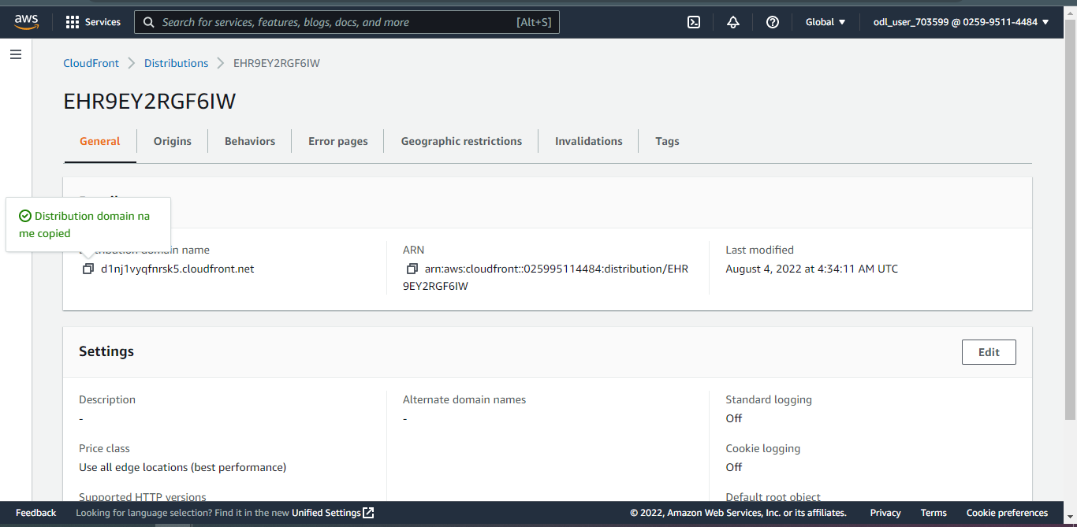

* 1. Open a browser, paste the distribution domain name, add **‘/’** your text file name, and click enter:



* 1. The output of the text file is displayed:

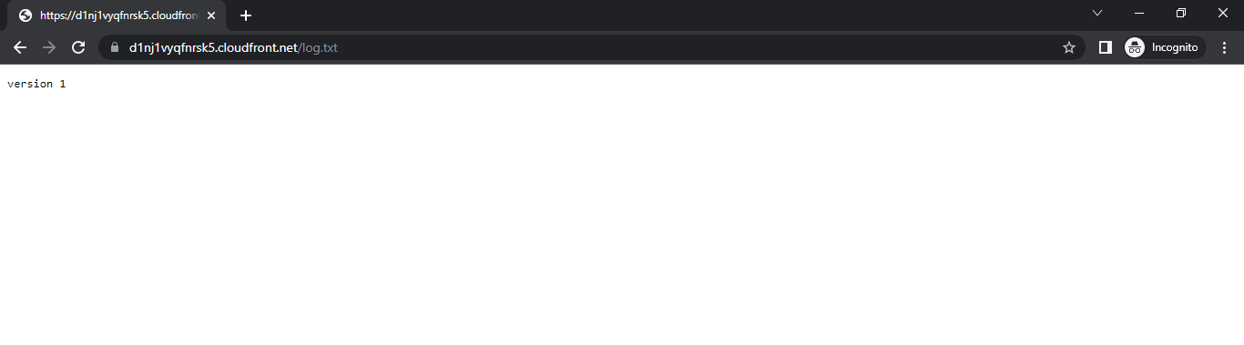

* 1. Open the text file that was created on the local PC and open the file:

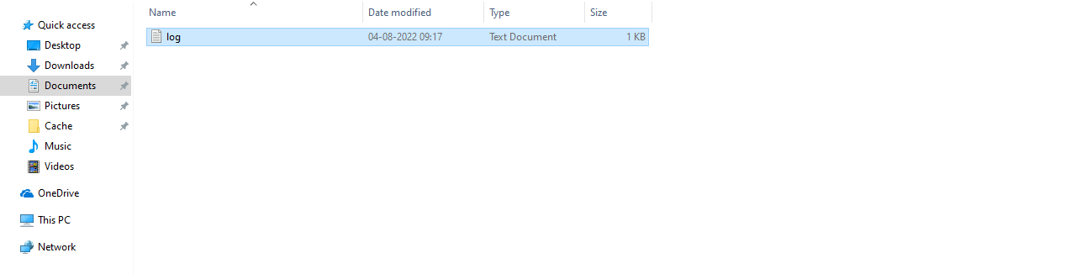

Note: Open the uploaded file in the S3 bucket and edit the file as shown in **2.11**.

* 1. Enter **Version 2 – After the creation of CloudFront** in the text file and save the file:

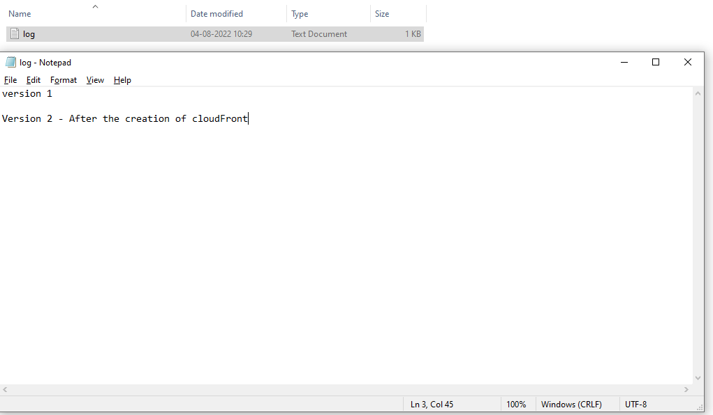

* 1. Upload the text file once again in the S3 bucket and delete the old text file:

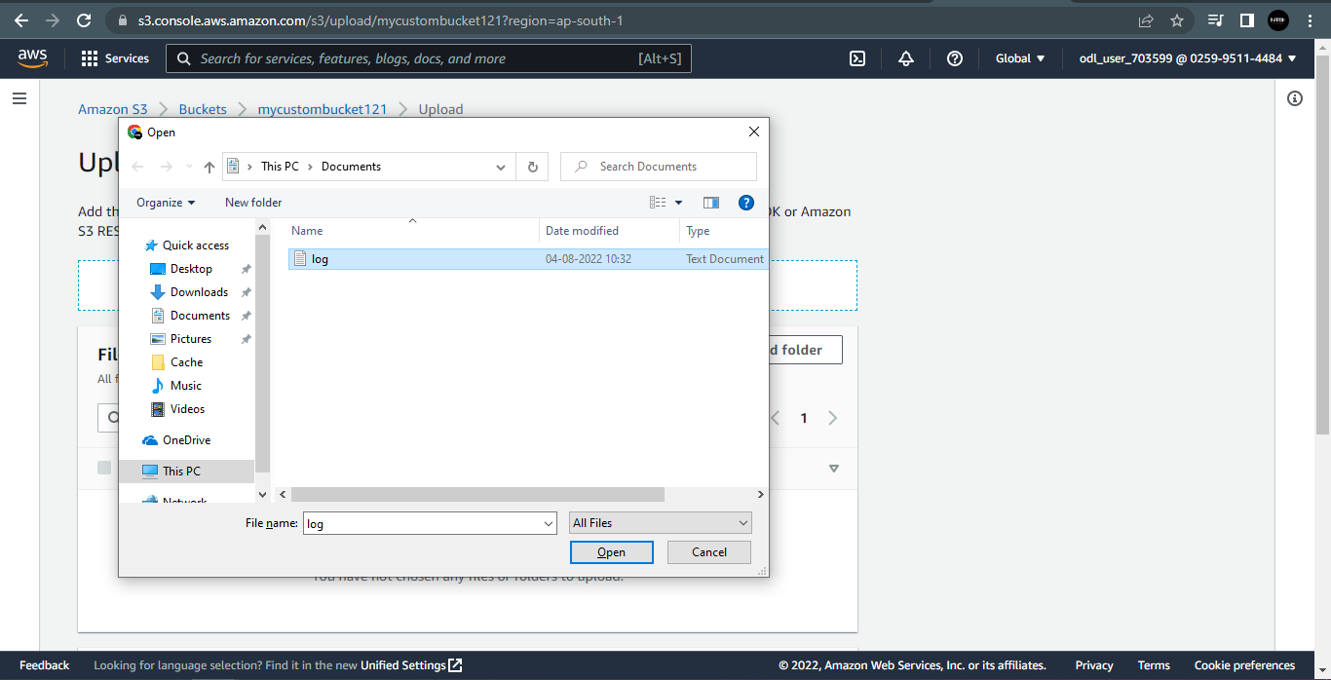

* 1. Repeat steps **2.11** and **2.12** again.
  2. The output of the text file is displayed:

