**Lesson 5 Demo 11**

**Origin Access Identity (OAI)**

**Objective:** To block S3 access for the public and restrict access only through the CloudFront using OAI

**Tools required:** AWS

**Prerequisites:** S3 bucket with an object addedand AWS account with CloudFront Distribution created

**Note**: Refer to Demo 09 of Lesson 5 for the creation of an S3 bucket and CloudFront Distribution

**Steps to be followed:**

1. Restricting the access only through the CloudFront using OAI

**Step 1: Restricting the access only through the CloudFront using OAI**

**Note**:

Public access needs to be blocked while creating an S3 bucket.

* 1. Navigate to the **CloudFront Distribution** created and click on it.

* 1. Go to the **Origins** option.

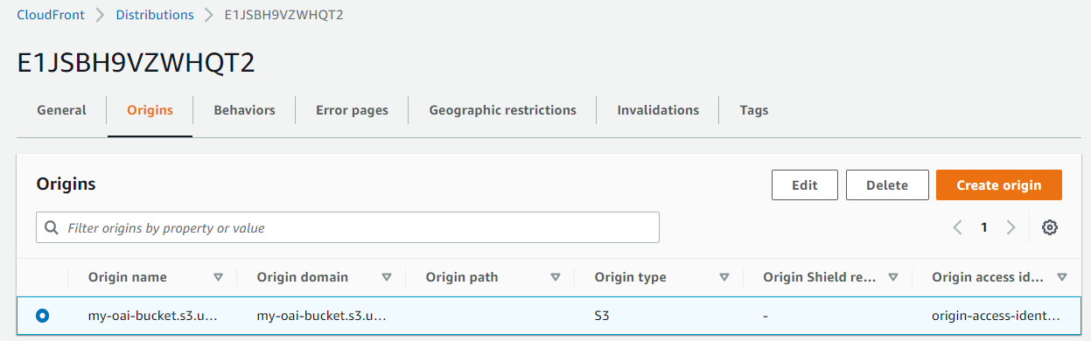

* 1. Click on the **Edit** tab.

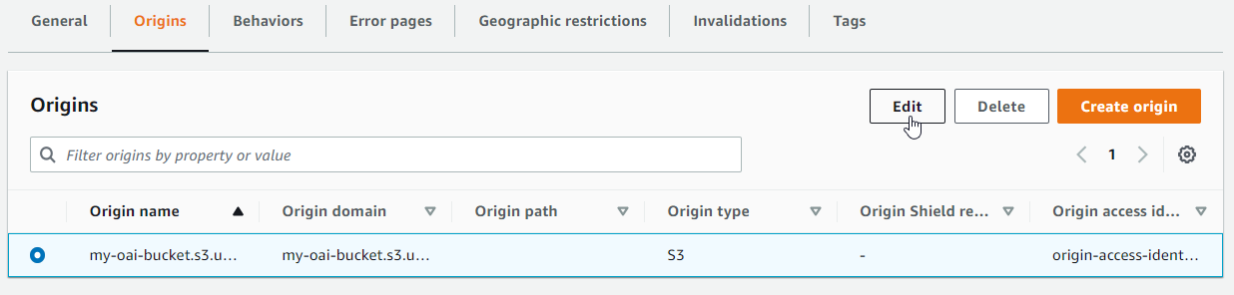

* 1. Select **Yes use OAI** and **Yes, update the bucket policy** options under **the S3 bucket access**.

* 1. Click on the **Save changes** tab.

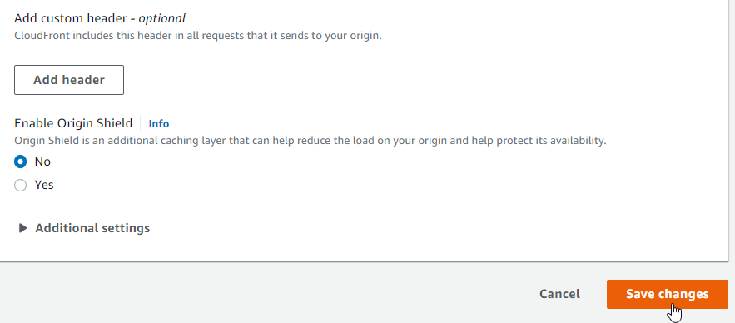

* 1. The **Origin my-oai-bucket** has been successfully updated.

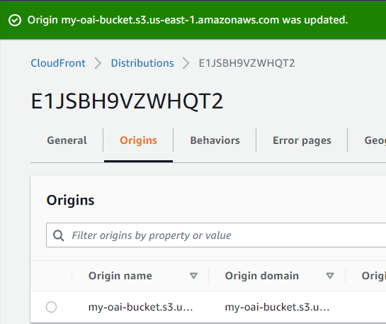

* 1. Copy and paste the **Origin domain name** on a browser.

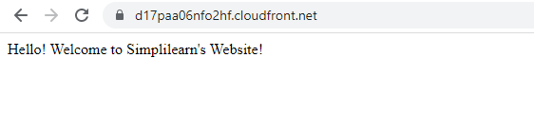

The Origin Access Identity has successfully restricted S3 access by blocking public access.

* 1. To verify if the public S3 access is blocked, copy and paste the S3 bucket domain link into a browser.

**Note**: Please make sure you are disabling the CloudFront Distribution after usage.

