**Lesson 5 Demo 12**

**Create a Global Accelerator**

**Objectives:**  Create a Global Accelerator using an EC2 instance

**Tools require:** AWS workspace.

**Prerequisites:** Create one EC2 instance named final-web-server

**Steps to be followed:**

1. Create an EC2 web Instance
2. Create a Global Accelerator

**Step** **1:** **Create an EC2 web instance**

* 1. Navigate to the AWS portal home screen, in the **Search tab** enter EC2, and click on **EC2**:

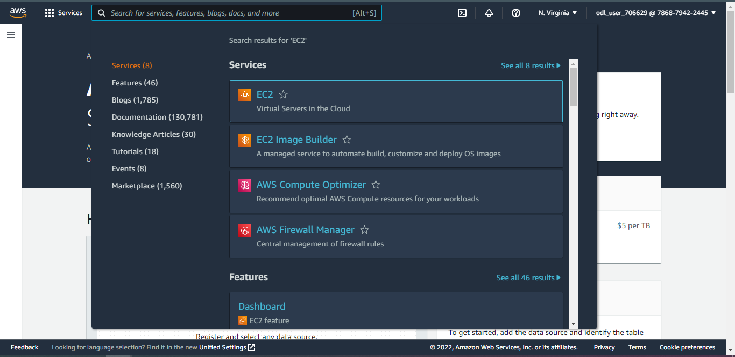

* 1. Click on **Instances:**

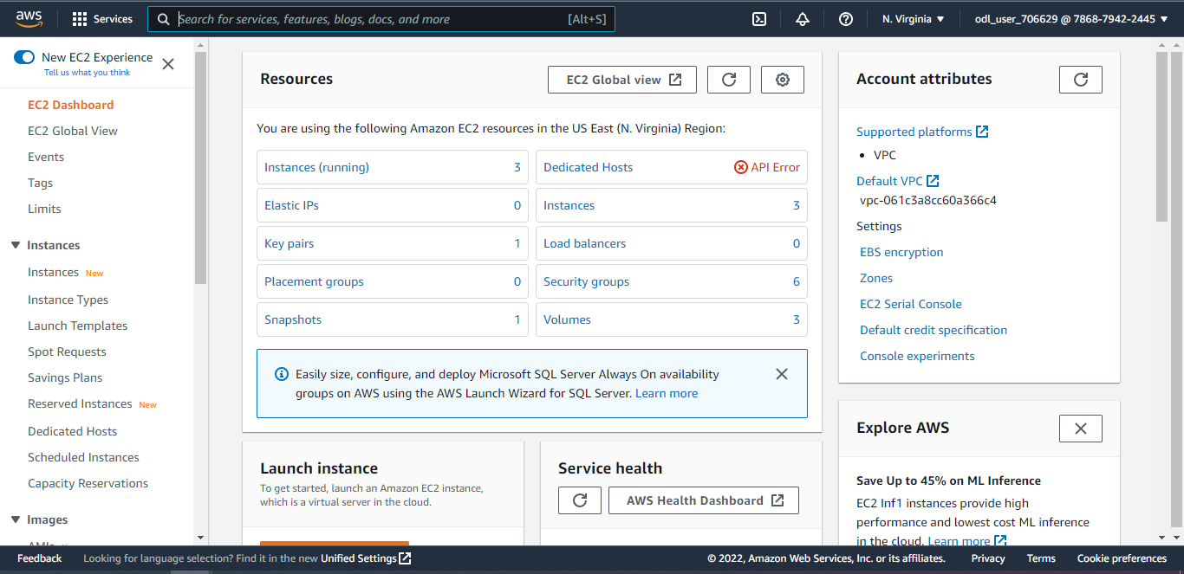

* 1. Click on the instance with the website and copy the **IPv4 address:**

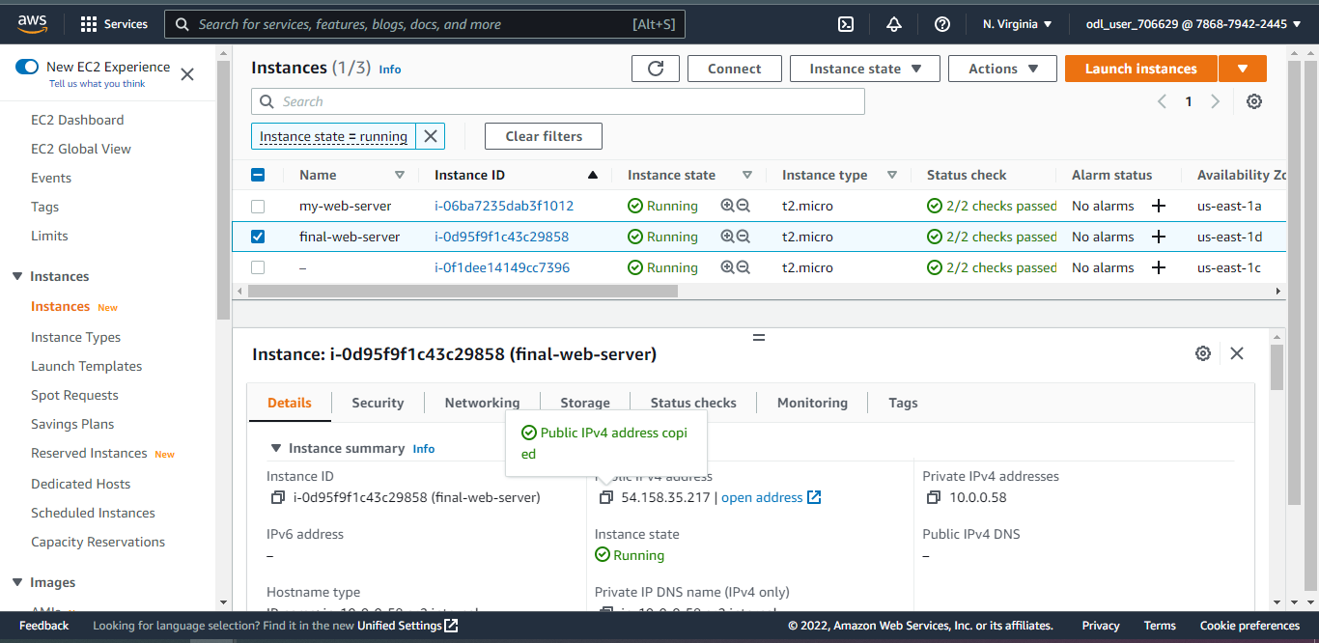

* 1. Open a new browser, paste the IPv4 address and press enter.

Note: This is required for creating a Global Accelerator.

**Step** **2:** **Create a Global Accelerator**

* 1. Navigate to the AWS portal home screen, click on the **Search tab** enter Global Accelerator, and click on **Global Accelerator**:

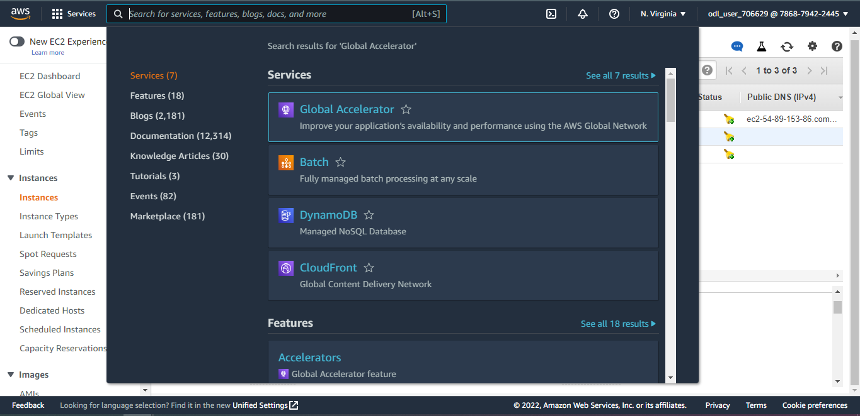

* 1. Click on **Create accelerator**:

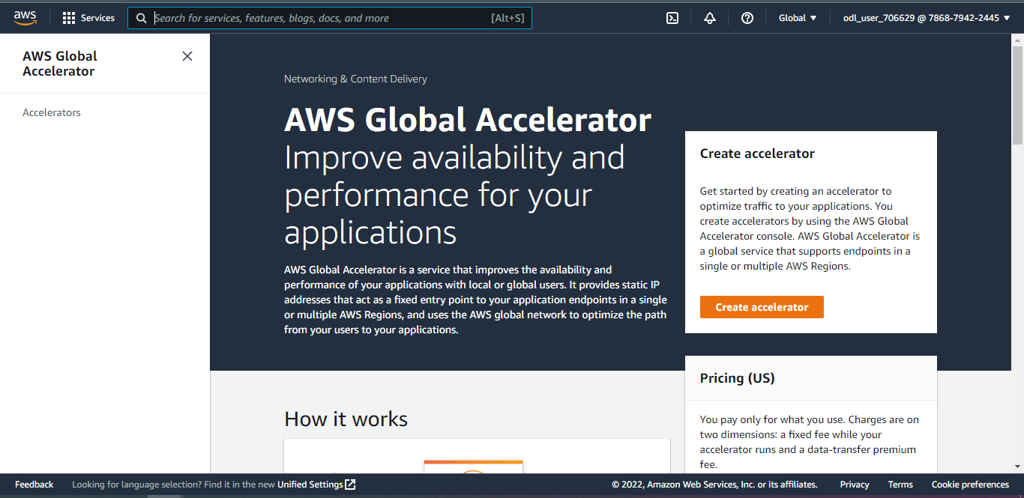

* 1. Enter the name for Accelerator and click on **Next**:

* 1. Enter **80** under **Ports**, select **TCP** under **Protocols**, and click on **Next:**

* 1. Select an **endpoint group** and click on **Next:**

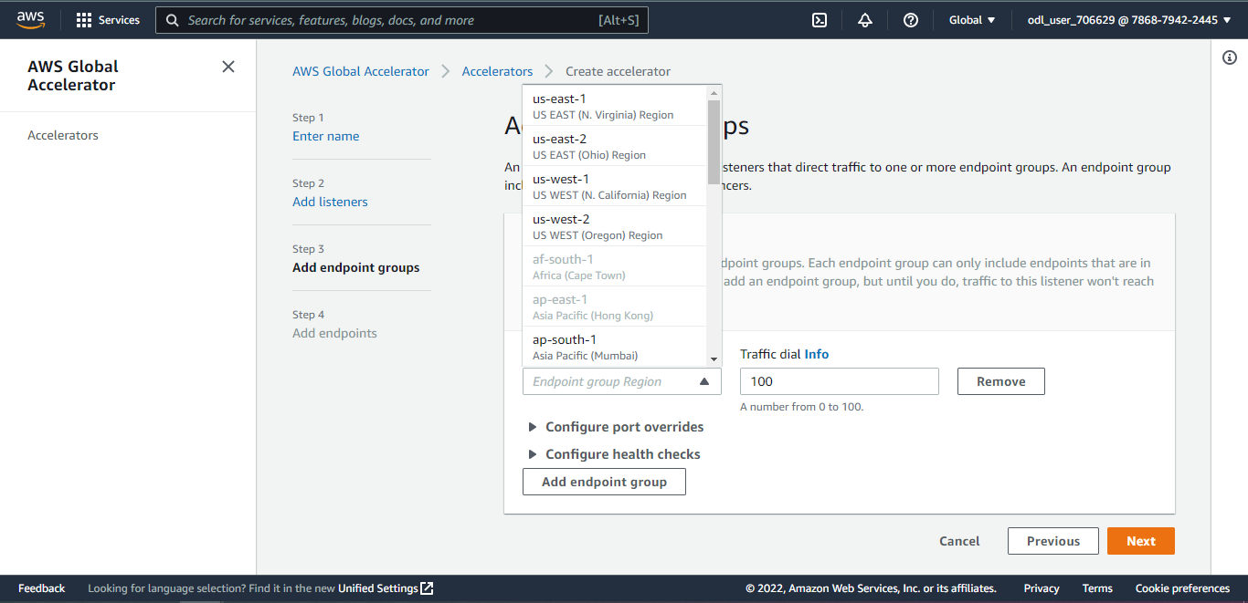

* 1. Select **EC2 instance** under **Endpoint type:**

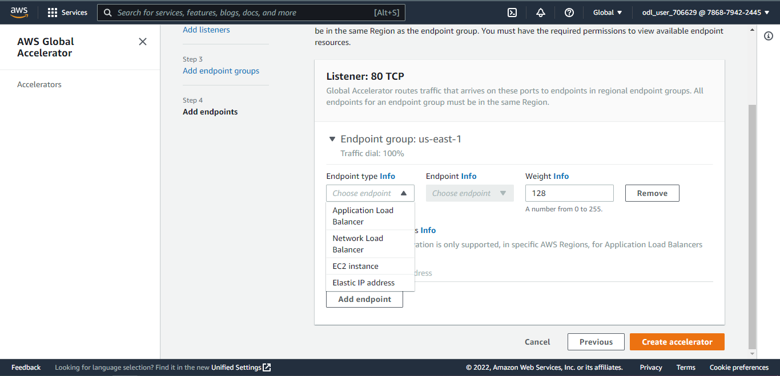

* 1. Select an endpoint and click on **Create accelerator:**

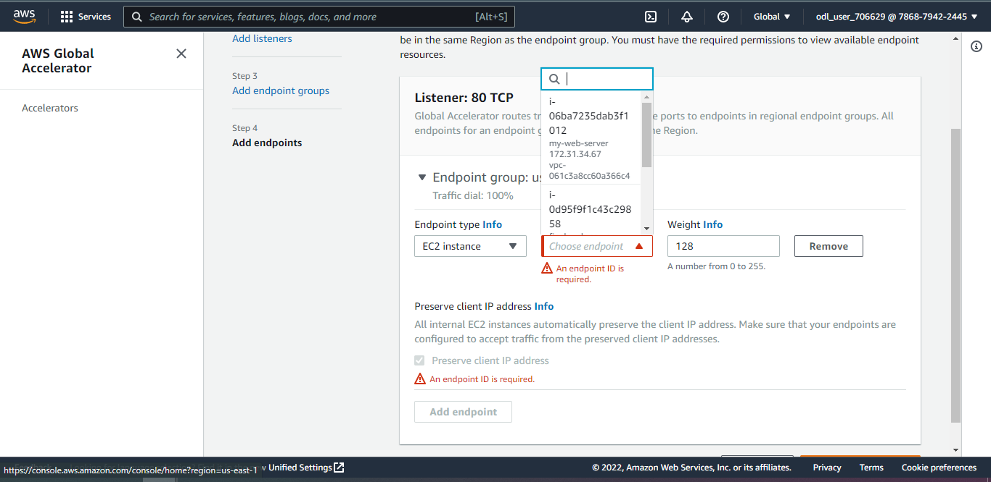

* 1. After the creation of the global accelerator and after the **Provisioning status** is changed to **Deployed,** copy the IP address.

* 1. Paste the IP address in a browser and press enter.

