Lesson 05 Lesson-end Project

**Customizing EC2 Instance for Web Instance**

**Project agenda:** To create VPC and launch a web instance

**Description:** You are required to create a custom VPC and create a subnet and attach the subnet to VPC. Create an internet gateway and route table and then launch an EC2 instance.

**Tools required:** AWS account

**Prerequisites:** AWS account

**Expected deliverables:** EC2 web instance

Steps to be followed:

1. Create a web instance
2. Create an internet gateway and attach it to VPC
3. Create a subnet and a route table

**Step 1: Creating a Custom VPC and enabling DNS hostname:**

* 1. In the AWS management console, search for **VPC:**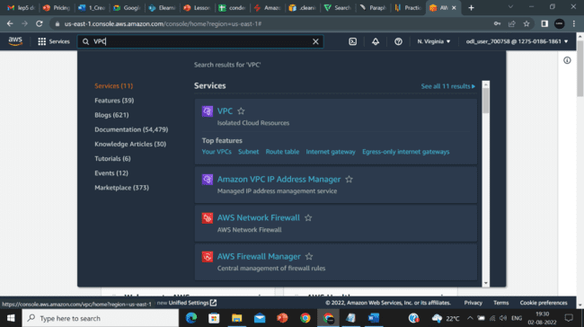
  2. Enter the **name**, and select the options shown below:

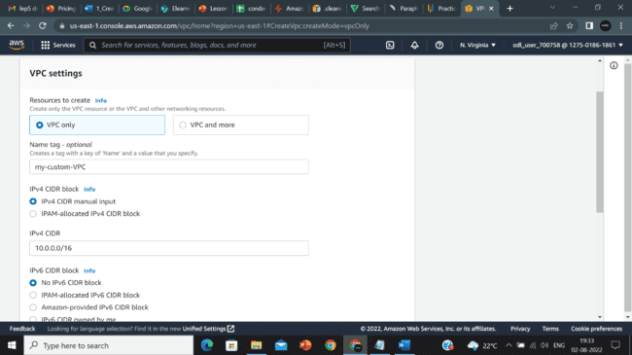

* 1. Click on **Create VPC:**

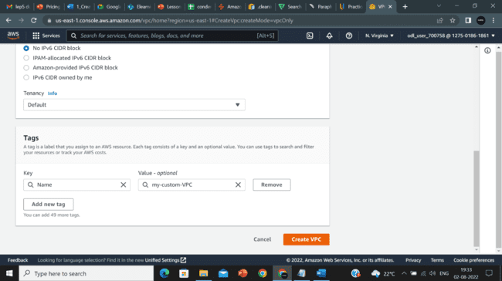

* 1. Select **Users VPC**, click on **Actions**, and then select **Edit DNS hostname**.

* 1. Click on **Enable** and **Save changes.**

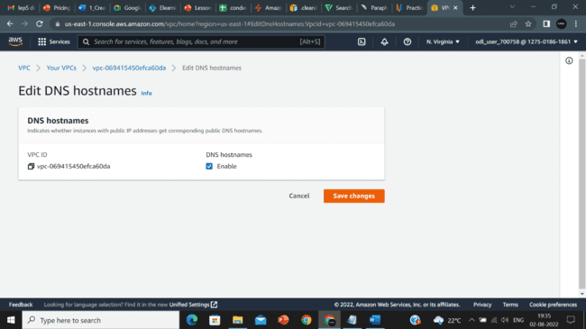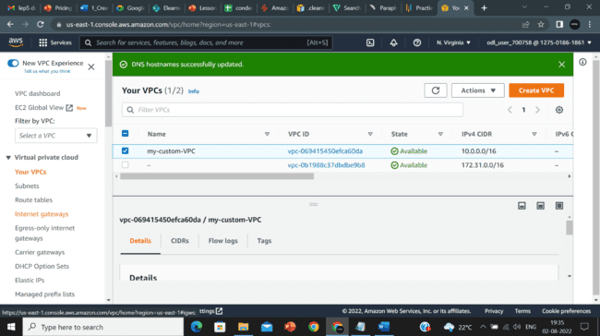

**Step 2: Create an internet gateway and attach it to VPC:**

* 1. In **EC2** console, click on **Internet gateways,** enter the **name** and click on Create internet gateway**:**

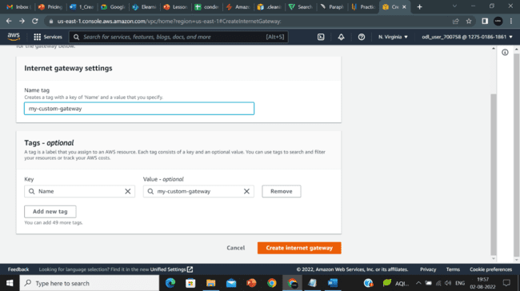

* 1. Select the users’ internet gateway, click on **Actions,** and select **Attach to VPC**:

* 1. Select user VPC and click on **Attach internet gateway**:

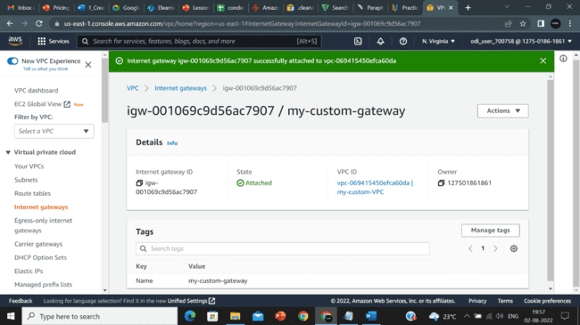

**Step 3: Create a subnet and a route table:**

* 1. Click on the **Subnets** and then click on **Create subnet:**

* 1. Select users VPC, and click on **Create subnet:**

* 1. Enter the **name**, and select the **Availability Zone**:

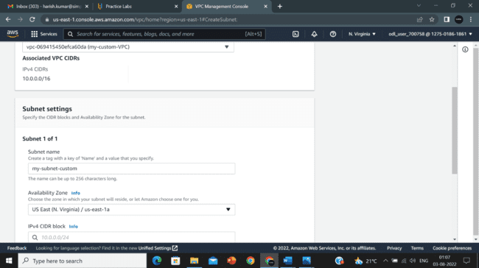

* 1. Copy **IPv4 CIDRs,** paste them into **IPv4 CIDRs Block,** and click on **Create subnet:**

* 1. Select users subnet, click on **Actions,** and select **Edit subnet settings**:

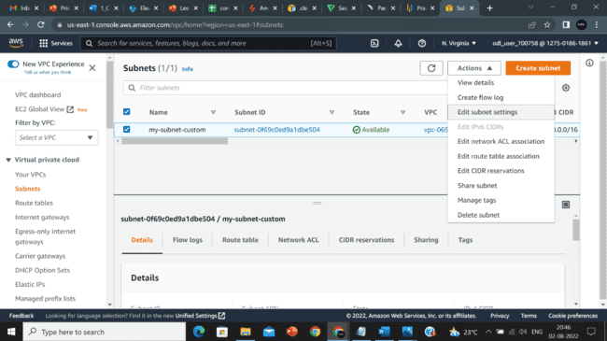

* 1. Enable auto-assign public IPv4 address under **Edit subnet settings**:

* 1. Click on **Create route table:**

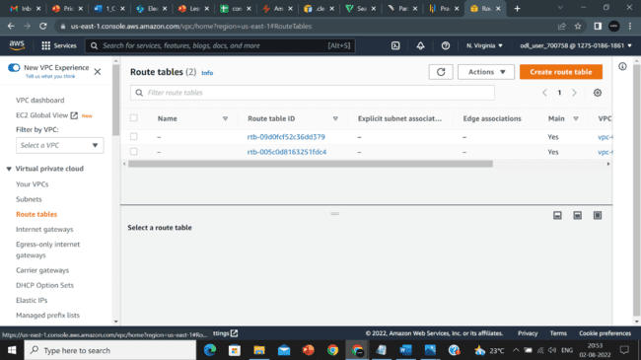

* 1. Selectuser VPC and click on **Create route table** below**:**

* 1. Select **the** users’ route table, click on **Actions,** and Select **Edit routes:**

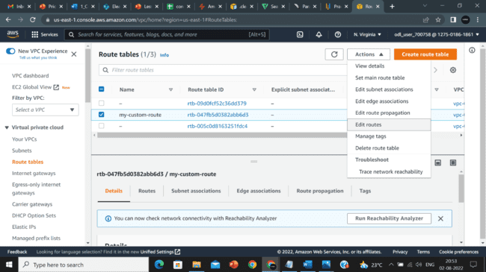

* 1. Click on **Add route:**

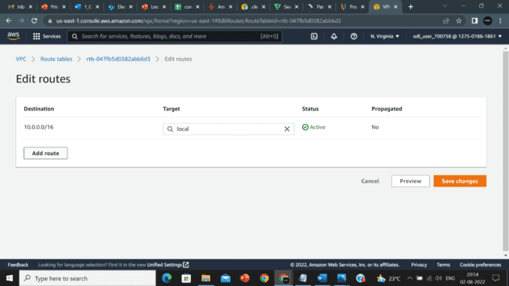

* 1. Select **Internet Gateway:**

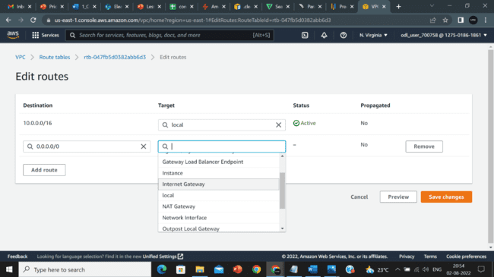

* 1. After selecting **Internet Gateway,** select the gateway you created, and click on **save changes:**

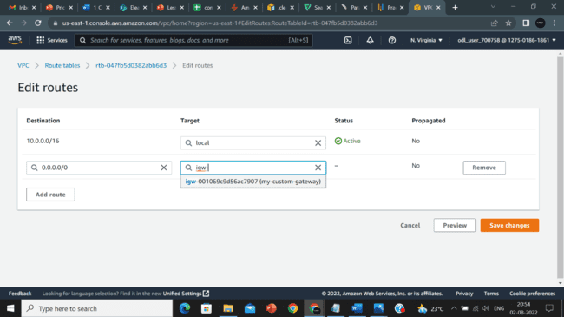

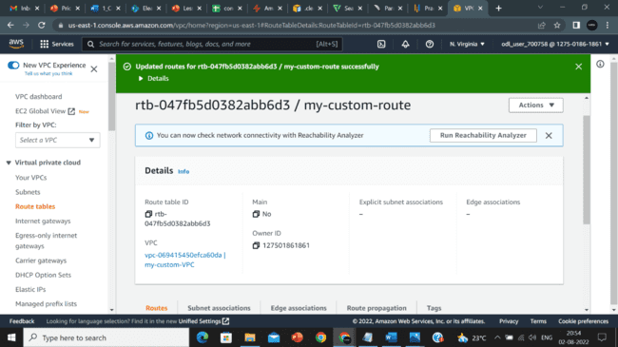

* 1. 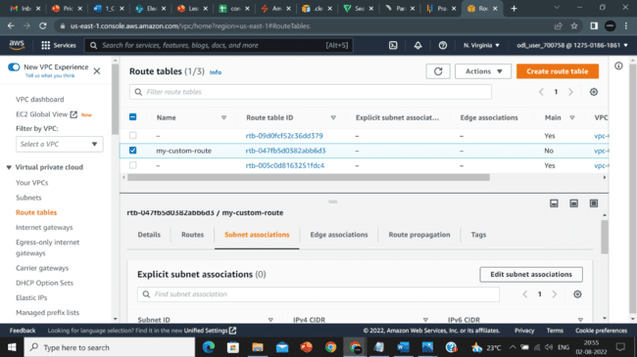Click on created subnet association and click in **Edit subnet associations:**
  2. Select users subnet and click on **Save associations:**

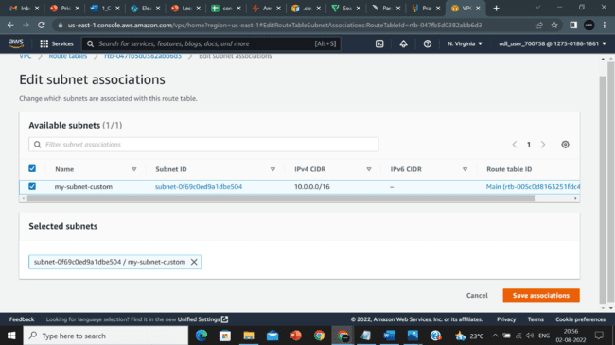

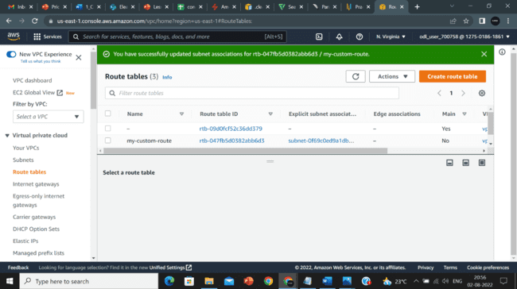

**Part – 4 Launch EC2 instance:**

* 1. Navigate to **EC2** in the console, click on **Instance,** click on **launch,** and enter the name for the instance**:**

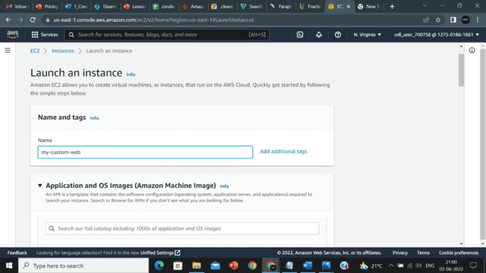

* 1. Click on **Amazon Linux:**

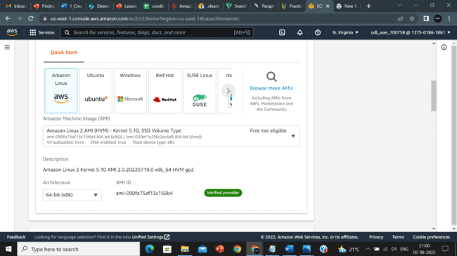

* 1. Select the **t2.micro** option:

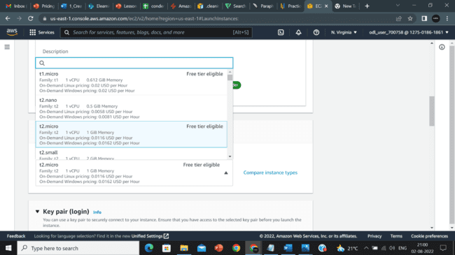

* 1. Create a **key pair**:

* 1. Click on **Network settings** and select your **VPC**:

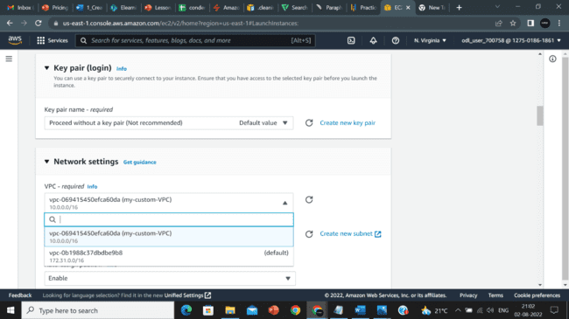

* 1. Select users custom subnet:

* 1. Select the inbound rules, and add **HTTP** and **HTTPS** rules:

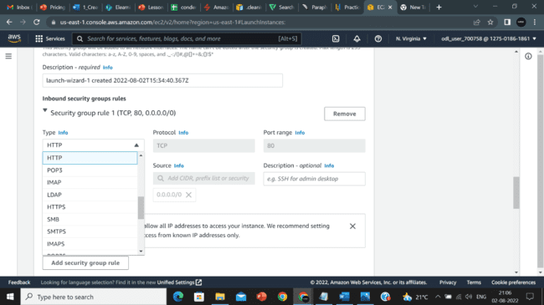

* 1. Click on **Advanced details,** enter the code in **User data,** and click on **Launch instance:**

* 1. Click on launch instance:

* 1. Select the instance created and copy the IPv4 address in the instance, and paste it in a browser:

