**Lesson 6 Demo 1**

**Create Table, Store, and Read Items in DynamoDB**

**Objectives:** To create a database table that can store and read items using the DynamoDB console

**Tools require:** AWS workspace

**Prerequisites:** AWS account

**Steps to be followed:**

1. Create a table
2. store the item and read the items

**Step** **1:** **Create a table**

1. Navigate to the AWS portal home screen, click on the Searchtab, then click on **DynamoDB**:A screenshot of a computer

   Description automatically generated
2. On the DynamoDB page, click on **Create table:**

1. Enter the **Table name**, **Partition key**, and enter a name under the **Sort key**:

1. Click on the **Create table**:

1. The table is created:

**Step** **2: Store the items and read the items**

1. Click on the created table, click on the **Actions,** and select **Explore items** options

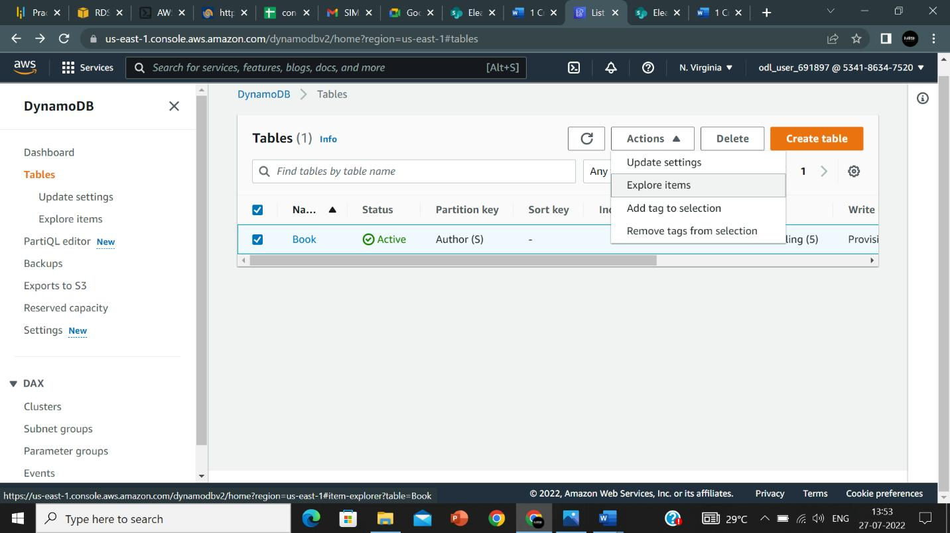

1. Click on create item:

1. Enter the item, we can add more attributes by clicking on **Add new attribute**:

1. Click on **Create item**:

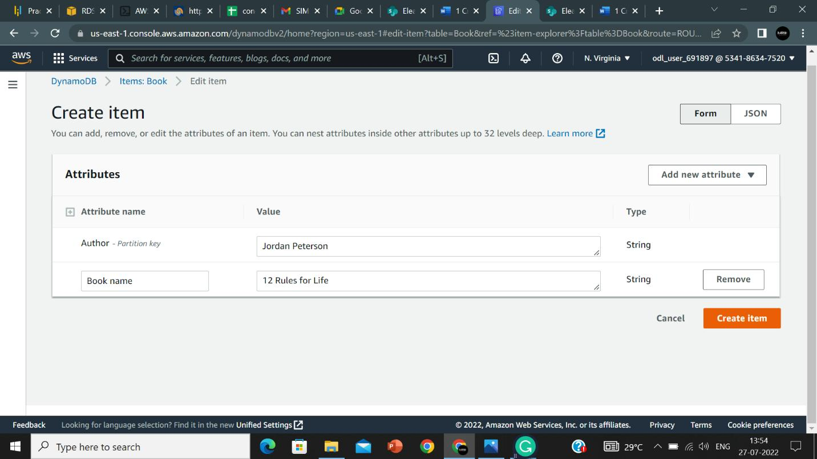

1. Click on **Scan/Query items** and click on **Run**:

1. The items are returned.

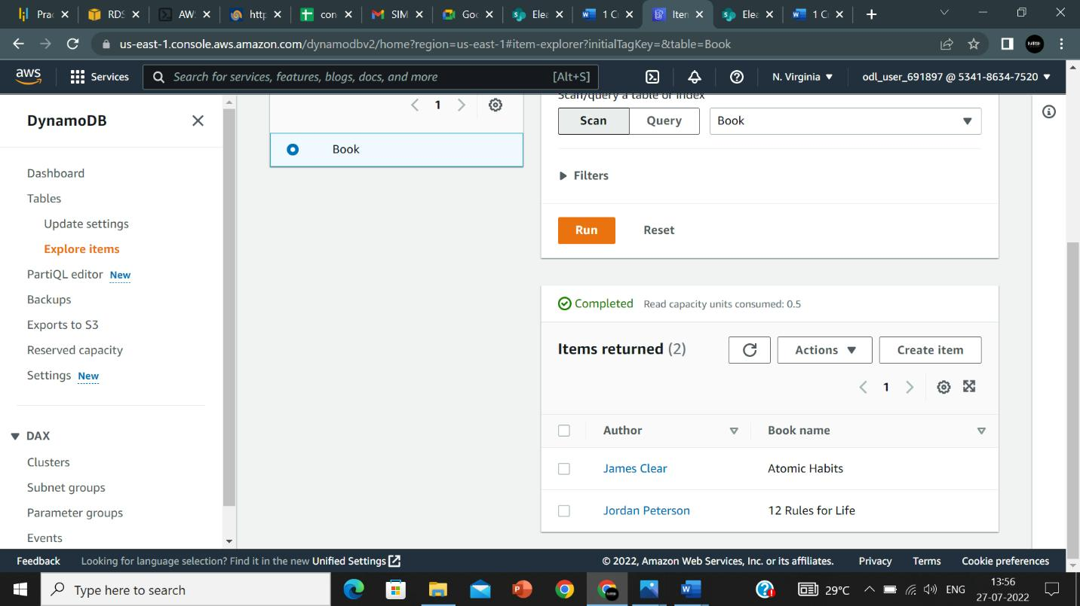

Thus, we were able to create a table, store items, and read the items from the table.