**Lesson 6 Demo 2**

**DynamoDB Global Table**

**Objectives:** To set up the prerequisites and create a global table

**Tools require:** AWS workspace

**Prerequisites:** AWS account

**Steps to be followed:**

1. Creating areplicain DynamoDB

**Step** **1:** **Creating areplicain DynamoDB**

1. Navigate to the AWS portal home screen, click on the Searchtab, and click on **DynamoDB**:

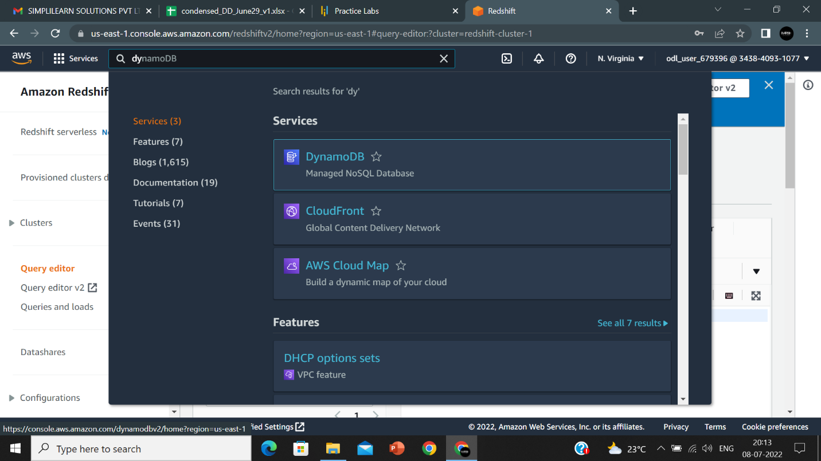

1. On the **Tables** page, select the table **book** and click on **Actions,** and select **Update settings** from the drop-down:

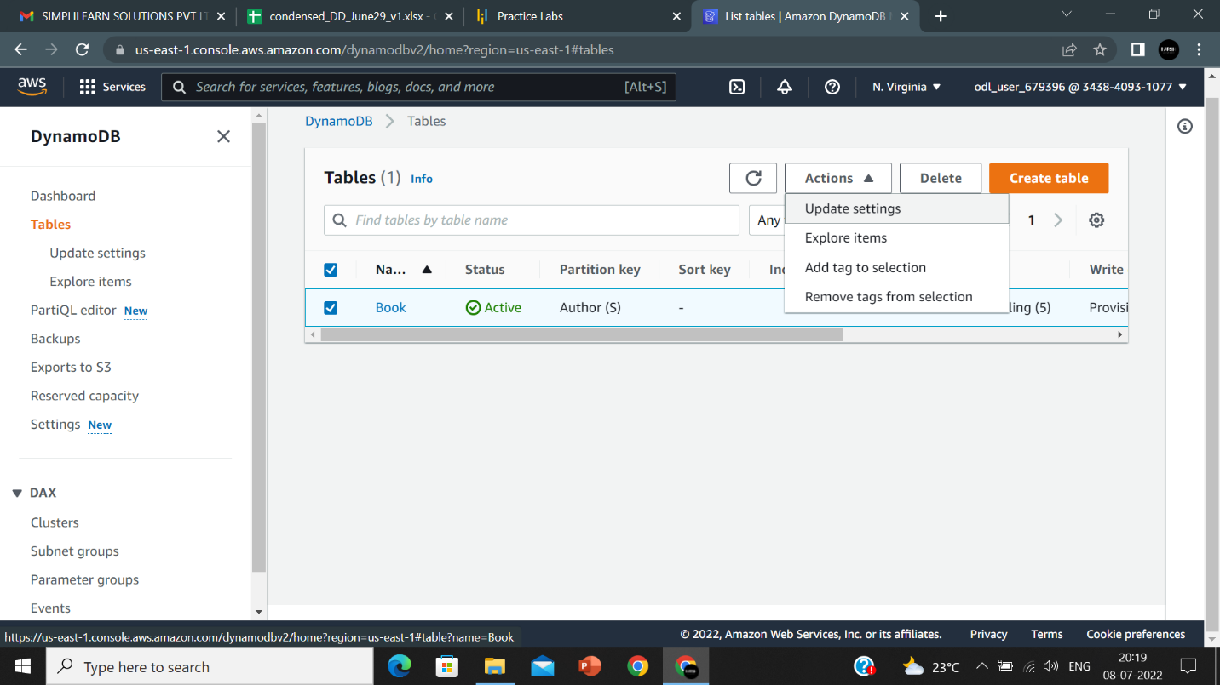

1. Select the **Global tables** option and click on **Create replica**:

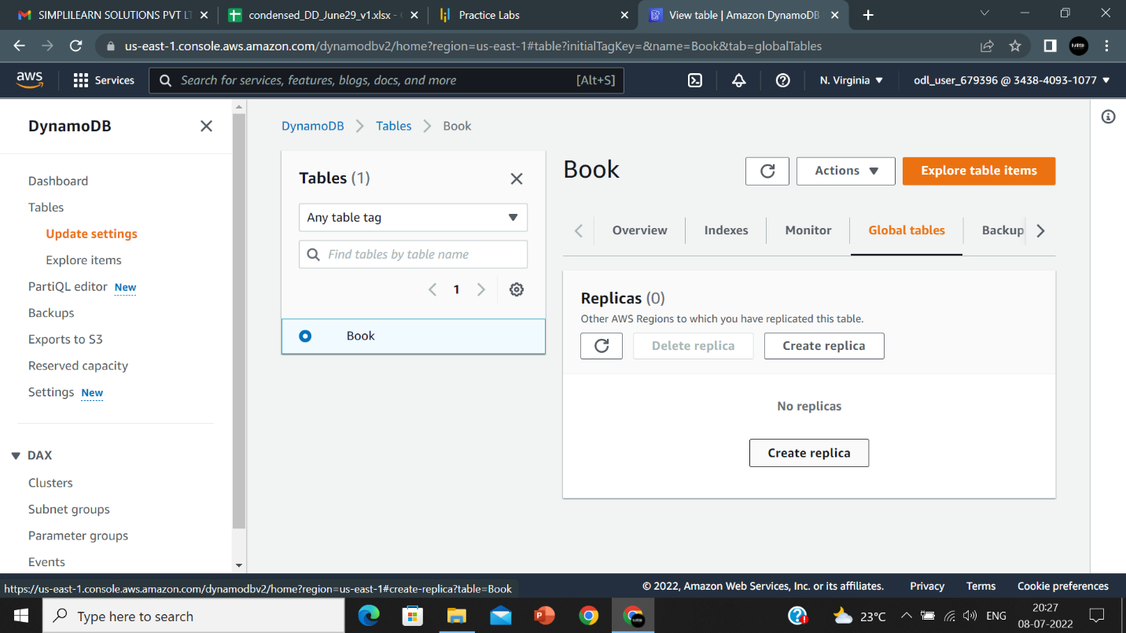

1. On the **Create replica** page, select a **Region** to replicate the table and then click on **Create replica**:

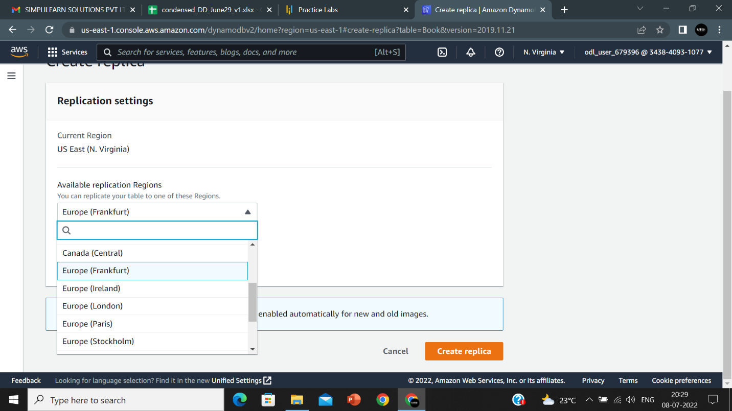

1. Replica of the table is created.

