**Lesson 6 Demo 3**

**Query data using Query Editor in Redshift**

**Objectives:** To set up the prerequisites and to create a table in redshift and query

**Tools require:** AWS workspace

**Prerequisites:** AWS account

**Steps to be followed:**

1. Creating atable in Redshift and querying data

**Step** **1:** **Creating atable in Redshift and querying data**

1. Navigate to the AWS portal home screen, click on the Searchtab, and click on **Amazon Redshift**:

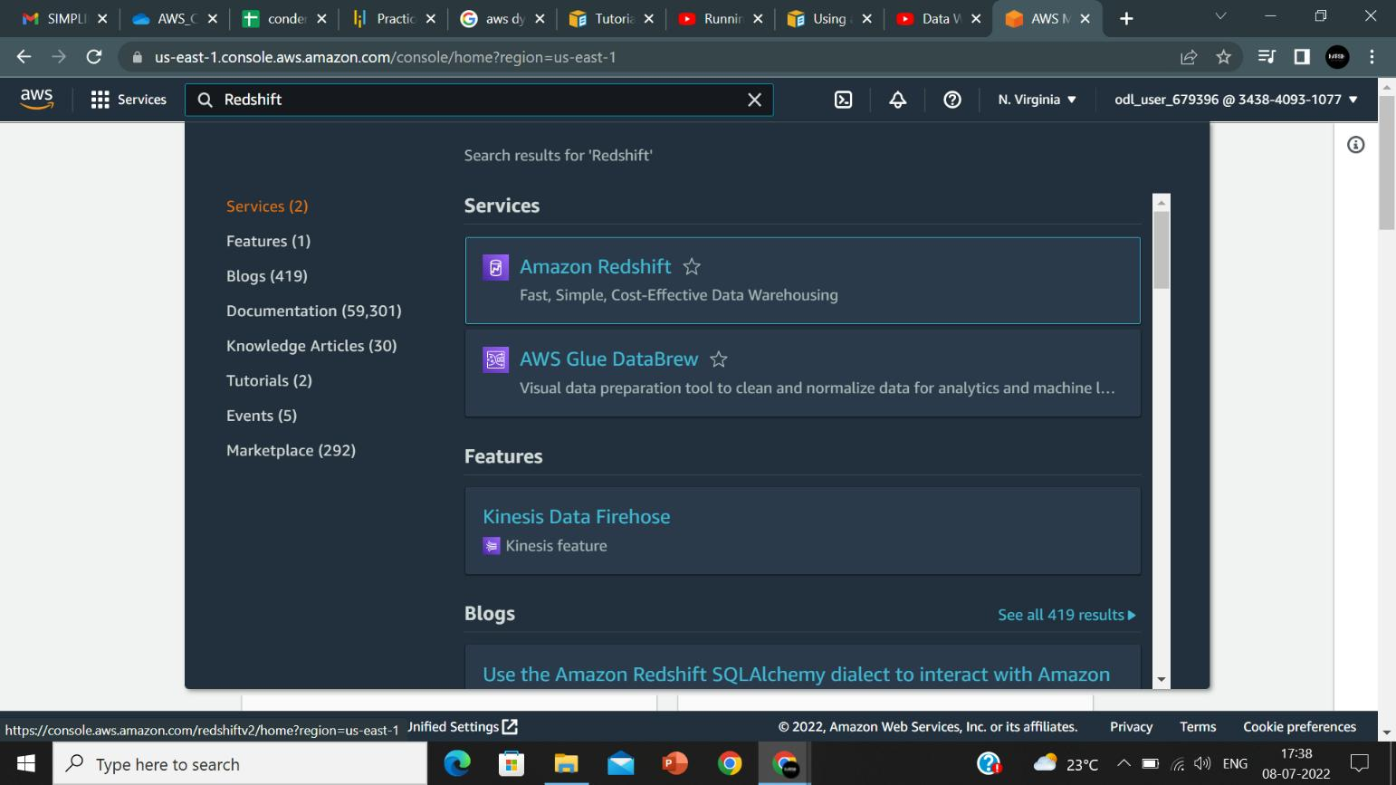

1. On the **Redshift page**, click on **Create cluster**.

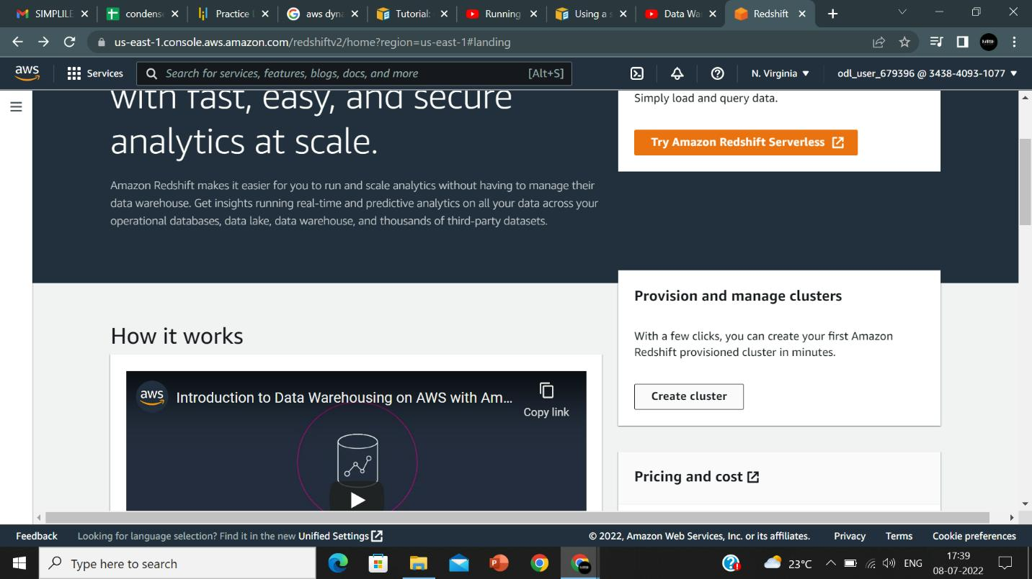

1. In the **Cluster configuration** section, specify the values or choose the default values for **Cluster identifier**, **Node type**, and **Nodes**:A screenshot of a computer

   Description automatically generated

**Note:**

* Cluster identifier: redshift-cluster-1
* Choose either **Production** or **Free trial**
* Choose the size of the cluster
* If you are not aware of the size of your cluster, click on **Help me choose**
* If you know the required size of your cluster, click on **I'll choose**
* Choose the Node type and number of Nodes to customize the size of your cluster

1. Click on **Create cluster**:

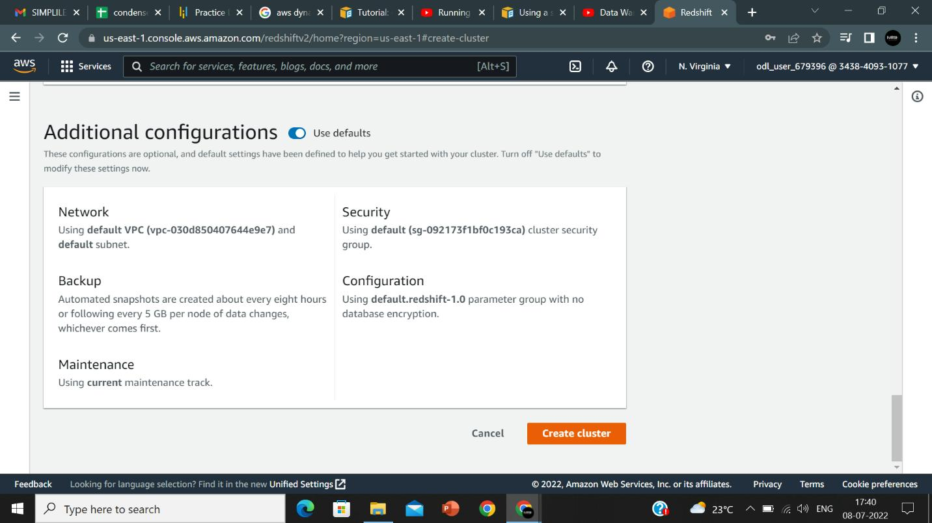

1. The cluster is created:

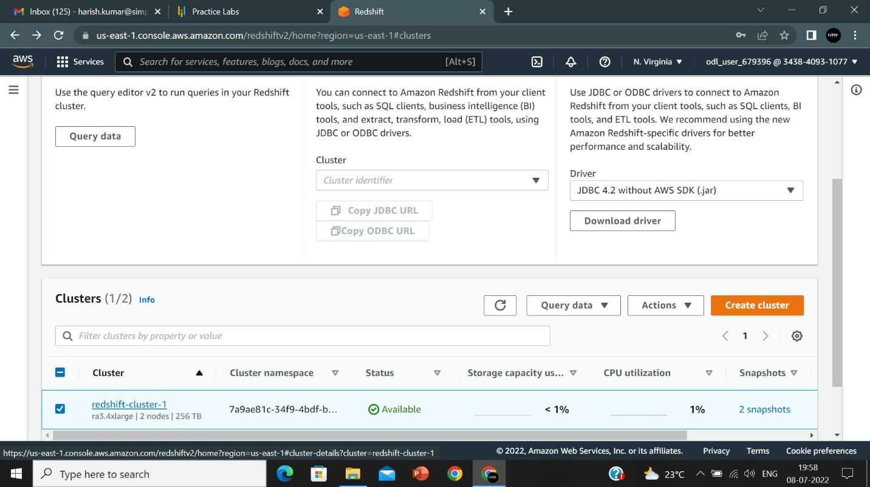

1. Click on **Query data,** select **Query in query editor:**

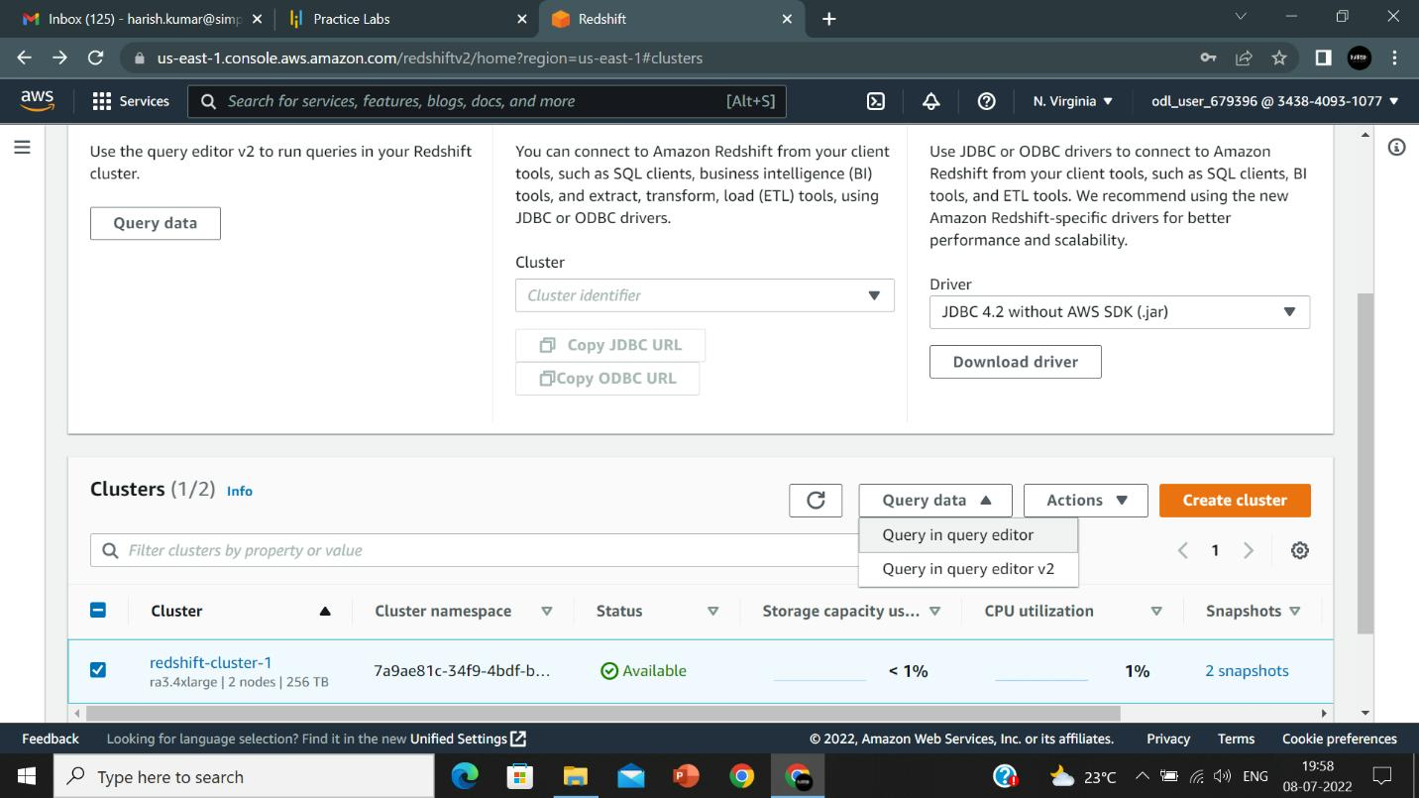

1. Click on **connect to database:**

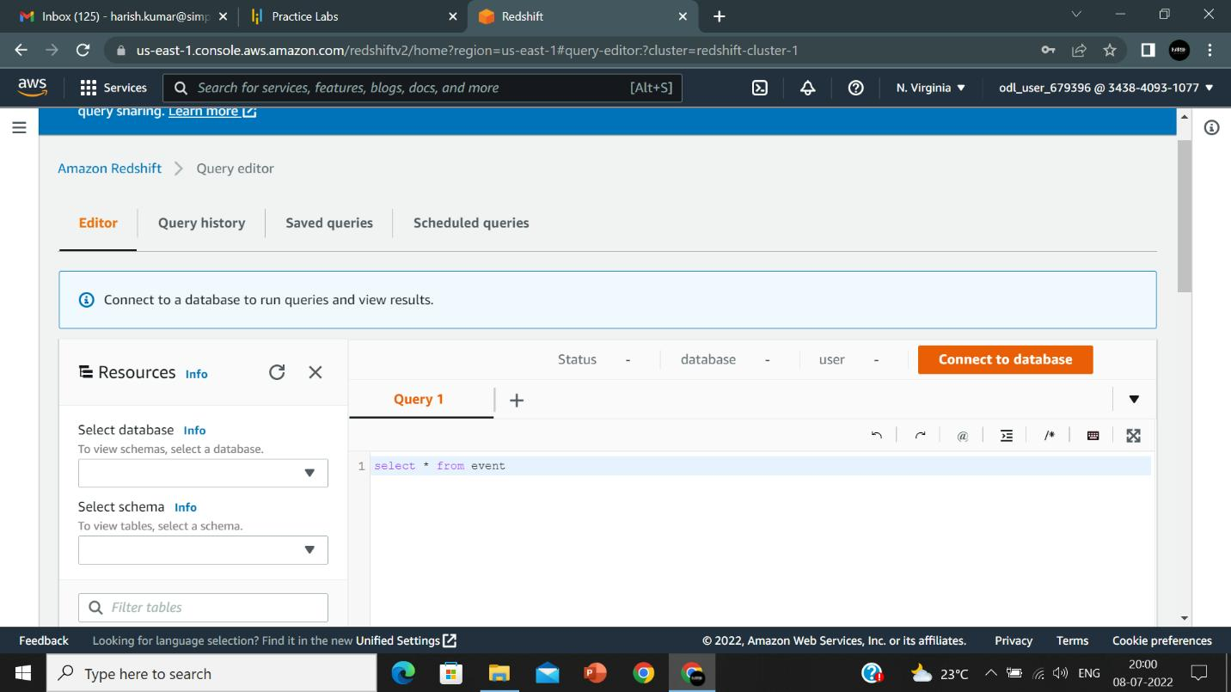

1. Click on **create a new connection**, enter the **database name**, and give the database user name accordingly, then click on **connect**

1. **Query 1** enter the query **select * from category:**

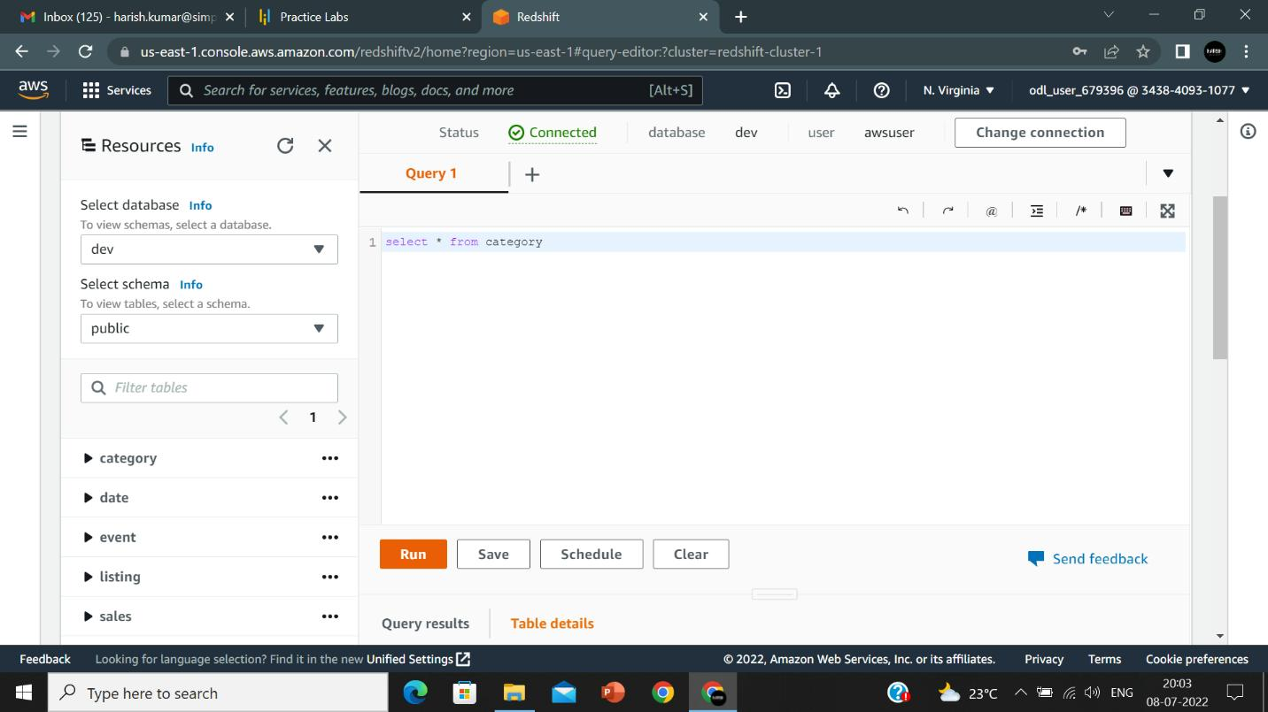

1.10 **Query 1** enter the query **select * from category:**

