Lesson 06 Lesson-end Project

**Deploy MySQL RDS using AWS**

**Project agenda:** To create and configure an RDS instance

**Description:** You are required to create an RDS database and, then deploy a Linux instance by creating it in EC2 and connecting SSH client through EC2.

**Tools required:** AWS account

**Prerequisites:** AWS account with CloudShell installed

**Expected deliverables:** RDS database with SSH Client

Steps to be followed:

1. Create an RDS database
2. Launch an EC2 instance with key-pair
3. Create security groups
4. Terminal for SSH

**Step 1: Create a RDS instance:**

* 1. In the AWS management console, search for **RDS,** click on **create databases,** and select **Standard create:**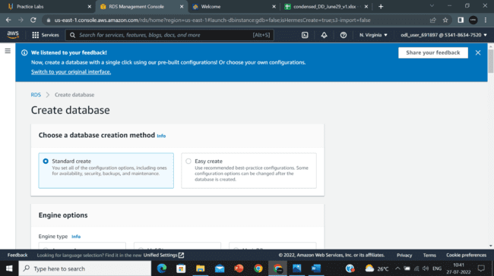
  2. Click on the **MySQL** option: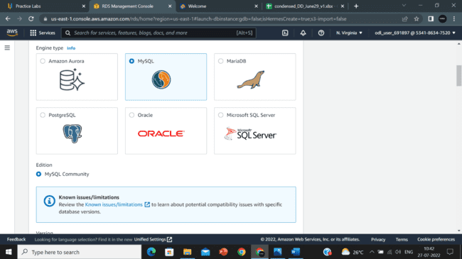

* 1. Select the option **MySQL 8.0.11** and click on **Free tier:**

* 1. Select the default options for the rest, enter a password, and then click on **Create database**.

* 1. After the creation of the database, take note of the **Endpoint:**

Step – 2: Launch an EC2 instance with key-pair

* 1. Navigate to **EC2** in Console, Click on **Launch instance:**

* 1. Enter the name of the instance, select the **Amazon Linux** option:

* 1. Select the option **t2.micro** for the instance:

]

* 1. Create a new **Key pair:**

* 1. Click on **Launch instance:**

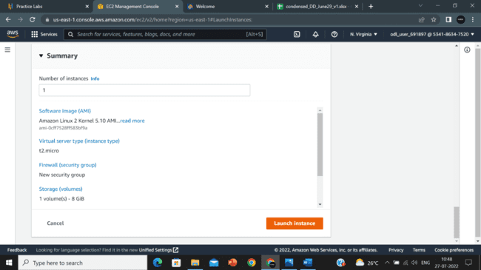

Step – 3: Create **security groups**:

* 1. Click on the settings icons in **Security group rules:** Graphical user interface, text, application, website

     Description automatically generated
  2. Select the page size, enable **Security group,** and click on **continue:**

* 1. Click on one of the **security group**:

* 1. Click on **Inbound rules:**

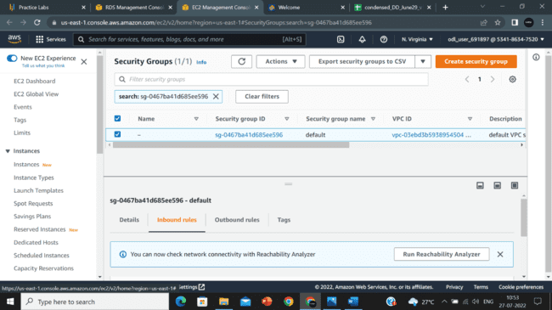

* 1. Click on **Edit inbound** rules:

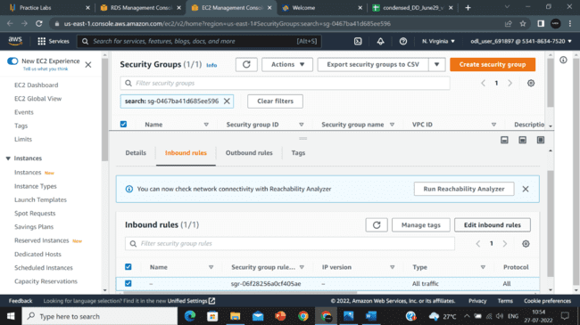

* 1. Delete the default inbound rules and **save rules**:

* 1. Click on **Add rule**:

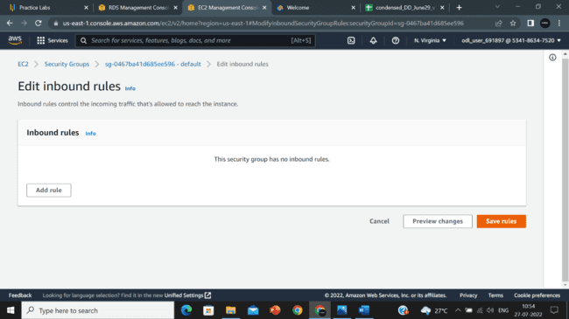

* 1. Select **MYSQL/Aurora** and click on **save rules:**

Step – 4 Terminal for SSH:

* 1. Navigate to **EC2** in Console, Click on **Instance,**  and click on **Connect:**

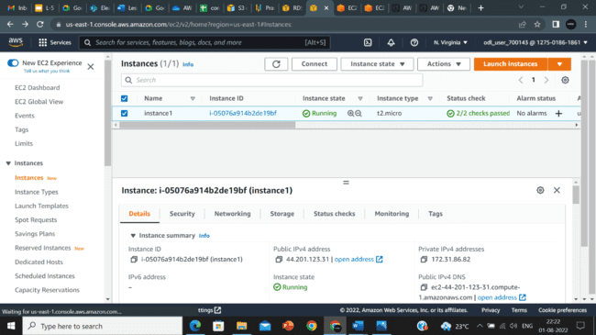

* 1. Click on **Connect:**

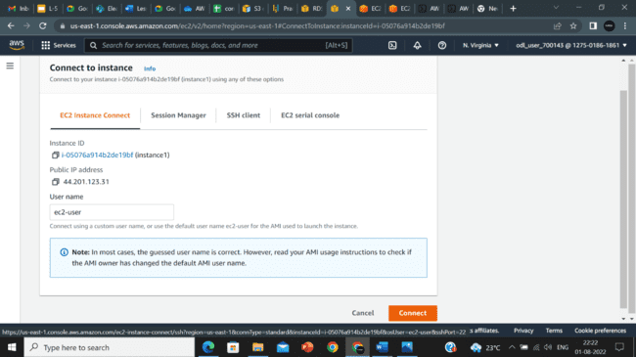

* 1. The EC2 terminal opens up:

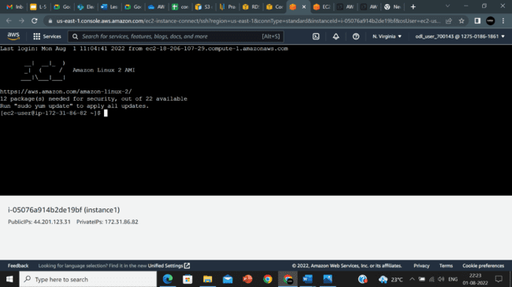

**Note**: Enter the following commands in EC2 terminal

1. sudo su
2. yum install mysql
3. mysql -h <YOUR RDS instance endpoint> -P 3306 -u <USERNAME of your RDS Instance> -p
4. Enter password when prompted