**Lesson 7 Demo 2**

**Creating and Adding Policy Generator, Managed Policy, Versions, Groups**

**Objective:** To create and configure a policy for the group using user

**Tools required:** AWS Lab

**Prerequisites:** Cloudshell should be installed

**Steps to be followed:**

1. Creating and managing policy.
2. Using group users can attach policy and permissions directly to the group.
3. Creating and managing S3 versioning.

**Step 1: Creating and managing policy.**

* 1. Go to your Amazon console and search **IAM** in the search bar.

* 1. In the IAM dashboard, click on **Policies** and click on **create policy**.

* 1. In **Service** search **S3**

* 1. In the **Actions** section, click on **Access level**, then select L**istAllMyBucket**. In the Write section, select **Create Bucket**.

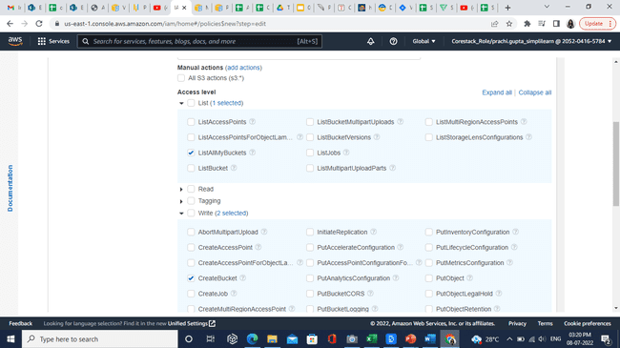

* 1. In the **Resources** section, select **All** **resources.** Then click on **Next: Tags.**

* 1. Click on the **Next: Review** button as shown below:

* 1. In the Name section, written as **S3BucketPolicy.** Then click on **Create policy** button.

* 1. In the IAM dashboard, select **Users** then click on **Add users**

* 1. Enter user name as **Cli-user.** Select **Access-key Programmatic access**. Then click on the **Next: Permissions** button.

* 1. Select **Attach existing policies directly** option. Click on the **Next: Tags** button.

* 1. Click on the **Next: Review** button.

* 1. Click on **Create user** button.

* 1. Click on **Cli-user.** Click on **Add permissions** button.

* 1. Select **Attach existing policies directly.** Search **S3** then select **S3BucketPolicy**.Then click on **Next: Review.**

* 1. Now click on **Add permissions** button.

* 1. In the search option type **CloudShell**

* 1. In cloudshell type **aws configure** command as shown below:

* 1. The AWS Access Key ID and Secret key refer to users’ **secret key** and **access key** as shown below:

* 1. Now try to list buckets under the user’s account. Use the **aws s3api list-buckets** command. If it shows an error because the user has no permission, perform the upcoming steps. Else, you can skip to step number 2.

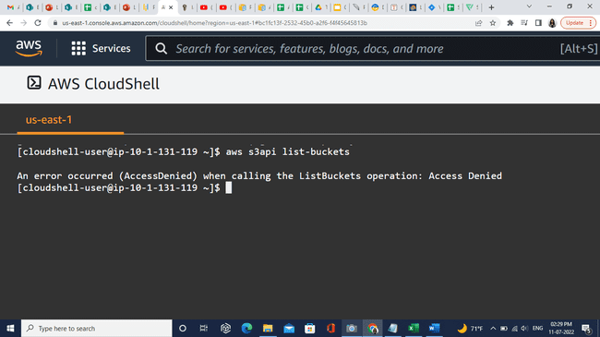

* 1. Go to the users list and click on **cli-user** as shown below:

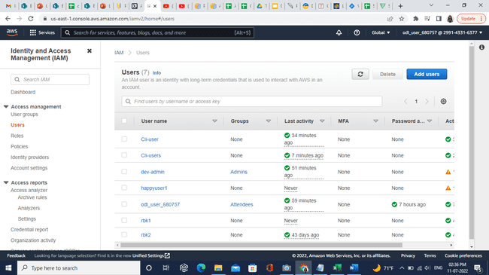

* 1. In the **Permissions** section, click on **Add permissions** button.

* 1. Select **Attach existing policies directly** and in filter policies, search and select **S3BucketPolicy** then click on the **Next: Review** button as shown below:

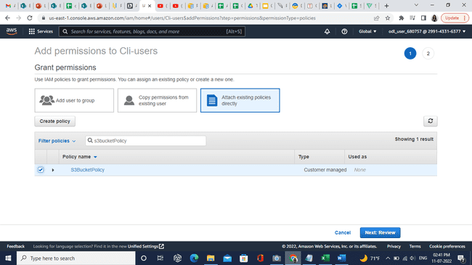

* 1. Click on **Add permissions.**

* 1. Permission is added successfully.

* 1. Make Cli request again for the listing bucket using the **aws s3api list-buckets** command. This will show the list of buckets that users have in their accounts.

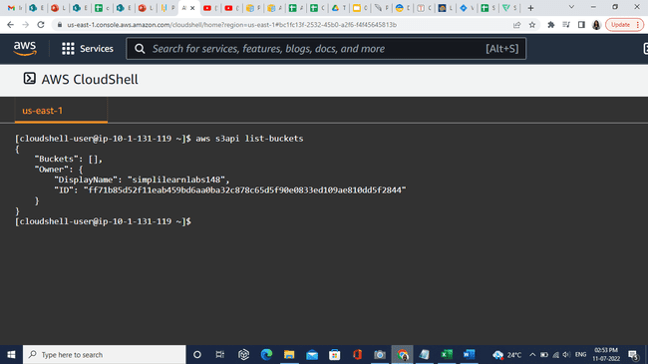

**Step 2: Using group users can attach policy and permissions directly to the group.**

1. Select **User** **groups** and click on **Create group** button.

1. Enter User group name as **Cli-user.**

1. In **Attach permissions policies** search s3 and select **S3BucketPolicy.**

1. Click on **Create group** button.

1. Click on **Cli-user**. Click on **Add users** button.

1. Select **Cli-user.** Click on **Add users** button.

**Step 3: Creating and managing S3 versioning.**

* 1. In services, search and select **S3.**

* 1. Click on **Create bucket** button.

1. Add bucket name as **demoversioningsimplilearn**, select Aws Region as **US East (N. Virginia) us-east-1.**

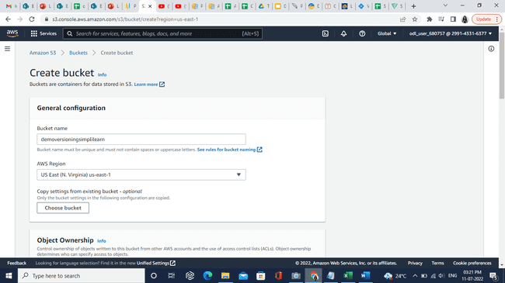

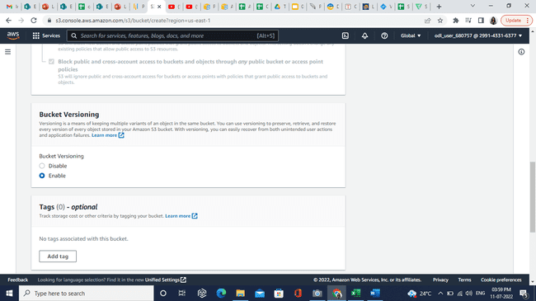

1. Click on **Create bucket** button.

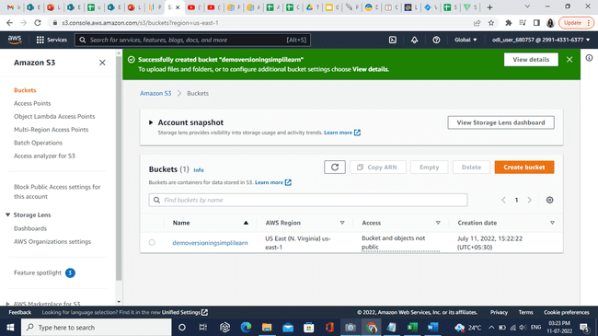

1. Click on **demoversioningsimplilearn**. In the **Objects** section upload a simple txt file as shown below:

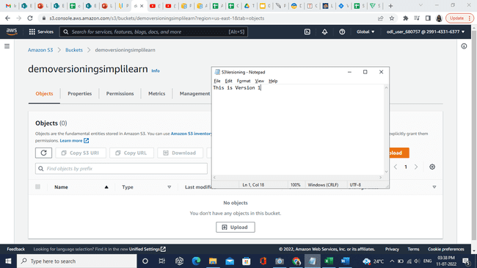

1. Click on the **Upload** button.

1. Click on **Add files** button. Then click on the **Upload** button.

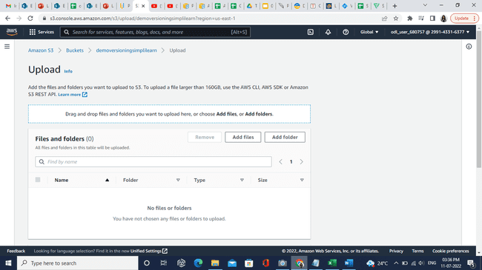

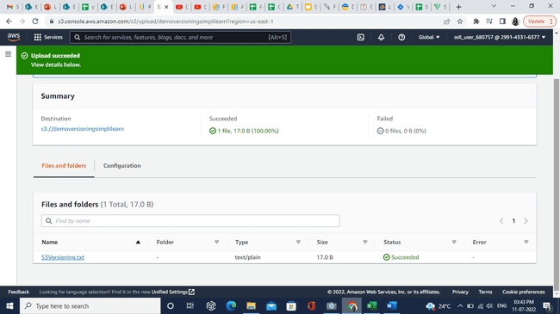

1. Click on the **S3Versioning.txt** file.



1. Click on **Open.**

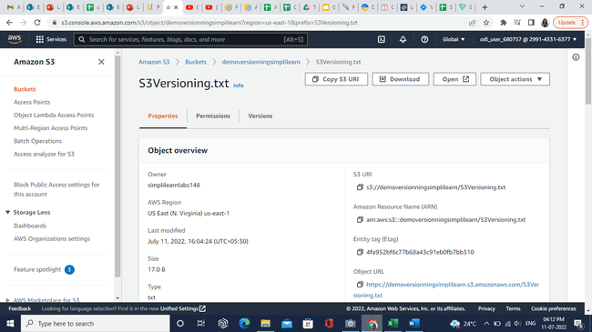

1. Page will show content in the text file.

1. Now make changes in the text file and save it and reupload the same file.

1. Click on **Open** now user will see updated data in the file.

