**Lesson 7 Demo 5**

**Restrict Access using VPC Endpoint**

**Objective:** To provide access to public and private subnets using the VPC endpoint

**Tools required:** AWS Lab

**Prerequisites:** None

**Steps to be followed:**

1. Create a custom VPC and enable DNS hostname
2. Create an Internet Gateway
3. Create 2 subnets
4. Create a Route table and attach them to subnets
5. Launch 3 instances
6. Launch public and private VM
7. Install DB on a private DB server
8. Create a bucket and upload a document
9. Create an Endpoint

**Step 1: Create a custom VPC and enable DNS hostname.**

* 1. In the AWS console, click on the **Services** and select **VPC.**

* 1. Click on the **Create VPC** button. In the **Name tag** enter the name.

* 1. In the **IPv4 CIDR** enter the **10.0.0.0/16** then click on the **Create VPC** button.

* 1. Click on the **Actions** and select the **Edit DNS hostnames** option.

* 1. Select **Enable** and click on the **Save changes** button.

**Step 2: Create an Internet Gateway**

* 1. Select the **Internet gateways** and click on the create button.

* 1. In the **Name tag,** enter the name and click on the **Create internet gateway** button.

* 1. Select the internet gateway, click on the **Actions,** then select the **Attach to VPC** option.

* 1. Select the VPC created previously and click on the **Attach internet gateway** button.

**Step 3: Create 2 subnets**

* 1. Select the **Subnets** and click on the **Create subnet** button.

* 1. Select the **VPC ID**.

* 1. Enter the name and **IPv4 CIDR,** then click on the **Create subnet** button.

Note:

Enter IPv4 10.0.1.0/24

* 1. Follow the above same procedure for creating a **private subnet.**

Note:

Enter Ipv4 10.0.2.0/24

* 1. Select the **public-subnet,** click on the **Actions** tab and select **Edit subnet settings.**

* 1. Select the **Enable auto-assign public IPv4 address** and click on the **Save** button.

**Step 4: Create a Route table and attach them to subnets.**

* 1. Select the **Route** **table** from the left pane and click on the **Create route table**.
  2. Enter the name and VPC then click on the create button.

* 1. Follow the same above procedure for creating **private-rt.**

* 1. Select the public route and click on the **Routes** tab.

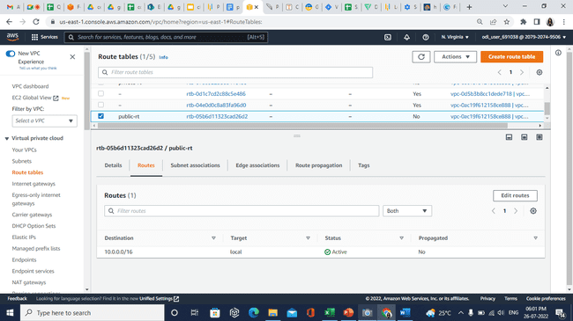

* 1. Click on the **Edit routes** button.
  2. Click the **Add route** button, select the **Internet Gateway,** then click on the **Save changes** button.

* 1. Once the route to the Internet is set, click on the **Subnet associations,** and select the **Edit subnet associations** button.

* 1. Select the **public-subnet** and click on the **Save associations**.

* 1. Attach the **private route table** to the **private subnet** using the previous steps.

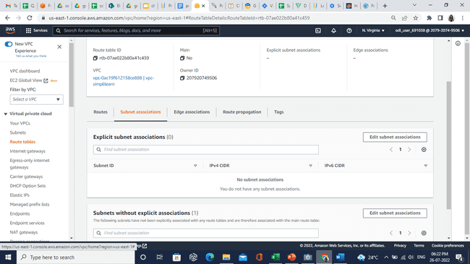

**Step 5: Launch 3 instances**

* 1. In the dashboard, search and select the **EC2**.
  2. Click on the **Launch instance**.
  3. Enter the name.

#### For the OS search and select the **Ubuntu Server 18.04 LTS (HVM), SSD Volume Type option.**

* 1. Click on the **Create new key pair.**

* 1. In the **Network settings** select the information as shown in the images below:

* 1. Click on the **Launch instance** button.
  2. Create a new instance for the private subnet.
  3. Enter the name and select the key pair created previously.

* 1. Create a NAT instance using the previous steps.

* 1. Select **amzn-ami-vpc-nat-hvm-2018.03.0.20181116-x86_64-ebs** option.

* 1. For network setting, refer to the following images:

* 1. For the security group, refer following images and launch instance:

Enter the security group SSH, HTTP, and HTTPS enter source IP-10.0.1.0/24 and again create **Custom TCP, HTTP, and HTTPS** using the following details:

* 1. Select the Nat-instance, click on the Actions, select the Networking, and click on the Change source/destination check.

* 1. Go to the VPC route table, select the private route and choose the **Routes** tab.

* 1. Click on the Edit routes button and select the **NAT instance created previously.**

**Step 6: Launch public and private VM**

* + 1. Go to the EC2 console and select the public instance.
    2. Copy the public IP and paste it into the **CloudShell** using the following command:

**chmod 400 demo.pem**

Note:

If you are getting an error, then in **CloudShell** in the **Actions** tab, click on the upload file and upload the **.pem** file.

Replace .pem name.

* 1. Copy and paste the following command in CloudShell:

**ssh -i demo.pem** [**ubuntu@100.26.215.92**](mailto:ubuntu@100.26.215.92)(replace the public ipv4 address accordingly):

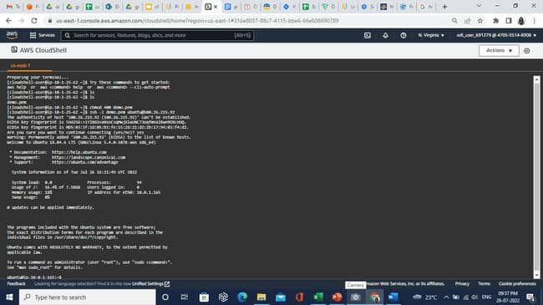

* 1. Enter the following command for ssh to private VM using public VM.

**sudo su**

**ping 10.0.2.92**

**Note:**

Replace 10.0.2.92 with private instance ip.

**Step 7: Install DB on a private DB server**

* 1. To install DB, enter the following command:

**wget https://storage.googleapis.com/skl-training/aws-codelabs/mattermost/install_mysql.sh**

**chmod 700 install_mysql.sh**

**sudo ./install_mysql.sh**

**Step 8: Create a bucket and upload a document.**

* 1. Create a bucket.

* 1. Upload the document, **Object Actions** and then click on the **Make public using ACL**.
  2. Click on the **Make public** button.

**Step 9: Create an Endpoint**

* 1. Open the VPC, select the Endpoints and click on the **Create endpoint**.

* 1. Enter the name.

* 1. Search and select the **com.amazonaws.us-east-1.s3** option.

* 1. Select the **VPC** and default **Route table** then click on the create button.

* 1. Launch the private VM using the following command:

**ping 10.0.2.11**

Note:

Replace 10.0.2.11 with the private instance IPv4.

* 1. Copy and paste the Object URL of the bucket document using the following command:

wget <https://demobucketsimplilearn.s3.amazonaws.com/bucketdoc.txt>

* 1. Now, in bucket policy enter the following code:

{

"Id": "VpcSourceIp",

"Version": "2012-10-17",

"Statement": [

{

"Sid": "VpcSourceIp",

"Action": "s3:*",

"Effect": "Deny",

"Resource": [

"arn:aws:s3:::DOC-EXAMPLE-BUCKET",

"arn:aws:s3:::DOC-EXAMPLE-BUCKET/*"

],

"Condition": {

"NotIpAddress": {

"aws:VpcSourceIp": [

"10.1.1.1/32",

"172.1.1.1/32"

]

}

},

"Principal": "*"

}

]

}

Note:

The above example of bucket policy blocks traffic to the bucket unless the request is from a specified private IP address (aws: VpcSourceIp).

After this edit, only wget in VMS in this VPC will work. VMS in any other VPC, for example, the default VPC, will not be able to access this bucket.