**Lesson 7 Demo 7**

**Create and configure AWS WAF**

**Objective:** To create and configure AWS WAF

**Tools required:** AWS Lab

**Prerequisites:** None

**Steps to be followed:**

1. Creating and configuring IP sets.
2. Creating and configuring web ACL.
3. Creating a Custom rule in web ACLs.

**Step 1: Creating and configuring IP sets.**

* 1. In the dashboard, search and select **WAF & Shield.**

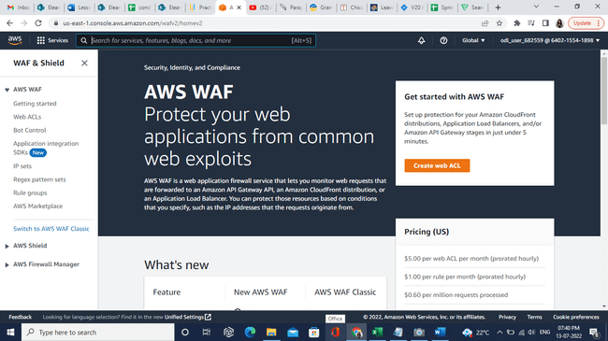

* 1. To create a user list IP or sider block, select **IP sets**.

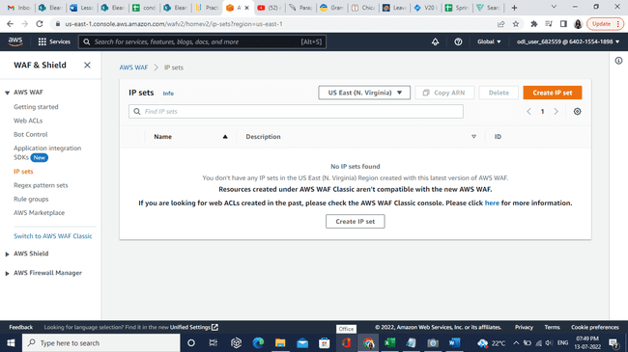

* 1. Select Regions as **Global (CloudFront)** and click on the **Create IP set** button.

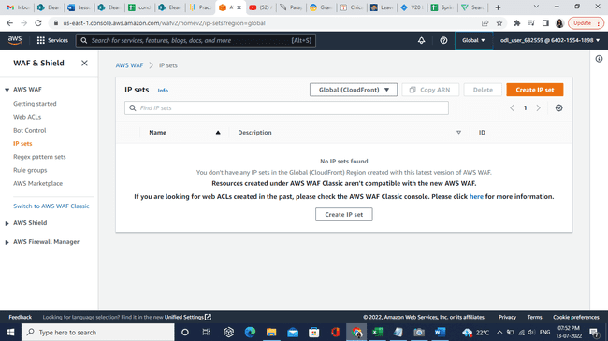

* 1. In the **IP set name** field, enter the name **DemoSimplilearnIP.**

* 1. Enter the IP address **8.8.8.8/32** and click on **Create IP set**.

* 1. The IP set is created successfully as shown below.

**Step 2: Creating and configuring web ACL.**

* 1. Select **Web ACLs** in the dashboard and click on **Create web ACL.**

* 1. In the **Name** section, enter the name as **DemoRuleSet.**

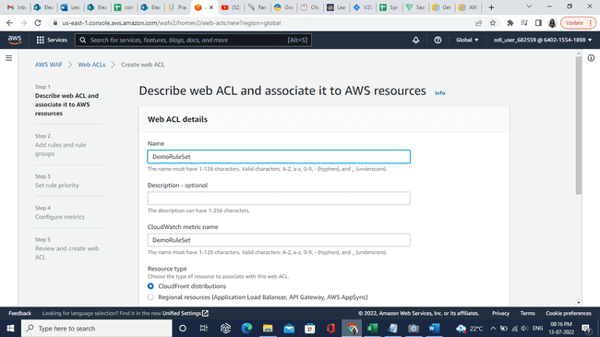

* 1. Click on the **Next** button.

* 1. In Add rules select **Add managed rule groups** option.

* 1. Select the options in **AWS managed rule groups** as shown below:

* 1. Click on **Edit** for each rule to enable **Set all rule actions to count**.

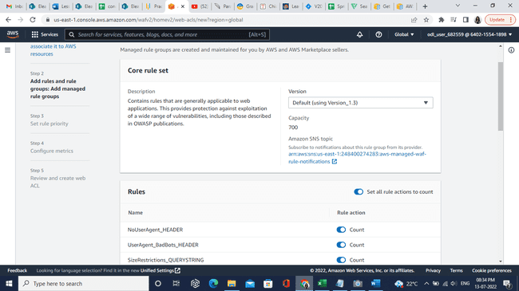

* 1. Click on the **Save rule**.

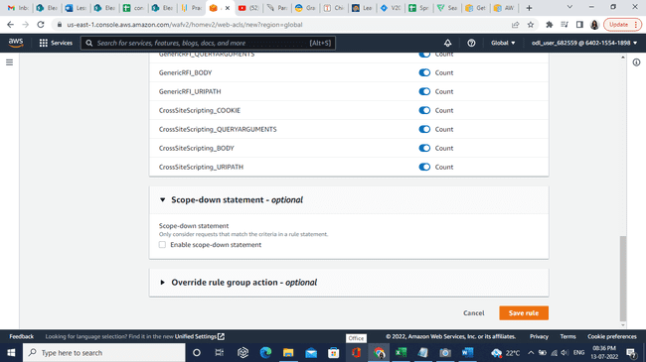

* 1. Click on **Add rules**.

* 1. Click on the **Next** button.

* 1. Click on the **Next** button.

* 1. Click on the **Next** button.

* 1. Click on **Create web ACL** button.

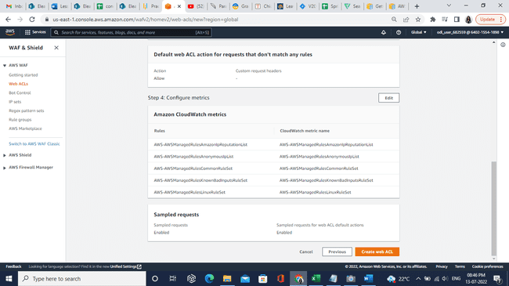

* 1. Web ACLs are created successfully.

**Step 3: Creating a Custom rule in web ACLs.**

* 1. Click on **DemoRuleSet** andselect **Rules**.

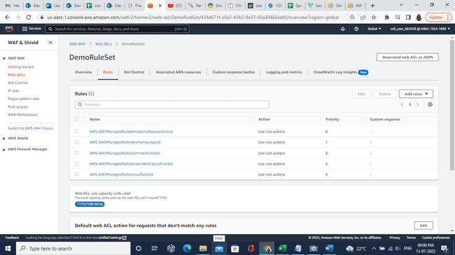

* 1. In Add **rules button** select, **Add my own rules and rule groups** option.

* 1. Select **Rule type** as **Rule builder.**

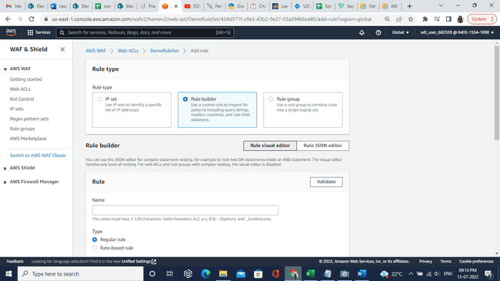

* 1. Enter Rule Name as **AdminProtection.**

* 1. In the Statement section, select **URI path** as the Inspect option.

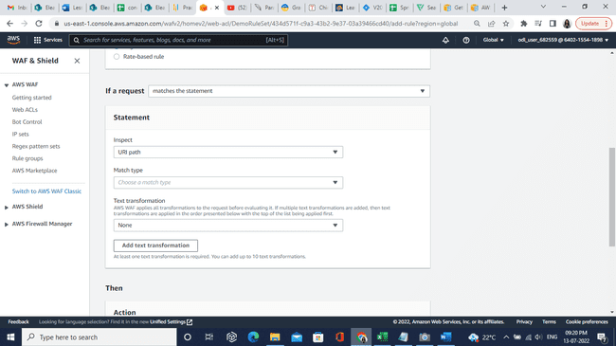

* 1. In **Match type** select the **Exactly matches string** option.

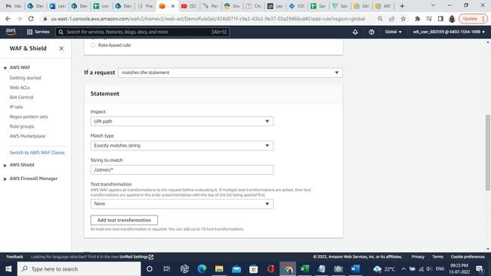

* 1. In String to match block, enter **/admin/\***.

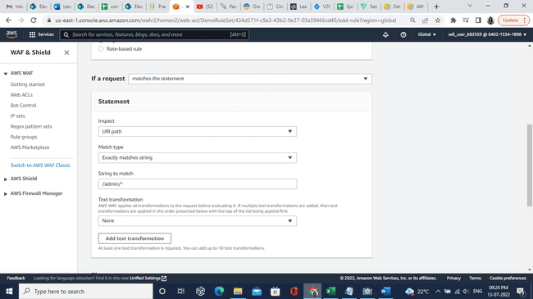

* 1. In Text transformation, select the **Lowercase** option.

* 1. Click on the **Add rule** option.

* 1. The rule is added successfully. Then click on the Save button.

