**Lesson 7 Demo 9**

**AWS Config Automated Remediation**

**Objectives:** To set up AWS Config Automated Remediation

**Tools required:** AWS WorkSpace

**Prerequisites:** Users must choose a rule and configure remediation for the rule before they can start applying remediation to noncompliant resources.

**Steps to be followed:**

1. Opening the AWS Config console by logging into the AWS Management Console at <https://console.aws.amazon.com/config/> and selecting Preferences from the navigation pane and selecting A Disable Trusted Advisor

**Step** **1:** **Open the AWS Config console logging into the AWS Management Console at https://console.aws.amazon.com/config/**

1. Login into the AWS account and open **AWS Management Console**

1.2 Upon clicking on **Services**, the following page appears

1.3 In the **Search** option, type **S3** and press enter

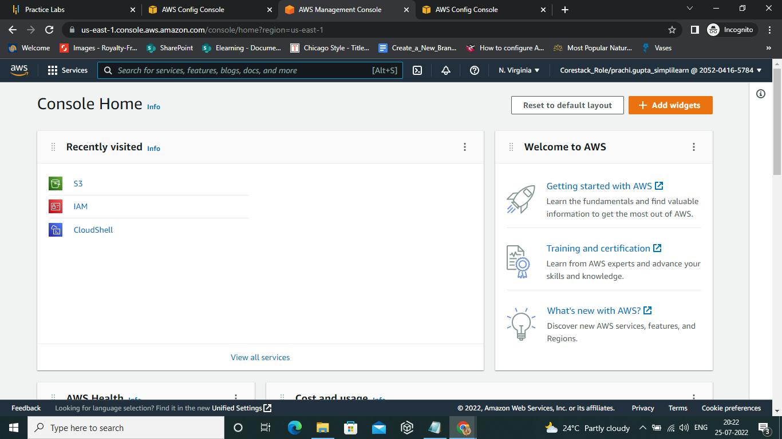

1.4 Click on **S3**,whichwill redirect to the dashboard

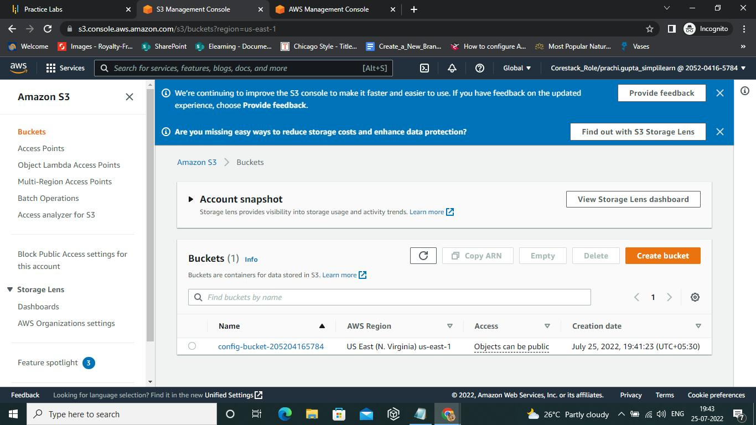

1.5 Navigate to **AWS Config.** Enter each resource type under Resource types. These resource kinds include customized, third-party, and AWS resources

* 1. Select **Record all resources supported in this region, Include global resource (e.g., AWS IAM resources),** and **Create AWS Config server-linked rule**

* 1. Enter the account ID to select a role from the account or an existing AWS Config service-linked role for **AWS Config.** AWS Config predefines service-linked roles that contain all the permissions needed for a service to call other AWS services.

* 1. Select the **Amazon S3 bucket** where AWS Config transmits configuration history and configuration snapshot files under **Delivery method**

* 1. Select **Next** if users are installing AWS Config in a region that supports rules

* 1. Next, select **Confirm**

* 1. Once AWS Config is set up, click on Rules and this will take you to the **Add Rule** page

* 1. Select **s3-bucket-server-side-encryption-enabled** from AWS Managed Rules and press **Next**

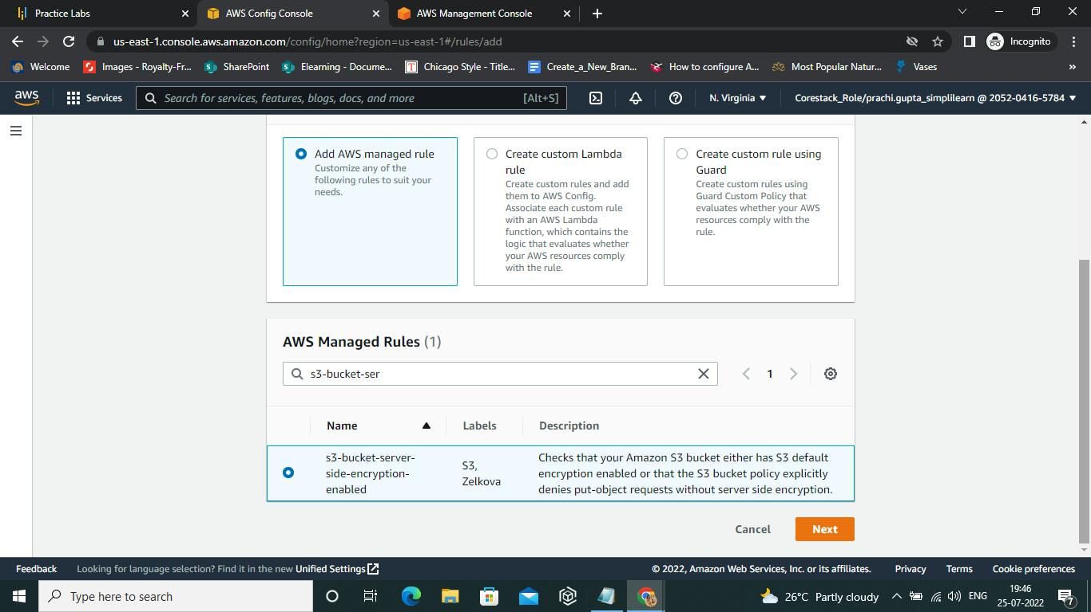

* 1. On pressing Next,the **Configure Rule** page appears

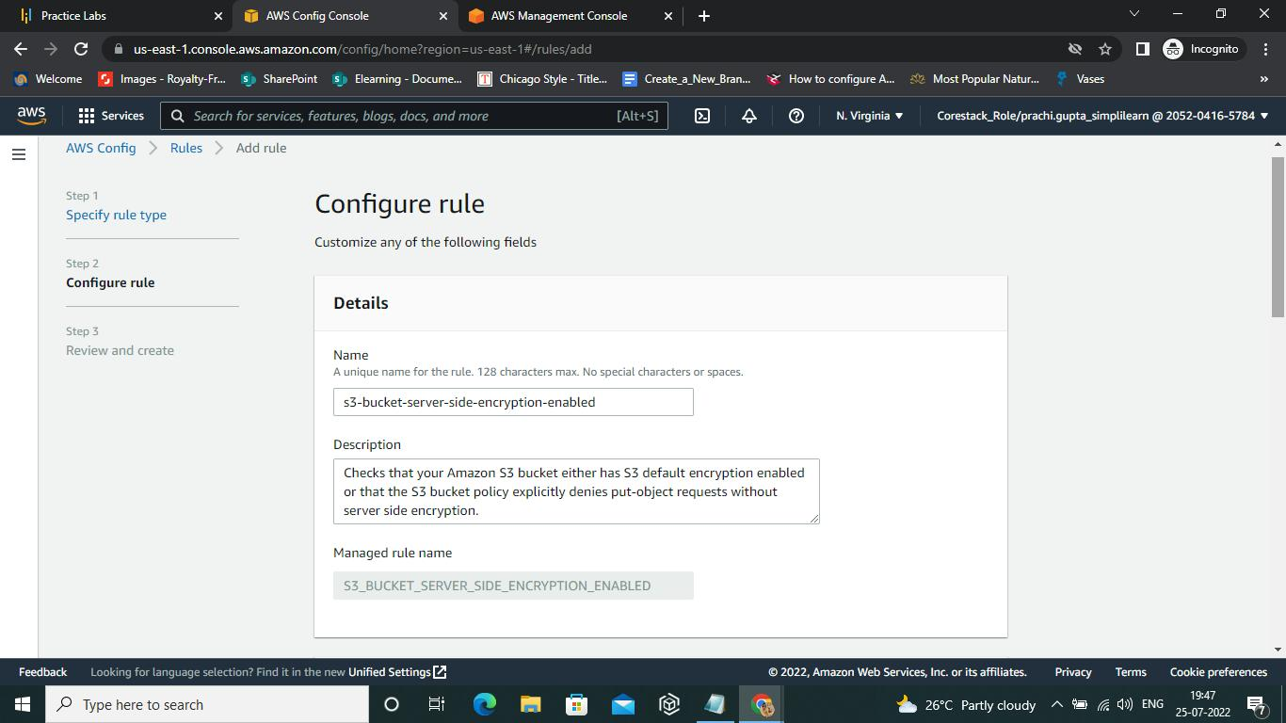

* 1. Then, on the **Review and create** page, click ok

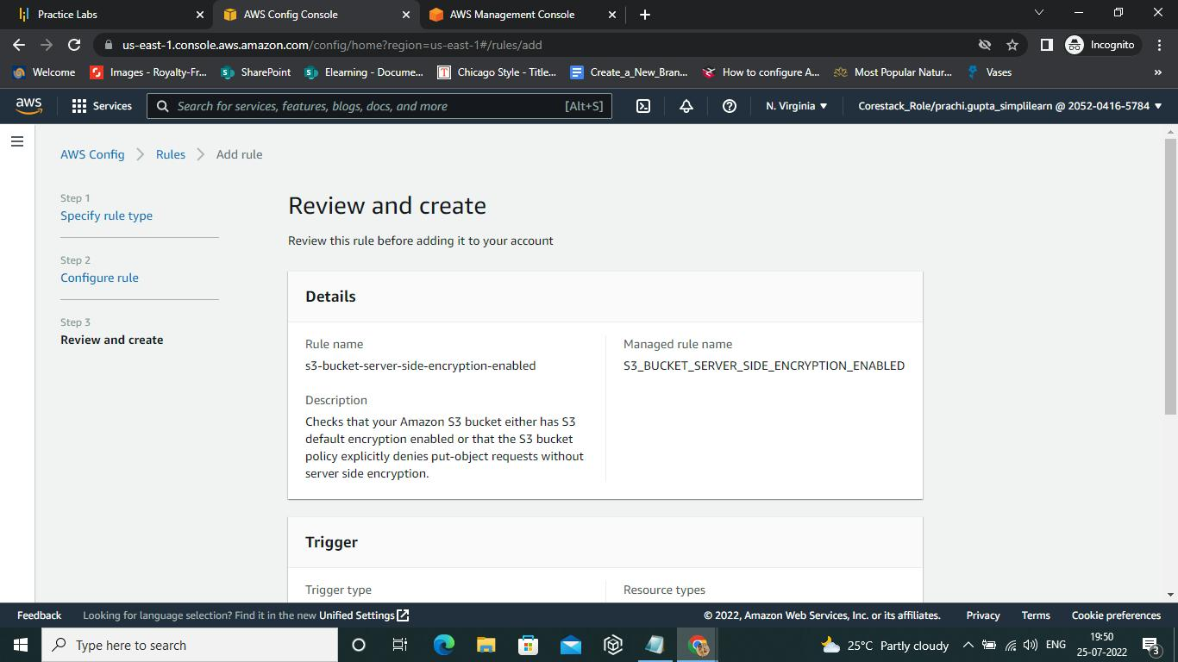

* 1. We can go back to **Aws Config** page and check the **Rule** properties

* 1. Once the validation is complete, click on the **create** button

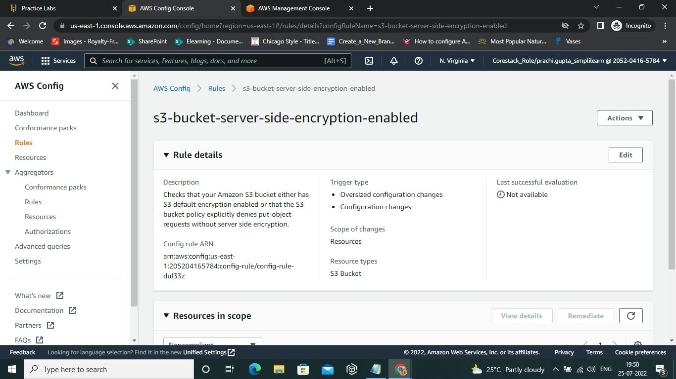

* 1. We can select **Actions** from the right-hand side of the Dashboard and can select **Remediate** from the dropdown. On selecting **Remediate**, the **Edit option for Remediation action** appears

* 1. Under **Resource ID parameter,** select one parameter based on the parameters available in the dropdown list

* 1. Now, select **Bucket** from the dropdown list and click on **Save changes**

* 1. Once the changes are saved, we are redirected to the AWS Config page with a **Success message**

* 1. To check the timeline of the Resources, check **Timeline**  
       
     A screenshot of a computer

     Description automatically generated

AWS configured automated remediation is performed.