**Lesson 7 Demo 11**

**Configure a Trusted Advisor**

**Objectives:** To set up the trusted advisor

**Tools required:** AWS workspace

**Prerequisites:** AWS account

**Steps to be followed:**

1. Open the Trusted Advisor console.
2. From the navigation pane, choose Preferences.
3. Choose Email Save Preferences.

**Step** **1:** **Open the Trusted Advisor console.**

1. Navigate to the AWS portal home screen and click on the **Services** tab.A screenshot of a computer

   Description automatically generated
2. On the **Services** page, click on **Management & Governance.**

1. Under the **Management & Governance**, click on **Trusted Advisor.**

1. On clicking the **Trusted Advisor** page, we navigate inside the **Dashboard** page.

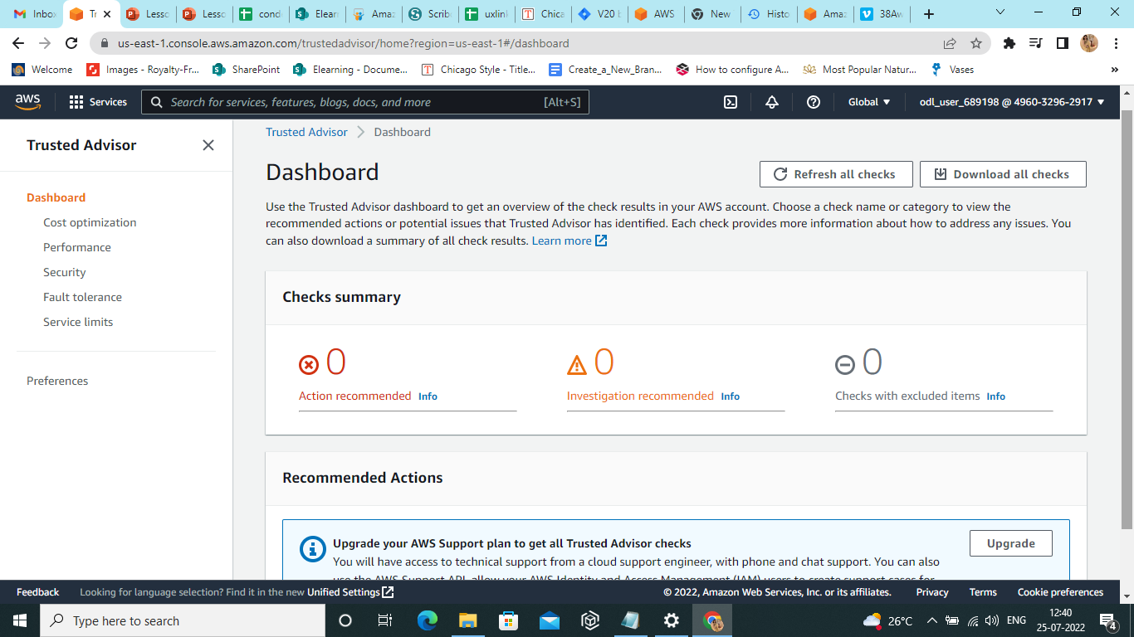

**Step 2: From the navigation pane, choose Preferences.**

1. On the **Dashboard** page, select **Preferences.**

**Step 3: Choose Email save preferences.**

