**Lesson 7 Lesson-End Project**

**Create and Configure Groups and Users Using Policies**

**Project agenda:** To create and configure groups and users using policies

**Description:** The admin of a corporate decides to **create 3 groups** (each with any 2 policies) of IAM users (2 in each group), each with their own set of policies for the tasks in their respective groups.

**Tools required:** AWS

**Prerequisites:** CloudShell must be installed

**Expected deliverables:** Out of the three groups, one group also must operate using CLI, without logging into the AWS console.

**Steps to be followed:**

1. Creating a group.
2. Configure the user for CLI operation.

**Step 1:** Creating a group.

* 1. In the dashboard, search and select IAM.

* 1. Click on the **User groups**.

* 1. Click on the **Create group** button.

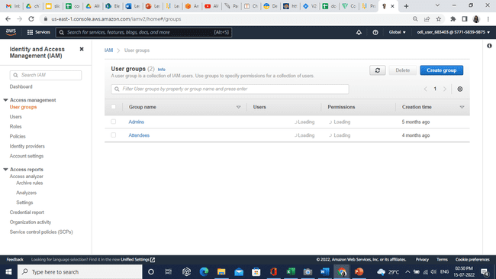

* 1. In the **User group name,** section enter **group1.**

* 1. In Attach permissions policies section, search **s3** and select the policies as shown below:

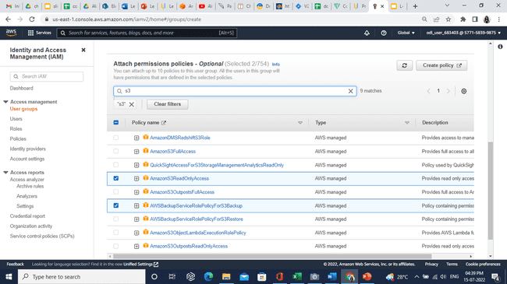

* 1. Click on the **Create group** button.

* 1. **group1** is created successfully.

* 1. Follow the same above procedure for creating **group2** and **group3**.

* 1. In the IAM dashboard, search and select **Users**. Then click on **Add users** button.

* 1. In the **User name** section, enter **user1_group1** and select AWS access type as shown below.

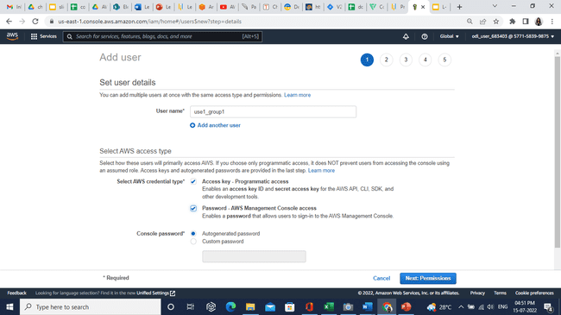

* 1. Click on the **Next: Permissions** button.

* 1. In **Add user to group,** select **group1** and click on **Next: Tags.**

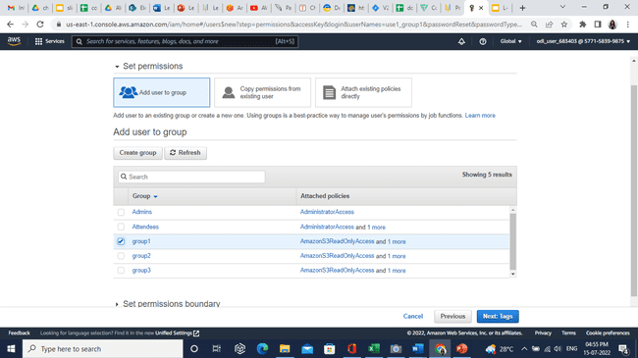

* 1. Click on the **Next: Review** button.

* 1. Click on the **Create user** button.

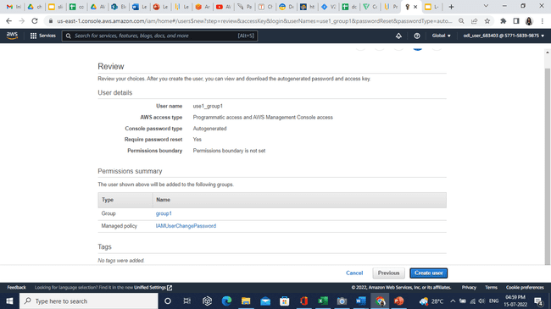

* 1. Download **.csv** file. And click on the **Close** button.

* 1. Now, create 6 users and attach every 2 users to 3 groups following the above procedure.

**Step 2:** Configure the user for CLI operation.

* + 1. In the dashboard search and select **CloudShell.**

* 1. Enter the following command:

**aws configure**

* 1. Open the downloaded **.csv** file and copy-paste the Access key ID and Secret access key into the terminal.

User is configured successfully.