**Lesson 8 Demo 1**

**Create Lambda Function, Test, and View Logs**

**Objectives:** To create the Lambda function, test, and view CloudWatch logs

**Tools**: AWS Lambda, AWS S3

**Prerequisites:** AWS Lab access with an AWS account created

**Steps to be followed:**

1. Log in to your AWS lab.
2. Go to Lambda service
3. Create Lambda function
4. Deploy the code
5. Test the code
6. View the CloudWatch logs

**Step 1: Log in to your AWS lab**

**Step 2: Go to Lambda service**

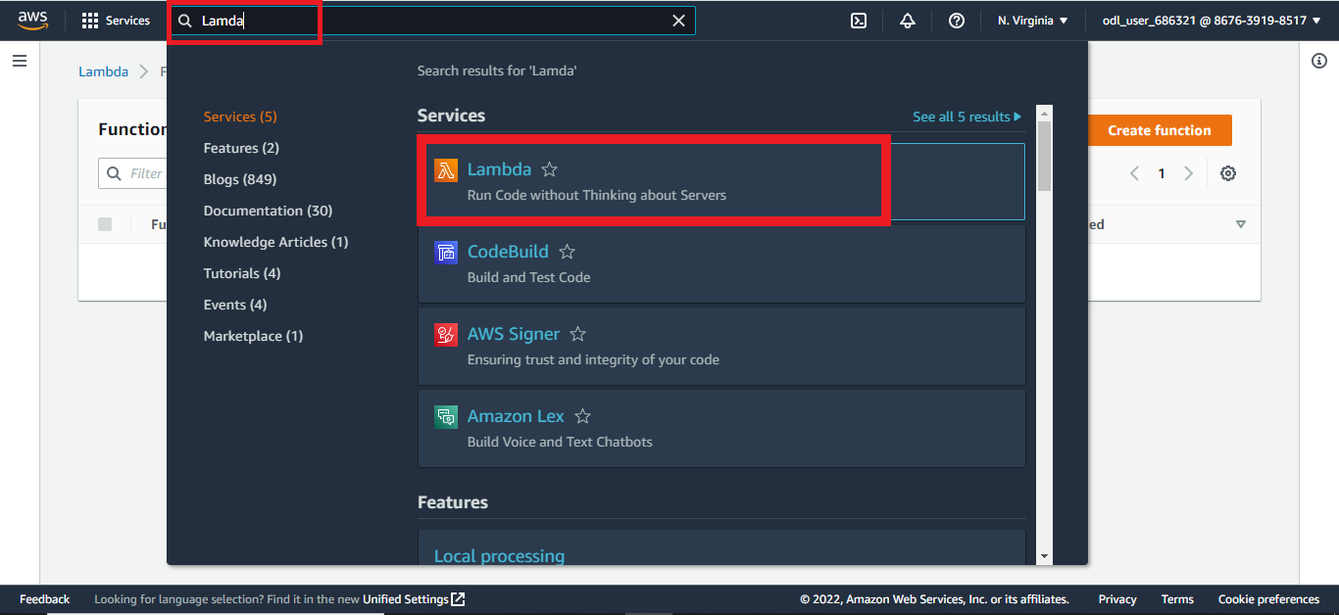

**Step 3: Create the Lambda function**

1. Select the **author from the scratch** option and add the **function name**.

1. Select python 3.9 as the language to write your function.

1. Create a new role from the policy templates.

1. The Lambda function is created.

**Step 4: Deploy the code**

4.1 Add the below code:

import json

def lambda_handler(event, context):

print('YOURLAMBDAFUNCTIONISSUCCESSFUL')

return {

'statusCode': 200,

'body': json.dumps('Hello from Lambda!')

}

4.2 Deploy the below code after configuring the test event.

**Step 5: Test the code**

**Step 6: View the cloudwatch logs**

The above mentioned are the cloudwatch logs.