**Lesson 8 Demo 2**

**Lambda Layers**

**Objective:** To create and configure the Lambda layer

**Tools required:** AWS Lab

**Prerequisites:** None

**Steps to be followed:**

1. Create a Lambda Function
2. Creating a Lambda Layer

**Step 1: Create a Lambda Function**

* 1. In the dashboard, search and select **Lambda**.

* 1. Click on the **Create function**.

* 1. In the **Basic information,** specify the following values:

1. Function name: simplilearn_lambda_function
2. Runtime: Node.js 16.x
3. Architecture: x86_64

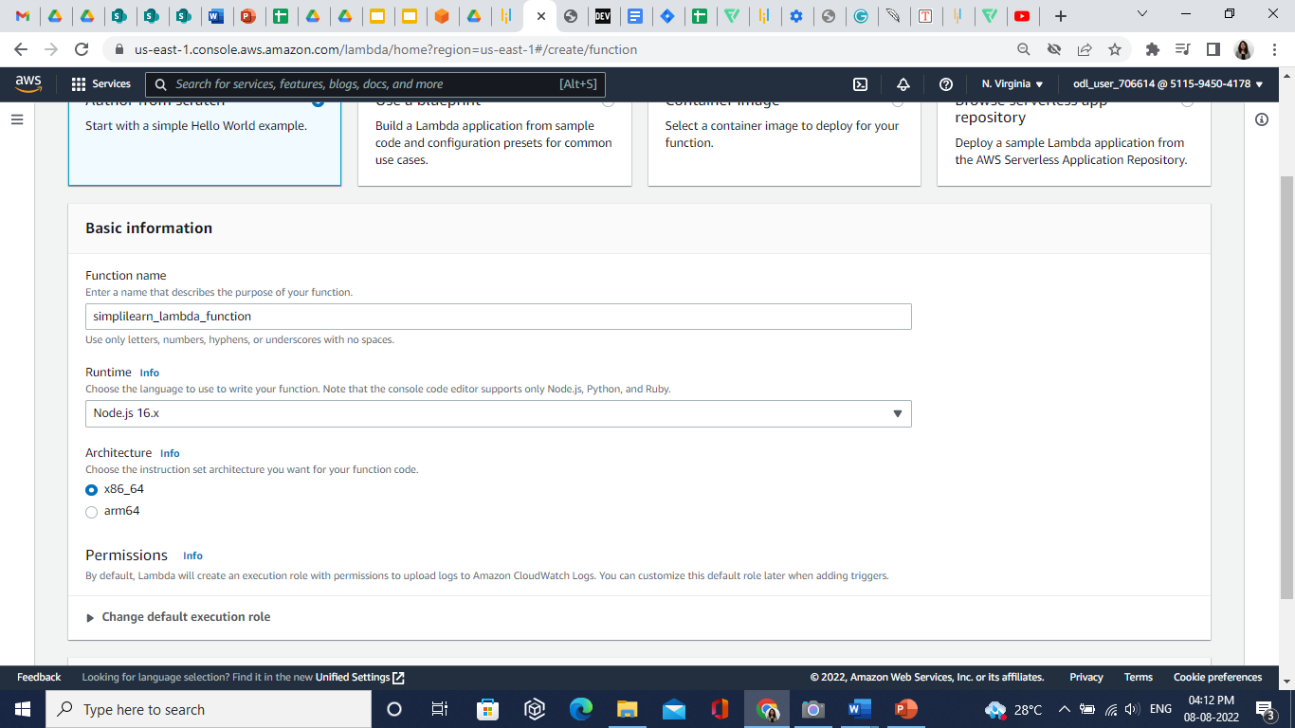

* 1. In the **Change default execution role section,** select **Create a new role with basic Lambda permissions.**

* 1. Click on the **Create function**.
  2. Lambda layer is created successfully.

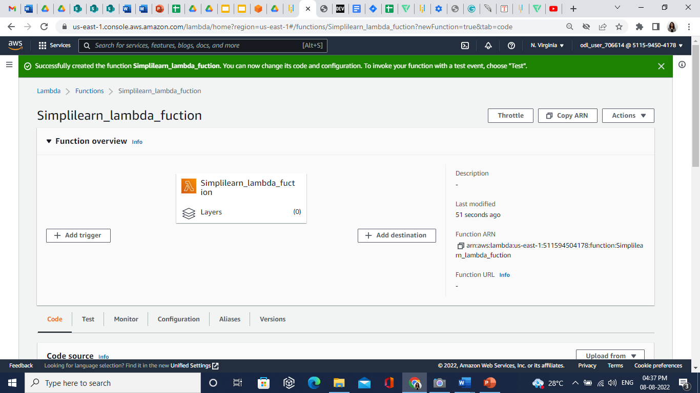

**Step 2: Creating a Lambda Layer**

* 1. In the created Lambda function, below the page select, in the **Layers** section, and click on the **Add a layer** button.

* 1. In the **Choose a layer** section, specify the following values:

1. Layer source: AWS layers
2. AWS layers: LambdaInsightsExtention
3. Version: 21

* 1. Click on the **Add** button.
  2. Lambda layer is created successfully.

