**Lesson 8 Demo 03**

**Create a Serverless Web App**

**Objectives:** To set up the prerequisites and create a VPC serverless web app

**Tools require:** AWS workspace

**Prerequisites:** None

**Steps to be followed:**

1. Creating a Serverless Web App

**Step** **1:** **Creating a Serverless Web App**

1. Navigate to the AWS portal home screen and click on the searchtab, click on **CloudShell**:

1. The **CloudShell** opened**:**

1. Enter **sam init** in the console**:**

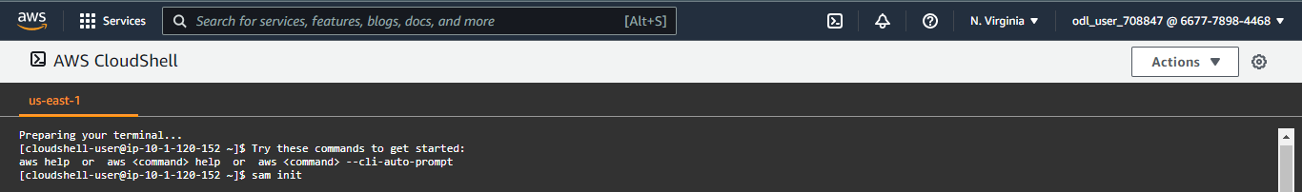

* 1. Enter **1 - (AWS Quick start template)** under choice for template**:**

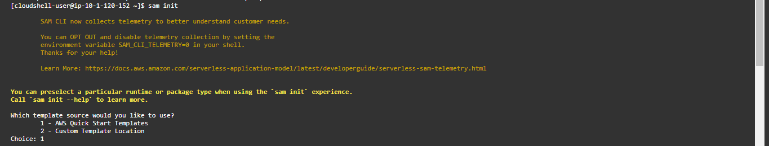

* 1. Enter **1 - (Hello World Example)** under **Template**:

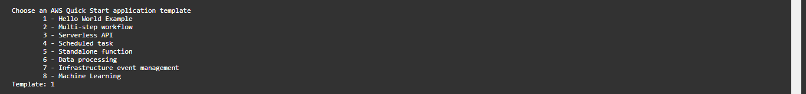

1. Enter **n**:



1. Enter choice **15 - (python3.7)** in **Runtime**:

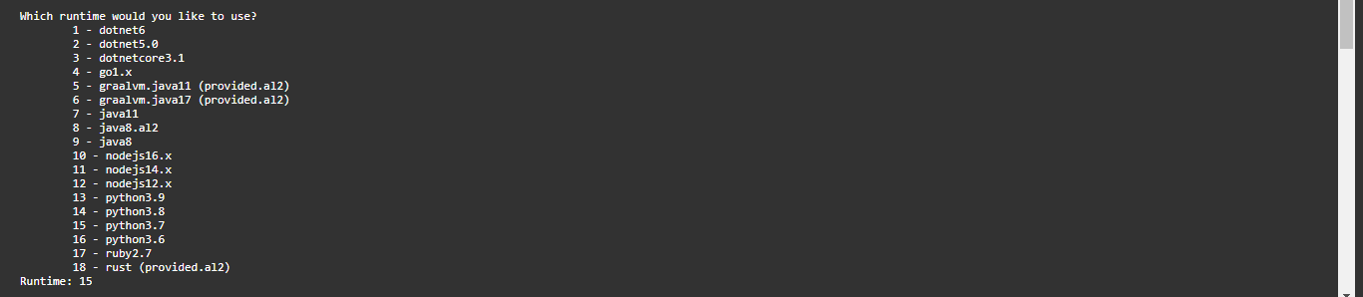

1. Enter **1 - (Zip)** in **Package type:**



1. Enter **y** to enable X-ray tracing**:** 
   1. Enter **test1** in **Project name:** Graphical user interface, text

      Description automatically generated
   2. Enter **cd test1** thenpress enter, and enter **sam build:**

* 1. Enter **y** in **Deploy this changeset**:

1.14 Copy URL in Outputs, under **Value**:

1.15 Open a tab in the browser and paste the URL and press enter:

