**Lesson 8 Demo 4**

**SQS Standard Queue, Visibility Timeout, DLQ**

**Objective:** To create a standard queue and perform the visibility timeout and DLQ

**Tools required:** AWS Lab

**Prerequisites:** None

**Steps to be followed:**

1. Create Standard SQS Queue
2. Send and Receive Messages
3. Message Polling
4. Visibility Timeout
5. Create DLQ

**Step 1: Create Standard SQS Queue**

* 1. In the dashboard, search and select the **Simple Queue Service** and Click on the **Create queue** button:

* 1. In the **Details** section, specify the **Type** as **Standard** and **Name** as **simplilearn_standard_queue:**

* 1. In the **Configuration** section, Specify the **Visibility timeout** as 30, **Delivery delay** as 4, and **Receive message wait time** as 5:

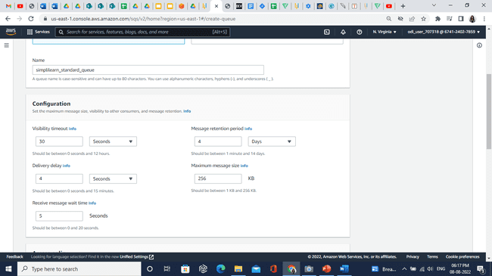

* 1. In the **Access policy**, keep the values default and click on the **Create queue** button:

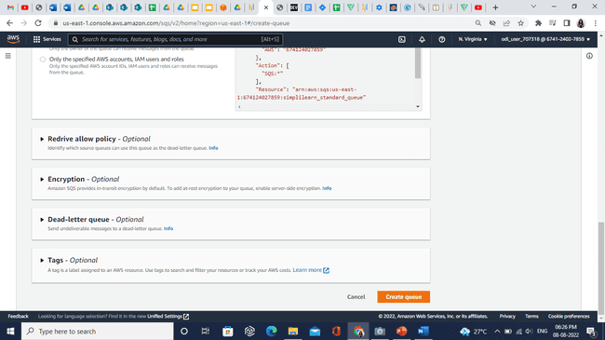

**Step 2: Send and Receive Messages**

* 1. Click on the **Send and receive messages** button:

* 1. In the **Send message** section, Specify the following values:

1. Message body: welcome to the Simplilearn
2. Delivery delay: 0
3. Click on the **Send message** button

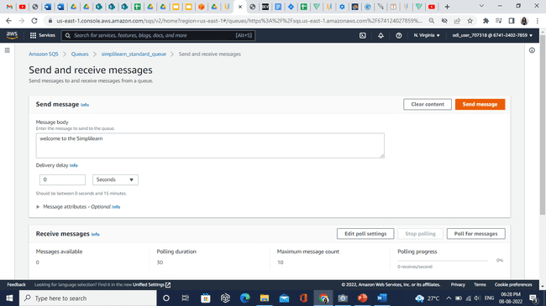

**Step 3: Message Polling**

* 1. Click on the **Poll for messages** button:

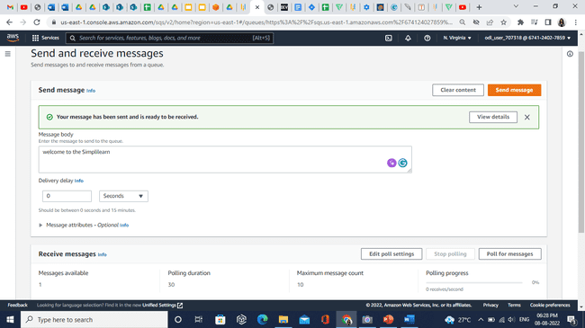

* 1. In the **Messages**, a message will appear. Click on the message **ID,** in the **Body** tab we can see the sent message:

**Step 4: Visibility Timeout**

* 1. Select the **Simplilearn_Standard_queue**. Edit the **Visibility timeout**. Click on the **Save** button.

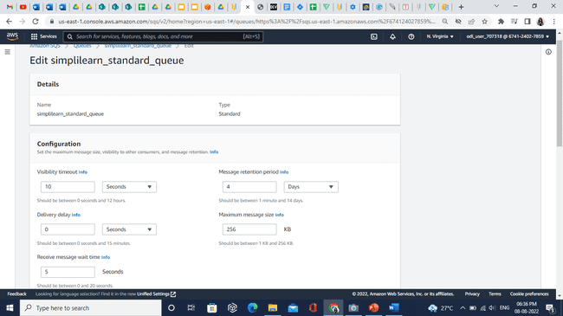

* 1. Click on the **Send and receive messages**.

* 1. In the Message body enter **Visibility timeout.** Click on the **Send message** button.

* 1. Click on the **Poll for messages** button. Message will appear in the **Messages** section.

**Step 5: Create DLQ**

* 1. Create another queue named as **dead-letter-queue**.

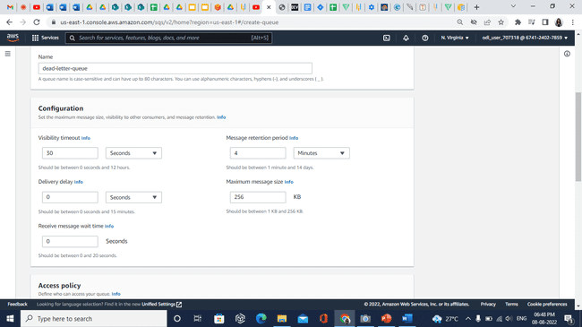

* 1. Click on the **Create queue** button. Click on the **Simplilearn_Standard_queue**. Then click on **Edit** button.

* 1. In the **Dead-letter-queue** section, specify the following values:

1. Set this queue to receive undeliverable messages: Enabled
2. Choose queue: select the dead-letter-queue
3. Maximum receives: 1

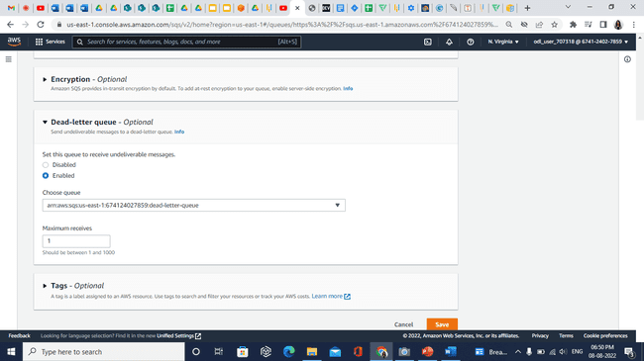

* 1. Click on the **Save** button. Select the **Simplilearn_Standard_queue** and click on the **Send and receive messages**.

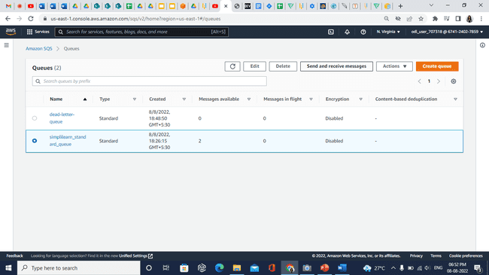

* 1. In the **Message body**, enter **Simplilearn** and click on the **Send message** button.

* 1. Go back to **Queues**, in the **Message** **available** we can see the total count is **3**.

* 1. Select the **Simplilearn_Standard_queue,** click on the **Send and receive messages**.

* 1. Click on the **Poll for messages**. The message will appear.

* 1. Go back to **Queues** page. Refresh the page 2-3 times. We will see messages are moved into **dead-letter-queue**.

* 1. Click on the **dead-letter-queue**.

* 1. Click on the **Start DLQ redrive** button.

* 1. In the **Velocity control settings**, select **System optimized**.

* 1. Click on the **DLQ redrive** button.

* 1. Go back to **Queues** page. We will see message is sent back to **Simplilearn_Standard_queue**.

