**Lesson 8 Demo 5**

**SQS FIFO Queue, Deduplication ID, Message Group**

**Objective:** To launch SQS, send messages using group id and duplication id

**Tools required:** AWS Lab

**Prerequisites:** None

**Steps to be followed:**

1. Create a Queue
2. Send Messages Including Message Group ID and Duplication ID

**Step 1: Create a Queue**

* 1. Open the AWS dashboard, search and select the **Simple Queue Service.**

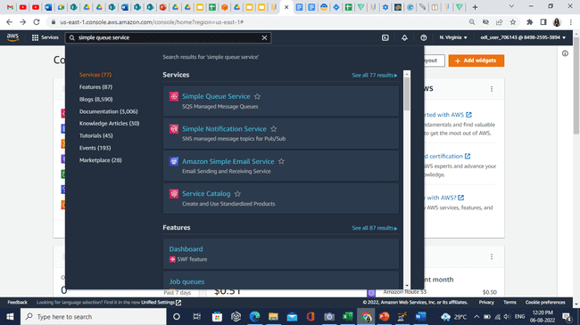

* 1. Click on the **Create queue**.

* 1. In the **Details** section, select **FIFO**.

* 1. Enter the name **Simplilearn-FIFO.fifo.** in the **Name** field.

**Note:** While entering the name don’t forget to add the **.fifo** suffix.

* 1. In the **Configuration** section, enable the **Content-based deduplication** option.

* 1. Click on the **Create queue**.

**Step 2: Send Messages Including Message Group ID and Duplication ID**

* 1. Click on the **Send and receive messages**.

* 1. In the **Send message** section, enter the following values:

1. Message body: Hello first message
2. Message group ID: simplilearn-group-id

* 1. In the **Message attributes,** specify the following values:

1. Name: Name
2. Enter value: Hello_world

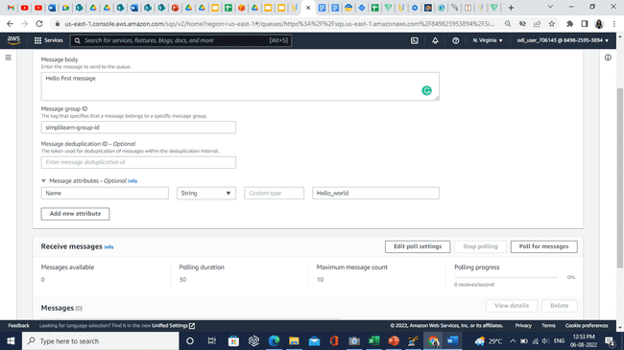

* 1. Click on the **Send message**.

* 1. In the **Receive messages** section, you can see the received message.

* 1. Click on the **Poll for messages.**

* 1. Message ID will appear here.

* 1. Click on the ID, in the **Body** tab you can see the message you have sent.

* 1. If you click on the **Send message** using the same **Message body** and **Message group ID,** it will not create any duplicate ID.
  2. Go back to the Message body again and edit the message. Keep the Message group ID the same.

* 1. Click on the **Send messages**.
  2. In the **Receive messages** section, you can see 2 messages available.

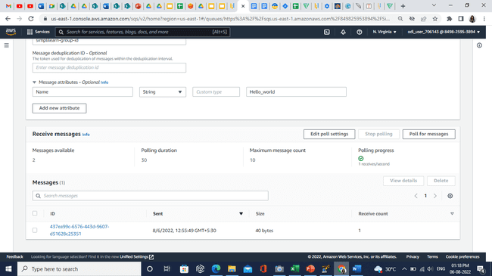

* 1. Click on the **Poll for messages**.
  2. In the **Messages**, you can see 2 different ID.

* 1. Click on the new created id, you can see the message you have sent.

