**Lesson 8 Demo 7**

**Create a Kinesis Data Stream**

**Objectives:** To set up the prerequisites and create a Kinesis Data Stream

**Tools required:** Amazon Workspaces

**Prerequisites:** AWS account

**Steps to be followed:**

1. Setting up the prerequisites for configuring a Kinesis Data Stream

**Step** **1:** **Setting up the prerequisites for configuring a Kinesis Data Stream**

1. Navigate to the Amazon Kinesis home screen and click on the Kinesistab

1. On the page, click on **Create data stream** under the **Kinesis Data Stream**

1. Scroll down the page and click on **Create data stream**

1. **Kinesis Data Stream** has been created successfully.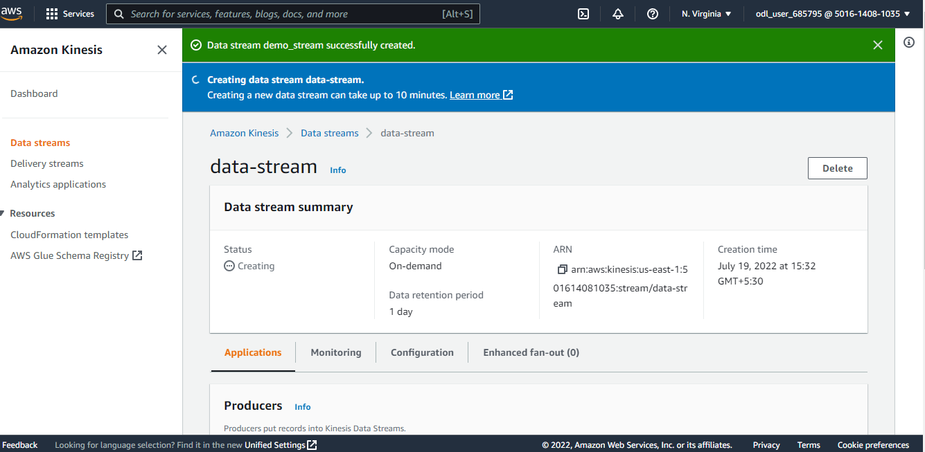
2. Under Capacity mode, if the user clicks on Provisioned. The user should enter the number of Provisioned and the number of shards to see the total data stream capacity.Graphical user interface, text, application, email

   Description automatically generated
3. The total capacity of a stream is the sum of the capacities of its shards. When we enter the number of streams, we get the number of provisioned shards. Hence the shards are counted successfully.  
   Graphical user interface, text, application, email

   Description automatically generated