**Lesson 8 Demo 8**

**Create a Kinesis Firehose**

**Objectives:** To publish streaming data to Firehose from CLI and Store in S3

**Tools required:** AWS Workspaces

**Prerequisites:** Amazon account

**Steps to be followed:**

1. Setting up Kinesis data Firehose and storing it in S3

**Step** **1:** **Setting up Amazon Kinesis Data Firehose and storing it in S3**

1. Navigate to the Amazon portal home screen and click on the **Create delivery stream** tab

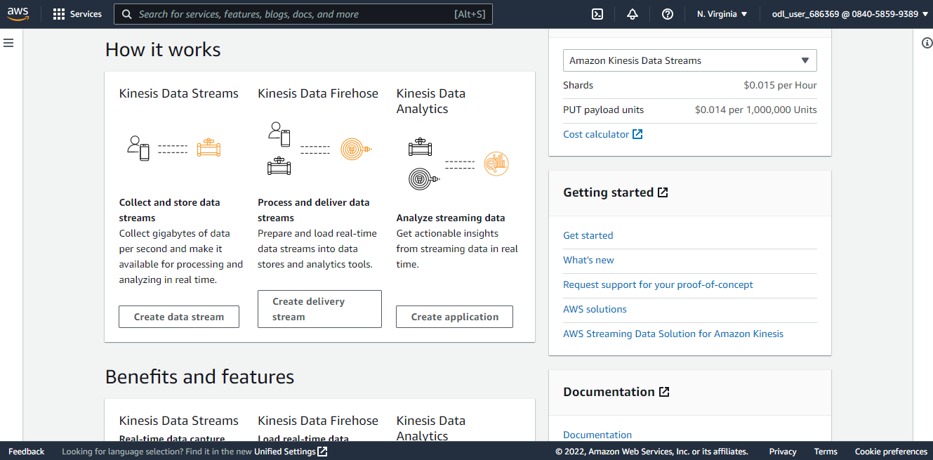

1. Upon clicking on **Create delivery stream**, the following page will appear. Select the source as **Direct PUT** and destination as **Amazon S3**

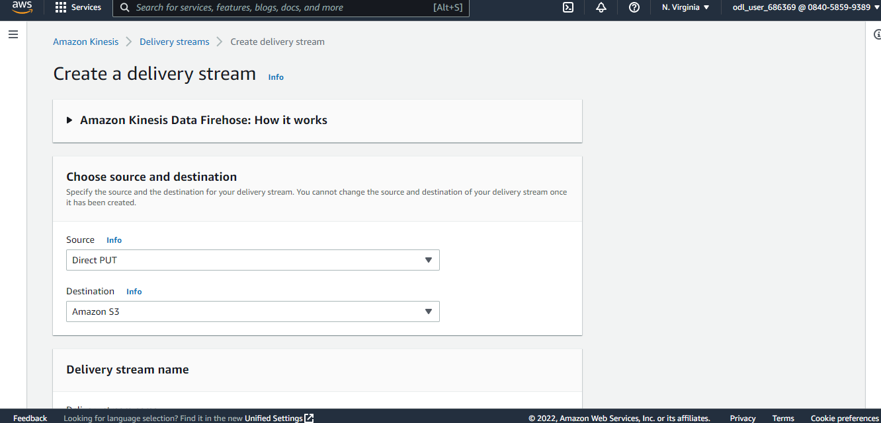

1. Now, create the S3 bucket

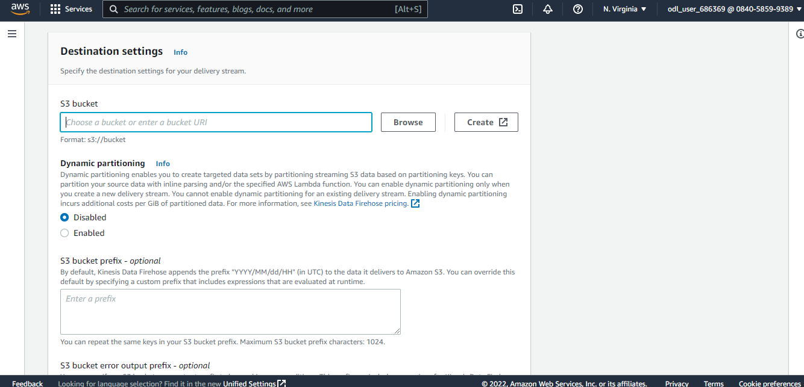

1. The user will then be directed to the following page:

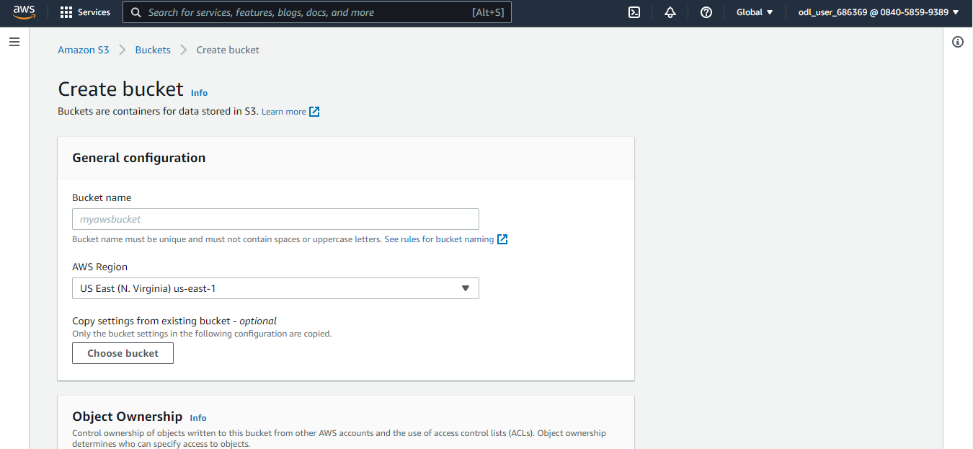

1. Next, enter the bucket details

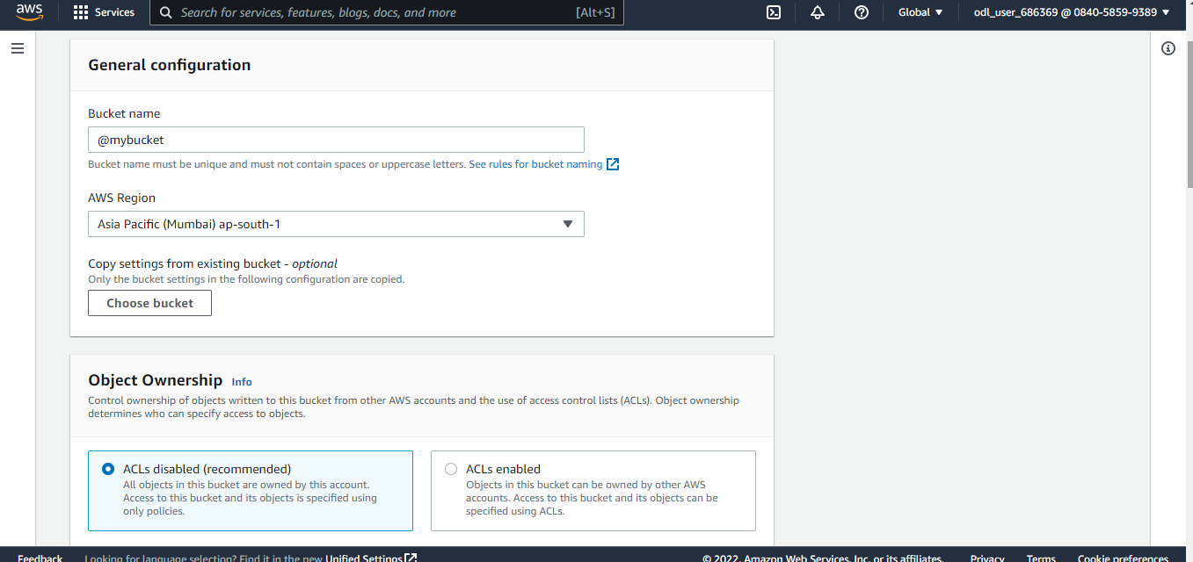

1. Scroll down to the **Block Public Access settings for this bucket**

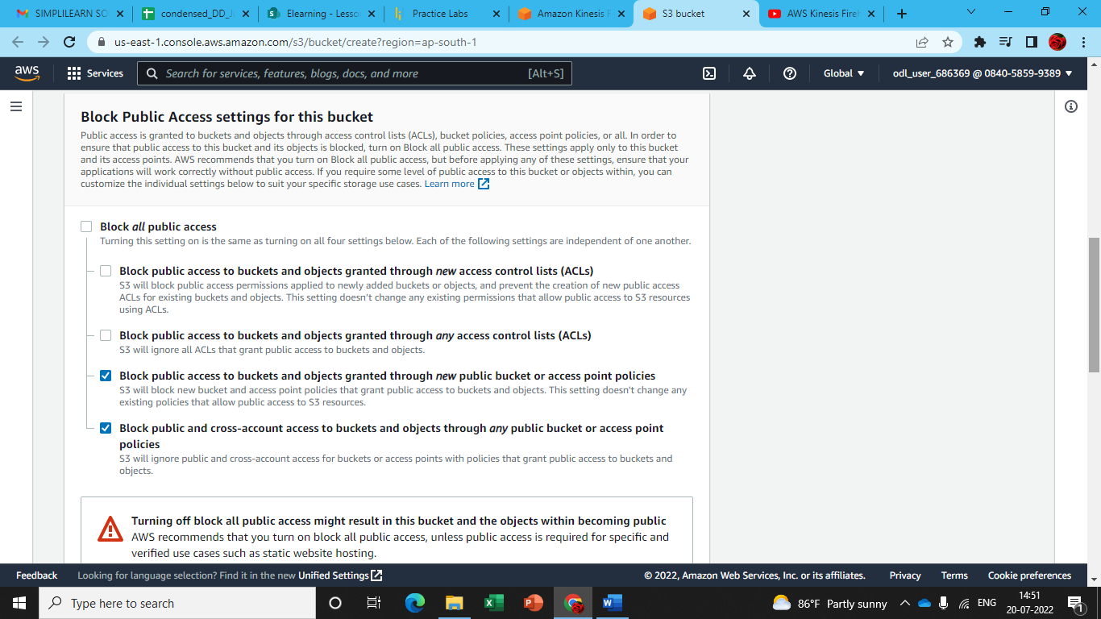

1. Click on the acknowledgment

1. Once the bucket creation is completed, click on **Create bucket**  
     
   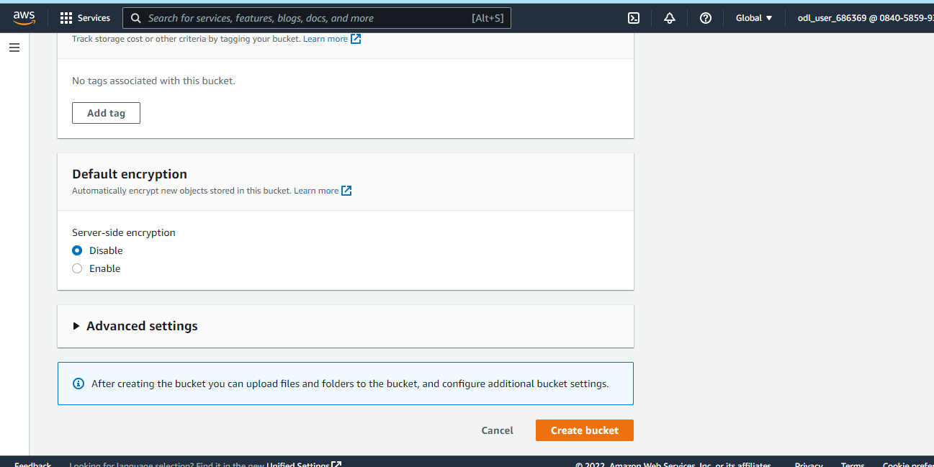

1.10 The bucket is created successfully.

1.11 Now, go back and click on the **browse** button

1.12 Click on bucket name and click on **Choose**

1.13 The bucket name will be displayed as follows:

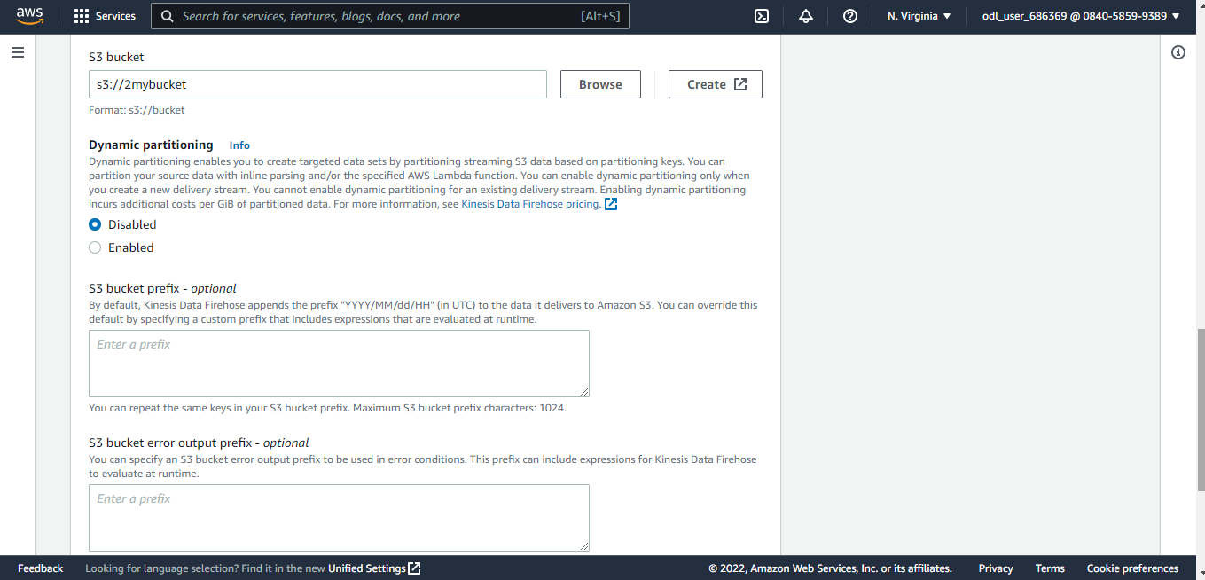

1.14 Now, click on **Create delivery stream**

1.15 Amazon data Firehose is successfully created.

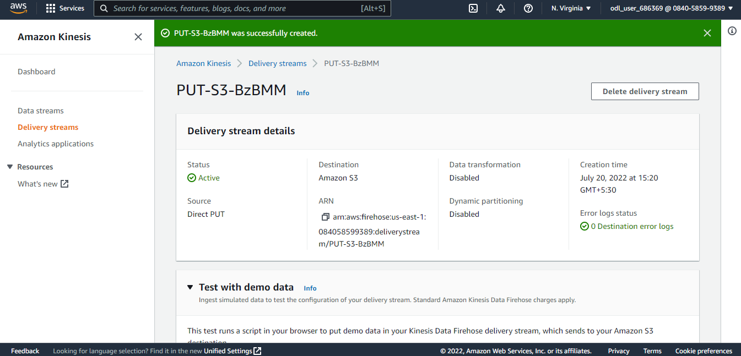

1.16 Here is the demo data to test the delivery stream. Click on **Start sending demo** **data**

The **Delivery stream metrics** information will appear here.



