**Lesson 8 Lesson-end Project**

**Launch a Lambda Function Performing a Task of Copying Contents Across S3 Bucket**

**Project agenda:** To launch the lambda function, perform the trigger operation on lambda

**Description:** Highly Available Architectures on AWS have business-transforming capabilities. As a solution architect, you have to replicate the contents of a bucket to the other buckets deployed in different regions, thereby making the resources highly available.

**Tools required:** AWS

**Prerequisites:** None

**This section will guide you to:**

1. Create an S3 Bucket
2. Create the Lambda Function
3. Test the Lambda Function
4. Add Trigger
5. Add Destination

**Step 1: Create S3 Bucket**

1. In the Amazon console, search for **S3** in the search bar.

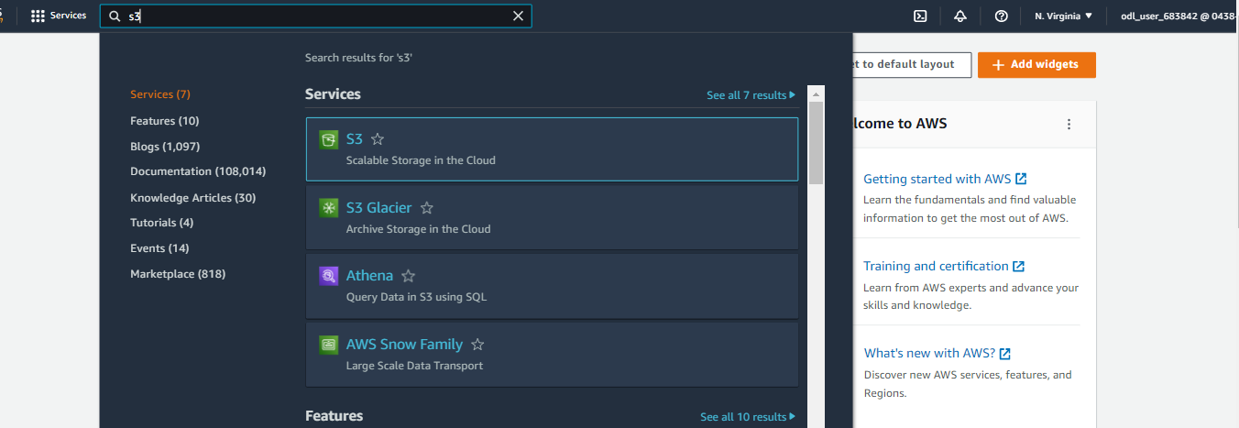

1. In the AWS S3 console, click **Create bucket.**

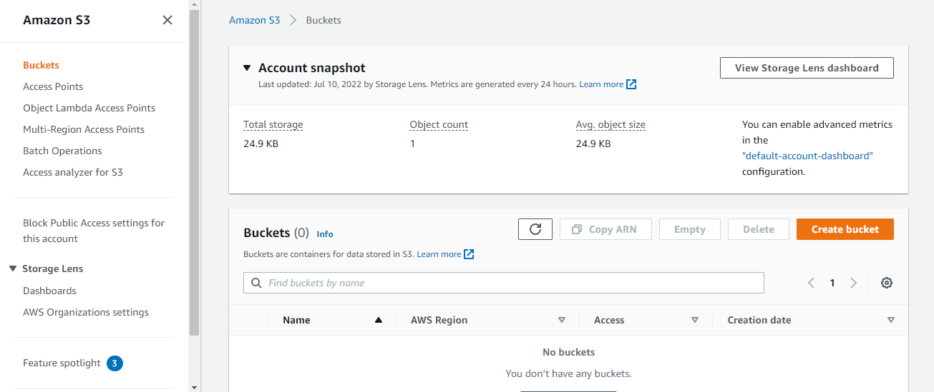

1.3 Add a name and unselect **Block all public access** and select the acknowledgment button

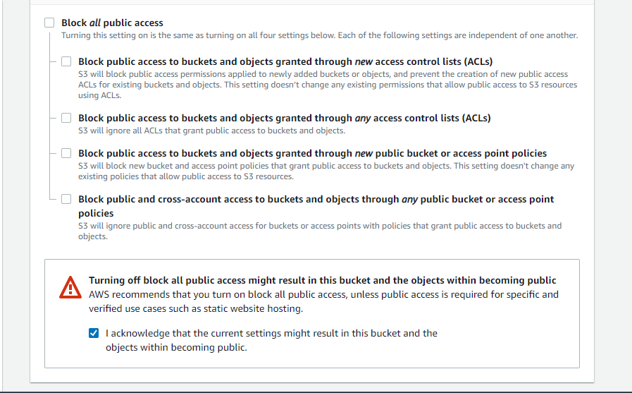

1. Click **Create bucket**

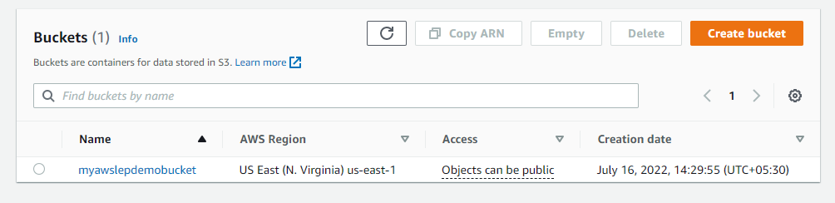

**Step 2: Create Lambda function**

1. In the Amazon console, search for **Lambda** in the search bar.

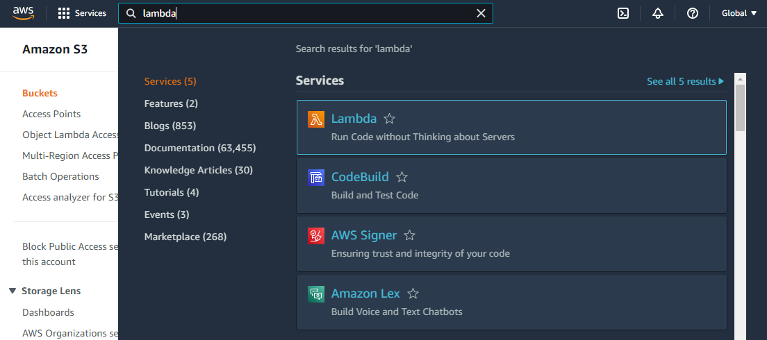

* 1. Select **Lambda** and click **Create function.**

1. Add a name and select **Python 3.6** from **Runtime** options.

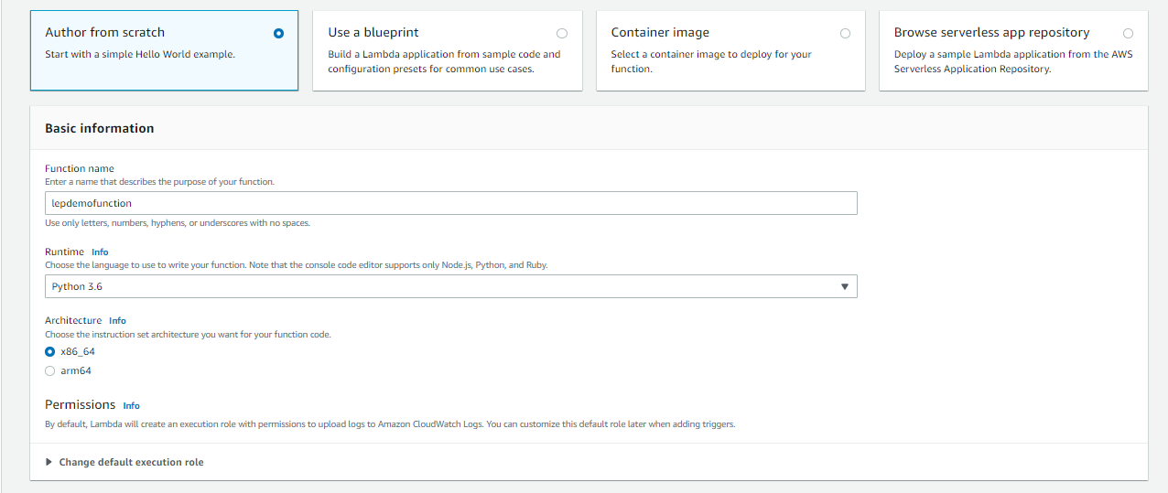

1. Click **Create function**

**Step 3: Test the Lambda Function**

1. Add **print("LAMBDAFUNCTIONTESTINGDONESUCESSFULLY")** to the code source

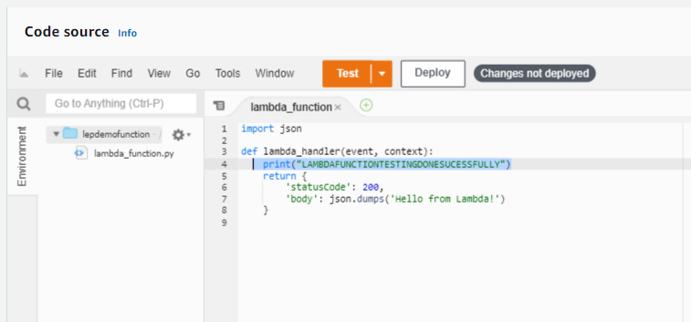

3.2 Select **Deploy**

1. Click on the **Test** button

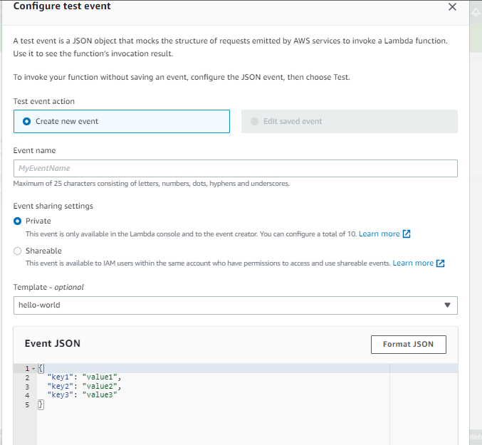

1. Add an event name and click **Save**

**Step 4:** Add Trigger

1. Select **Add trigger**

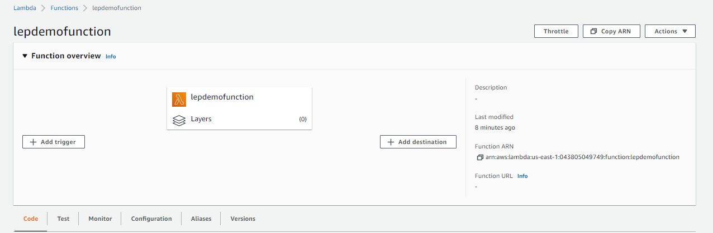

1. Select **S3** in the **Trigger configuration**

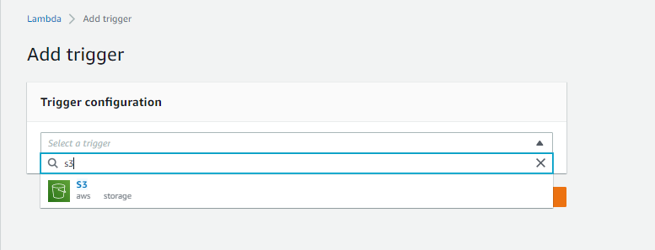

1. Select the bucket created from the **Bucket** dropdown and select **PUT** in **Event type**

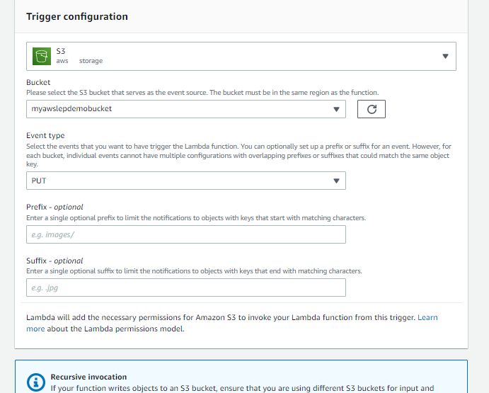

1. Click **Add**

**Step 5:** Add destination

1. Click on **Add destination** button from the **Function overview**

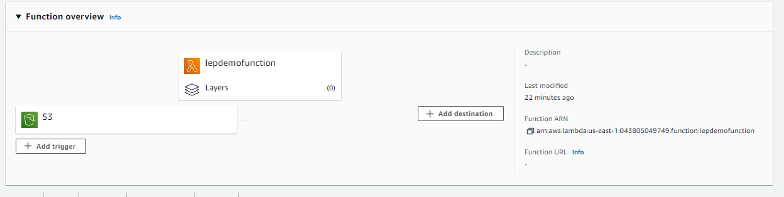

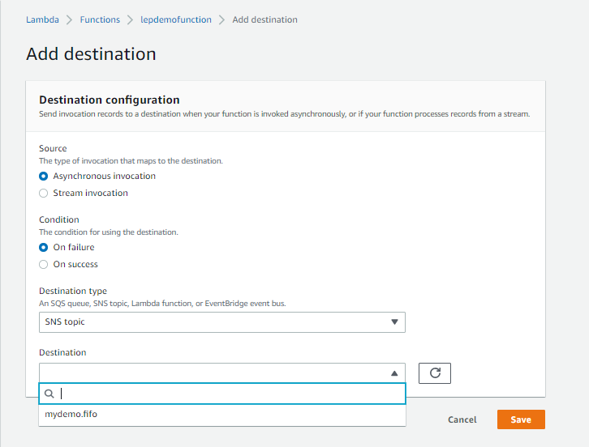

NOTE:

Choose/Create the topic with the targeted subscribers.