**Lesson 9 Demo 1**

**CloudWatch Alarm**

**Objective:** To stop an idle instance using the CloudWatch alarm

**Tools required:** AWS account

**Prerequisites:** A running EC2 instance.

Steps to be followed:

1. Create the CloudWatch alarm to stop the instance.

**Step 1: Create CloudWatch alarm to stop the instance**

* 1. In the AWS management console, search for **CloudWatch** and then click on

**CloudWatch:**

1.2In the CloudWatch menu, click on **Create alarm:**

1.3 Click on **Select metric** then click on **Next:**

1.4 Click on **EC2** and then select **Per-Instance Metrics:**

1.5 In the Metric table, select the **CPUUtilization** of your instance and then click on **Select metric:**

1.6 Select **Static** in the **Threshold type, Lower** in **CPUUtilization** andenter **30** in **threshold   
 value** and then click on **Next:**

1.7 In Alarm state trigger do the following:

* Select **In alarm** and select **Create new topic**
* Enter the **topic name** and **email id**,then click on **Create topic**

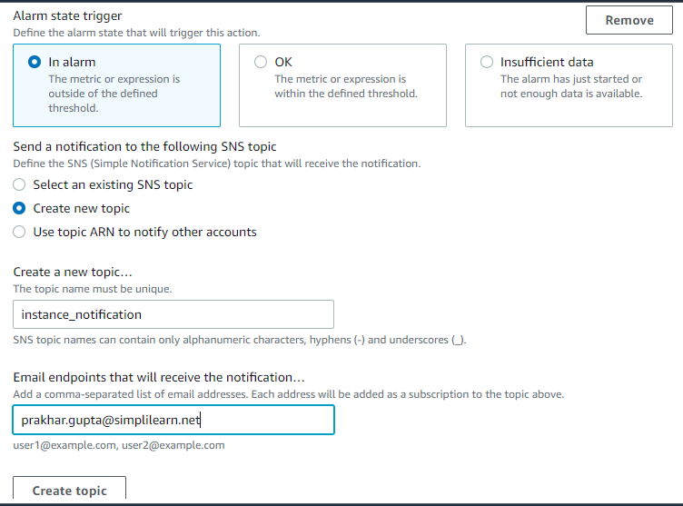

**Note:** Once the new topic is created, **Select an existing SNS** topic will be automatically selected.

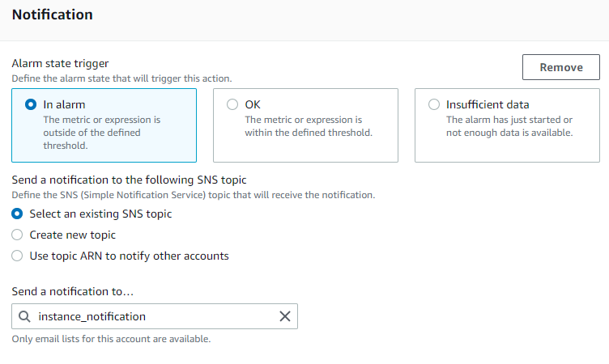

1.8 In the **EC2 action,** select **Stop this instance:**

1.9 In **Add name and description,** write any name for your alarm, then click on **Next:**

1.10 Once the alarm is created, it will appear on the **Alarms** dashboard:

1.11 Now go to the EC2 dashboard and then check the **Instance state** and **Alarm status:**

1.12 Refresh your instance status in every 20 sec then after some time you will find that the

alarm will be triggered, and instance will stop:

Hence, the moment CPU utilization goes below 30%, the instance will be stopped.