**Lesson 9 Demo 3**

**Create an S3 Bucket Using CloudFormation**

**Objective:** To create a S3 Bucket stack using CloudFormation

**Tools Required:** An AWS account

**Prerequisite:** AWS Subscription to CloudFormation

Steps to be followed:

1. Create an S3 bucket template
2. Create an S3 bucket stack using CloudFormation

**Step 1: Create a Template**

1.1 Open a new file in a notepad

1.2 Write the following code in the notepad for the S3 bucket template:

**Resources:**

**S3Bucket:**

**Type: 'AWS::S3::Bucket'**

**DeletionPolicy: Retain**

**Properties:**

**BucketName: docfilename**

Save the file with a “.yaml” extension on your local system.

**Step 2: Creating an S3 bucket stack using CloudFormation**

2.1 Go to the AWS Management Console, and search for **Cloud Formation:**

* 1. In the Cloud Formation Management Console, click on the **Create Stack**:

* 1. In **Create stack** console do the following:
* Choose **Upload a Template** in **Specify template** section.
* Click on **Choose file** and upload the template created in step 1, then click on **Next**:

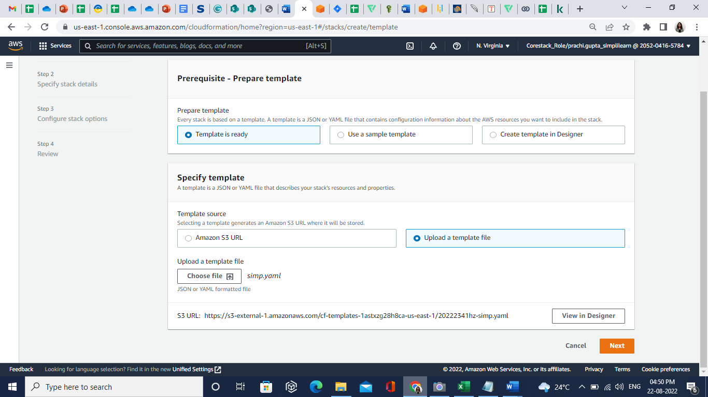

2.4 Enter an arbitrary name for the stack and click on **Next:**

In the **Configure stack options,** keep all settings as default and click on **Next**

* 1. Open the **Duplicate** tab, in the dashboard search and select the **IAM**
  2. Select the **Roles** and click on the Create role button

* 1. In the **Select trusted entity** section, specify the following values:
     + - Trusted entity type: AWS service
       - Use case: CloudFormation

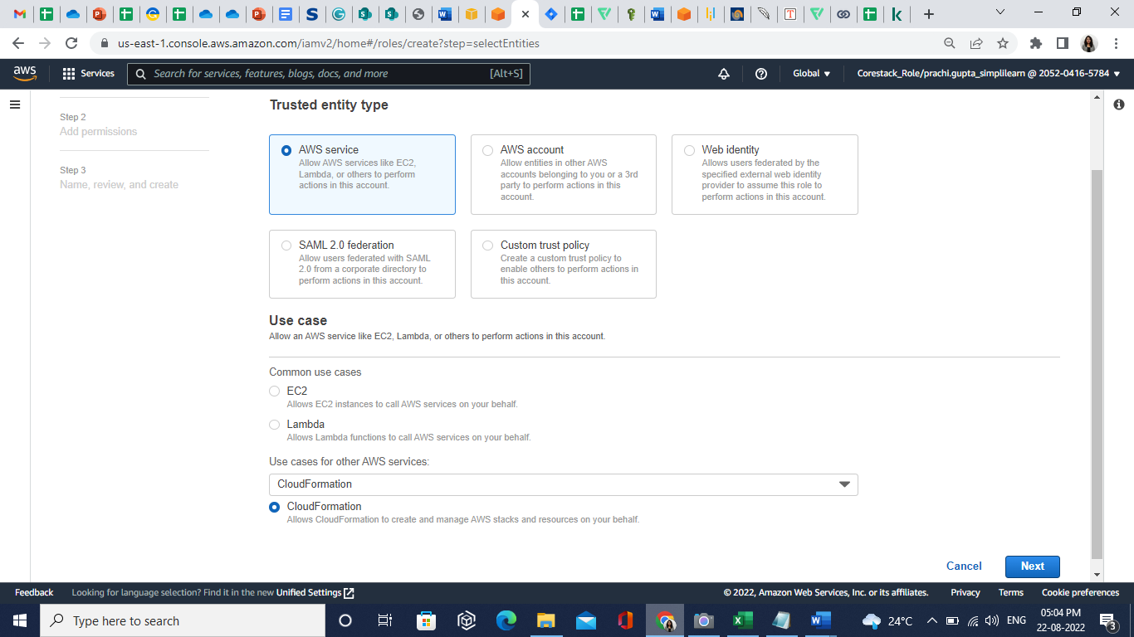

* 1. Click on the **Next** button
  2. In the **Permissions** **policies**, search and select **AmazonS3FullAccess**

* 1. Enter the **role name** and click on the **Create role** button
  2. Go back to the **Stack**, in **Configure stack options** page, select the **IAM role**

* 1. In **Stack failure options**, select **Preserve successfully provisioned resources** and then click on the Next button

* 1. Review all the settings under the **Review** tab, click on **Create Stack:**

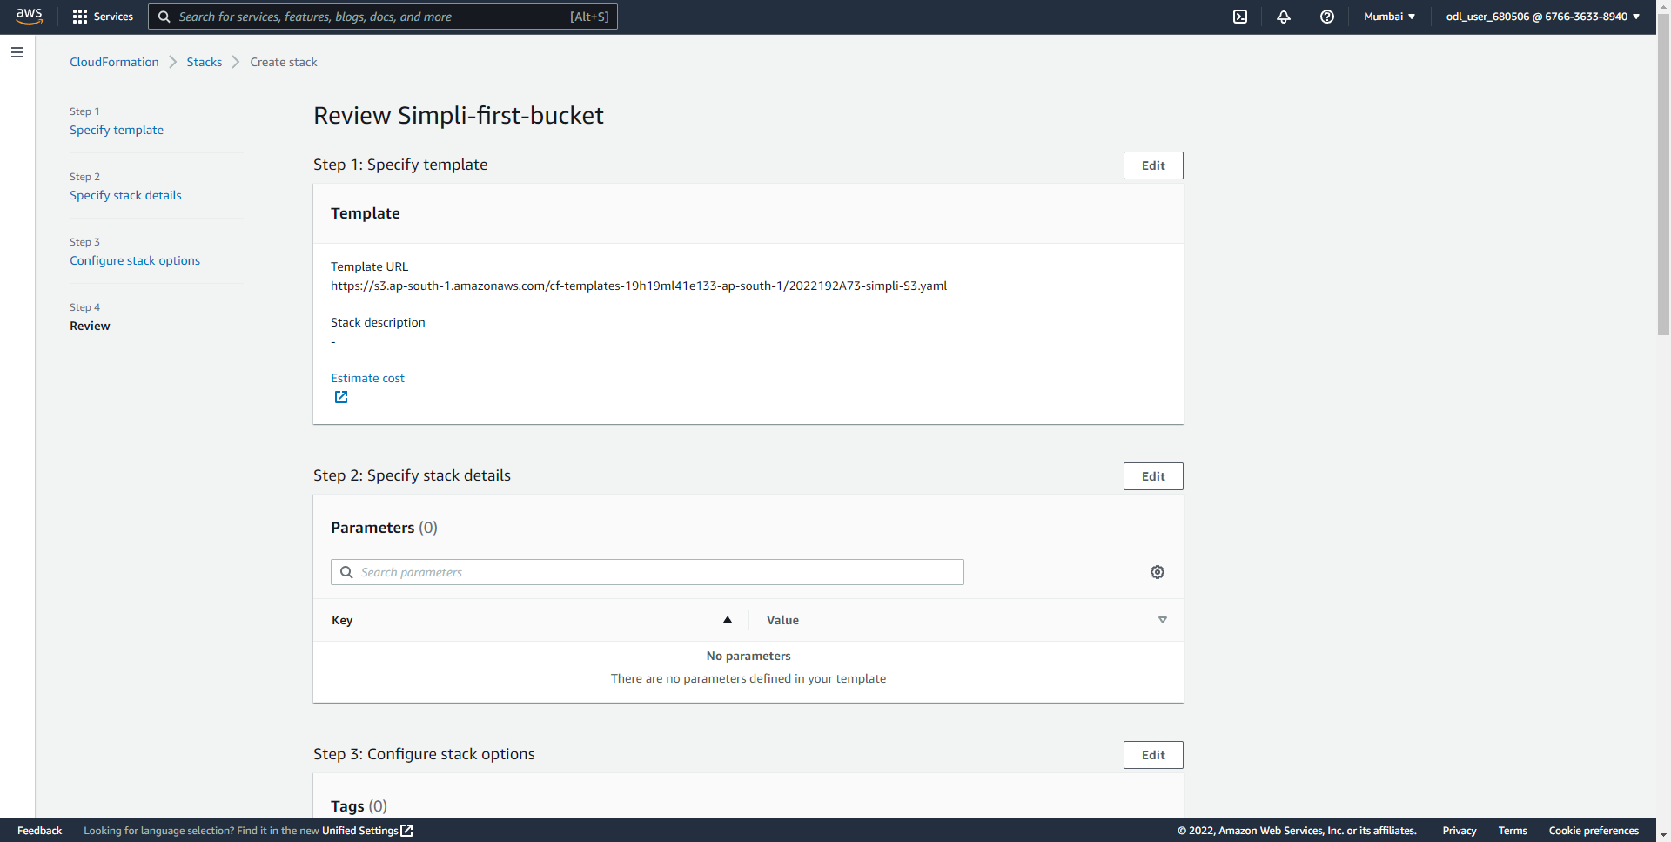

The newly created S3 bucket will be displayed in the list: 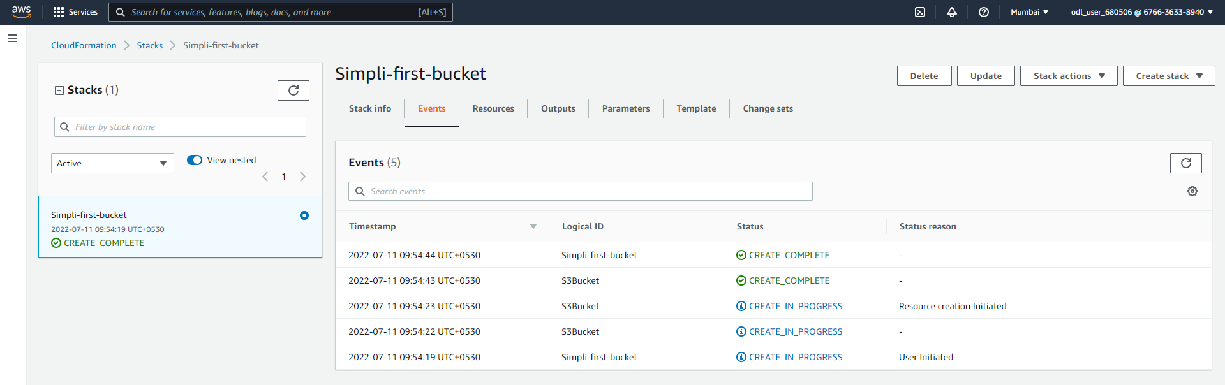

Hence the S3 bucket is created using CloudFormation.