**Lesson 9 Demo 4**

**Delete an Existing Stack**

**Objectives:** To delete an existing stack

**Tools Required:** AWS account

**Prerequisite:** A pre-existing S3 bucket

Steps to be followed:

1. Locate an existing stack and delete it

**Step 1: Locate an existing stack and delete it**

* 1. In the AWS Management Console, search for **S3,** then click on **S3**:

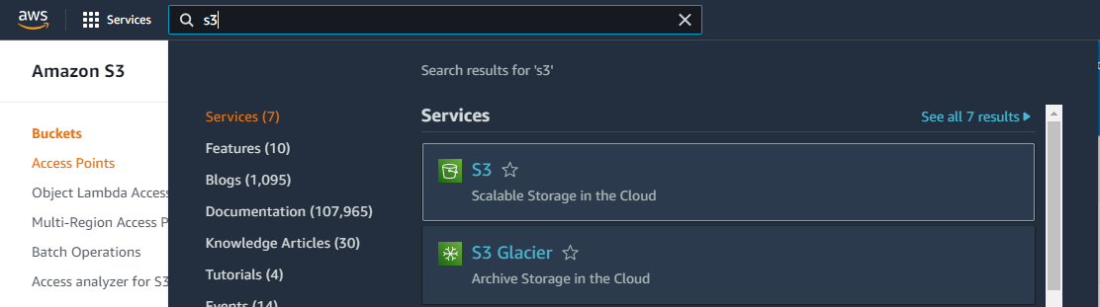

* 1. In the S3 Management Console, find the bucket to delete, select it and click on **Delete:**

* 1. Enter the exact **Bucket name,** and choose **Delete bucket:**

* 1. 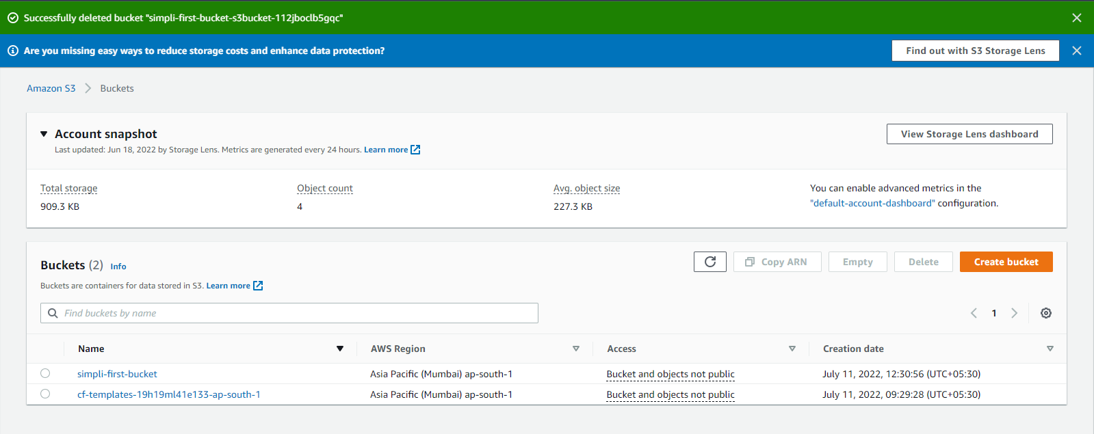Go to the dashboard to see the updated bucket list:

Now, the bucket you have deleted in Step 1.2 will not appear in your Buckets

Dashboard.