**Lesson 9 Demo 5**

**Updating an Existing Stack**

**Objective:** To update a stack by deleting an S3 bucket

**Tools Required:** An AWS account

**Prerequisite:** NA

Steps to be followed:

1. Create an S3 bucket stack using CloudFormation
2. Delete an S3 bucket from the stack

**Step 1: Creating an S3 bucket stack using CloudFormation**

* 1. Go to the AWS Management Console and search for **CloudFormation**

1.2 In the Cloud Formation Management Console, click on the **Create stack.**

1.3 In **Create stack** console, do the following:

* Choose to **Create template in Designer** in **Specify template** section
* Click on **Create template in Designer**

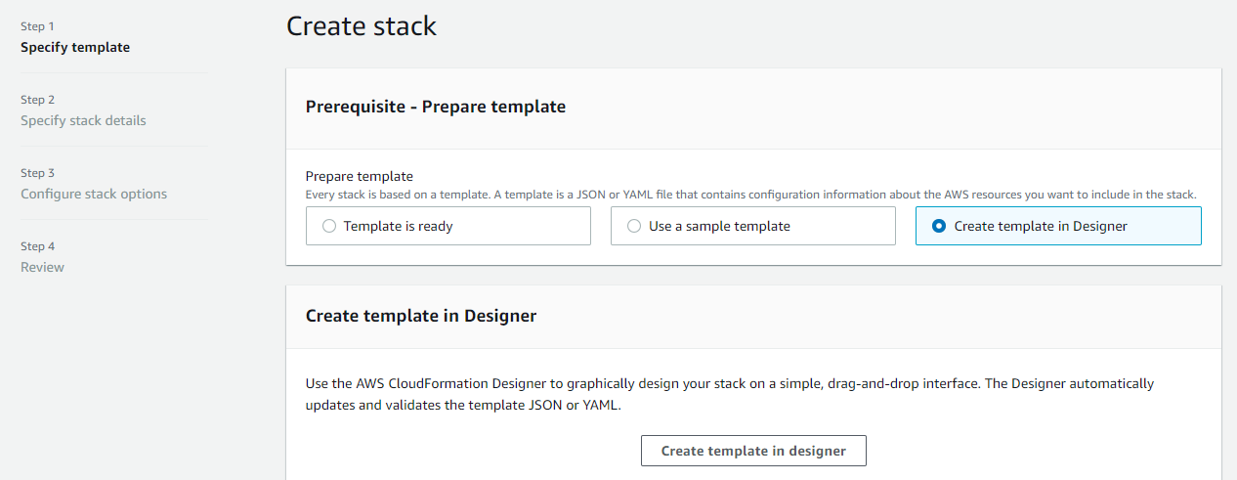

1.4 In the **Template designer** do the following:

* In the **Resource types,** select **S3** thenclick on **Bucket.**

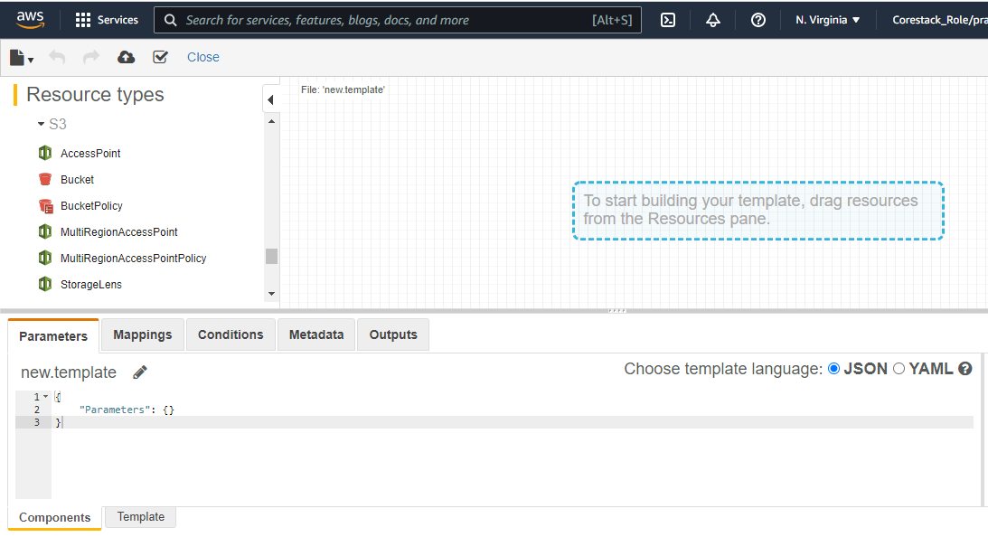

* Drag 3 **Buckets** from the **Resource pane** to the **right pane**
* Go to the **Template** tab on the lower pane of the **Template designer**

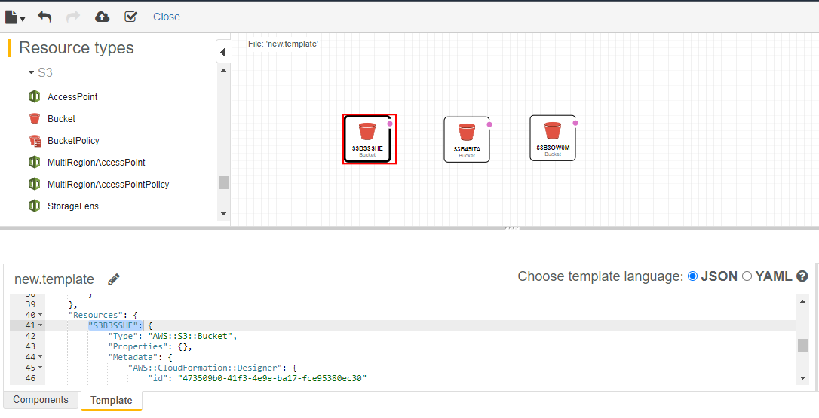

Then save the template in with an arbitrary name

* Now, edit the names of all three buckets by going into the Resources section of the

**Template** andenter an arbitrary name for the first bucket:

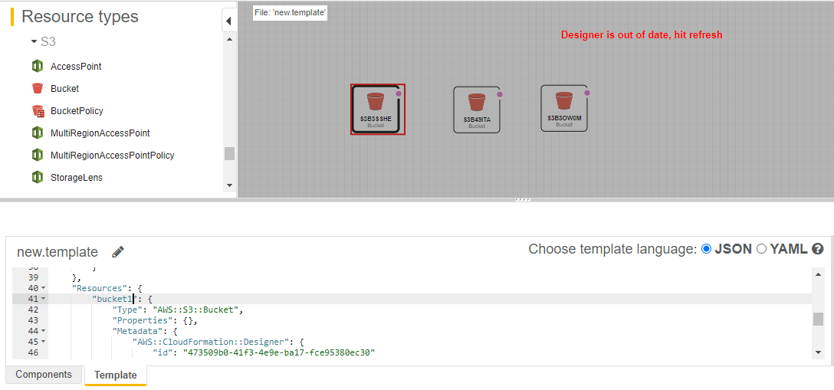

* Similarly, enter an arbitrary name for the second and third bucket:

* Click on the **Save** icon and save the template

* Save the template as **Amazon S3 bucket** andenter an arbitrary name for the template

* Now click on the **Upload** icon and upload the template

* Now you will be redirected to the **Create stack** window. Then click on the **Next** step.

1.5 In **Specify stack details,** enter an arbitrary name for the stack. Then click on **Next.**

* Similarly, in **Configure Stack options,** click on **Next**

1.6 In the **Review** section, click on **Create stack**

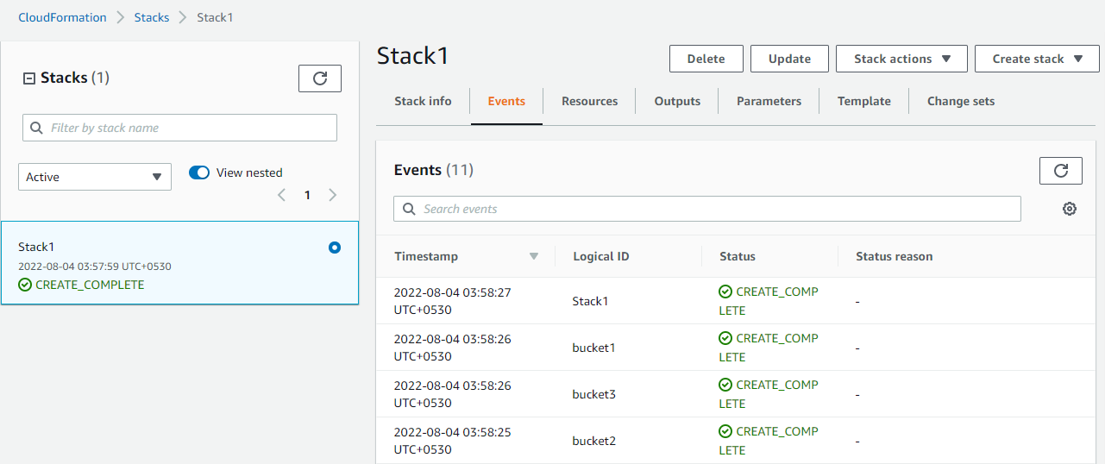

1.7 Now go to the S3 bucket dashboard. There you will find all the three buckets created.

**Note**: Open a duplicate tab and perform the above step and keep this tab open till the end of this demo.

**Step 2: Delete an S3 bucket from the stack**

2.1 Now go to the CloudFormation dashboard, then select the stack you just created and click on **Update**

2.2 Select **Edit template in designer** then, click on **View in Designer**

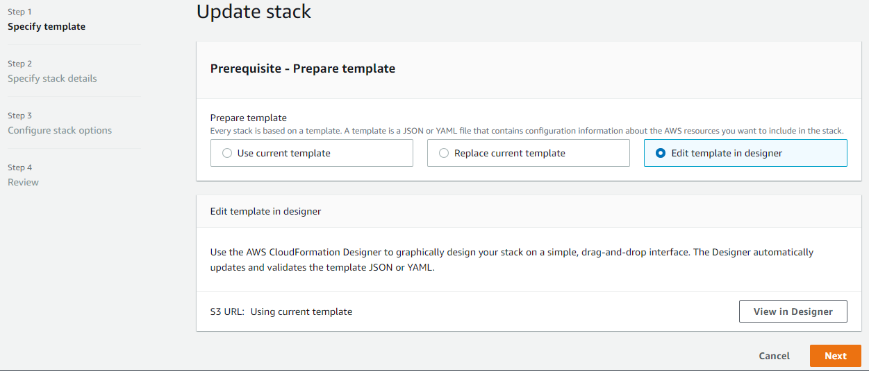

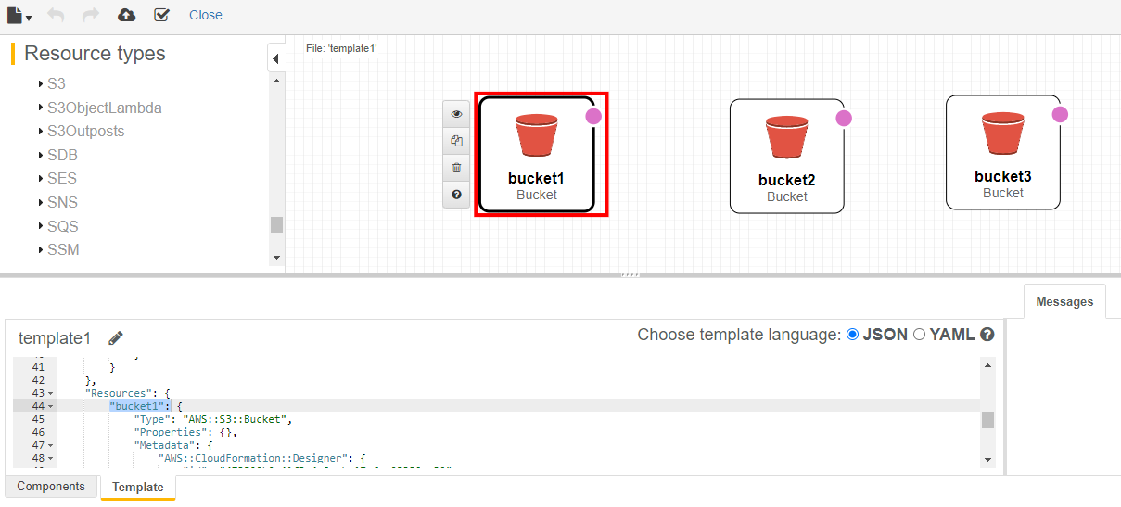 2.3 Select the first bucket and click on the delete icon to delete the bucket from the stack

* After deleting the bucket, click on the upload icon to upload the template.

2.4 In the **Update stack** section, click on **Next.**

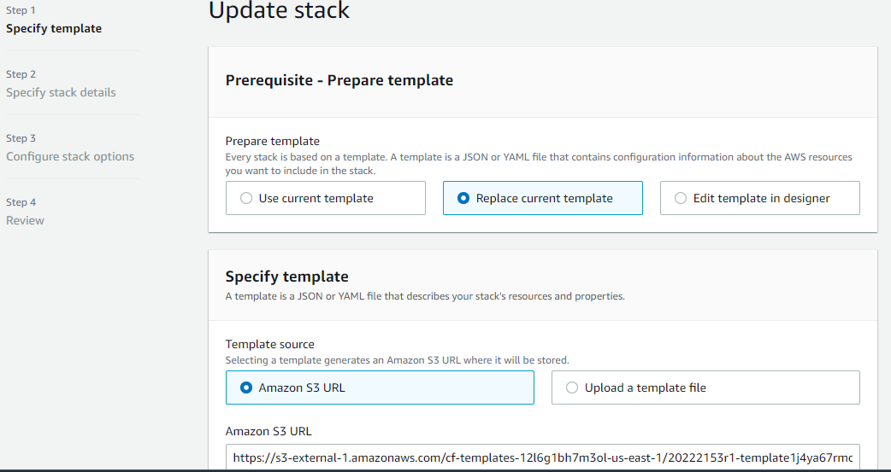

* Similarly, click on **Next** for **Specify stack details** and **Configure stack options**
* Then click on **Create stack** in **Review** section

* After two minutes, the status changes to **UPDATE_COMPLETE.**

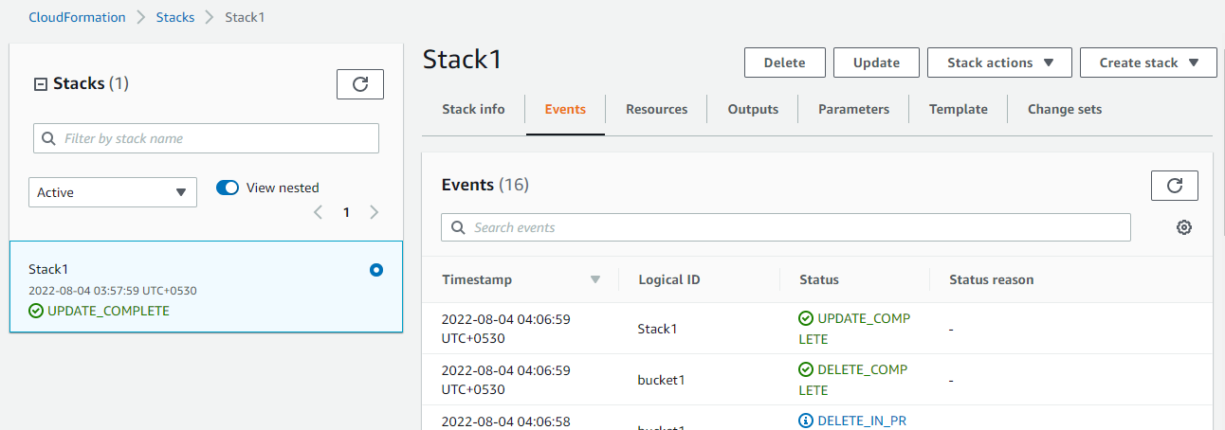

* Now go to the tab which you opened in step 1.7, then refresh the dashboard. There you will find that only the second and third buckets are present, which means that the first bucket is deleted.

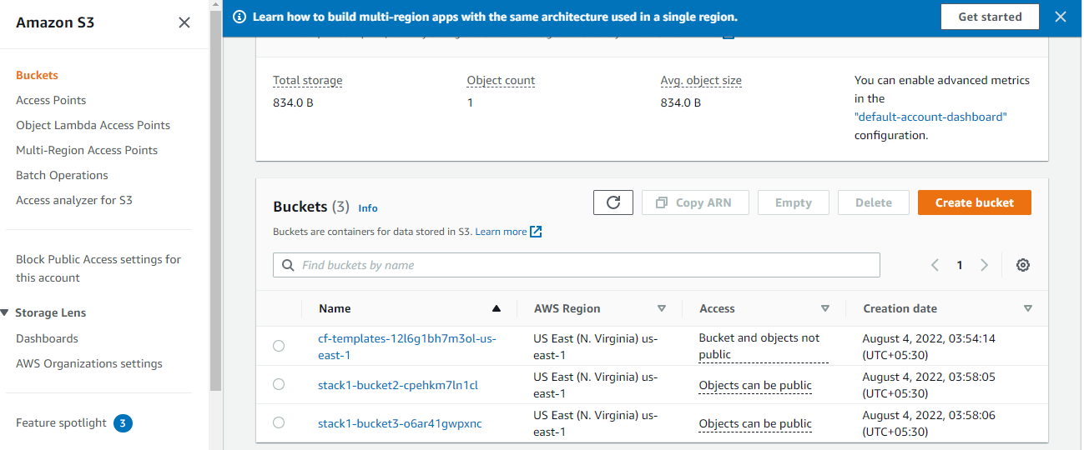

Hence, you have successfully updated the stack by deleting one S3 bucket from it.