**Lesson 9 Demo 6**

**Update Input Parameters in an Existing Stack**

**Objectives:** To update the parameters for your existing template

**Tools required:** AWS Lab

**Prerequisites:** None

Steps to be followed:

1. Log in to your AWS lab
2. Go to CloudFormation
3. Deploy a stack using a template
4. Update the template for a set of parameters
5. Test the updates

**Step 1: Log in to your AWS lab**

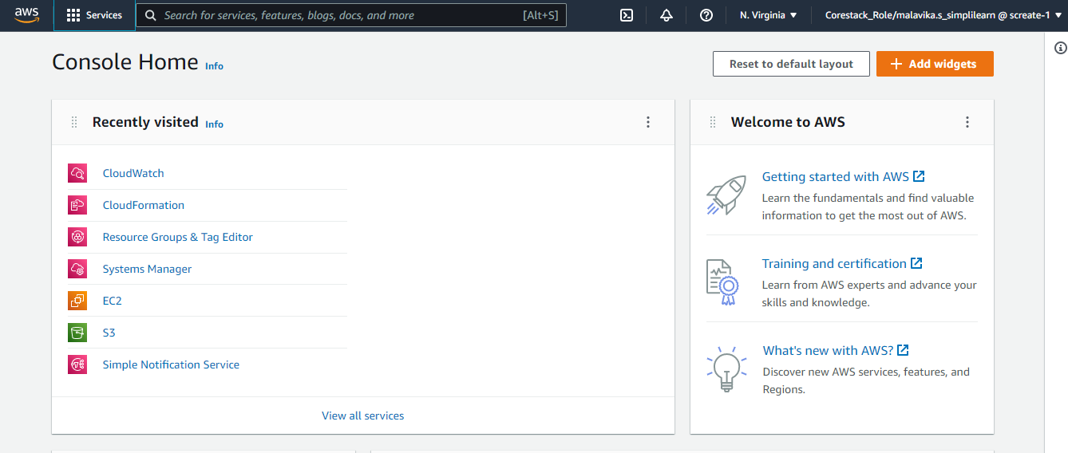

**Step 2: Go to CloudFormation**

* 1. In the dashboard, search and select the **CloudFormation**, then click on the **Create stack** button

**Step 3: Deploy a stack using a template**

**Step 4: Update the template for a set of parameters**

1. Before updating

1. After updating

**Step 5: Test the updates**

Hence, the parameters are updated successfully.